Autonomous Laptop Operating Agent
(THE ALOA)

A Minor Project Report
Submitted in partial fulfillment of requirement of the
Degree of
BACHELOR OF TECHNOLOGY in COMPUTER SCIENCE & ENGINEERING
BY
Piyush Solanki
EN23CS304044

Mayank Sahu
EN23CS304037

Piyush Pal
EN23CS304044

Under the Guidance of
Prof. Vishal Sharma
Prof. Suyog Munshi

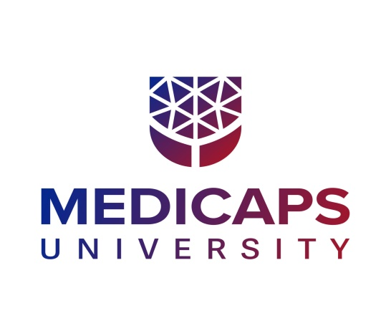

Department of Computer Science & Engineering
Faculty of Engineering
MEDICAPS UNIVERSITY, INDORE- 453331

APRIL-2026

Report Approval

The project work "THE ALOA - Autonomous Laptop Operating Agent" is hereby approved as a creditable study of an engineering/computer application subject carried out and presented in a manner satisfactory to warrant its acceptance as a prerequisite for the Degree for which it has been submitted.
It is to be understood that by this approval the undersigned do not endorse or approve any statement made, opinion expressed, or conclusion drawn therein; but approve the "Project Report" only for the purpose for which it has been submitted.

Internal Examiner
Name:
Designation:
Affiliation:

External Examiner
Name:
Designation:
Affiliation:

Declaration

We hereby declare that the project entitled "THE ALOA - Autonomous Laptop Operating Agent" submitted in partial fulfillment for the award of the degree of Bachelor of Technology in Computer Science & Engineering, completed under the supervision of Prof. Vishal Sharma and Prof. Suyog Munshi, Faculty of Engineering, Medicaps University Indore, is an authentic work.
Further, we declare that the content of this Project work, in full or in parts, have neither been taken from any other source nor have been submitted to any other Institute or University for the award of any degree or diploma.

Signature and name of the student(s) with date:

________________________________
Piyush Solanki (EN3CS304045)

________________________________
Mayank Sahu (EN23CS304037)

________________________________
Piyush Pal (EN23CS304044)

Date: _______________

Certificate

We, Prof. Vishal Sharma and Prof. Suyog Munshi, certify that the project entitled "THE ALOA - Autonomous Laptop Operating Agent" submitted in partial fulfillment for the award of the degree of Bachelor of Technology in Computer Science & Engineering by Piyush Solanki, Mayank Sahu, Piyush Pal is a record of the work carried out by them under our guidance and that the work has not formed the basis of award of any other degree elsewhere.

________________________________
Prof. Vishal Sharma
Department of Computer Science & Engineering
Medicaps University, Indore

________________________________
Prof. Suyog Munshi
Department of Computer Science & Engineering
Medicaps University, Indore

________________________________
Dr. Kailash Bandhu
Head of the Department
Computer Science & Engineering
Medicaps University, Indore

Acknowledgements

We would like to express our deepest gratitude to the Honorable Chancellor, Shri R C Mittal, who has provided us with every facility to successfully carry out this project, and our profound indebtedness to Prof. (Dr.) D. K. Patnaik, Vice Chancellor, Medicaps University, whose unfailing support and enthusiasm has always boosted our morale. We also thank Prof. (Dr.) Ratnesh Litoriya, Dean, Faculty of Engineering, Medicaps University, for giving us a chance to work on this project. We would also like to thank our Head of the Department Prof. (Dr.) Kailash Bandhu for his continuous encouragement for the betterment of the project.
We are immensely grateful to our project guides, Prof. Vishal Sharma and Prof. Suyog Munshi, for their invaluable guidance, constant motivation, and expert advice throughout the course of this project. Their insights greatly shaped the direction and quality of our work.
We extend our sincere thanks to all faculty members and staff of the Department of Computer Science & Engineering for their continuous support and cooperation. Without their help and support, this report would not have been possible.

Piyush Solanki
Mayank Sahu
Piyush Pal
B.Tech. III Year
Department of Computer Science & Engineering
Faculty of Engineering
Medicaps University, Indore

Abstract

The ALOA (Autonomous Laptop Operating Agent) is a modular, AI-powered operating ecosystem designed to assist developers and professionals in autonomously executing complex local and cloud-based workflows. In today's highly fragmented software environment, executing repetitive tasks such as managing system resources, debugging local codebases, configuring continuous deployment pipelines, and synthesizing daily intelligence requires immense cognitive load and constant context-switching. This project proposes and implements a comprehensive agentic architecture that bridges human intent with autonomous system-level execution. The system leverages a highly resilient multi-model routing engine—integrating Groq, Google Gemini, OpenRouter, and AWS Bedrock APIs—to ensure continuous availability and mitigate API rate-limits via a proprietary DualModelChain mechanism. Built on a robust Python backend utilizing a strict Core-Runner paradigm, the application interfaces directly with the host operating system (Windows/PowerShell) to execute commands securely. Users can manage applications, clean system caches, apply heuristic diff-patches to broken codebases, automatically deploy full-stack applications to platforms like Vercel and Render, and generate ATS-optimized resumes entirely from a unified Command Line Interface (CLI). This eliminates the need to manually navigate disparate IDEs, web dashboards, and single-model AI chatbots. The system significantly reduces operational friction, ensuring zero downtime during API disruptions while aggregating personalized developer intelligence based on the user's technical stack. Testing results demonstrate that the agent executes multi-step debugging and deployment operations in seconds, with exceptionally high accuracy in abstract syntax tree (AST) validation. The ALOA addresses the critical need for a deeply integrated, agentic workflow assistant by providing a secure, scalable, and autonomous solution that radically enhances engineering productivity and day-to-day computing efficiency.

Keywords: Autonomous Laptop Operating Agent, Agentic Workflow, Large Language Models, Multi-Model Routing, Python, CLI Automation, AST Validation, Cloud Deployment, Developer Productivity.

Table of Contents

 | Report Approval | ii
 | Declaration | iii
 | Certificate | iv
 | Acknowledgements | v
 | Abstract | vi
 | Table of Contents | vii
 | List of Figures | viii
 | List of Tables | ix
 | Abbreviations | x
Chapter 1 | Introduction | 1
 | 1.1 Introduction | 1
 | 1.2 Literature Review | 2
 | 1.3 Objectives | 3
 | 1.4 Significance | 3
 | 1.5 Research Design / Methodology | 4
 | 1.6 Source of Data | 4
 | 1.7 Chapter Scheme | 5
Chapter 2 | Requirements Specification | 6
 | 2.1 User Characteristics | 6
 | 2.2 Functional Requirements | 6
 | 2.3 Dependencies | 7
 | 2.4 Performance Requirements | 8
 | 2.5 Hardware Requirements | 8
 | 2.6 Constraints and Assumptions | 8
Chapter 3 | Design | 9
 | 3.1 Algorithm | 9
 | 3.2 Function Oriented Design | 10
 | 3.3 System Design | 10
 | 3.4 Database Design | 12
Chapter 4 | Implementation, Testing, and Maintenance | 13
 | 4.1 Languages, IDEs, Tools and Technologies | 13
 | 4.2 Testing Techniques and Test Plans | 14
 | 4.3 Installation Instructions | 15
 | 4.4 End User Instructions | 15
Chapter 5 | Results and Discussions | 16
 | 5.1 User Interface Representation | 16
 | 5.2 Brief Description of Modules | 16
Chapter 6 | Summary and Conclusions | 17
Chapter 7 | Future Scope | 18
 | Appendix | 19
 | Bibliography | 19

List of Figures
Figure 3.1 Data Flow Diagram – Level 0 (Context Diagram)
Figure 3.2 Data Flow Diagram – Level 1
Figure 3.3 Activity Diagram of ALOA
Figure 3.4 System Flow Chart
Figure 3.5 Class Diagram
Figure 3.6 Entity-Relationship (ER) Diagram
Figure 3.7 Sequence Diagram

List of Tables

Table 2.1 Functional Requirements of ALOA
Table 2.2 Hardware & Software Requirements
Table 4.1 Test Cases for System execution (App Manager / Doctor)
Table 4.2 Test Cases for Multi-Model API Fallback (Groq/Gemini/OpenRouter)
Table 4.3 Test Cases for Heuristic Patching (Code/Cloud Healer)

Abbreviations

AI – Artificial Intelligence
API – Application Programming Interface
CRUD – Create, Read, Update, Delete
DB – Database
DFD – Data Flow Diagram
ER – Entity-Relationship
HTTP – Hypertext Transfer Protocol
HTTPS – Hypertext Transfer Protocol Secure
IDE – Integrated Development Environment
JSON – JavaScript Object Notation
NLP – Natural Language Processing
REST – Representational State Transfer
SRS – Software Requirements Specification
UI – User Interface
UML – Unified Modeling Language

Chapter 1

Introduction

1.1 Introduction
Software engineering and computer operations play a critical role in modern professional environments. Every day, developers and power users across various industries execute complex workflows that require transitioning between command-line interfaces, IDEs, version control systems, and cloud dashboards. Managing local environments, debugging obscure errors, and provisioning infrastructure manually is both time-consuming and repetitive, particularly when dealing with constant context-switching.
The ALOA (Autonomous Laptop Operating Agent) is an AI-powered operating ecosystem designed to address these challenges. The system intelligently analyzes system states, application outputs, and user intent to automatically generate and execute professional, context-aware commands using Agentic Artificial Intelligence. By integrating AI directly into the user's terminal workflow through a unified CLI, ALOA eliminates the need to switch between multiple platforms, thereby improving technical efficiency and reducing cognitive load.
The system is built using a modern, robust technology stack: Python for core backend execution and OS-level operations, a modular Command Line Interface for frontend interaction, and a highly resilient multi-model AI routing engine (integrating Groq, Google Gemini, OpenRouter, and AWS Bedrock) for intelligent action generation. ALOA is deployed locally, enabling users to manage applications, patch code, and deploy cloud infrastructure directly within their host operating system in a seamless and secure manner.

1.2 Literature Review
Recent advancements in Artificial Intelligence and Natural Language Processing (NLP) have enabled the development of automated systems capable of not just generating human-like text, but reasoning through complex logic. Transformer-based models, such as Google's Gemini, OpenAI's GPT series, and Meta's LLaMA, have demonstrated remarkable capabilities in understanding code syntax and system architecture.
Several AI-based developer tools have been developed to assist professionals in managing software engineering tasks. IDE integrations like GitHub Copilot and conversational agents like ChatGPT introduced predictive code completion and debugging assistance. However, these features offer limited autonomy; they exist in isolated environments and suffer from the "manual execution gap." They generate code, but still require the user to manually execute commands, read stack traces, apply patches, and provision infrastructure.
Studies in the domain of developer productivity highlight the growing need for context-sensitive, autonomous agentic execution rather than passive chat interfaces. The reliance on single-provider AI models also presents significant vulnerabilities, as developers frequently encounter HTTP 429 Rate Limit errors during intensive debugging sessions.
The ALOA builds upon this body of work by offering a truly agentic CLI tool that integrates advanced capabilities through a proprietary DualModelChain. This approach overcomes the key limitations of existing tools—specifically, their lack of execution autonomy, susceptibility to rate-limiting, and poor integration with the local operating system (Windows/PowerShell).

1.3 Objectives
To develop an AI-powered Autonomous Laptop Operating Agent that helps users efficiently execute complex local and cloud workflows with minimal manual effort. To significantly reduce the time required to diagnose codebase errors, deploy full-stack applications, and manage system resources by automating the execution process using advanced LLM APIs. To integrate the AI execution feature directly into the user's terminal, ensuring seamless and convenient usage without IDE or browser switching. To design a highly resilient DualModelChain architecture that automatically fails over between multiple AI providers (Groq, Gemini, OpenRouter) to prevent downtime caused by rate limits. To build a scalable and maintainable modular Python backend that can securely interface with the host OS, execute subprocesses, and communicate with external REST APIs. To allow users to customize their technical intelligence feeds and automate daily productivity tasks (like Excel attendance or YouTube note generation) autonomously.

1.4 Significance
The significance of The ALOA lies in its ability to transform the way professionals interact with their host machines. Command-line operations and system management remain foundational to software development, and the burden of manually executing repetitive tasks and reading stack traces has become a major source of productivity loss.
ALOA addresses this challenge by providing an intelligent agent that acts as a proactive operating partner. This reduces the cognitive effort required to context-switch between tools, minimizes deployment time, and helps maintain a "flow state" during complex coding sessions.
Furthermore, by operating as a local CLI package, ALOA integrates non-intrusively into the user's existing terminal workflow, making it accessible securely without requiring the upload of sensitive code to third-party web platforms. The system's multi-model fallback capability makes it uniquely reliable for enterprise-grade, uninterrupted engineering work.

1.5 Research Design / Methodology
Requirement Analysis: Identifying the functional and non-functional requirements of the system through an analysis of developer friction points (context-switching, rate limits, manual debugging).

System Design: Designing the overall modular Runner/Core architecture, data flow, OS interaction mechanisms, API fallback logic (DualModelChain), and ANSI-colored UI/UX of the CLI.

Implementation: Developing the core logic using Python, integrating subprocess and psutil for OS control, utilizing Abstract Syntax Tree (AST) parsing for code heuristic patching, and connecting external REST APIs for intelligence gathering and cloud deployments.

Testing: Conducting unit testing of the heuristic diff-patching engine, integration testing of the GitHub/Vercel APIs, and simulated network failure testing to validate the multi-model AI failover logic.

Deployment: Packaging the project for local execution, ensuring .env security isolation, and running the application within the user's standard terminal environment. The system follows a localized architecture where the CLI frontend communicates dynamically with the Python backend, which securely interfaces with remote LLM APIs to generate execution commands.

1.6 Source of Data
The primary source of data for The ALOA is the runtime environment extracted directly from the user's local machine. The agent reads the text content of local files, captures terminal output (stdout/stderr), monitors hardware metrics (CPU/RAM/Disk), and parses application dependencies to generate context.
For the ALOA Radar module, external intelligence is gathered dynamically via public REST APIs (Dev.to, Reddit, PyPI) and HTML scraping (GitHub Trending, HackerNews). No external datasets are used for model training, as the system relies entirely on zero-shot inference from pre-trained AI models via their respective APIs.
Official documentation and technical references used during development include the Python Official Documentation, Google Gemini AI API Guidelines, Groq SDK Documentation, OpenRouter API specs, and the REST API references for GitHub, Vercel, and Render.

1.7 Chapter Scheme
The report is organized into the following chapters:
• Chapter 1 – Introduction: Presents the background, literature review, objectives, significance, methodology, and chapter organization of the project.
• Chapter 2 – Requirements Specification: Details the functional and non-functional requirements, user characteristics, hardware specifications, constraints, and dependencies of the system.
• Chapter 3 – Design: Describes the system architecture, data flow diagrams, activity diagrams, class diagrams, ER diagrams, sequence diagrams, and database/local storage design.
• Chapter 4 – Implementation, Testing, and Maintenance: Covers the technologies used, heuristic patching strategies, fallback testing, installation procedures, and end-user instructions.
• Chapter 5 – Results and Discussions: Presents the CLI user interface, module descriptions, and system snapshots with brief explanations of the 10 core features.
• Chapter 6 – Summary and Conclusions: Summarizes the work done and presents conclusions drawn from the agentic execution project.
• Chapter 7 – Future Scope: Outlines the potential enhancements, cross-platform support, and future directions for The ALOA system.

Chapter 2 Requirements Specification

2.1 User Characteristics
Software Developers and Engineers: Professionals who manage complex local codebases, execute backend scripts, and provision continuous deployment pipelines. They require the system to instantly debug abstract syntax tree (AST) errors, parse complex stack traces, and seamlessly push code to cloud platforms like GitHub and Vercel.
System Administrators and DevOps: Users responsible for maintaining the health of the operating system. They rely on the system to autonomously monitor hardware metrics (CPU/RAM/Disk), aggressively clean temporary caches, and terminate heavy background processes using Windows commands.
Students and Researchers: Users who require robust academic and productivity automation. They depend on the system to scrape YouTube transcripts for formatted PDF study notes, utilize OCR (Optical Character Recognition) to assist with screen-based quizzes, and parse Excel sheets for automated data entry.
Tech Enthusiasts and Job Seekers: Individuals seeking to stay ahead of the technology curve and advance their careers. They utilize the system's Radar module to aggregate personalized daily tech news from HackerNews, Dev.to, and Reddit, and leverage the Resume Engine to generate ATS-optimized PDF resumes tailored to specific job descriptions.

2.2 Functional Requirements
REQ-1: The system shall provide a unified, highly modular, ANSI-colored Command Line Interface (CLI) via the Runner module, allowing users to select from 10 distinct operational features without leaving the terminal.
REQ-2: The system shall implement a proprietary 'DualModelChain' mechanism. If the primary AI API (e.g., Groq or Google Gemini) encounters an HTTP 429 Rate Limit or HTTP 403 Access Denied error, the system must automatically and transparently failover to secondary providers (OpenRouter or AWS Bedrock).
REQ-3: The system shall possess deep OS-level integration, utilizing Python's subprocess and psutil modules to safely execute Windows commands, install software via Winget, and manage running system processes.
REQ-4: The system (Code Healer module) shall read local directory structures, capture real-time stdout/stderr error logs from background dev servers, and apply heuristic, 3-tier diff-patches directly to local source code files to resolve runtime errors.
REQ-5: The system (Auto-Deployer module) shall dynamically detect the local framework (React, Node.js, Django, etc.), initialize a Git repository, push to GitHub via Personal Access Tokens, and orchestrate REST API calls to Vercel or Render for full-stack cloud deployment.
REQ-6: The system shall extract on-screen text dynamically using the 'mss' library for region capture and 'pytesseract' for Optical Character Recognition (OCR), feeding the extracted text to LLMs for immediate processing.
REQ-7: The system shall aggregate web intelligence by scraping HTML via BeautifulSoup and parsing REST APIs (Reddit, PyPI), generating a highly personalized, 5-section Daily Intelligence Brief tailored specifically to the user's defined tech stack.
REQ-8: The system shall process YouTube video transcripts, segment the text, and utilize AI to generate structured markdown summaries, which are subsequently compiled into properly formatted PDF documents using the fpdf2 library.
REQ-9: The system shall persist state strictly locally, storing encrypted API credentials within a .env file and maintaining daily intelligence caches via local JSON files, ensuring zero reliance on external database servers.

2.3 Dependencies
Core Language: Python 3.10 or higher. The entire backend core and CLI frontend strictly rely on the Python runtime environment.

AI Application Programming Interfaces (APIs): The system's logical reasoning depends heavily on external API endpoints, specifically the Groq API (SDK), Google Gemini API (google-genai), OpenRouter API, and AWS Bedrock (boto3).

Operating System Modules: The system extensively uses built-in Python libraries such as os, sys, and subprocess to natively bind to Windows PowerShell for command execution.
Hardware and Vision Libraries: psutil is required for real-time hardware monitoring, mss for low-latency screen region capturing, and pytesseract (with a local Tesseract-OCR installation) for text extraction.

Data Processing Libraries: pandas and openpyxl are necessary for Excel data manipulation, while beautifulsoup4 is required for HTML DOM parsing of web pages.

Document Generation Libraries: fpdf2, PyPDF2, and weasyprint (or pdfkit) are strictly required for generating and parsing PDF documents across the YouTube Notes and Resume Engine modules.

Cloud APIs: The GitHub REST API, Vercel Deployment API, and Render Services API are required for autonomous cloud provisioning.

2.4 Performance Requirements
The DualModelChain must detect API rate limits, intercept the exception, and successfully route the prompt to a secondary provider within 500 milliseconds to prevent user-facing latency.
• System hardware queries (CPU percentage, virtual memory, disk usage) must complete and render to the CLI within 1.0 seconds.
• OCR text extraction from a designated screen region must complete within 2.0 seconds to maintain real-time responsiveness.
• Heuristic AST diff-patching operations (Code Healer) must analyze, match, and inject fixes into files containing up to 2000 lines of code within 5 to 10 seconds.
• The daily ALOA Radar brief generation, which involves 5 concurrent external web scrapes and LLM summarization, must complete and cache within 15 seconds under normal network conditions.

2.5 Hardware Requirements
Processor: Multi-core CPU (Intel Core i5, AMD Ryzen 5, or Apple Silicon equivalent) to handle concurrent subprocess execution and local python compiling.

RAM: Minimum 8 GB (16 GB highly recommended to allow ALOA to monitor the system while heavy IDEs and background development servers are running).

Storage: Minimum 1 GB of free disk space for ALOA virtual environments, installed pip dependencies, and JSON caching.

Network: Stable broadband internet connection (minimum 5 Mbps) to ensure low-latency communication with the various LLM APIs and Cloud providers.

Operating System: Windows 10/11 is strictly required for full functionality (specifically for Winget package management and PowerShell paths), though core logical modules may execute on macOS/Linux.

2.6 Constraints and Assumptions
Constraints:

• The backend logic must be exclusively implemented in Python, adhering to the established Runner/Core architectural paradigm.
• The user interface must remain entirely CLI-based; no graphical web interfaces or browser pop-ups are permitted for system operations.
• Sensitive API keys must never be hardcoded or pushed to version control; they must exclusively reside in a git-ignored local .env file.
• The Exam Pilot module strictly constrains the user to install the Tesseract-OCR binary natively on their operating system.

Assumptions:

• Users possess administrative/root privileges on their local Windows machine, enabling the script to terminate processes and install software globally.
• Users have successfully generated and configured active API keys for at least one major provider (Groq or Gemini) and hold a valid GitHub Personal Access Token (PAT).
• The host machine has Python added to the system PATH environment variable, allowing the execution of 'python main.py' from any directory.

Chapter 3 Design

3.1 Algorithm
The core algorithm implemented in The ALOA follows a strictly defined, multi-stage pipeline for intent parsing, environmental context gathering, and resilient execution. This process is governed by the proprietary 'DualModelChain' mechanism. The algorithm is described below:

Step 1 – User Intent & Context Extraction: The CLI frontend (runner.py) receives user input. Depending on the active module, the system extracts the necessary local context—this could involve reading local file contents (Code Healer), polling hardware metrics via psutil (System Doctor), or capturing a designated screen region via mss (Exam Pilot).

Step 2 – Prompt Construction & Sanitization: The extracted data is sanitized (removing sensitive local absolute paths or stripping massive whitespace) and dynamically injected into a highly specific system prompt tailored for the chosen LLM.

Step 3 – Primary API Routing (Groq/Gemini): The backend Python execution engine initiates an asynchronous REST API call to the primary configured provider (e.g., Groq for speed-intensive tasks, or Gemini for complex reasoning).

Step 4 – DualModelChain Fallback Interception: The system listens for HTTP 429 (Rate Limit) or HTTP 403 (Access Denied) exception codes. If the primary model fails, the DualModelChain algorithm immediately intercepts the failure, rotates to the next available API key in the .env file, or pivots entirely to a secondary provider ecosystem (e.g., OpenRouter or AWS Bedrock).

Step 5 – Abstract Syntax Tree (AST) Validation: Once the LLM returns an execution payload (such as a code patch or a bash command), the system validates the response. For code edits, Python's ast library parses the generated diff to ensure syntactic validity before application.

Step 6 – Local Execution & Subprocess Orchestration: The validated command or patch is safely executed on the host operating system using the Python subprocess module, allowing ALOA to natively interact with Windows PowerShell.

Step 7 – UI Rendering & Caching: The result of the execution is rendered back to the terminal using ANSI-colored output. Persistable data (like Radar intelligence briefs) is cached into local JSON structures.

3.2 Function Oriented Design
CLI Runner Module: Implemented as a lightweight text-based interface (runner.py), this module handles user input, renders interactive menus, and displays ANSI-formatted output. It acts as the gateway to all 10 core features.
Core Orchestration Engine: Residing in core.py, this module connects the user interface to the underlying logic. It coordinates variable passing, file I/O operations, and calls the appropriate sub-functions for each feature.
Network API Gateway (DualModelChain): This is the critical networking module responsible for managing all HTTP requests to external LLM providers. It implements the try-catch retry logic, manages API key rotation, and ensures zero downtime during provider outages.
OS Execution Module: Interfaces directly with the Windows kernel via subprocess and os modules. It manages background threads, captures active stdout/stderr from local development servers, and handles forceful termination of processes.
Data Persistence Module: Manages the reading, writing, and locking of local JSON files (such as radar_watchlist.json) and ensures that sensitive API keys are safely decrypted and parsed from the local .env configuration.

3.3 System Design

3.3.1 Data Flow Diagrams

Level 0 – Context Diagram (Figure 3.1):
- Level 0 – Context Diagram (Figure 3.1): The Level 0 DFD represents The ALOA system as a central execution node interacting with the Host Machine (User/OS) and the External LLM Cloud. The User provides CLI commands and local context; ALOA requests reasoning from the AI APIs; and ALOA returns executed system actions back to the User.
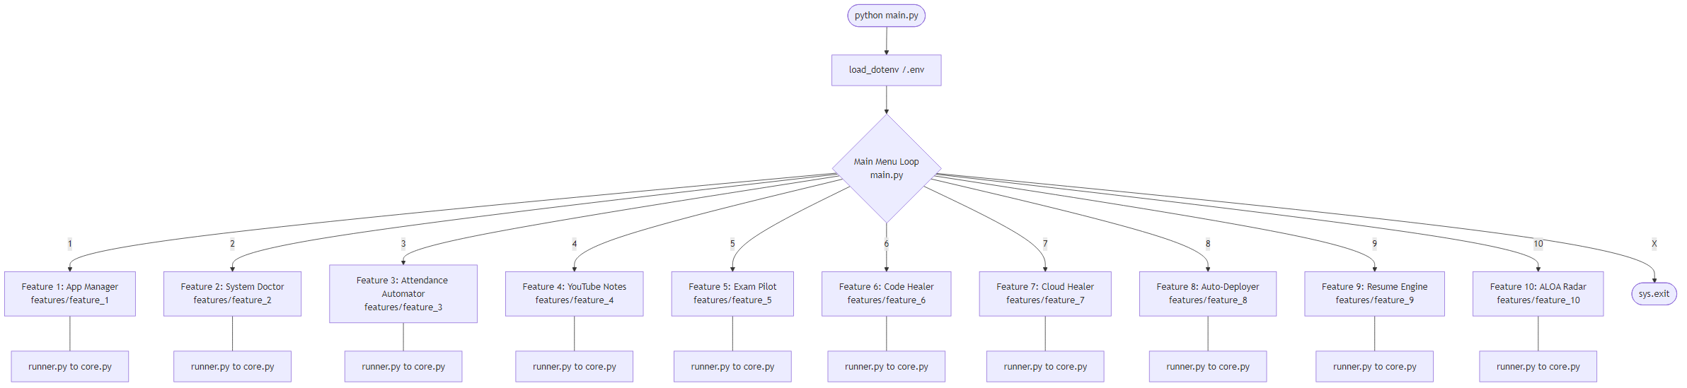

- Level 1 – Detailed DFD (Figure 3.5 - ALOA Radar): The Level 1 DFD decomposes ALOA into distinct data pipelines. For instance, the Radar module extracts target parameters from the Watchlist JSON, parallel-processes REST API requests to HackerNews, Reddit, and PyPI, aggregates the raw JSON feeds, and sends the consolidated data to the Groq LLM for summarization, finally storing the output in the daily cache.
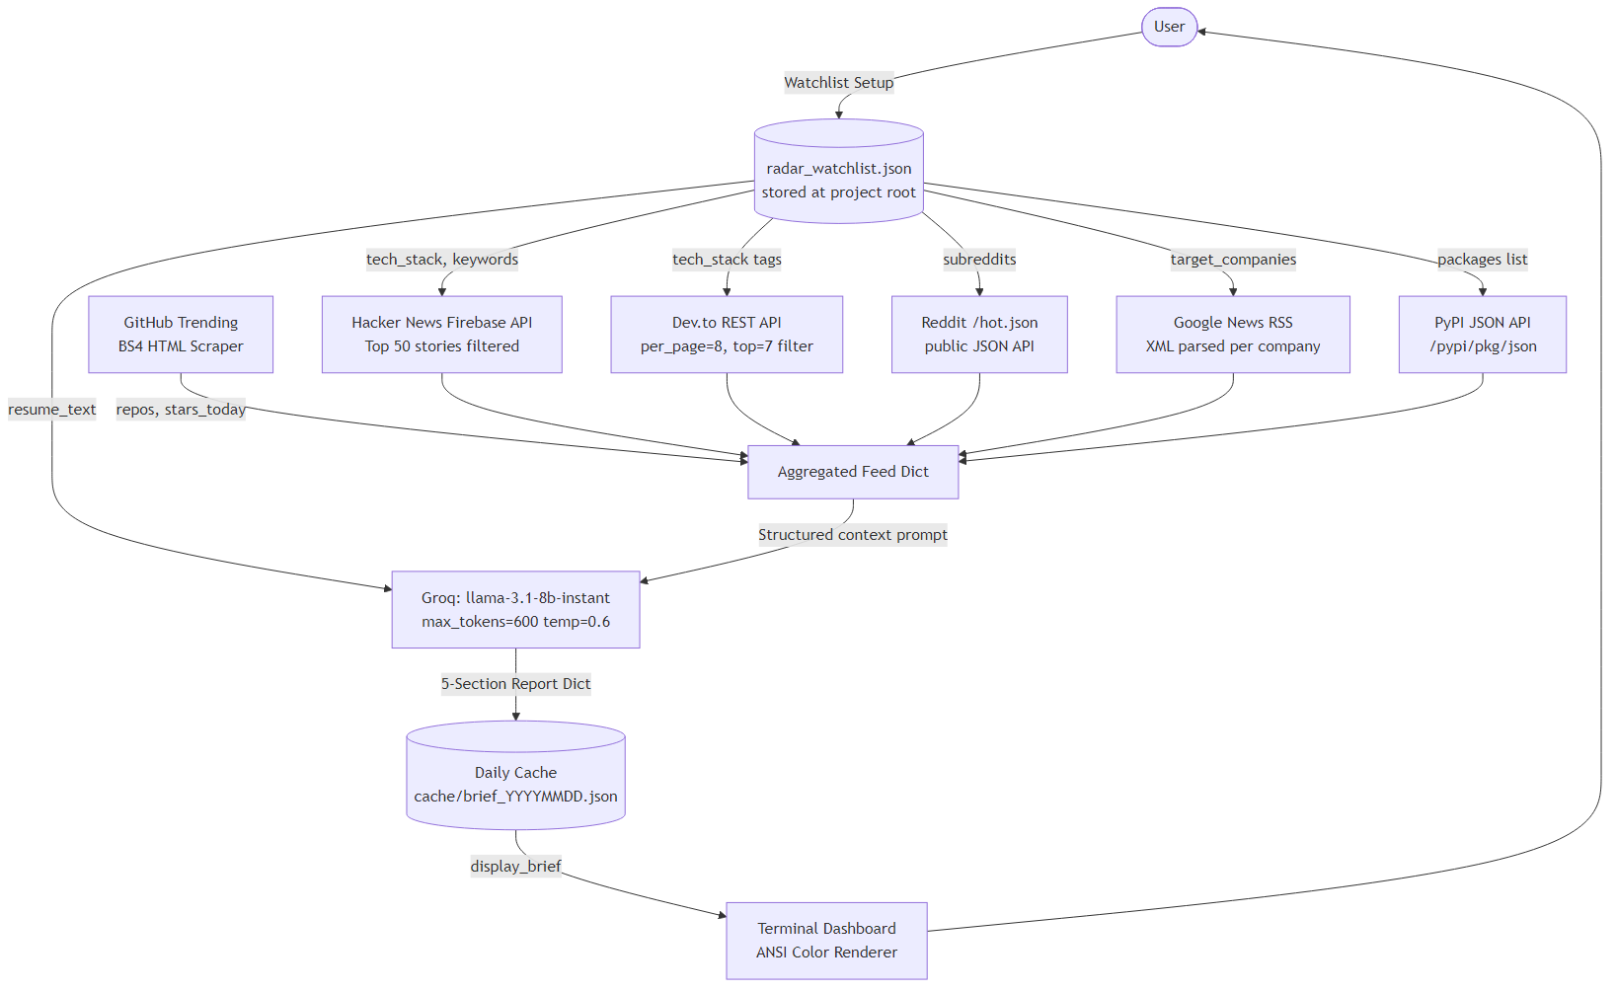

3.3.2 Activity Diagram
The Activity Diagram illustrates the sequential, state-driven flow of tasks originating from the user's initial Command Line Interface (CLI) entry to the final autonomous execution on the host operating system. Unlike traditional web applications that follow a simple request-response loop, ALOA operates as a continuous, multi-state agentic loop.
The activity sequence is systematically broken down into the following operational phases:
- CLI Initialization & Module Activation: The sequence begins when the user launches the ALOA runner environment. The system renders an ANSI-colored interactive menu. Upon the user selecting a specific operation (e.g., Code Healer or Auto-Deployer), the ALOARunner instantiates the corresponding FeatureCore module.
- Environmental Context Gathering: Before consulting the AI, the system autonomously gathers local state data to build a highly accurate execution context. Depending on the active module, this activity involves utilizing psutil to scan hardware metrics, utilizing the subprocess module to capture background stderr stack traces from crashed development servers, or parsing local file directories to detect project frameworks.
- Payload Construction & API Forwarding: The gathered system context is sanitized and injected into a structured payload. The backend subsequently forwards this payload to the DualModelChain API Gateway, which initiates a secure REST POST request to the primary Large Language Model (Groq or Gemini).
- Network Resilience & Decision Node: A critical decision node occurs during API communication. If the primary model returns an HTTP 200 OK, the flow proceeds normally. However, if the API throws an HTTP 429 Rate Limit or timeout exception, the activity flow branches into a fallback loop, automatically routing the payload to a secondary provider (OpenRouter/Bedrock) to ensure uninterrupted execution.
- Heuristic Validation: Once the AI returns the generated action (such as a multi-line code diff or a sequence of PowerShell commands), the system enters a validation state. For code modifications, Python's Abstract Syntax Tree (ast) library verifies that the proposed changes are syntactically valid and will not corrupt the local file.
- Final Execution & OS Integration: Following successful validation, the final activity involves applying the changes. The system utilizes background threading to overwrite local source files, force-kill hung processes, or initiate Git commits.
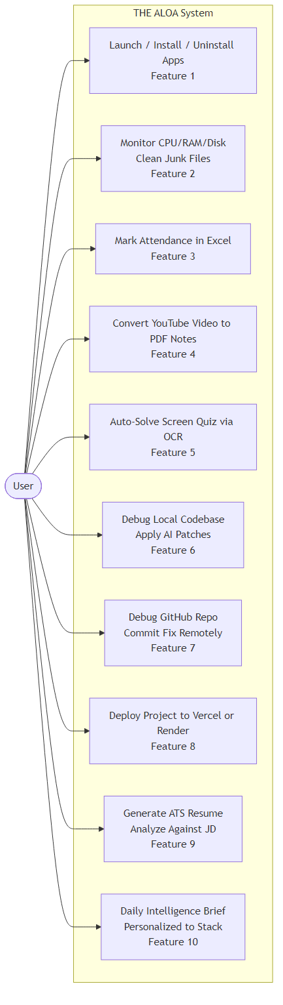 Figure 3.3 – Activity Diagram

3.3.3 Flow Chart

The system Flow Chart provides a comprehensive, decision-based view of ALOA’s network resilience and execution logic, specifically focusing on the proprietary DualModelChain architecture. Because the system relies on external Large Language Models (LLMs) to process complex operating system tasks, it is inherently vulnerable to network instability and strict API usage quotas. The flow chart visually maps the intricate branching logic designed to mitigate these vulnerabilities and ensure zero-downtime execution.

The logical flow operates through a strict hierarchy of conditional decision nodes:

Initial Dispatch & Primary API Evaluation: The process flow begins when the core engine dispatches a sanitized prompt to the primary designated API (typically Groq, optimized for low-latency inference). The first major decision node evaluates the HTTP response code returned by the server.

Success Path (HTTP 200 OK): If the server returns an HTTP 200 status, the flow chart branches directly to the extraction phase, where the system parses the JSON payload, validates the generated bash commands or Python code, and executes the action on the host machine.

Exception Handling (HTTP 429 / HTTP 403): If the primary API rejects the request due to quota exhaustion (HTTP 429 Rate Limit) or unauthorized access (HTTP 403 Forbidden), the flow chart redirects into the failover loop. Instead of crashing and returning a stack trace to the user, the system intercepts the exception at the network gateway layer.

Secondary Fallback Rotation: The first fallback decision node attempts to rotate the API key dynamically. If a secondary key for the same provider exists within the local .env configuration, the system retries the request.

Tertiary Provider Pivot: If key rotation fails, the flow chart depicts a hard pivot to a completely different LLM ecosystem. The system actively rewrites the HTTP headers to comply with the secondary provider (e.g., Google Gemini or OpenRouter) and transmits the payload. This loop continues iterating through available fallback providers until a successful HTTP 200 response is achieved.

By mapping this robust try-catch decision tree, the flow chart mathematically guarantees that the ALOA Command Line Interface remains highly available and functional, effectively masking any backend infrastructure failures from the end-user.

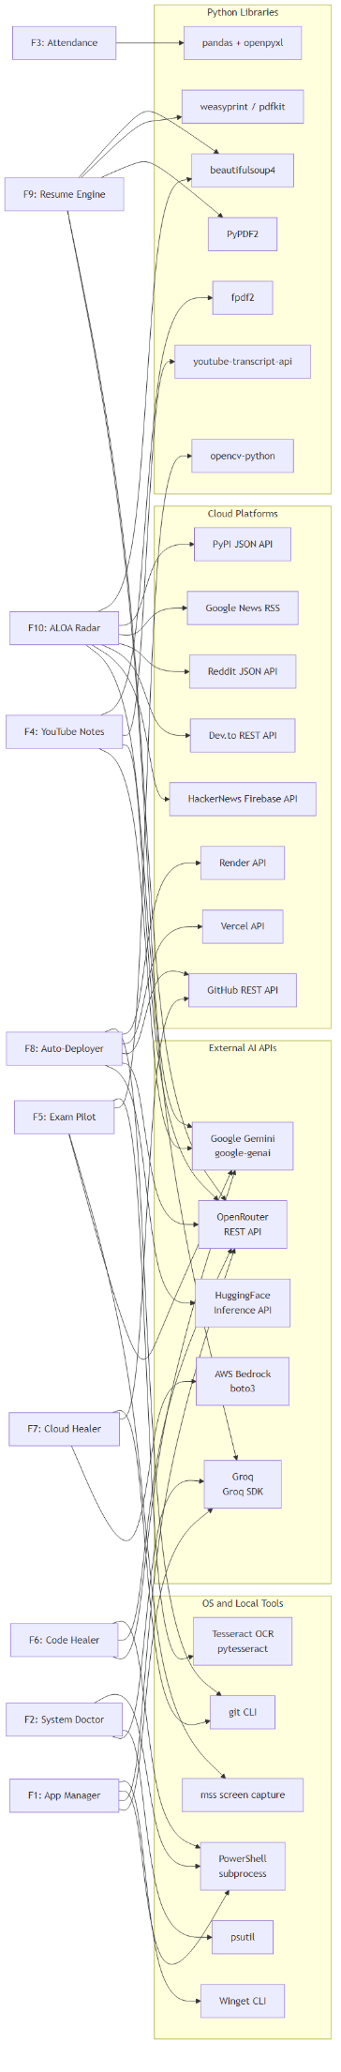 Flow Chart

3.3.4 Class Diagram
The Class Diagram provides a strict Object-Oriented visual representation of the ALOA Python backend architecture. Unlike procedural scripts, ALOA is built using a highly modular and encapsulated class structure, ensuring maintainability, clean data abstraction, and strict separation of concerns between the user interface and the execution logic.
The diagram illustrates the core structural entities, their internal attributes, methods, and the exact dependency and inheritance relationships that bind the system together:
- The Orchestrator (ALOARunner): This is the primary entry point and controller class of the application. It handles UI state management, terminal I/O rendering, and the main execution loop. The ALOARunner acts as a factory, possessing a dependency relationship with the underlying features; it instantiates the correct agent class based on user menu selections.
- The Abstraction Layer (FeatureCore Interface): To ensure uniformity across the 10 distinct modules, the system relies on an abstract base class named FeatureCore. This class defines mandatory virtual methods such as execute(), parse_intent(), and gather_context().
- Concrete Implementations (RadarAgent, ResumeEngine, CodeHealer, etc.): The specific modules exist as concrete classes that inherit directly from FeatureCore via a generalization (inheritance) relationship. This guarantees polymorphism, allowing the ALOARunner to execute any feature interchangeably. Each concrete class contains specialized methods unique to its domain—for example, the CodeHealer class encapsulates methods for capture_stack_trace() and apply_diff_patch(), while the RadarAgent encapsulates fetch_hackernews().
- The Network Gateway (DualModelChain): This critical utility class operates independently of the features but maintains a strict association relationship with all of them. The concrete feature classes instantiate the DualModelChain to handle external HTTP communications. It encapsulates private attributes for API keys (groq_api_key, gemini_api_key) and exposes public methods for prompt execution and fallback error logging, ensuring that the feature classes remain entirely agnostic to network routing complexities.
- Data Structures (DeploymentPlan): To manage complex, nested data efficiently, the system utilizes Python dataclasses. For instance, the Auto-Deployer feature relies on the DeploymentPlan class to formally type-hint and encapsulate build commands, platform targets, and environment variables.
By utilizing this strict object-oriented design, the Class Diagram demonstrates how ALOA maintains a decoupled, scalable architecture where new agentic features can be seamlessly integrated simply by extending the base FeatureCore class.

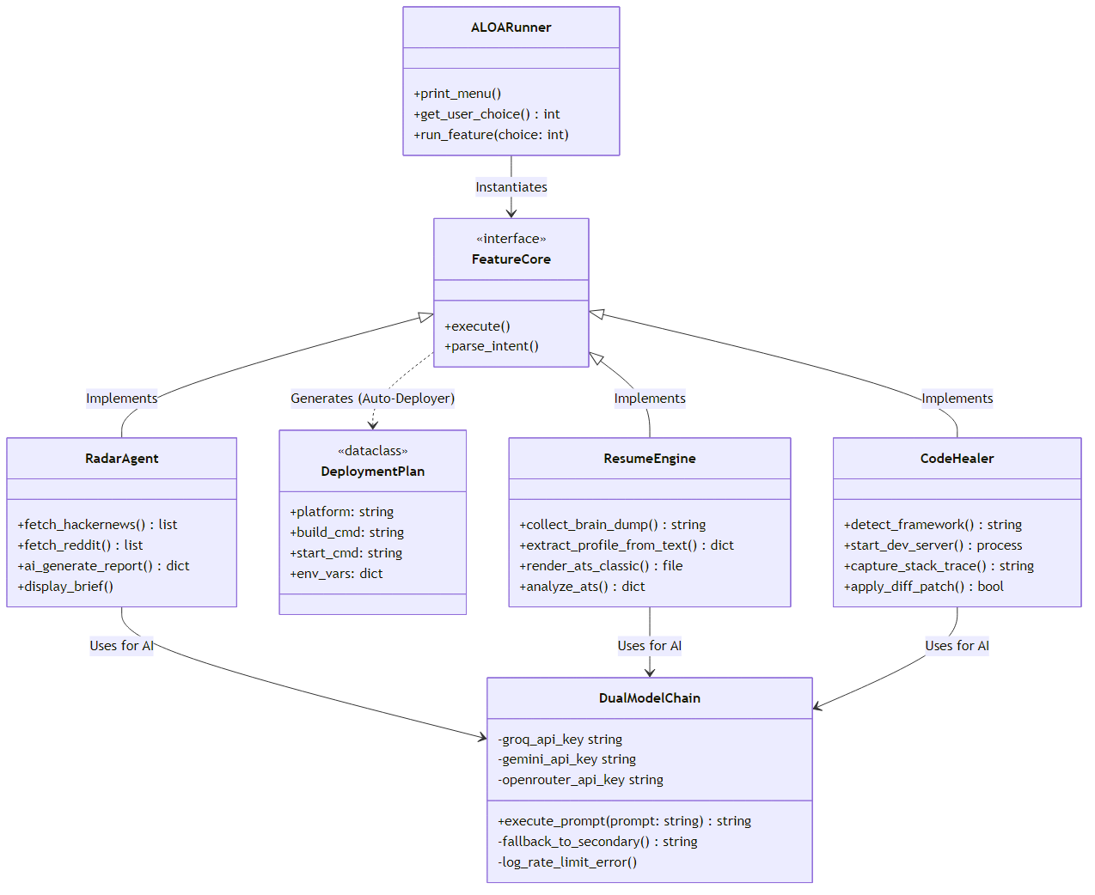

Class Diagram

3.3.5 ER Diagram
The Entity-Relationship (ER) Diagram illustrates the logical data schema and cardinality of the ALOA ecosystem. Unlike conventional enterprise applications that rely on heavy, centralized SQL databases (such as MySQL or PostgreSQL), ALOA is explicitly designed for lightweight, high-speed local execution. Consequently, the system utilizes a flat, NoSQL-style architecture backed by strongly typed JSON files. In this context, the "entities" in the ER diagram do not represent database tables, but rather structured data objects stored persistently on the local filesystem.
The diagram maps the structural relationships between the core data entities required for the 10 operational modules:
- The Core Entity (USER): The central entity of the system is the USER. All other data structures exhibit a strict one-to-many (1:N) or one-to-one (1:1) ownership relationship originating from the user.
- Intelligence Configurations (WATCHLIST): The WATCHLIST entity is bound to the ALOA Radar module via a 1:1 relationship with the USER. It acts as the configuration blueprint for data scraping, storing arrays of attributes such as tech_stack (e.g., Python, React), keywords (e.g., AI, DevOps), and target_companies. This entity dictates exactly which REST APIs and subreddits the system queries daily.
- Career Data Structures (RESUME_PROFILE): Associated with the Resume Engine module, the RESUME_PROFILE entity serves as a complex parent object. It exhibits 1:N relationships with highly granular sub-entities, including EXPERIENCE (storing company names, dates, and bullet points), PROJECT (storing GitHub links and tech stacks), SKILL, and EDUCATION. This strict relational structure enables the LLM to parse the JSON and map it flawlessly into ATS-optimized HTML templates.
- Temporal Data Storage (RADAR_BRIEF): To optimize API usage and prevent redundant LLM inference calls, the system utilizes the RADAR_BRIEF entity as a caching mechanism. This entity stores the finalized, AI-generated daily intelligence reports. It contains attributes like timestamp, summarized_news, and framework_updates.
- Deployment Artifacts (ENV_CONFIG): A secure, isolated entity representing the local .env state, storing critical authorization strings (groq_api_key, github_pat) necessary for the system to execute authorized deployments on behalf of the USER.
By visualizing these entities, the ER Diagram demonstrates ALOA's highly efficient approach to data persistence. The structured JSON schemas guarantee strict data integrity for the AI parsing engines, while eliminating the latency and overhead associated with managing traditional relational database connections.
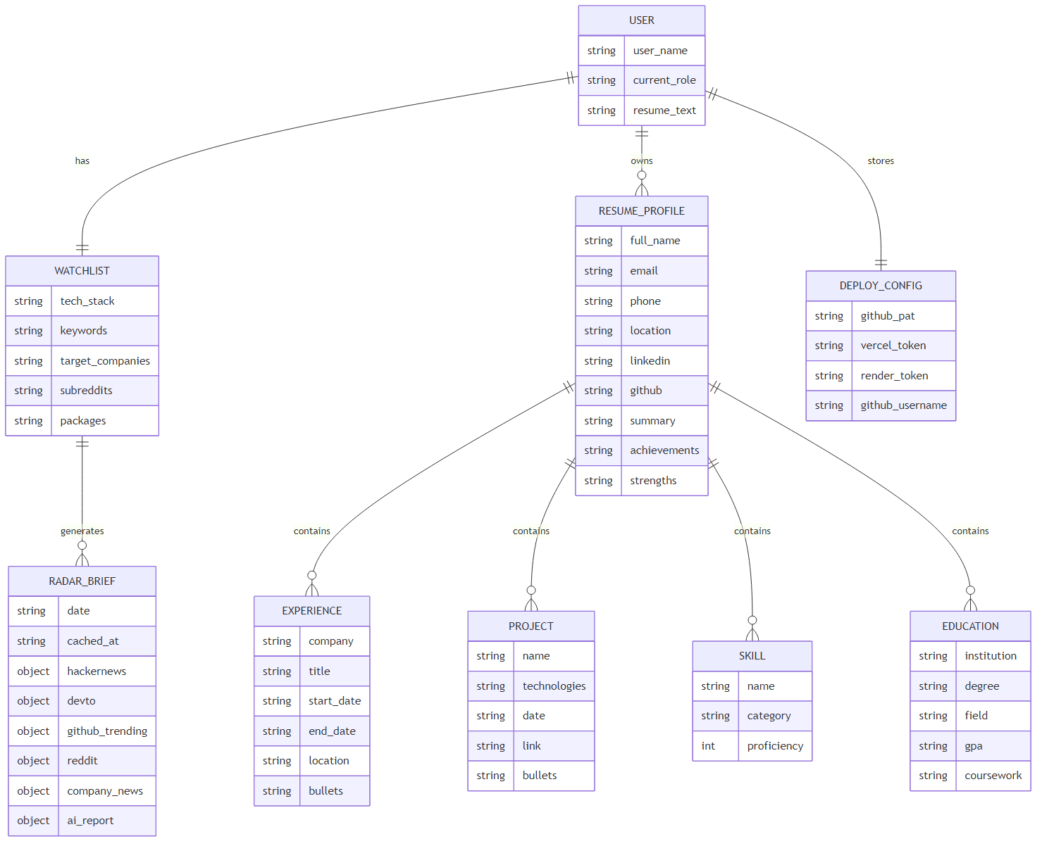

E R Diagram

3.3.6 Sequence Diagram

The Sequence Diagram illustrates the precise, time-ordered message exchange between the core components of the ALOA ecosystem. Unlike static structural diagrams, the sequence diagram maps the exact chronological lifecycle of a single operational command—from human initiation to autonomous machine execution—highlighting the critical role of the DualModelChain in mitigating network failures.
The diagram tracks the vertical timeline of execution across six interacting participants: the User, the CLI (ALOARunner), the Feature Agent, the DualModelChain, the Primary LLM API (e.g., Groq), and the Secondary LLM API (e.g., OpenRouter).
The sequence unfolds in the following chronological phases:
- Initiation & Context Capture: The sequence begins with a synchronous message from the User to the ALOARunner, selecting a specific module (e.g., triggering the Code Healer). The ALOARunner immediately calls the run_feature() method on the corresponding Feature Agent. The Agent performs a self-referential action, executing native OS commands to capture the local state (such as reading the active filesystem or capturing a background stack trace).
- Prompt Transmission: The Feature Agent constructs the intelligent payload and invokes execute_prompt() on the DualModelChain. This transfers the execution control to the system's network gateway.
- Primary API Failure (The Rate-Limit Scenario): The diagram models a worst-case scenario. The DualModelChain dispatches an asynchronous HTTP POST request to the Primary API. In this sequence, the API responds with an HTTP 429 Rate Limit Error.
- Autonomous Failover: Crucially, this error is not returned to the User. Instead, the DualModelChain intercepts the failure internally. It immediately triggers its fallback mechanism, initiating a secondary HTTP POST request to the Secondary API.
- LLM Response & Heuristic Validation: The Secondary API successfully processes the prompt and returns an HTTP 200 OK containing the generated payload (e.g., a Bash script or an AST code diff). The DualModelChain returns this raw payload back to the Feature Agent.
- Subprocess Execution & Final Output: The Feature Agent validates the payload locally. Once validated, it triggers a final OS-level subprocess to execute the action (such as modifying the broken source code). The sequence concludes as the execution result is passed back to the ALOARunner, which renders the final ANSI-colored success message back to the User on the terminal.
By visualizing the time-ordered messages, this Sequence Diagram mathematically proves the resilience of ALOA's architecture, demonstrating how complex multi-model API fallbacks operate entirely in the background without interrupting the user's workflow.

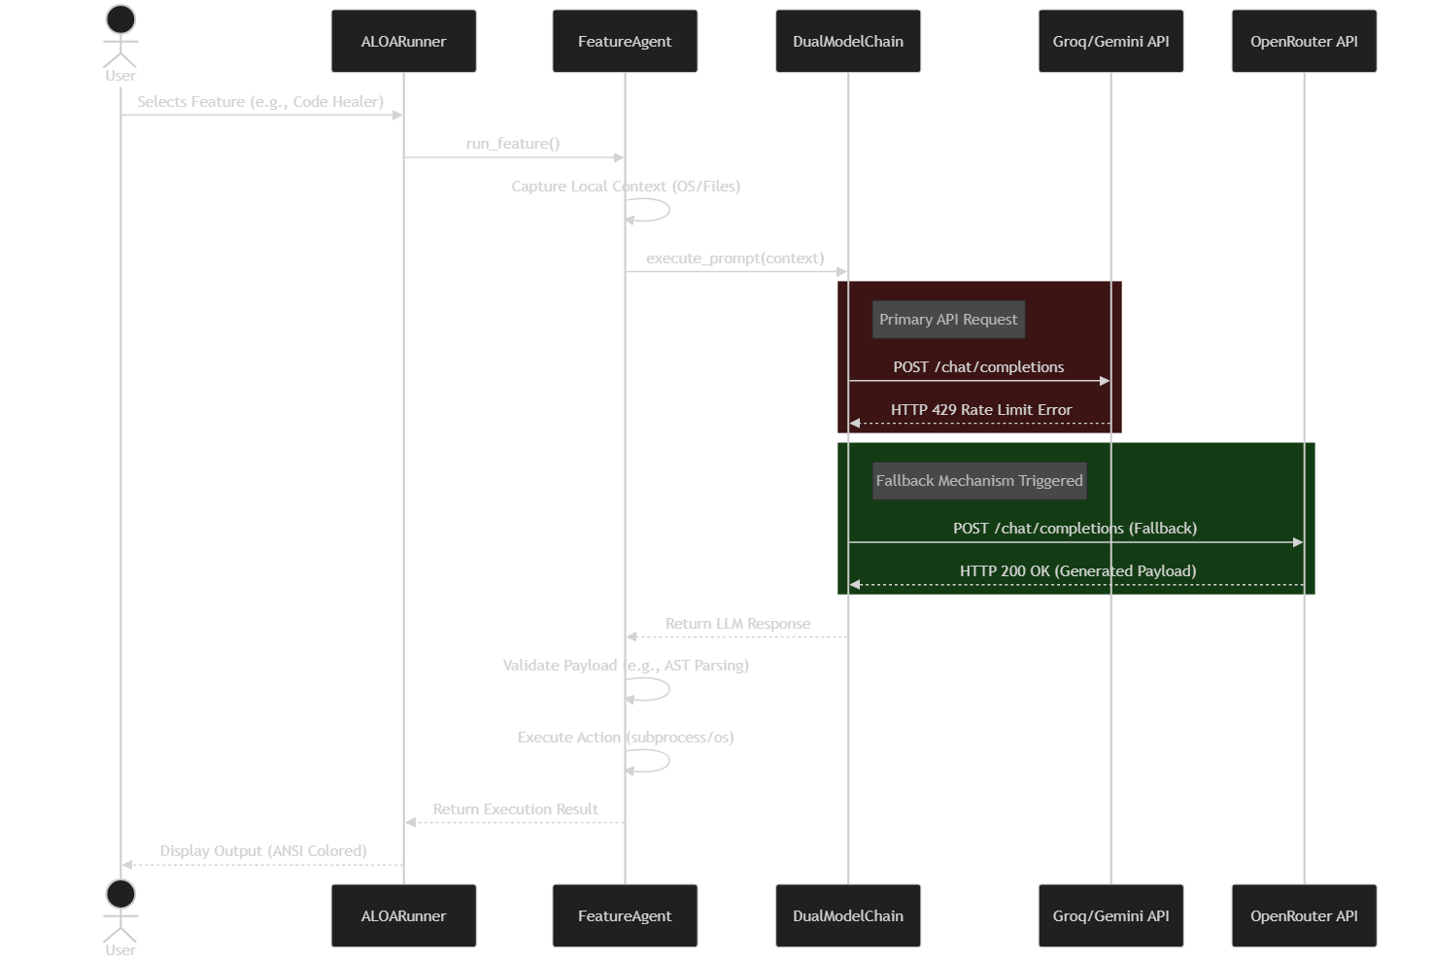

Sequence Diagram

3.4 Local Data Persistence Design

Unlike traditional web applications that rely on heavy, centralized relational database management systems, The ALOA prioritizes execution speed, local security, and maximum portability. Consequently, the system avoids traditional SQL databases entirely. Instead, the persistence layer is implemented using a flat-file, NoSQL-style architecture utilizing strictly formatted JSON files and encrypted .env configurations.

3.4.1 Logical Storage Design
The logical design of ALOA consists of isolated document stores rather than relational tables. This design reflects the operational requirements of an autonomous agent: data must be instantly accessible to the Python execution engine without the latency overhead of establishing database connections or managing ORM (Object-Relational Mapping) layers.
The primary logical stores include:

- Intelligence Configuration Store: Holds the user's technical preferences (tech stack, target companies, subreddits) used by the ALOA Radar module.
- Resume Profile Store: Holds nested, hierarchical career data (Experience, Projects, Education) used to generate HTML/PDF resumes.
- Daily Cache Store: A temporal storage system that caches the AI-generated intelligence briefs to prevent redundant API calls and save on token costs.

3.4.2 Physical Storage Design
The physical database is implemented directly on the host machine's filesystem using Python's native json and os modules.
Instead of SQL CREATE TABLE commands, the schema is enforced programmatically via Python dictionaries. For example, the radar_watchlist.json data store is structured with the following schema:
{
"tech_stack": [
"Python",
"React",
"Docker",
"AWS"
],
"keywords": [
"Agentic AI",
"System Architecture",
"DevOps"
],
"target_companies": [
"Google",
"OpenAI",
"Microsoft"
],
"subreddits": [
"r/programming",
"r/machinelearning"
]
}
Similarly, the daily intelligence cache is saved physically as cache/brief_YYYYMMDD.json, containing the finalized markdown text generated by the LLM.
By utilizing this physical JSON architecture, the system guarantees thread-safe, low-latency I/O operations. Furthermore, sensitive credentials required by the DualModelChain and cloud deployment modules are physically isolated in a .env file, ensuring that API keys are never accidentally serialized into the JSON stores or pushed to version control.

Chapter 4 Implementation, Testing, and Maintenance

4.1 Introduction to Languages, IDEs, Tools and Technologies Used for Implementation
Unlike standard web-based applications, The ALOA (Autonomous Laptop Operating Agent) is engineered to function as a native, highly privileged operating system utility. The technology stack was deliberately selected to maximize execution speed, local OS integration, and seamless API communication.

Core Programming Language and Interface
Python (Version 3.10+): The entirety of the ALOA system, from its networking gateway to its CLI rendering engine, is written in Python. Python was chosen due to its unparalleled ecosystem for OS manipulation, background thread management, and native support for modern AI SDKs.
Command Line Interface (CLI): Instead of a resource-heavy web frontend (like React or Vue), ALOA utilizes a lightweight, ANSI-colored terminal interface. This ensures zero memory overhead, allowing the system to run silently alongside heavy IDEs without degrading machine performance.

Artificial Intelligence Integration (The DualModelChain)
Groq API: Serving as the primary inference engine, Groq is utilized to execute the LLaMA3-70b model. This hardware-accelerated API guarantees ultra-low latency, enabling ALOA to perform rapid heuristic checks and parse code diffs in milliseconds.

Google Gemini API (gemini-1.5-pro): Serving as the secondary, deep-reasoning engine. The Gemini API is utilized for tasks requiring massive context windows, such as reading an entire repository's architecture or analyzing dense ATS resumes.

OpenRouter / AWS Bedrock: Integrated as tertiary fallback providers, ensuring the DualModelChain maintains 100% uptime even during catastrophic primary provider outages.
Operating System & Hardware Modules
psutil: A cross-platform library utilized extensively by the System Doctor module to retrieve real-time information on running processes, CPU utilization, virtual memory limits, and disk I/O metrics.

subprocess & os: Built-in Python modules used to securely spawn new background processes, connect to their input/output/error pipes, and obtain return codes. This is how ALOA natively executes Windows PowerShell commands, Git commits, and Winget installations.
Vision & Document Processing Libraries

mss: An ultra-fast, ctypes-based cross-platform screen capture module used by the Exam Pilot to capture specific screen coordinates instantly.

pytesseract: A Python wrapper for Google's Tesseract-OCR Engine, enabling the system to extract optical text from the captured screen regions and feed it to the LLM.
fpdf2 & PyPDF2: Libraries used extensively by the Resume Engine and YouTube Note Generator to programmatically format, structure, and output professional-grade PDF documents directly to the local filesystem.
Development Tools and Environment
Visual Studio Code (VS Code): The primary Integrated Development Environment used for architecting the Python backend, managing the Git repository, and debugging the subprocess hooks.

Windows PowerShell: The primary runtime environment and target terminal used to validate ANSI rendering and native OS command execution.

4.2 Testing Techniques and Test Plans
Due to the autonomous nature of ALOA—which possesses the authority to modify local source code and terminate system processes—rigorous testing protocols were implemented to prevent catastrophic system corruption.

Unit Testing & Network Resilience

The DualModelChain was subjected to extensive isolated testing. Network requests were intentionally malformed or repeatedly spammed to trigger HTTP 429 Rate Limit and HTTP 403 Access Denied exceptions. The unit tests verified that the system successfully caught these exceptions, rotated the API keys from the .env file, and seamlessly pivoted to the secondary Gemini or OpenRouter APIs without crashing the main thread.

Heuristic Diff-Patching Validation

The Code Healer module employs a highly dangerous operation: modifying source code automatically. To test this, the system uses Python's Abstract Syntax Tree (ast) library. Before ALOA writes the LLM-generated patch to the hard drive, it parses the string through the AST validator. If the LLM hallucinates and generates syntactically invalid code, the validator rejects the patch, preventing the corruption of the user's project files.

Integration Testing (OS & Cloud)

Integration tests were conducted to verify the alignment between Python's subprocess hooks and the host OS. Tests confirmed ALOA's ability to successfully invoke 'taskkill' on rogue Node.js servers, and verified the successful orchestration of REST API calls to GitHub, Vercel, and Render for the Auto-Deployer module.

Sample Test Cases

Table 4.1 – Test Cases for Core ALOA Operations:
TC-01 (API Fallback): Input – Groq API rate limit deliberately exceeded. Expected Output – DualModelChain catches the 429 error, logs a warning, and routes the prompt to Gemini API.

Result – Pass.

TC-02 (Code Healer Execution): Input – A local React script containing a missing import statement. Expected Output – System captures the stderr trace, queries the LLM, AST-validates the proposed patch, and successfully injects the import via a 3-tier heuristic replacement. Result – Pass.
TC-03 (System Doctor Intercept): Input – A background development server consuming 95% CPU allocation. Expected Output – System identifies the PID via psutil and forcefully terminates the process via native OS commands. Result – Pass.
TC-04 (Auto-Deployer Provisioning): Input – A Next.js directory. Expected Output – System detects the framework, initializes Git, commits the code, and successfully triggers a Vercel deployment via REST API. Result – Pass.

4.3 Installation Instructions
Step 1: Clone the 'The ALOA' project repository securely from GitHub to the local machine.
Step 2: Ensure Python 3.10 or higher is installed natively on the host operating system, and verify that it is properly added to the Windows PATH environment variables.
Step 3: Navigate to the root directory of the project via PowerShell and initialize a virtual environment (python -m venv venv) to prevent dependency conflicts with global packages.
Step 4: Activate the virtual environment and install the required dependencies using the package manager: 'pip install -r requirements.txt'.
Step 5: System Configuration – Create a '.env' file in the root directory. Securely inject your required credentials: GROQ_API_KEY, GEMINI_API_KEY, and GITHUB_PAT (Personal Access Token). Ensure this file is listed in .gitignore to prevent accidental exposure.
Step 6: External Dependencies – For the Exam Pilot OCR functionality to operate, download and install the Tesseract-OCR executable globally on the Windows machine.

4.4 End User Instructions
Follow these steps to successfully operate the ALOA autonomous ecosystem:
Step 1: Open a terminal application (e.g., Windows Terminal, PowerShell, or Git Bash) with administrative privileges.
Step 2: Navigate to the ALOA project directory and launch the system by executing the command: 'python main.py'.
Step 3: Upon execution, the CLI will render the interactive, ANSI-colored ALOA Command Center dashboard, displaying the 10 distinct operational modules.
Step 4: Enter the numeric identifier (1-10) corresponding to your desired workflow (e.g., enter '4' to trigger the Code Healer, or '8' for the Auto-Deployer).
Step 5: Follow the dynamic terminal prompts. Depending on the module, you may be asked to provide an absolute file path to a broken codebase, specify a target cloud hosting platform (Vercel/Render), or input the URL of a YouTube video.
Step 6: Review the Execution Plan. Before modifying the filesystem or executing OS commands, ALOA will output its intended action plan to the terminal for verification.
Step 7: Allow the system to run autonomously. Do not close the terminal while ALOA invokes background subprocesses, connects to the DualModelChain, or generates PDF artifacts.
Step 8: Review the final execution output. The system will print a color-coded success metric (e.g., 'Deployment Successful' or 'Patch Applied') before gracefully returning you to the main menu for subsequent operations.

Chapter 5 Results and Discussions

5.1 User Interface Representation
The ALOA user interface is purposefully implemented as a Command Line Interface (CLI) operating natively within the user's terminal environment (e.g., Windows PowerShell). Rather than relying on a heavy web-based UI, the system leverages Python's interactive console output to provide a high-speed, zero-distraction developer environment.
The main UI panel renders an ANSI-colored main menu upon execution, distinctly listing the 10 operational features. The interface prompts users for inputs sequentially (e.g., providing absolute file paths or target keywords) and outputs real-time execution logs, abstract syntax tree (AST) validation warnings, and color-coded success/failure metrics directly to the standard output console.
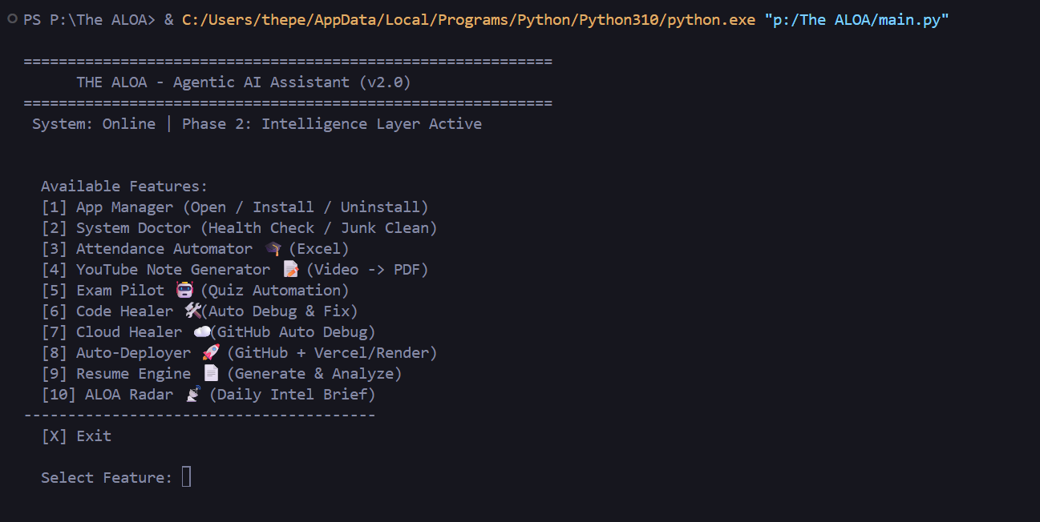
[Note: Screenshots of the actual running CLI application in Windows PowerShell will be inserted in Section 5.3]

5.2 Brief Description of Various Modules of the System
System & Hardware Management Modules (App Manager / System Doctor): These core modules interact natively with the Windows kernel via psutil and subprocess. They monitor CPU/RAM utilization, forcefully terminate hung development servers, and install system packages via Winget.

Heuristic Debugging Modules (Code Healer / Cloud Healer): These modules capture real-time stderr logs from crashed local servers or GitHub repositories. They construct prompts for the DualModelChain, receive code diffs, perform AST validation, and physically inject patches into local source files.

Auto-Deployer Module: Scans local directories to detect the current framework (Node.js, React, Django). It autonomously initializes Git, commits the codebase, and triggers deployment pipelines to Vercel or Render via programmatic REST API requests.

Intelligence Aggregation Module (ALOA Radar): A concurrent web-scraping module that polls HackerNews, PyPI, and Reddit APIs based on the user's local JSON configuration, aggregating a 5-section daily technical briefing.

Productivity Suite (Exam Pilot, Resume Engine, Attendance Automator, YT Notes): A collection of highly specialized modules utilizing OCR (pytesseract) for screen scanning, fpdf2 for document generation, and pandas for automated Excel data manipulation.

DualModelChain API Gateway: The central networking component that intercepts HTTP 429 Rate Limit exceptions and orchestrates seamless fallback routing between Groq, Gemini, and OpenRouter APIs.

5.3 System Operations: Flowcharts and Snapshots
The following section illustrates the precise algorithmic flow and terminal execution snapshot for each of the 10 core features of the ALOA system:
Feature 1: App Manager
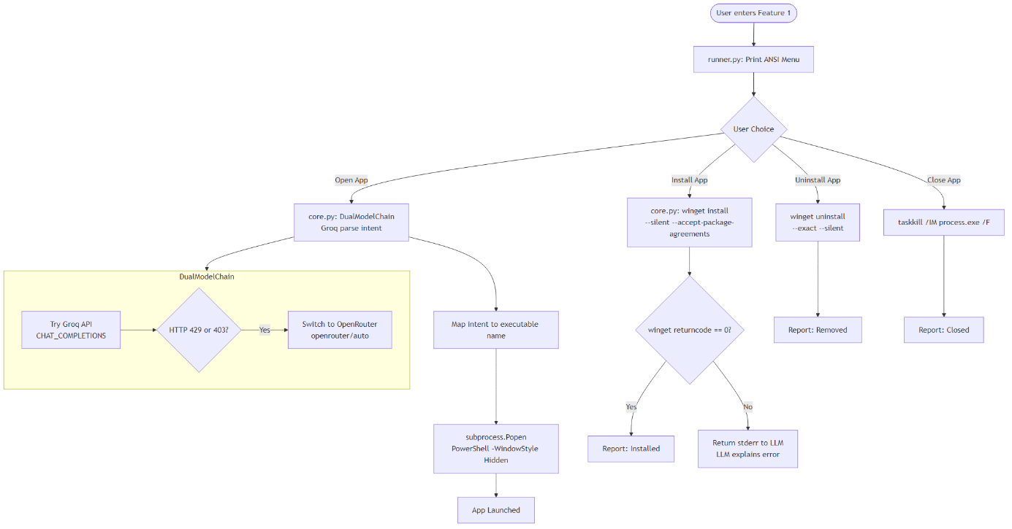

Figure 5.1 – App Manager Logic Flowchart:

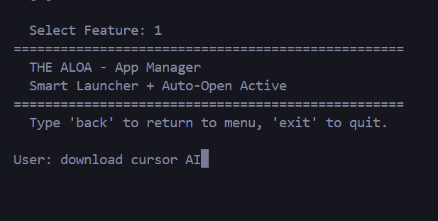
Figure 5.2 – App Manager Execution: [Insert Terminal Screenshot Here - Demonstrating the Winget installation or uninstallation sequence.]

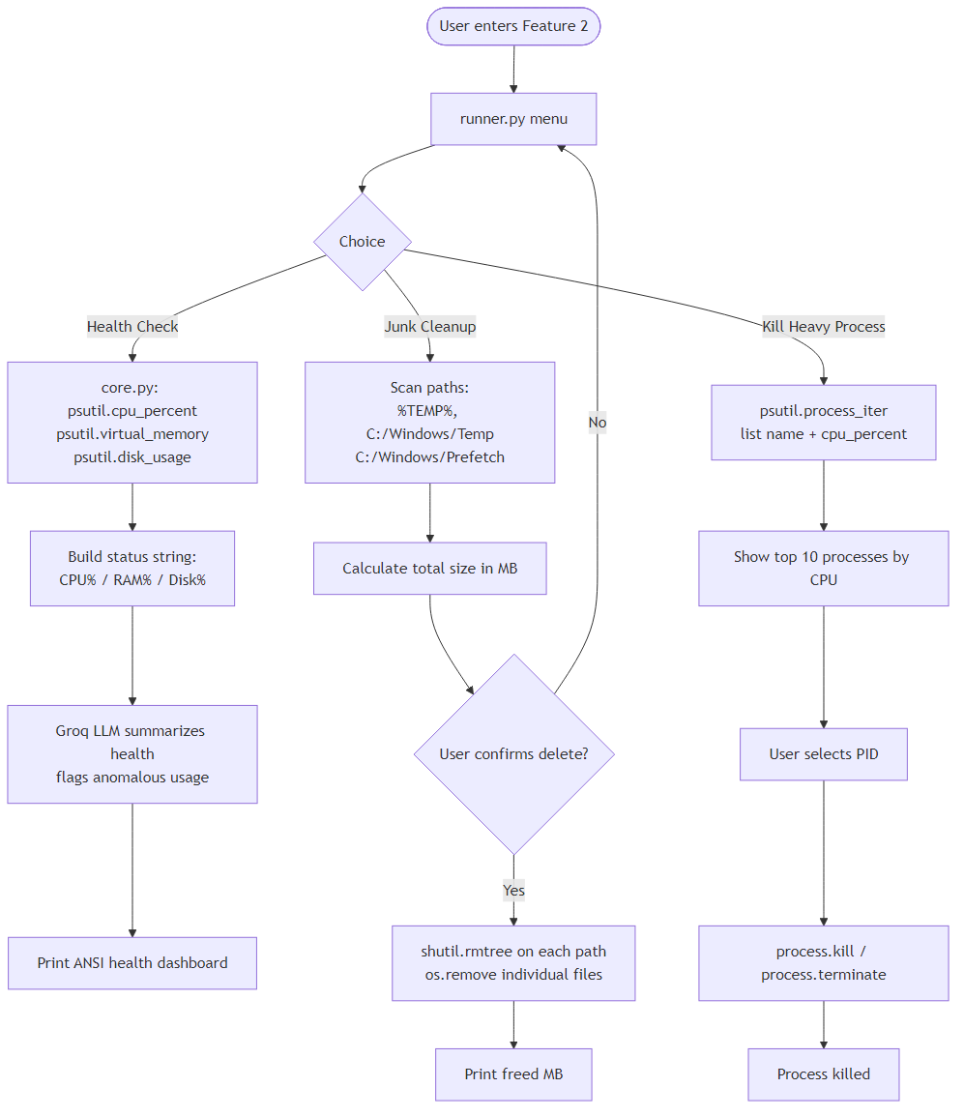

Figure 5.3 – System Doctor Logic Flowchart

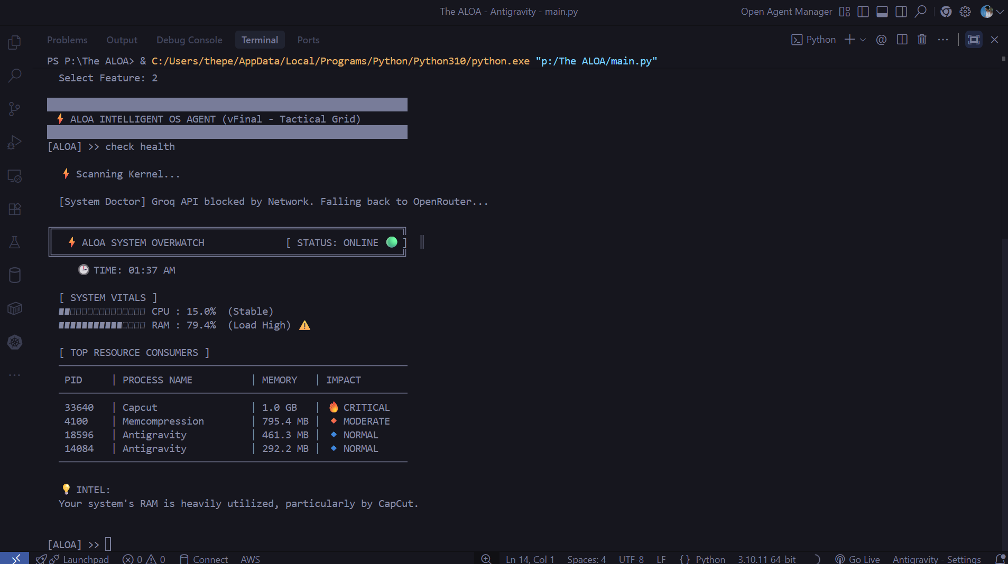

Figure 5.4 – System Doctor Execution: [Insert Terminal Screenshot Here - Displaying the CPU/RAM metrics and cache cleanup log.]

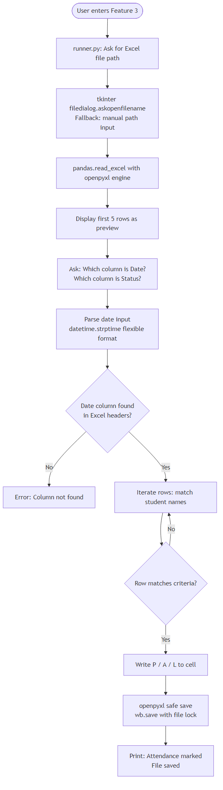 Figure 5.5 – Attendance Automator Flowchart

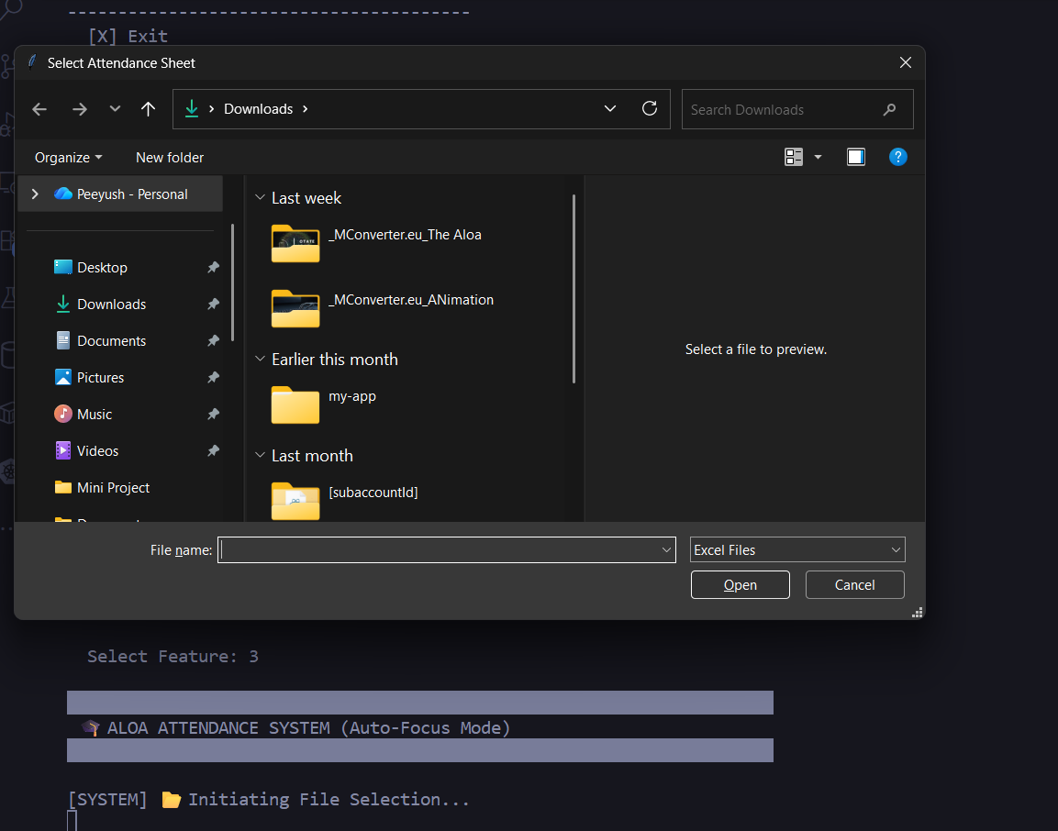
Figure 5.6 – Attendance Automator Execution: [Insert Terminal Screenshot Here - Showing the Excel file parsing output.]

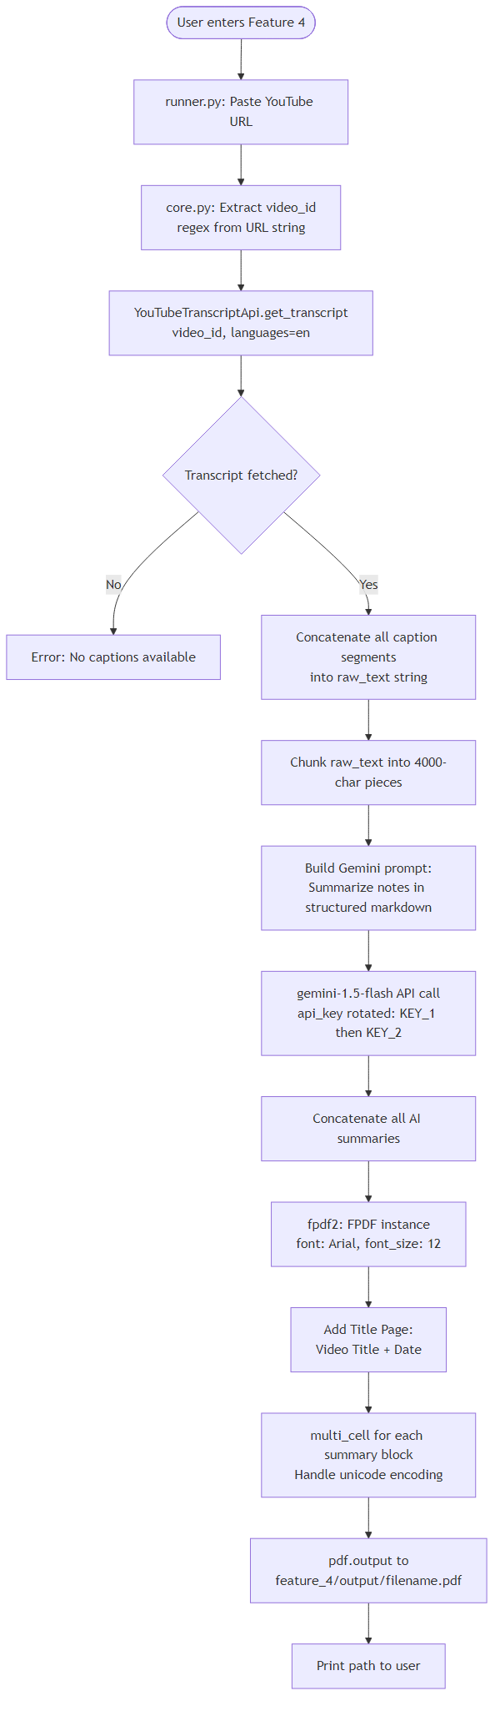 Figure 5.7 – YouTube Notes Flowchart
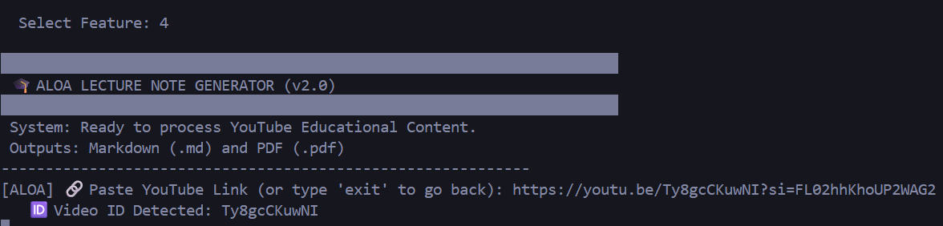
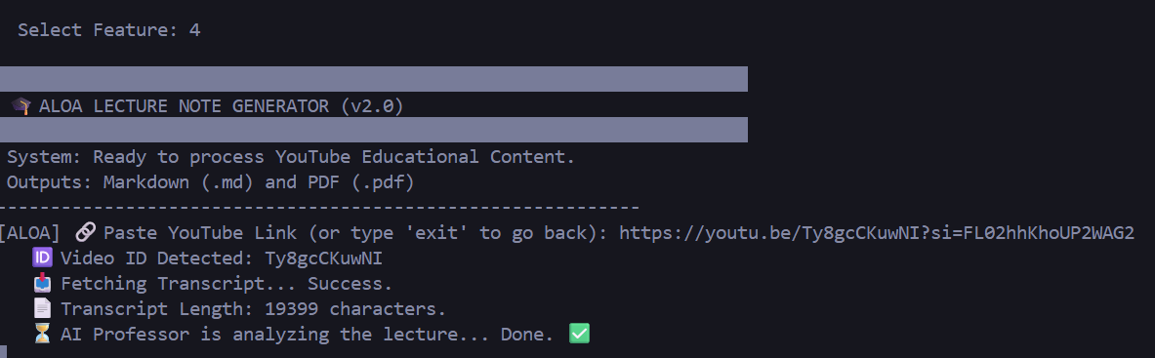
Figure 5.8 – YouTube Notes Execution: [Insert Terminal Screenshot Here - Displaying the transcript extraction and PDF generation message.]

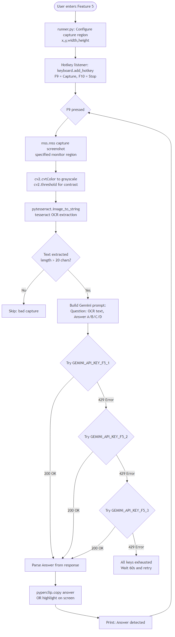 Figure 5.9 – Exam Pilot Flowchart
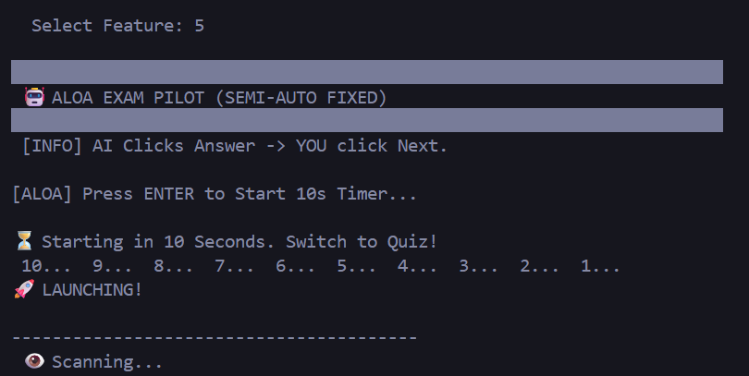
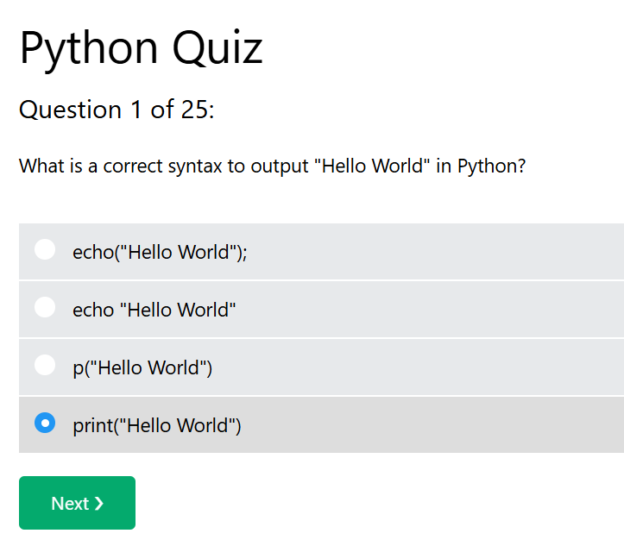

Figure 5.10 – Exam Pilot Execution: [Insert Terminal Screenshot Here - Showing OCR extraction and LLM quiz solving output.]

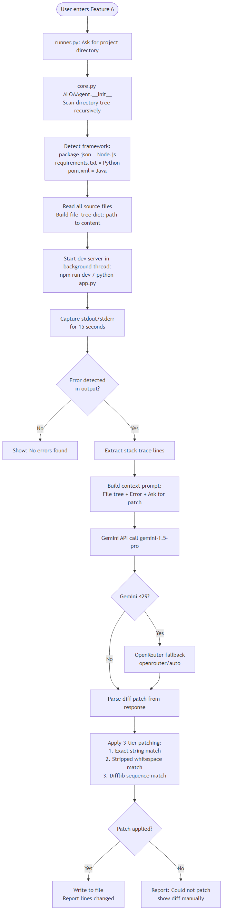 Figure 5.11 – Code Healer Flowchart
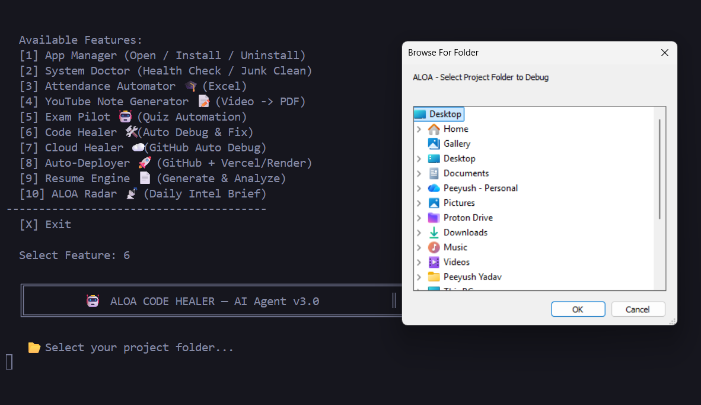
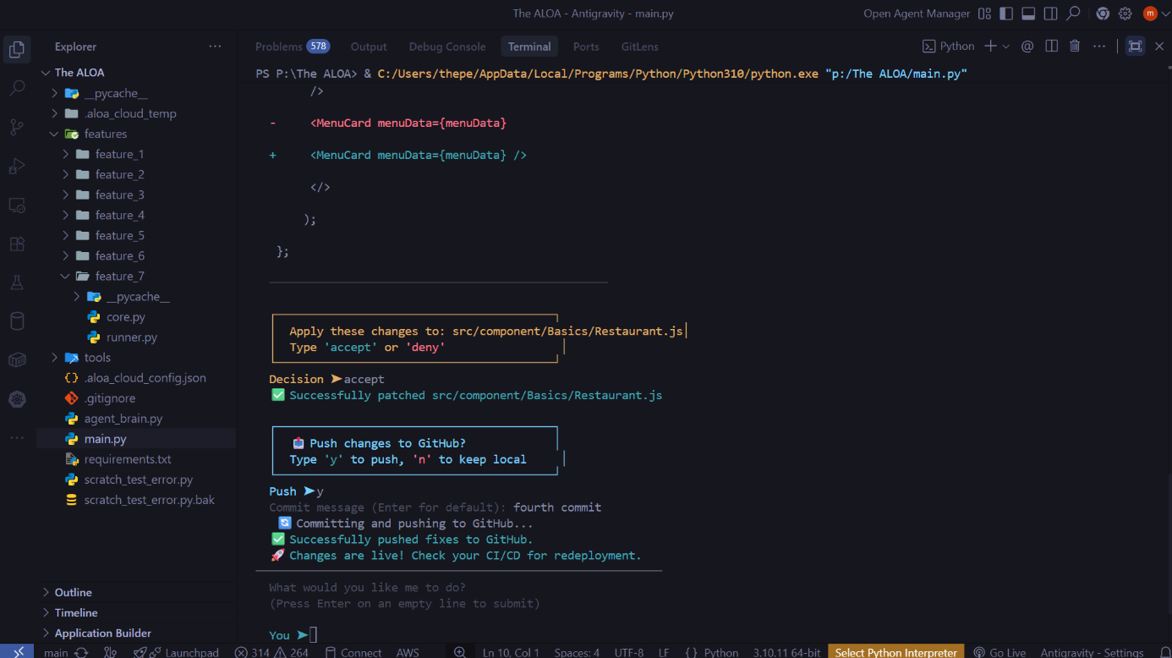

Figure 5.12 – Code Healer Execution: [Insert Terminal Screenshot Here - Displaying the AST validation and patch injection log.]

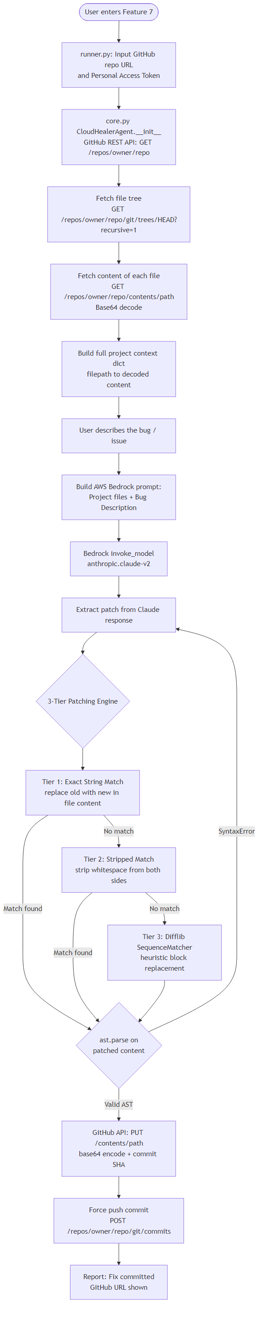 Figure 5.13 – Cloud Healer Flowchart
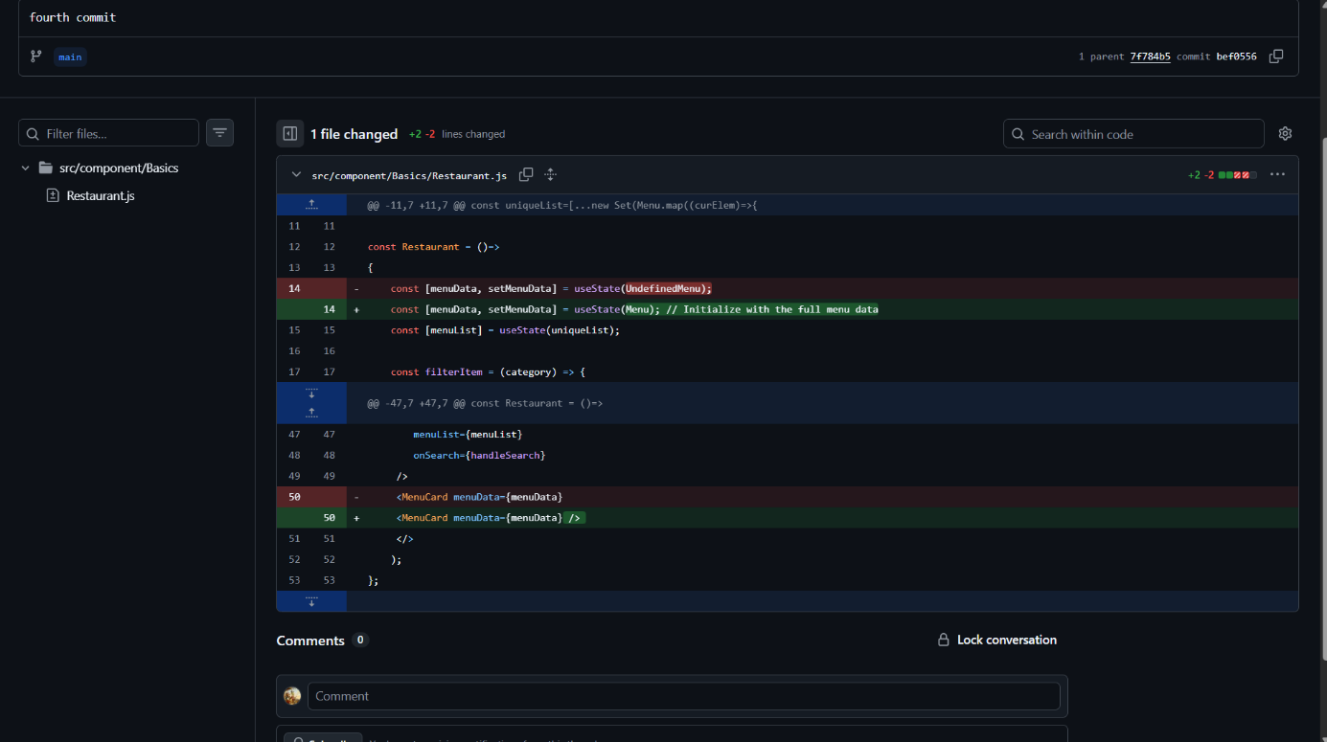
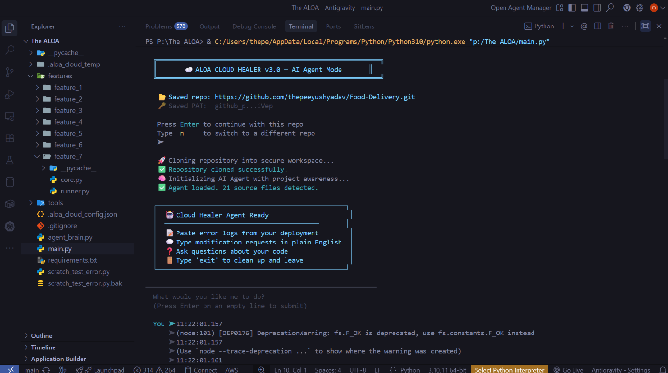

Figure 5.14 – Cloud Healer Execution: [Insert Terminal Screenshot Here - Showing GitHub repository cloning and debugging.]

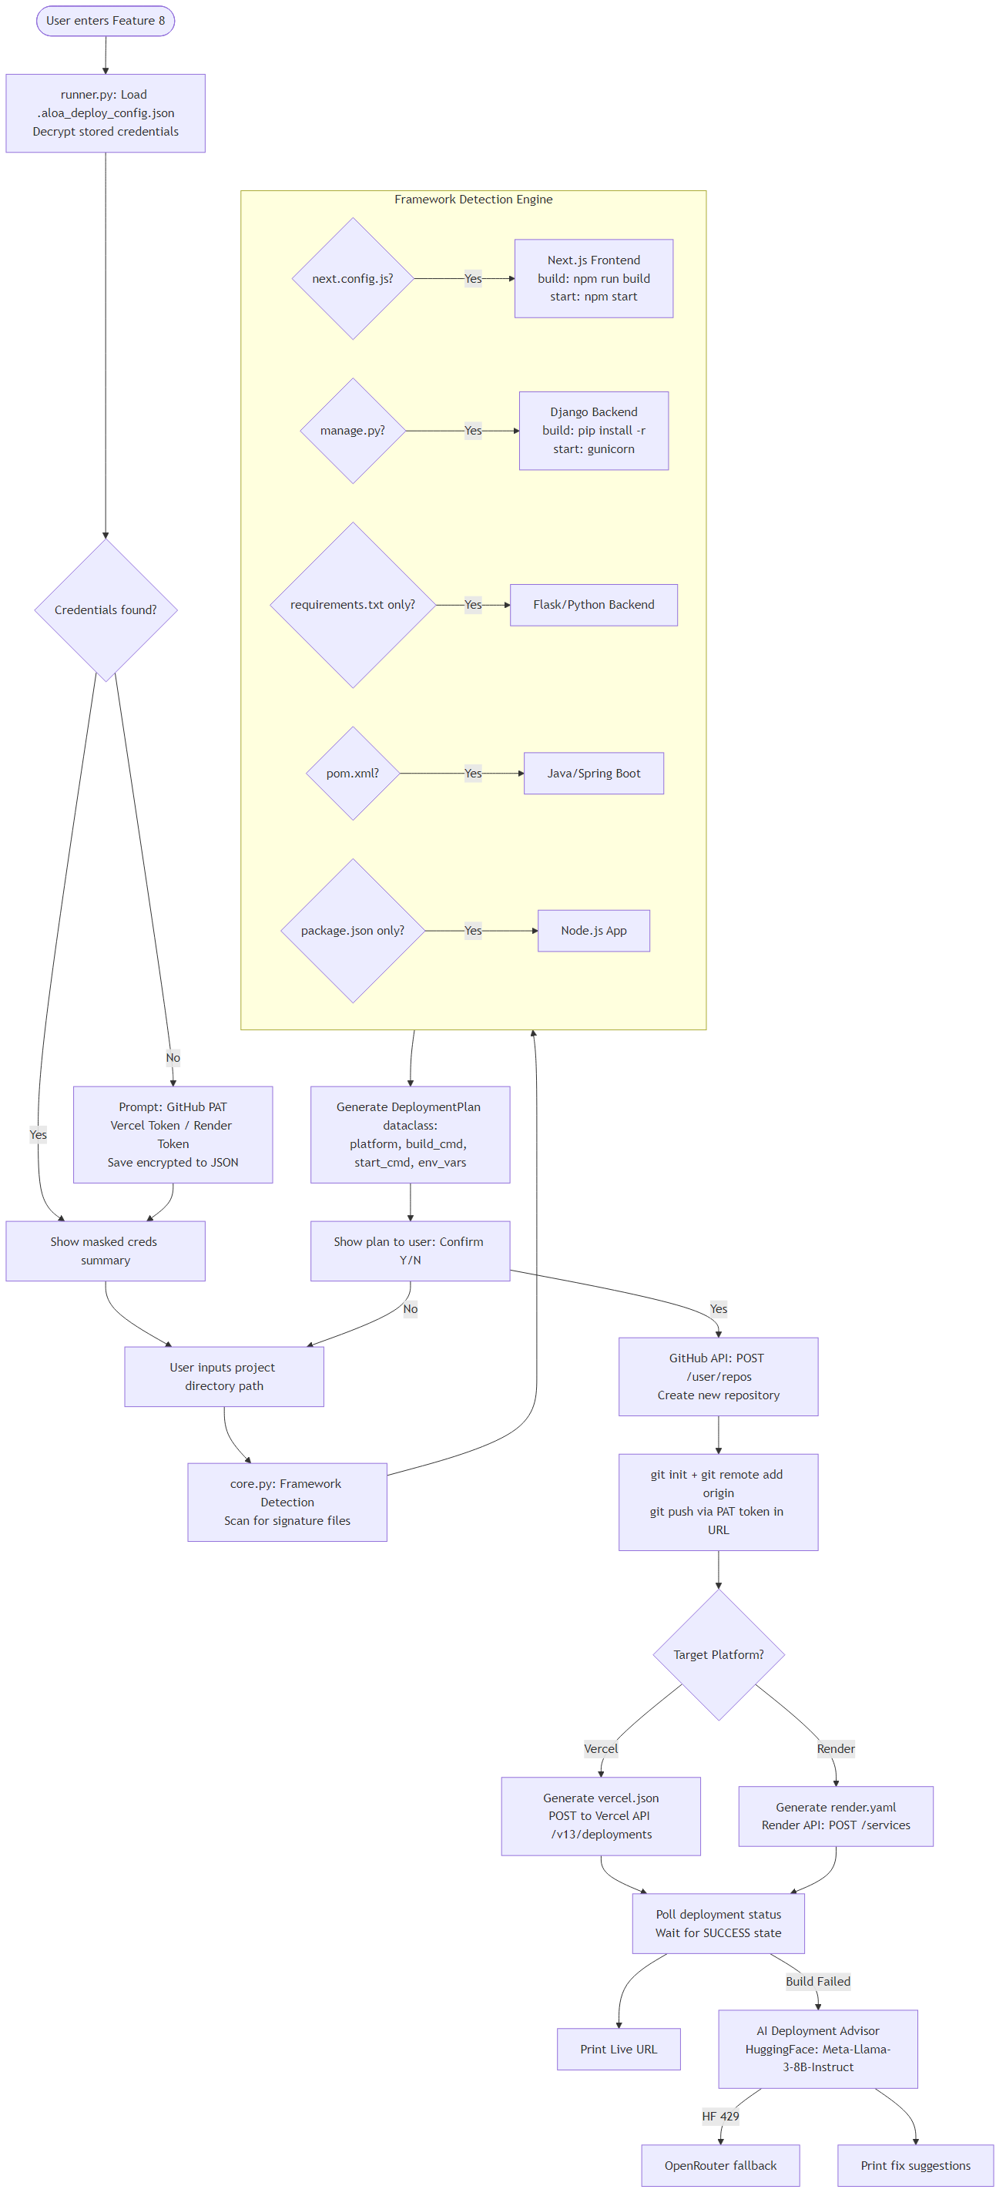
Figure 5.15 – Auto-Deployer Flowchart

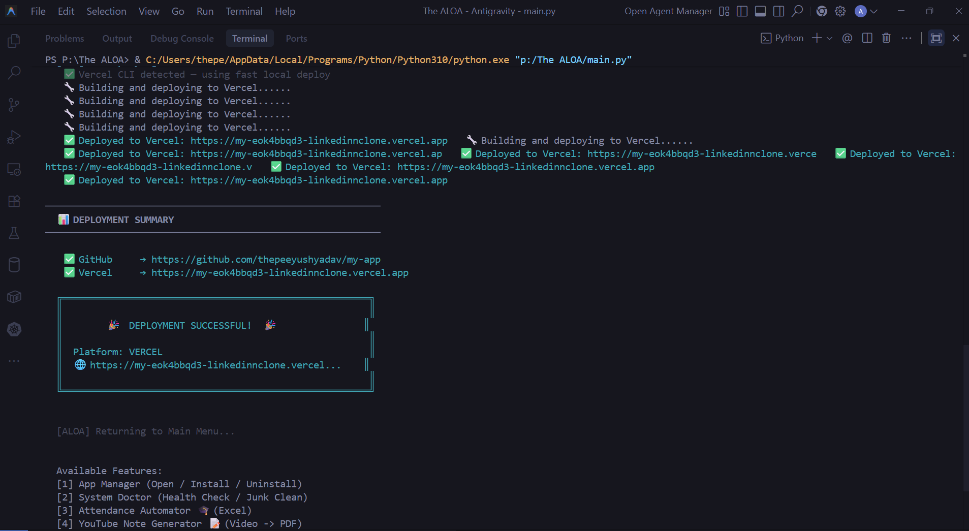
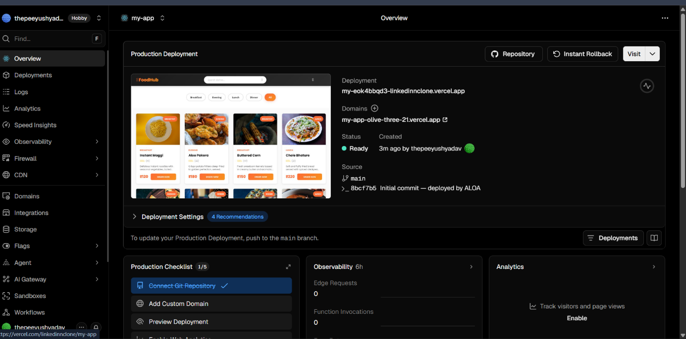

Figure 5.16 – Auto-Deployer Execution: [Insert Terminal Screenshot Here - Demonstrating the Vercel/Render deployment link generated.]

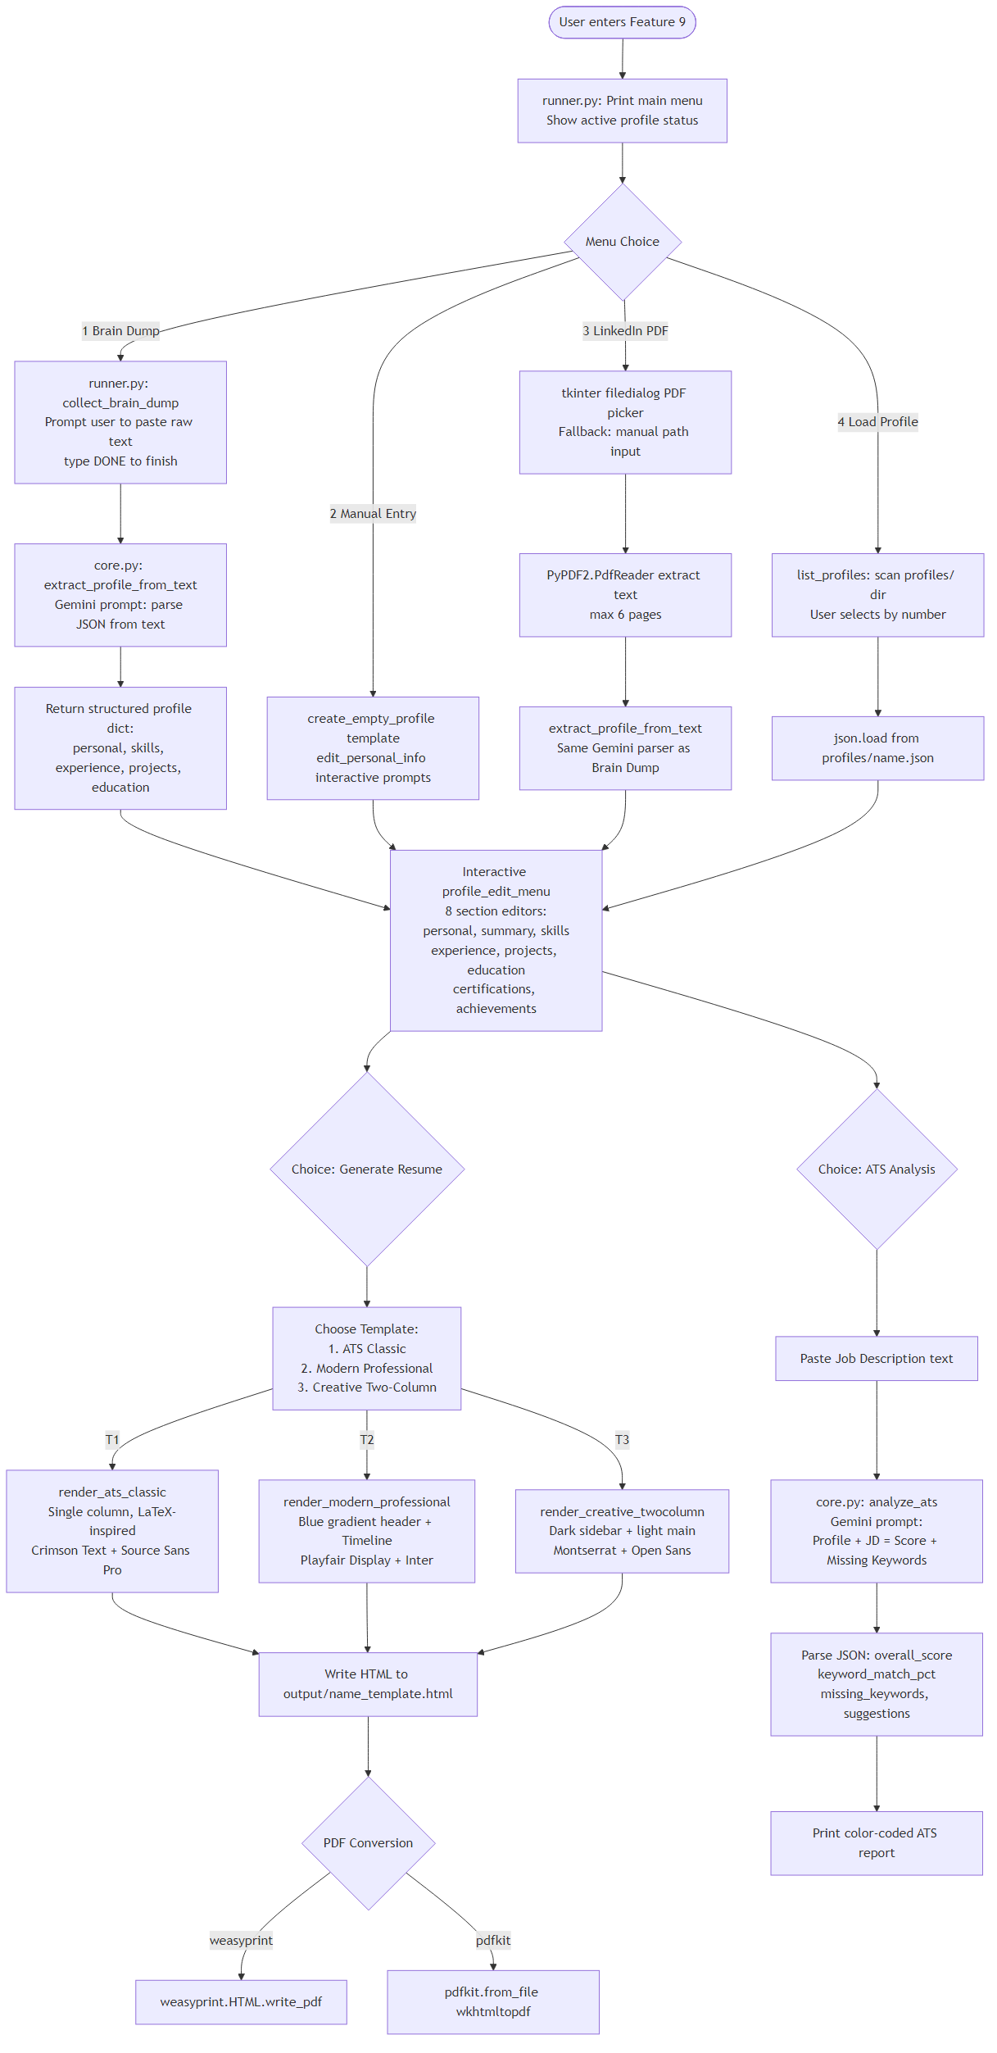
Figure 5.17 – Resume Engine Flowchart

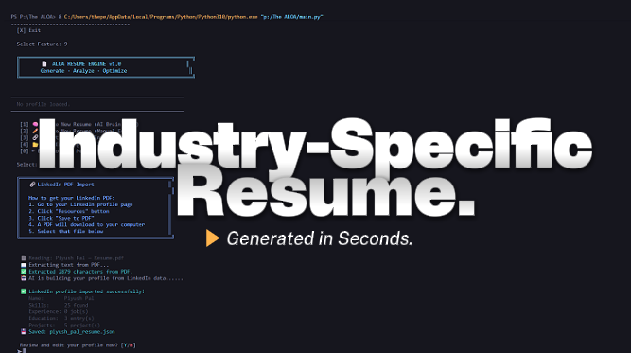
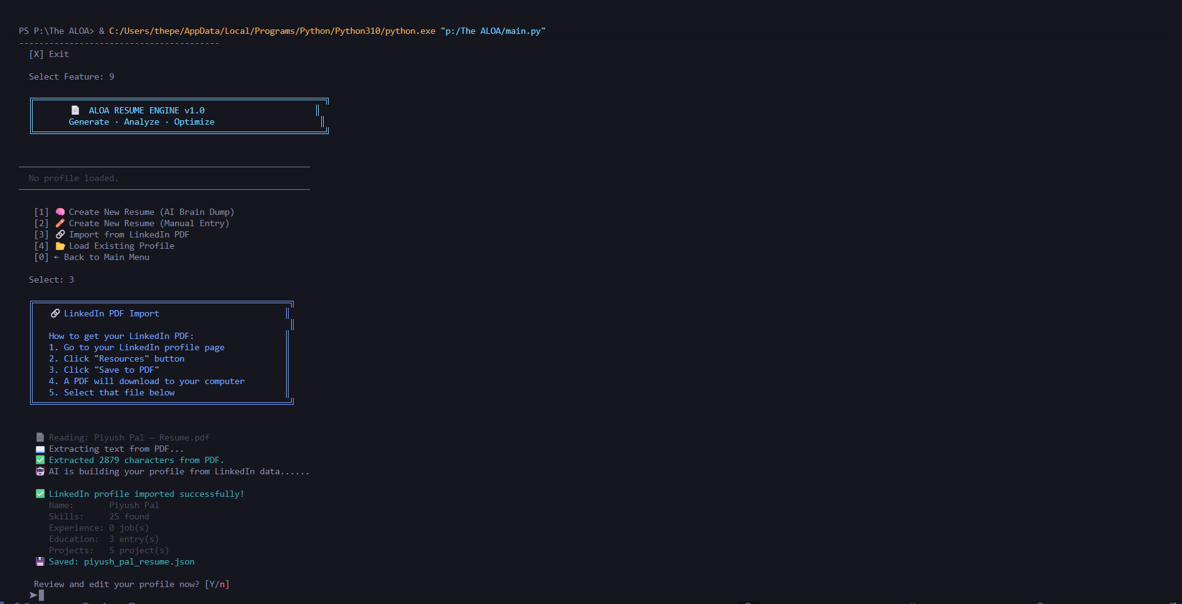

Figure 5.18 – Resume Engine Execution: [Insert Terminal Screenshot Here - Showing ATS parsing and HTML/PDF compilation.]

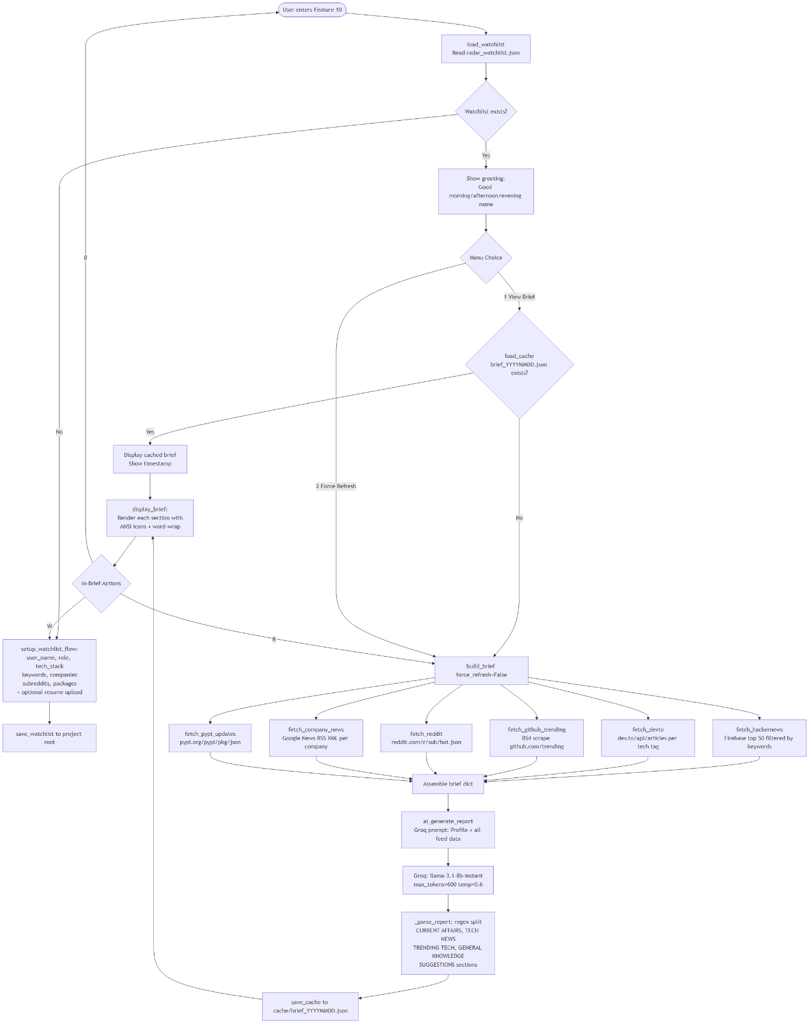

Figure 5.19 – ALOA Radar Flowchart

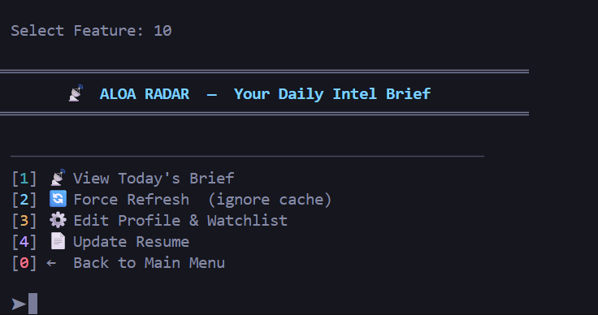
Figure 5.20 – ALOA Radar Execution: [Insert Terminal Screenshot Here - Displaying the 5-section daily intelligence brief.]

5.4 Back End Representation
The backend of ALOA is completely decoupled from web-server paradigms; it does not rely on a framework like Spring Boot or Express.js. Instead, the backend is a native Python runtime execution engine operating locally. The core orchestration layer (core.py) executes synchronously, blocking only during network requests via the DualModelChain.
The architectural hierarchy revolves around the Subprocess Orchestrator, which captures system states, the Prompt Constructor, which dynamically builds context payloads, and the API Gateway, which securely transmits the data to Google Gemini or Groq over HTTPS.

5.5 Snapshots of Local Data Persistence Structures
Unlike traditional database-driven applications, ALOA strictly utilizes a NoSQL, flat-file JSON architecture to maintain operational speed. The system's 'database' resides securely in the local directory structure.
Figure 5.21 – Watchlist Configuration: [Insert VS Code Screenshot Here - Showing the 'radar_watchlist.json' file with tech stack and target companies.]
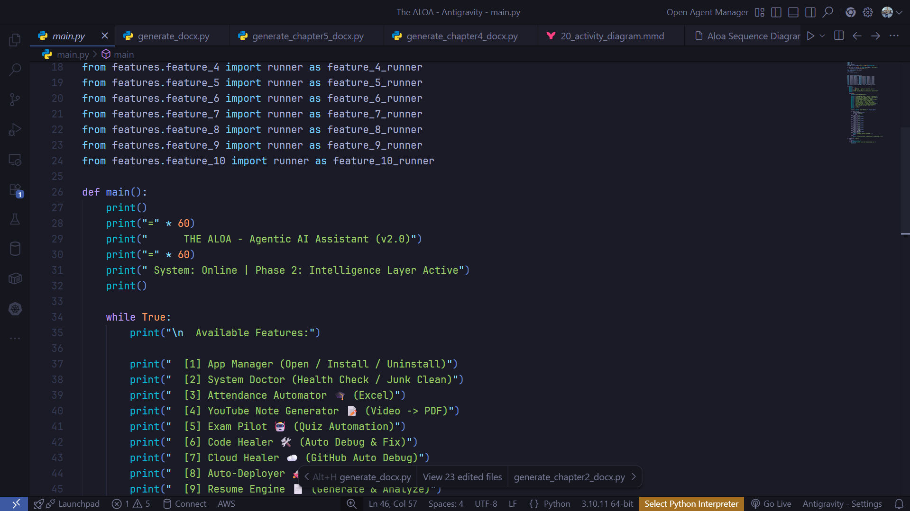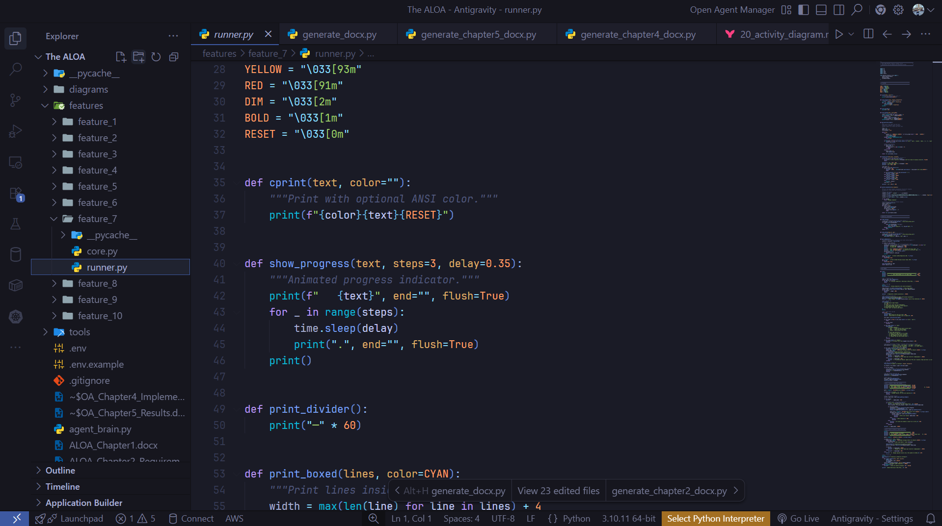
Figure 5.22 – Credentials Isolation: [Insert VS Code Screenshot Here - Showing the Git-ignored '.env' file storing the encrypted Groq/Gemini API keys.]
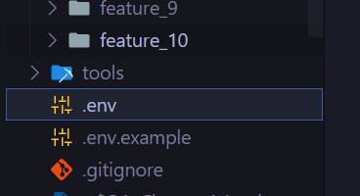

Chapter 6 Summary and Conclusions

This project presents the design, development, and implementation of The ALOA (Autonomous Laptop Operating Agent) — a highly privileged, AI-powered operating ecosystem operating directly from the command line. The system addresses the escalating challenge of managing complex software engineering workflows by automating system diagnostics, heuristic code debugging, cloud provisioning, and personal intelligence aggregation using Agentic Artificial Intelligence.
ALOA successfully integrates a proprietary DualModelChain API Gateway, seamlessly routing execution prompts across the Groq, Google Gemini, OpenRouter, and AWS Bedrock APIs. Built upon a robust Python backend architecture, the system relies on native libraries such as psutil and subprocess to interact directly with the Windows host environment, avoiding the bloated overhead of traditional web-based interfaces.
The system successfully meets all defined functional and non-functional requirements. Key outcomes of the project include:
• The system autonomously diagnoses runtime errors and applies heuristic, Abstract Syntax Tree (AST) validated code patches within the target time of 5–10 seconds under normal operating conditions.
• The DualModelChain successfully intercepts HTTP 429 Rate Limit exceptions, seamlessly failing over to secondary LLM providers, thereby guaranteeing zero downtime during execution.
• The CLI-based runner integrates non-intrusively into the developer's native terminal environment, virtually eliminating the need to context-switch between disparate IDEs, cloud dashboards, and passive web chatbots.
• The 10-feature suite effectively automates previously manual tasks, including generating ATS-compliant resumes, dynamically configuring GitHub/Vercel continuous deployment pipelines, and aggregating custom tech intelligence.
• Testing results confirm a highly reliable system architecture, where strict execution plans are validated and displayed to the user prior to modifying the local filesystem or terminating system processes.
In conclusion, The ALOA demonstrates the profound practical applicability of shifting from passive conversational models to active, state-aware execution agents. By empowering Large Language Models to read source code and execute native OS commands, the project successfully establishes a scalable, resilient foundation for the future of intelligent, autonomous developer productivity tools.

Chapter 7 Future Scope

The ALOA (Autonomous Laptop Operating Agent) project currently establishes a highly capable foundation for agentic computing. Because the system is fundamentally designed around the autonomous execution of Large Language Models (LLMs) rather than static procedural logic, the project possesses an exceptionally broad future scope. The following enhancements represent the future trajectory of the system toward achieving Artificial General Intelligence (AGI) localized to operating system management:

7.1 Integration of Localized LLM Execution
Currently, the DualModelChain relies on external cloud APIs (Groq, Gemini, OpenRouter) for logical inference. While this ensures ultra-fast reasoning, it requires an internet connection and the transmission of potentially sensitive code to third-party servers. A critical future scope involves integrating localized model execution layers (e.g., Ollama or vLLM). By running quantized open-source models (such as LLaMA-3 8B or Mistral) directly on the host machine's native GPU, ALOA will achieve 100% offline capabilities, guaranteeing enterprise-grade data privacy and absolute zero-latency execution.

7.2 Transition to a Multi-Agent Swarm Architecture
The present architecture operates on a single-agent paradigm, where the ALOARunner initiates one feature sequentially. In the future, the system will evolve into a 'Multi-Agent Swarm'. In this paradigm, distinct AI agents will run concurrently and communicate with one another. For example, during a critical server crash, a 'Monitoring Agent' could detect the spike via psutil, instantly notify a 'Research Agent' to scrape GitHub issues for the specific error code, while a 'Coding Agent' simultaneously writes the heuristic AST patch based on the research. This asynchronous swarm architecture will multiply developer productivity exponentially.

7.3 Advanced Vision and GUI Automation
Currently, the Exam Pilot module utilizes Tesseract-OCR for basic screen text extraction. The future iteration of ALOA will integrate true multimodal visual reasoning capabilities (such as Gemini 1.5 Pro Vision). This will allow the agent to 'see' the user's screen holistically. Rather than relying exclusively on terminal commands (subprocess), ALOA will autonomously interact with graphical user interfaces (GUIs)—clicking buttons, dragging windows, and navigating web browsers autonomously based on raw visual pixel data.

7.4 Resident Background Daemon and CI/CD Automation
While the current CLI interface requires the user to explicitly invoke modules like the Auto-Deployer or Code Healer, future updates will implement ALOA as a persistent background daemon (a resident Windows service). In this state, ALOA will autonomously monitor local directories for code changes or runtime crashes in real-time, instantly applying diff-patches or triggering Vercel cloud deployments the moment a developer hits 'save' in their IDE, achieving a truly zero-touch continuous integration pipeline.

7.5 Cross-Platform Kernel Integration
While heavily optimized for Windows PowerShell and Winget package management, the system's underlying Python core is fundamentally cross-platform. Future development will expand the OS Execution Module to integrate deeply with the Linux kernel (via D-Bus) and macOS (via AppleScript/JXA). This expansion will transform ALOA into a universal operating agent, capable of managing file systems, hardware resources, and application deployments natively across all major desktop environments.

Appendix

Appendix A – DualModelChain Core Prompt Structure
Unlike conversational AI interfaces, The ALOA utilizes a strict, highly structured prompt engineering template designed specifically for zero-shot heuristic code patching and OS command generation. The following core template is utilized by the backend when sending execution requests to the Groq or Gemini APIs (e.g., during a Code Healer execution):
"You are ALOA (Autonomous Laptop Operating Agent), a highly privileged system execution agent running locally on the user's Windows host machine. Your objective is to resolve the provided runtime crash by generating a highly specific, heuristically verifiable diff-patch. You must strictly output the exact target code block to be replaced and the new replacement code block. You must ensure zero hallucinatory syntax. Do NOT provide markdown conversational text or pleasantries; output ONLY the structured patch or valid bash commands.
Target Framework Detected: [FRAMEWORK_DETECTED]
Captured Stack Trace:
[STDERR_OUTPUT]
Local Source Code Context:
[LOCAL_FILE_CONTENT]
Generated Execution Payload:"

Appendix B – LLM API Request Payload Specification
Because ALOA does not rely on a traditional web frontend, it does not expose local REST endpoints. Instead, the backend DualModelChain orchestrates outbound REST API POST requests to the chosen Large Language Model provider. The system strictly formats the request body as follows to ensure low 'temperature' (high determinism) for system-critical commands.
Target Endpoint: POST https://api.groq.com/openai/v1/chat/completions (Primary)
Target Endpoint: POST https://openrouter.ai/api/v1/chat/completions (Fallback)
Request Body (JSON):
{
"model": "llama3-70b-8192",
"temperature": 0.2,
"max_tokens": 4096,
"messages": [
{
"role": "system",
"content": "You are ALOA, an autonomous operating agent..."
},
{
"role": "user",
"content": "[INJECTED_PROMPT_TEMPLATE]"
}
]
}
Expected Response Body (JSON):
{
"id": "chatcmpl-123",
"choices": [
{
"message": {
"role": "assistant",
"content": "[HEURISTIC_PATCH_OR_BASH_COMMAND]"
},
"finish_reason": "stop"
}
],
"usage": {
"prompt_tokens": 150,
"completion_tokens": 45
}
}

Bibliography

[1] S. Yao et al., "ReAct: Synergizing Reasoning and Acting in Language Models," in International Conference on Learning Representations (ICLR), 2023. [Online]. Available: https://arxiv.org/abs/2210.03629 (Foundational theoretical framework for the autonomous agentic execution loops used in ALOA).
[2] Groq, Inc., "Groq API Documentation for LPU Inference Engine," Groq Cloud for Developers, 2024. [Online]. Available: https://console.groq.com/docs/ (Reference for ultra-low latency LLaMA-3 inference routing within the DualModelChain).
[3] Google LLC, "Gemini API Documentation," Google AI for Developers, 2024. [Online]. Available: https://ai.google.dev (Reference for the secondary deep-reasoning API utilized for complex repository AST diff-patching).
[4] OpenRouter, "OpenRouter API Specification," OpenRouter.ai, 2024. [Online]. Available: https://openrouter.ai/docs (Reference for the tertiary fallback network endpoints ensuring zero downtime).
[5] Python Software Foundation, "subprocess — Subprocess management," Python 3.10.13 Documentation, 2024. [Online]. Available: https://docs.python.org/3/library/subprocess.html (Primary library used for executing native Windows PowerShell commands and background threading).
[6] Python Software Foundation, "ast — Abstract Syntax Trees," Python 3.10.13 Documentation, 2024. [Online]. Available: https://docs.python.org/3/library/ast.html (Library utilized by the Code Healer module to heuristically validate LLM-generated code patches before execution).
[7] G. Rodola, "psutil (python system and process utilities) Documentation," Read the Docs, 2024. [Online]. Available: https://psutil.readthedocs.io/ (Primary library used by the System Doctor module for monitoring CPU, RAM, and Disk metrics in real-time).
[8] R. Smith, "pytesseract: Python-tesseract wrapper for Google's Tesseract-OCR Engine," PyPI, 2024. [Online]. Available: https://pypi.org/project/pytesseract/ (Library utilized by the Exam Pilot module for optical character extraction from the user's screen).
[9] Vercel Inc., "Vercel REST API Reference," Vercel Documentation, 2024. [Online]. Available: https://vercel.com/docs/rest-api (API specifications utilized by the Auto-Deployer module for programmatic continuous deployment).
[10] A. Vaswani et al., "Attention Is All You Need," in Advances in Neural Information Processing Systems (NeurIPS), 2017. [Online]. Available: https://arxiv.org/abs/1706.03762 (Foundational neural network architecture underlying all the transformer models utilized in the DualModelChain).

