Exercise 1 (Mongo DB)

1. Creates a database called “hotel” and a collection called “guests”.

* use hotel

1. Inserts a new guest document into the “guests” collection with the following details:

* db.guests.insert({"Name":"John Smith", "Email":"johnsmith@example.com", "Phone":"555-1234", "Reservation Details":{"check-in date":"2023-04-01", "check-out date":"2023-04-05"}, "Room number":101})

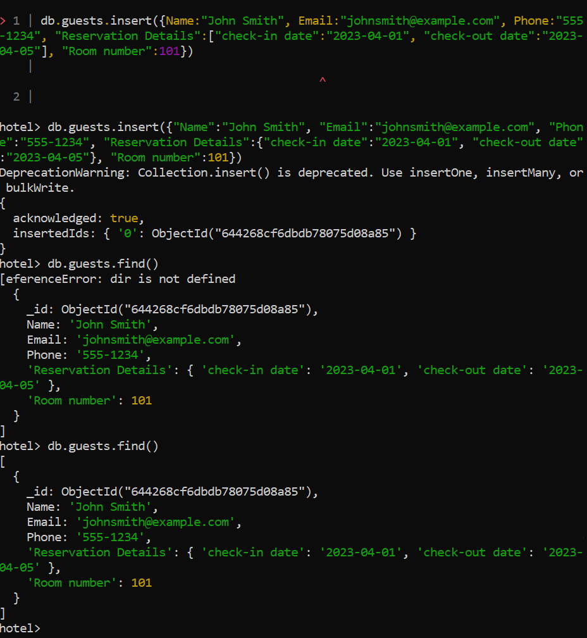

1. Queries the “guests” collection and prints out the document for the guest with email “johnsmith@example.com”.

* db.guests.find({"Email":"johnsmith@example.com"})

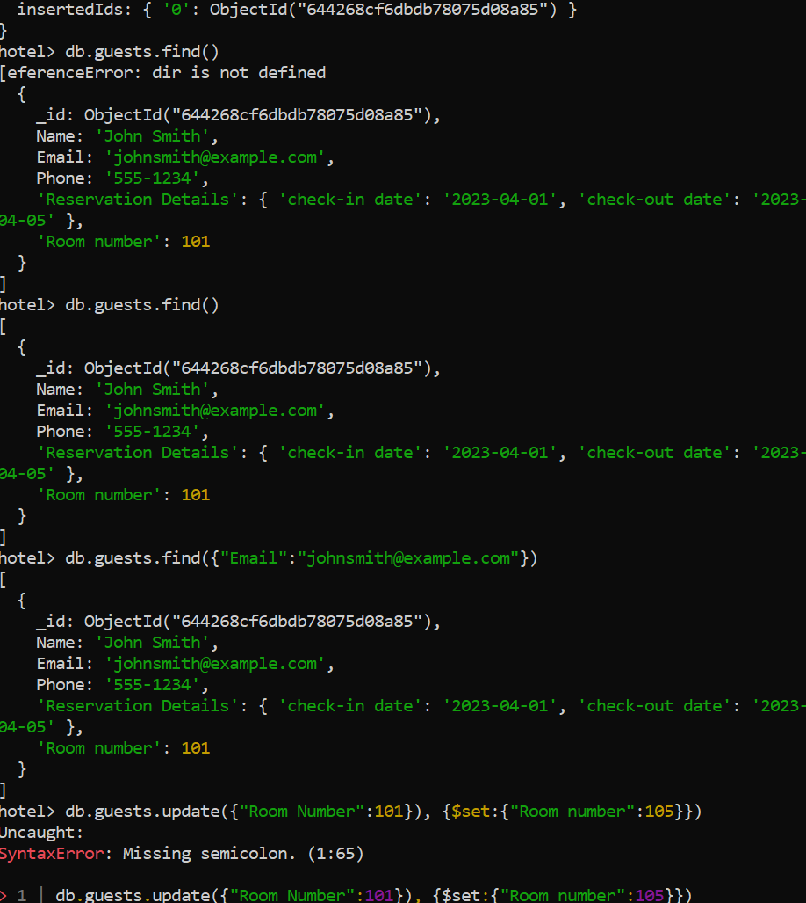

1. Change the room number from 101 to 105

* db.guests.update({"Room number":101}, {$set:{"Room number":105}})

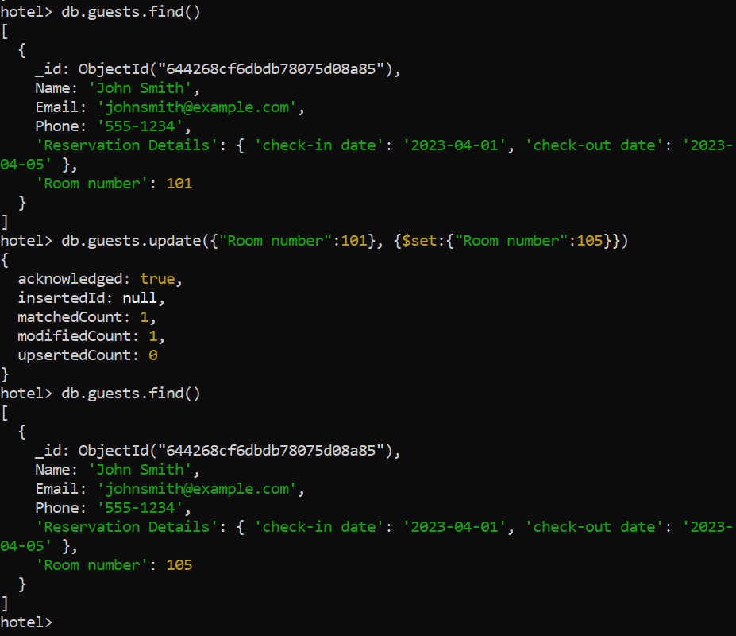

1. Remove the table

* db.guests.drop()

1. Remove the database

* db.dropDatabase()

