Microservices with API gateway (Mandatory Hands On)

Creating Microservices for account and loan

Code:

Account

<project xmlns="http://maven.apache.org/POM/4.0.0"

xmlns:xsi="http://www.w3.org/2001/XMLSchema-instance"

xsi:schemaLocation="http://maven.apache.org/POM/4.0.0 https://maven.apache.org/xsd/maven-4.0.0.xsd">

<modelVersion>4.0.0</modelVersion>

<parent>

<groupId>org.springframework.boot</groupId>

<artifactId>spring-boot-starter-parent</artifactId>

<version>3.1.5</version>

<relativePath/> <!-- lookup parent from repository -->

</parent>

<groupId>com.cognizant</groupId>

<artifactId>account</artifactId> <!-- change to 'loan' in loan project -->

<version>0.0.1-SNAPSHOT</version>

<name>account</name>

<description>Account Microservice</description>

<packaging>jar</packaging>

<properties>

<java.version>17</java.version>

</properties>

<dependencies>

<dependency>

<groupId>org.springframework.boot</groupId>

<artifactId>spring-boot-starter-web</artifactId>

</dependency>

<dependency>

<groupId>org.springframework.boot</groupId>

<artifactId>spring-boot-devtools</artifactId>

<scope>runtime</scope>

<optional>true</optional>

</dependency>

<dependency>

<groupId>org.springframework.boot</groupId>

<artifactId>spring-boot-starter-test</artifactId>

<scope>test</scope>

</dependency>

</dependencies>

<build>

<plugins>

<plugin>

<groupId>org.springframework.boot</groupId>

<artifactId>spring-boot-maven-plugin</artifactId>

</plugin>

</plugins>

</build>

</project>

package com.cognizant.account.controller;

import org.springframework.web.bind.annotation.GetMapping;

import org.springframework.web.bind.annotation.PathVariable;

import org.springframework.web.bind.annotation.RestController;

import java.util.Map;

*@RestController*

public class AccountController {

*@GetMapping*("/accounts/{number}")

public Map<String, Object> getAccountDetails(*@PathVariable* String number) {

return Map.*of*(

"number", number,

"type", "savings",

"balance", 234343

);

}

}

package com.cognizant.account;

import org.springframework.boot.SpringApplication;

import org.springframework.boot.autoconfigure.SpringBootApplication;

*@SpringBootApplication*

public class AccountApplication {

public static void main(String[] args) {

SpringApplication.*run*(AccountApplication.class, args);

}

}

Output:

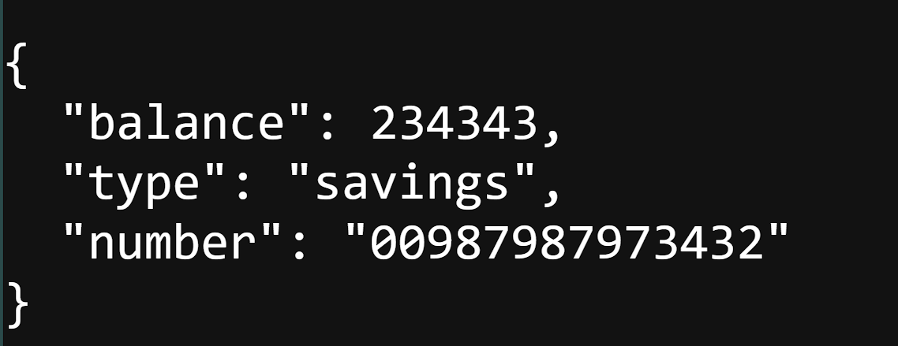

Loan

<project xmlns="http://maven.apache.org/POM/4.0.0"

xmlns:xsi="http://www.w3.org/2001/XMLSchema-instance"

xsi:schemaLocation="http://maven.apache.org/POM/4.0.0 https://maven.apache.org/xsd/maven-4.0.0.xsd">

<modelVersion>4.0.0</modelVersion>

<parent>

<groupId>org.springframework.boot</groupId>

<artifactId>spring-boot-starter-parent</artifactId>

<version>3.1.5</version>

<relativePath/> <!-- lookup parent from repository -->

</parent>

<groupId>com.cognizant</groupId>

<artifactId>loan</artifactId> <!-- change to 'loan' in loan project -->

<version>0.0.1-SNAPSHOT</version>

<name>loan</name>

<description>Account Microservice</description>

<packaging>jar</packaging>

<properties>

<java.version>17</java.version>

</properties>

<dependencies>

<dependency>

<groupId>org.springframework.boot</groupId>

<artifactId>spring-boot-starter-web</artifactId>

</dependency>

<dependency>

<groupId>org.springframework.boot</groupId>

<artifactId>spring-boot-devtools</artifactId>

<scope>runtime</scope>

<optional>true</optional>

</dependency>

<dependency>

<groupId>org.springframework.boot</groupId>

<artifactId>spring-boot-starter-test</artifactId>

<scope>test</scope>

</dependency>

</dependencies>

<build>

<plugins>

<plugin>

<groupId>org.springframework.boot</groupId>

<artifactId>spring-boot-maven-plugin</artifactId>

</plugin>

</plugins>

</build>

</project>

package com.cognizant.loan.controller;

import org.springframework.web.bind.annotation.\*;

import java.util.HashMap;

import java.util.Map;

*@RestController*

*@RequestMapping*("/loans")

public class LoanController {

*@GetMapping*("/{number}")

public Map<String, Object> getLoanDetails(*@PathVariable* String number) {

Map<String, Object> response = new HashMap<>();

response.put("number", number);

response.put("type", "car");

response.put("loan", 400000);

response.put("emi", 3258);

response.put("tenure", 18);

return response;

}

}

package com.cognizant.loan;

import org.springframework.boot.SpringApplication;

import org.springframework.boot.autoconfigure.SpringBootApplication;

*@SpringBootApplication*

public class LoanApplication {

public static void main(String[] args) {

SpringApplication.*run*(LoanApplication.class, args);

}

}

Output:

