ReactJS-HOL (Mandatory Hands On)

Create a new React Application with the name “myfirstreact”, Run the application to print “welcome to the first session of React” as heading of that page.

Code:

*import* './App.css'**;**

function App() {

**return** (

    <h1>Welcome the first session of React</h1>

  )**;**

}

*export* **default** App**;**

Output:

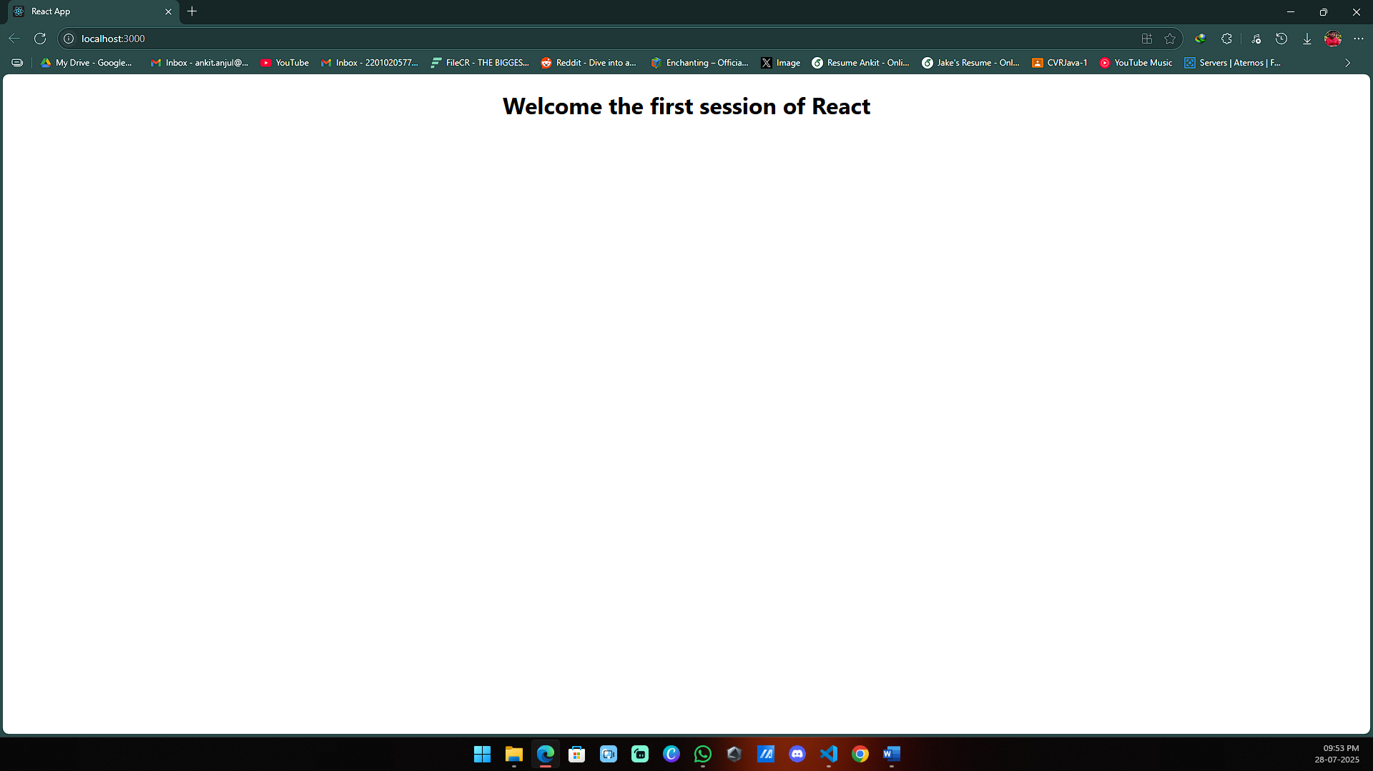

Create a react app for Student Management Portal named StudentApp and create a component named Home which will display the Message “Welcome to the Home page of Student Management Portal”. Create another component named About and display the Message “Welcome to the About page of the Student Management Portal”. Create a third component named Contact and display the Message “Welcome to the Contact page of the Student Management Portal”. Call all the three components.

Code:

*import* React**,** { Component } *from* 'react'**;**

class Home *extends* *Component* {

  render() {

**return** (

      <div>

        <h3>Welcome to the Home Page of Student Management Portal</h3>

      </div>

    )**;**

  }

}

*export* **default** Home**;**

*import* React**,** { Component } *from* 'react'**;**

class About *extends* *Component* {

  render() {

**return** (

      <div>

        <h3>Welcome to the About Page of Student Management Portal</h3>

      </div>

    )**;**

  }

}

*export* **default** About**;**

*import* React**,** { Component } *from* 'react'**;**

class Contact *extends* *Component* {

  render() {

**return** (

      <div>

        <h3>Welcome to the Contact Page of Student Management Portal</h3>

      </div>

    )**;**

  }

}

*export* **default** Contact**;**

*// import logo from './logo.svg';*

*import* './App.css'**;**

*import* Home *from* './Components/Home'**;**

*import* About *from* './About'**;**

*import* Contact *from* './Contact'**;**

function App() {

**return** (

    <div *className***=**"App">

      <Home />

      <About />

      <Contact />

    </div>

  )**;**

}

*export* **default** App**;**

Output:

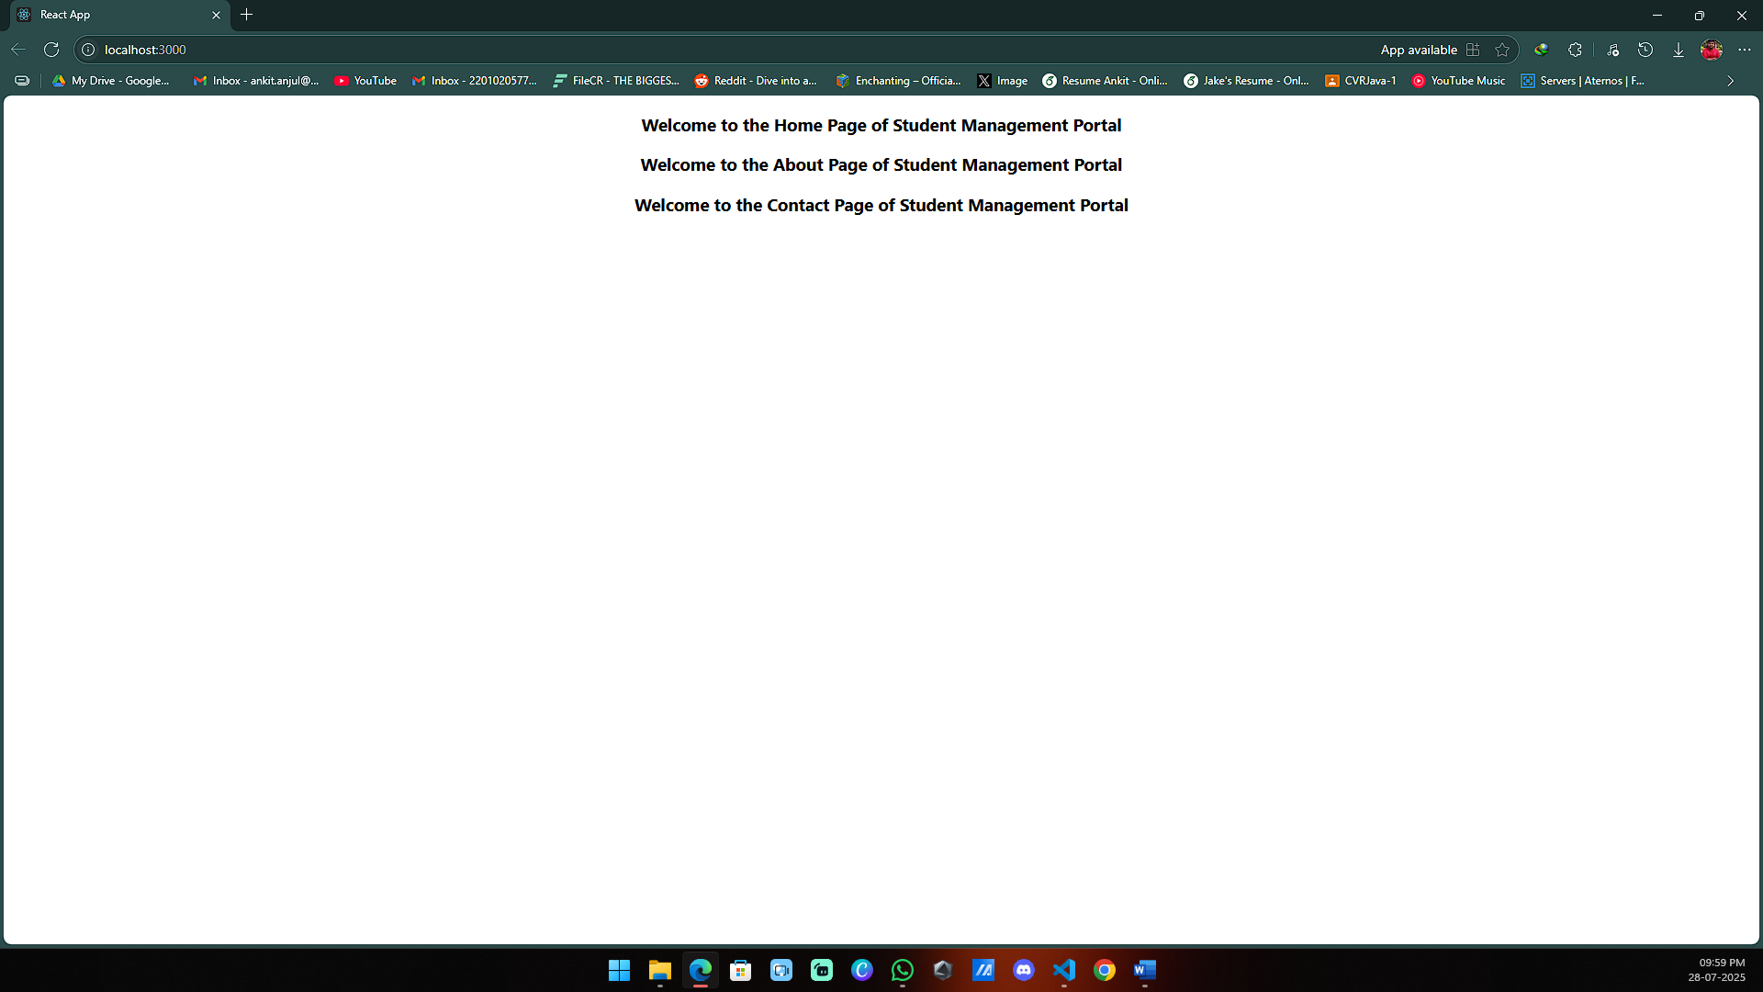

Create a react app for Student Management Portal named scorecalculatorapp and create a function component named “CalculateScore” which will accept Name, School, Total and goal in order to calculate the average score of a student and display the same.

Code:

*import* '../Stylesheets/mystyle.css'

const percentToDecimal **=** (**decimal**) **=>** {

**return** (decimal**.**toFixed(2) **+** '%')

}

const calcScore **=** (**total,** **goal**) **=>** {

**return** percentToDecimal(total **/** goal)

}

*export* const CalculateScore **=** ({ **Name,** **School,** **total,** **goal** }) **=>** (

    <div *className***=**"formatstyle">

        <h1><font *color***=**"Brown">Student Details:</font></h1>

        <div *className***=**"Name">

            <b><span> Name: </span></b>

            <span>{Name}</span>

        </div>

        <div *className***=**"School">

            <b><span> School: </span></b>

            <span>{School}</span>

        </div>

        <div *className***=**"Total">

            <b><span>Total:</span></b>

            <span>{total}</span>

            <span>Marks</span>

        </div>

        <div *className***=**"Score">

            <b>Score:</b>

            <span>

                {calcScore(

                    total**,**

                    goal

                )}

            </span>

        </div>

    </div>

)

*.Name* {

    font-weight**:** 300**;**

    color**:** blue**;**

}

*.School* {

    color**:** crimson**;**

}

*.Total* {

    color**:** darkmagenta**;**

}

*.formatstyle* {

    text-align**:** center**;**

    font-size**:** large**;**

}

*.Score* {

    color**:** forestgreen**;**

}

*import* { CalculateScore } *from* '../src/Components/CalculateScore'**;**

function App()

{

**return**(

    <div>

      <CalculateScore *Name***=**{"Steeve"}

*School***=**{"DNV Public School"}

*total***=**{284}

*goal***=**{3}

      />

    </div>

  )

}

*export* **default** App**;**

Output:

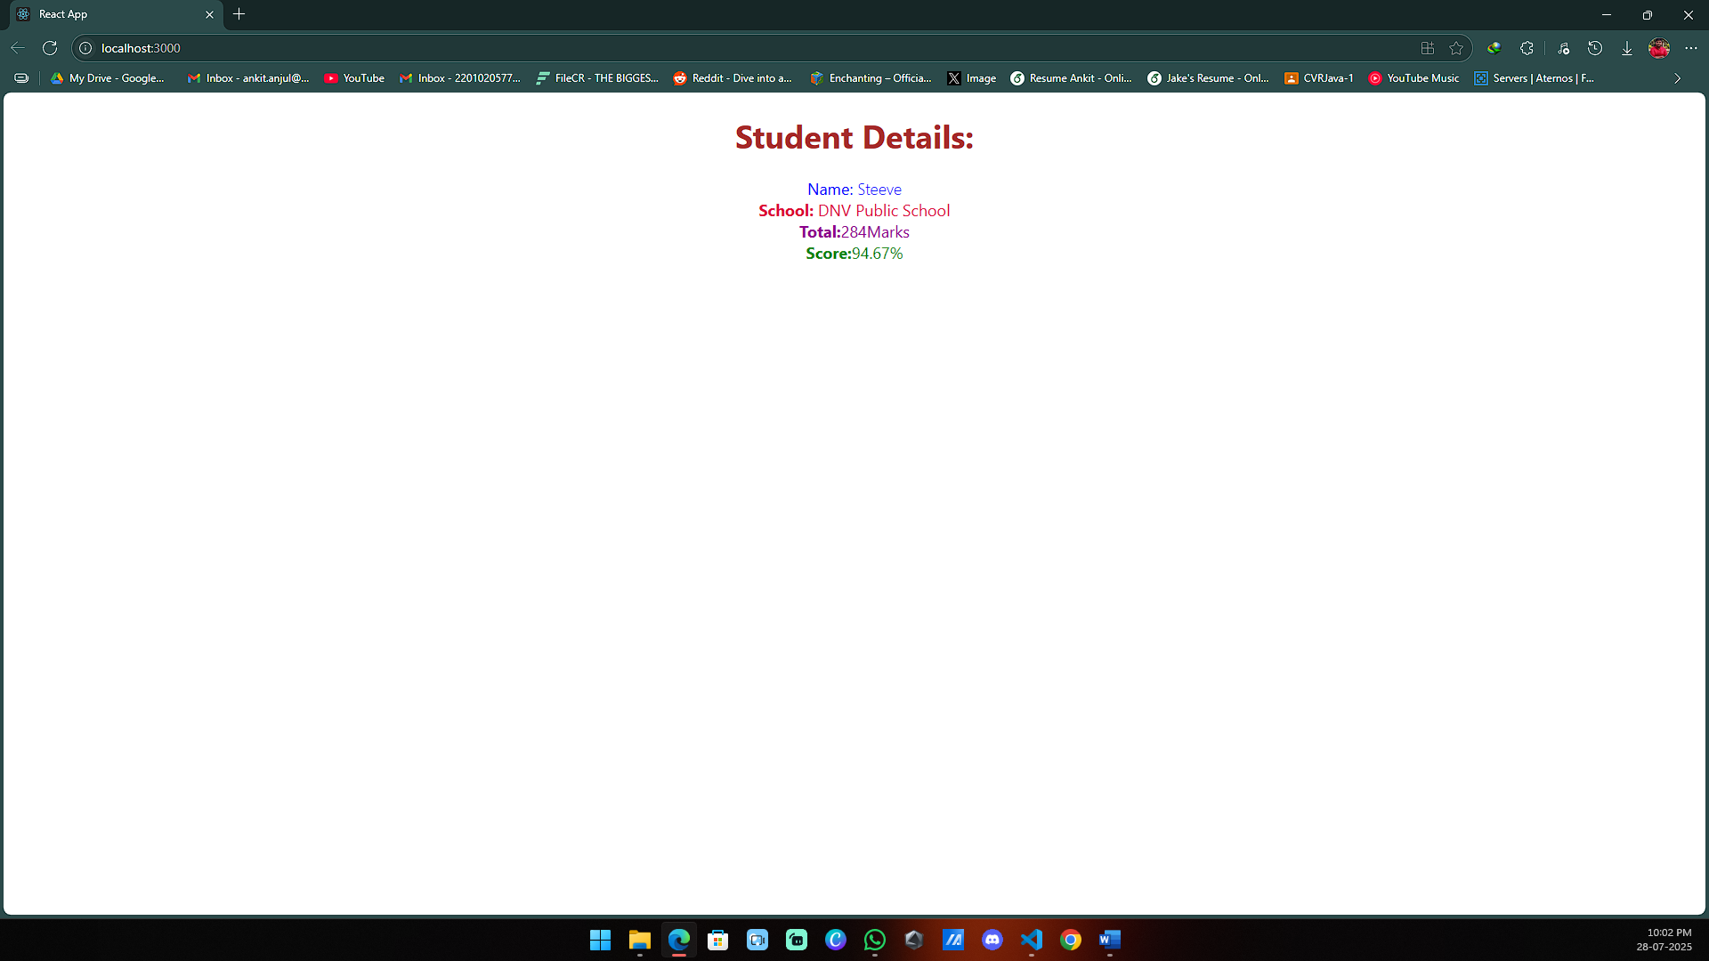

Implement componentDidMount() hook & Implementing componentDidCatch() life cycle hook.

Code:

*import* React *from* 'react'**;**

class Post *extends* React**.***Component* {

  constructor(**props**) {

*super*(props)**;**

  }

  render() {

**return** (

      <div *className***=**"post-container">

        <h2>{*this***.***props***.***title*}</h2>

        <p>{*this***.***props***.***body*}</p>

      </div>

    )**;**

  }

}

*export* **default** Post**;**

*import* React *from* 'react'**;**

*import* Post *from* './Post'**;**

class Posts *extends* React**.***Component* {

    constructor(**props**) {

*super*(props)**;**

*this***.***state* **=** {

            posts**:** []**,**

        }**;**

    }

    loadPosts **=** () **=>** {

        fetch('https://jsonplaceholder.typicode.com/posts')

**.**then((**response**) **=>** response**.**json())

**.**then((**data**) **=>** *this***.**setState({ posts**:** data }))

**.**catch((**error**) **=>** {

**throw** error**;**

            })**;**

    }**;**

    componentDidMount() {

*this***.**loadPosts()**;**

    }

    componentDidCatch(**error,** **info**) {

        alert('An error occurred: ' **+** error**.**toString())**;**

    }

    render() {

**return** (

            <div>

                {*this***.***state***.***posts***.**map((**post**) **=>** (

                    <Post *key***=**{post**.***id*} *title***=**{post**.***title*} *body***=**{post**.***body*} />

                ))}

            </div>

        )**;**

    }

}

*export* **default** Posts**;**

Output:

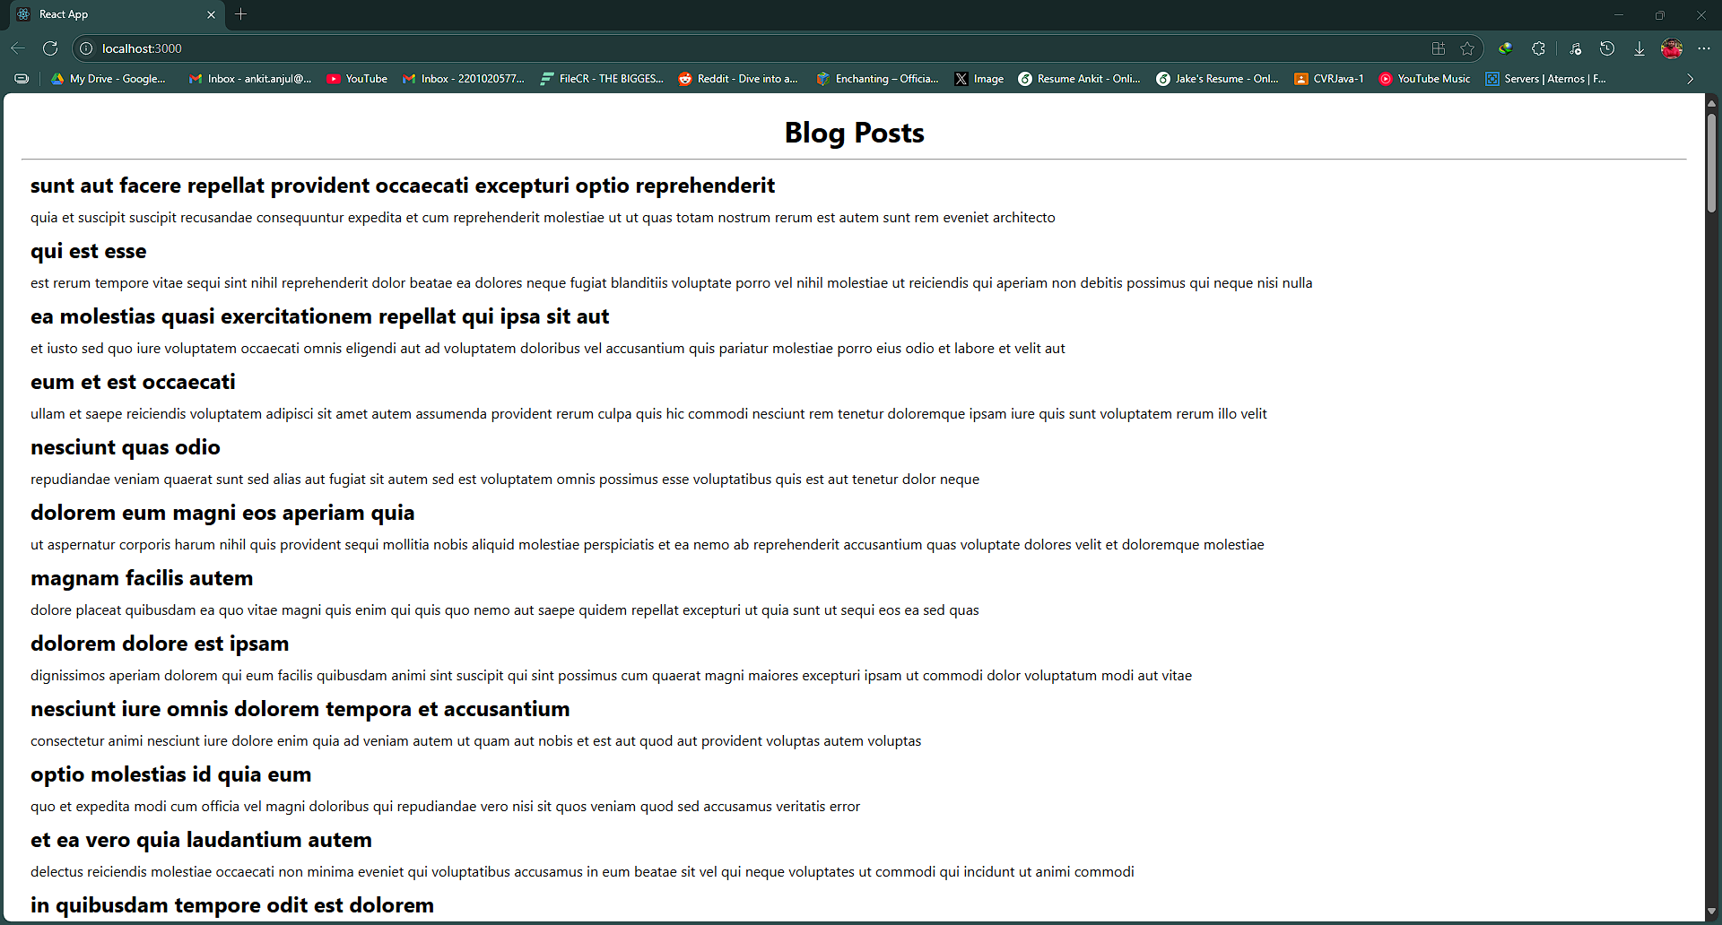

My Academy team at Cognizant want to create a dashboard containing the details of ongoing and completed cohorts. A react application is created which displays the detail of the cohorts using react component. You are assigned the task of styling these react components.

Code:

*.box* {

  width**:** 300px**;**

  display**:** inline-block**;**

  margin**:** 10px**;**

  padding**:** 10px 20px**;**

  border**:** 2px solid black**;**

  border-radius**:** 10px**;**

}

dt {

  font-weight**:** 500**;**

}

*import* styles *from* './CohortDetails.module.css'**;**

function CohortDetails(**props**) {

    const getTitleStyle **=** (**status**) **=>** ({

        color**:** status **===** "Ongoing" **?** "green" **:** "blue"

    })**;**

**return** (

        <div *className***=**{styles**.***box*}>

            <h3 *style***=**{getTitleStyle(props**.***cohort***.***currentStatus*)}>

                {props**.***cohort***.***cohortCode*} -

                <span>{props**.***cohort***.***technology*}</span>

            </h3>

            <dl>

                <dt>Started On</dt>

                <dd>{props**.***cohort***.***startDate*}</dd>

                <dt>Current Status</dt>

                <dd>{props**.***cohort***.***currentStatus*}</dd>

                <dt>Coach</dt>

                <dd>{props**.***cohort***.***coachName*}</dd>

                <dt>Trainer</dt>

                <dd>{props**.***cohort***.***trainerName*}</dd>

            </dl>

        </div>

    )**;**

}

*export* **default** CohortDetails**;**

Output:

