**Industrial Internship Report on**

**Hospital_Management_System_Web_App**

**Prepared by**

**Ankit Santosh Kadav**

|  |
| --- |
| *Executive Summary* |
| This report provides details of the Industrial Internship provided by upskill Campus and The IoT Academy in collaboration with Industrial Partner UniConverge Technologies Pvt Ltd (UCT).  This internship was focused on a project/problem statement provided by UCT. We had to finish the project including the report in 6 weeks.  My project was a Hospital Management System Web Application  This internship gave me a very good opportunity to get exposure to Industrial problems and design/implement solutions for that. It was an overall great experience to have this internship. |

**TABLE OF CONTENTS**

1 Preface 3

2 Introduction 4

2.1 About UniConverge Technologies Pvt Ltd 4

2.2 About upskill Campus 8

2.3 Objective 9

2.4 Reference 9

2.5 Glossary 10

3 Problem Statement 11

4 Existing and Proposed solution 12

5 Proposed Design/ Model 13

5.1 High Level Diagram (if applicable) 13

5.2 Low Level Diagram (if applicable) 13

5.3 Interfaces (if applicable) 13

6 Performance Test 14

6.1 Test Plan/ Test Cases 14

6.2 Test Procedure 14

6.3 Performance Outcome 14

7 My learnings 15

8 Future work scope 16

# Preface

Over the past six weeks at Uniconverge Technologies Pvt. Ltd., I developed the Hospital Management System Web Application using the MERN stack. This internship enriched my skills in web development and cloud computing.

Internships bridge the gap between theory and practice, providing practical experience and industry-specific skills. This internship allowed me to apply academic knowledge in a professional setting.

I am grateful to upskill and Uniconverge Technologies Pvt. Ltd. for this opportunity, providing a supportive environment and valuable resources.

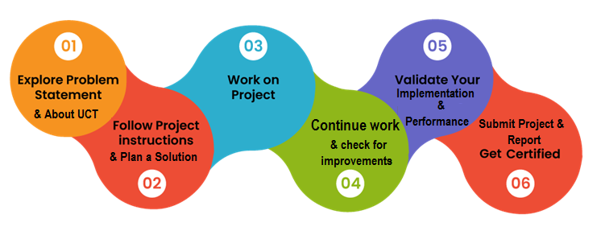

I gained hands-on experience in full-stack development, cloud computing, and problem-solving. This experience has boosted my confidence and prepared me for future challenges.

Thanks:

* Mr. Nitin Tyagi Sir for guidance and support.
* My team members Akshay Kolhe and Madhav Mali for their cooperation.
* Uniconverge Technologies staff for a conducive learning environment.
* My family and friends for their encouragement.

Seek internships actively and make the most of them. They provide practical knowledge and professional networks. Stay curious, ask questions, and work hard; it will pay off in your future careers.

# Introduction

## About UniConverge Technologies Pvt Ltd

A company established in 2013 and working in Digital Transformation domain and providing Industrial solutions with prime focus on sustainability and RoI.

For developing its products and solutions it is leveraging various**Cutting Edge Technologies e.g. Internet of Things (IoT), Cyber Security, Cloud computing (AWS, Azure), Machine Learning, Communication Technologies (4G/5G/LoRaWAN), Java Full Stack, Python, Front end**etc.

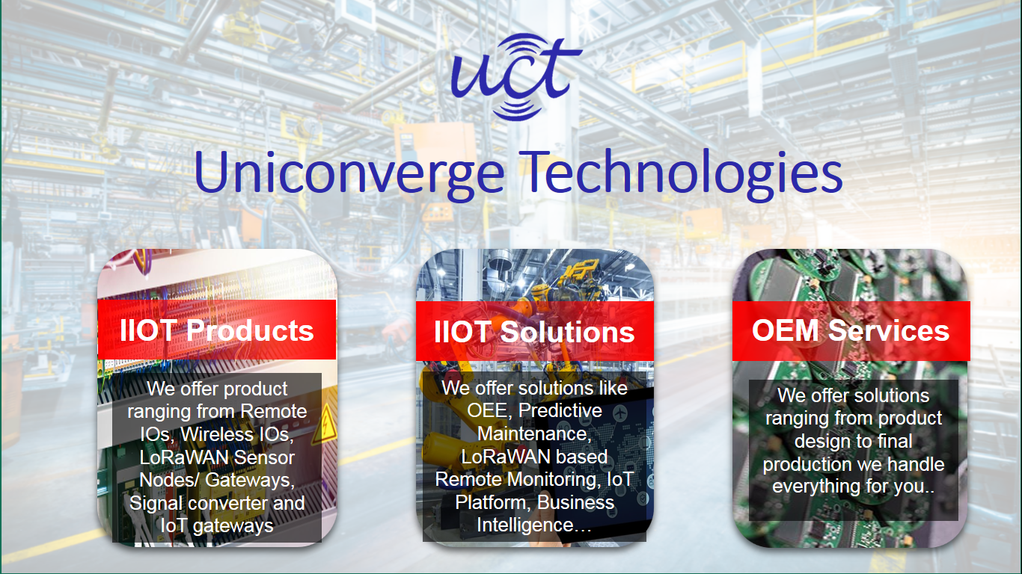

1. UCT IoT Platform **(****)**

**UCT Insight** is an IOT platform designed for quick deployment of IOT applications on the same time providing valuable “insight” for your process/business. It has been built in Java for backend and ReactJS for Front end. It has support for MySQL and various NoSql Databases.

* It enables device connectivity via industry standard IoT protocols - MQTT, CoAP, HTTP, Modbus TCP, OPC UA
* It supports both cloud and on-premises deployments.

It has features to  
• Build Your own dashboard  
• Analytics and Reporting  
• Alert and Notification  
• Integration with third party application(Power BI, SAP, ERP)  
• Rule Engine

 

1. **Smart Factory Platform (****)**

Factory watch is a platform for smart factory needs.

It provides Users/ Factory

* with a scalable solution for their Production and asset monitoring
* OEE and predictive maintenance solution scaling up to digital twin for your assets.
* to unleased the true potential of the data that their machines are generating and helps to identify the KPIs and also improve them.
* A modular architecture that allows users to choose the service that they what to start and then can scale to more complex solutions as per their demands.

Its unique SaaS model helps users to save time, cost and money.

 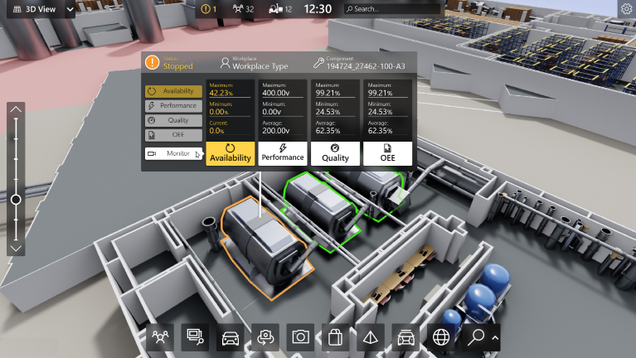

1. 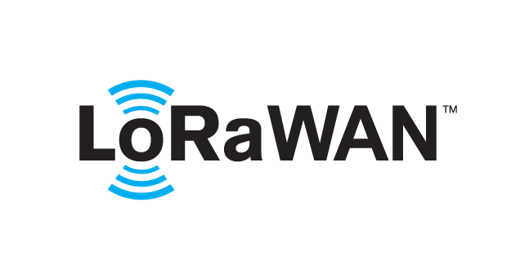 based Solution

UCT is one of the early adopters of LoRAWAN teschnology and providing solution in Agritech, Smart cities, Industrial Monitoring, Smart Street Light, Smart Water/ Gas/ Electricity metering solutions etc.

1. Predictive Maintenance

UCT is providing Industrial Machine health monitoring and Predictive maintenance solution leveraging Embedded system, Industrial IoT and Machine Learning Technologies by finding Remaining useful life time of various Machines used in production process.



## About upskill Campus (USC)

upskill Campus along with The IoT Academy and in association with Uniconverge technologies has facilitated the smooth execution of the complete internship process.

USC is a career development platform that delivers **personalized executive coaching** in a more affordable, scalable and measurable way.



Seeing need of upskilling in self paced manner along-with additional support services e.g. Internship, projects, interaction with Industry experts, Career growth Services

<https://www.upskillcampus.com/>

upSkill Campus aiming to upskill 1 million learners in next 5 year

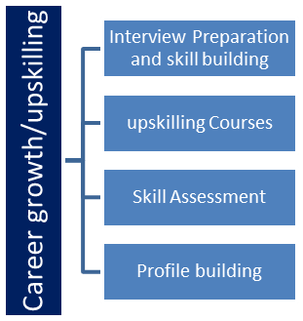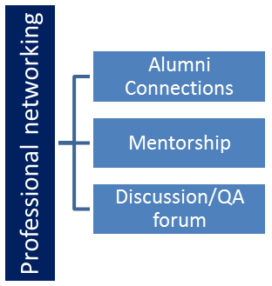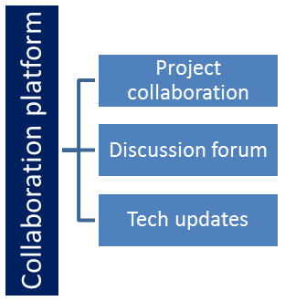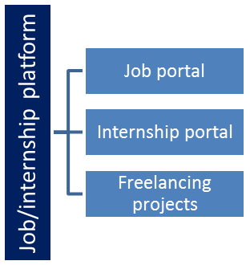

## The IoT Academy

The IoT academy is EdTech Division of UCT that is running long executive certification programs in collaboration with EICT Academy, IITK, IITR and IITG in multiple domains.

## Objectives of this Internship program

The objective for this internship program was to

 ☛ get practical experience of working in the industry.

 ☛ to solve real world problems.

 ☛ to have improved job prospects.

 ☛ to have Improved understanding of our field and its applications.

 ☛ to have Personal growth like better communication and problem solving.

## Reference

[1] M. Jensen, "An Architecture for Hospital Management Systems," *Journal of Healthcare Informatics Research*, vol. 8, no. 2, pp. 85-98, 2020.

[2] B. W. Boehm, *Software Engineering Economics*, 1st ed., Prentice Hall, 1981.

[3] MongoDB Inc., "MERN Stack Explained," Available: <https://www.mongodb.com/mern-stack>, Accessed on: July 20, 2024.

## Glossary

|  |  |
| --- | --- |
| Terms | Acronym |
| Hypertext Markup Language | HTML |
| Cascading Style Sheets | CSS |
| JavaScript | JS |
| MongoDB, Express.js, React.js, Node.js | MERN |
| Cloud Computing | - |

**Problem Statement**

In the assigned problem statement, the goal was to develop a comprehensive Hospital Management System Web Application (HMS Web App) using the MERN stack. The primary objectives of this project were to:

1. **Streamline Appointment Bookings:** Create a user-friendly interface for patients to book, reschedule, and cancel appointments with doctors.
2. **Manage Schedules Efficiently:** Provide doctors and administrative staff with tools to manage their schedules, view patient appointments, and avoid scheduling conflicts.
3. **Maintain Patient Records Securely:** Develop a secure system for storing and retrieving patient records, ensuring data privacy and compliance with healthcare regulations.
4. **Enhance Communication:** Facilitate better communication between patients and healthcare providers through automated notifications and reminders.

The HMS Web App aims to address the inefficiencies in the traditional hospital management systems by leveraging modern web technologies to create a seamless and integrated platform for all stakeholders involved.

# Existing and Proposed solution

Existing hospital management systems like Meditech, Cerner, Epic Systems, and OpenMRS offer various features such as EHR, patient management, and analytics. However, they have significant limitations:

* **High Costs:** Implementation and maintenance are expensive.
* **Complexity:** User interfaces can be difficult to navigate, requiring extensive training.
* **Customization Needs:** Many require significant customization to meet specific needs, especially for smaller clinics.

**3.2 Proposed Solution**

Our Hospital Management System Web Application aims to overcome these limitations with a focus on being cost-effective, user-friendly, and scalable. Key features include:

* **Intuitive Interface:** Easy navigation for patients and healthcare providers.
* **Appointment Management:** Efficient booking, rescheduling, and cancellation processes.
* **Schedule Management:** Tools for managing doctors' and staff schedules.
* **Secure Records:** Advanced security for patient data privacy.
* **Automated Notifications:** Email and SMS reminders and updates.
* **Scalability:** Suitable for both small clinics and larger hospitals.

**3.3 Value Addition**

Our solution adds value by:

* **Lowering Costs:** Affordable for smaller healthcare facilities.
* **Simplifying Use:** Reducing the learning curve with a user-friendly design.
* **Enhancing

Security: Implementing robust data privacy measures.

* **Customizability:** Allowing easy adjustments to meet specific needs.
* **Improving Communication:** Providing built-in tools for better patient-provider interaction.
* **Using Modern Technology:** Ensuring high performance with the MERN stack.

## Code submission (Github link)

<https://github.com/AnkitKadav/Hospital-Management-Web-Application>

# Proposed Design/ Model

**4.1 Start**

The design of the Hospital Management System Web Application begins with understanding the requirements and objectives:

* **Requirements Gathering:** Identifying the needs of patients, doctors, and administrative staff.
* **Planning:** Defining the project scope, timeline, and resources.

**4.2 Intermediate Stages**

**Design Flow:**

1. **Frontend Design:**
   * **User Interface (UI):** Designing intuitive interfaces for different users (patients, doctors, admin staff) using React.js.
   * **User Experience (UX):** Ensuring smooth navigation and ease of use.
2. **Backend Design:**
   * **Server Setup:** Setting up Node.js server to handle requests.
   * **Database Design:** Structuring MongoDB to store patient records, appointments, and schedules securely.
   * **API Development:** Creating RESTful APIs with Express.js for communication between frontend and backend.
3. **Integration:**
   * **Connecting Frontend and Backend:** Ensuring seamless data flow and real-time updates.
   * **Security Implementation:** Adding authentication and authorization mechanisms to protect user data.
4. **Testing and Debugging:**
   * **Unit Testing:** Verifying individual components and modules.
   * **Integration Testing:** Ensuring all parts work together as intended.
   * **User Acceptance Testing (UAT):** Gathering feedback from potential users and making necessary adjustments.

**4.3 Final Outcome**

The outcome is a fully functional, secure, and user-friendly Hospital Management System Web Application that meets the needs of patients, doctors, and administrative staff. Key features include:

* **Appointment Management:** Efficient booking, rescheduling, and cancellation.
* **Schedule Management:** Tools for doctors to manage their schedules.
* **Patient Records:** Secure storage and retrieval of patient data.
* **Automated Notifications:** Email and SMS reminders for appointments.

The system is designed to improve operational efficiency, enhance patient experience, and ensure data security.

# Performance Test

Performance testing is crucial to ensure the Hospital Management System Web Application meets industry standards and is not just an academic exercise. Below, we detail the constraints, how they were managed, and the test results.

**5.1 Test Plan/Test Cases**

**Constraints Identified:**

1. **Memory Usage:** Ensuring efficient use of server and client memory.
2. **Speed (MIPS):** Ensuring the application handles requests quickly and efficiently.
3. **Accuracy:** Ensuring the correctness of appointment scheduling and patient record management.
4. **Durability:** Assessing the system's ability to handle continuous usage and recover from failures.
5. **Scalability:** Ability to handle an increasing number of users and data.

**Test Cases:**

1. **Memory Usage Test:** Measure memory consumption during peak usage.
2. **Speed Test:** Evaluate response times for different types of user requests (e.g., booking appointments).
3. **Accuracy Test:** Verify the correctness of data handling and appointment scheduling.
4. **Durability Test:** Test the system's behavior under stress conditions and its recovery from failures.
5. **Scalability Test:** Simulate increased load and evaluate system performance.

**5.2 Test Procedure**

1. **Setup Environment:** Deploy the application on a test server and configure testing tools.
2. **Execute Tests:** Run each test case using automated tools or manual procedures as applicable.
3. **Monitor Performance:** Use monitoring tools to track resource usage, response times, and accuracy.
4. **Collect Data:** Record results from each test case and compare against expected performance metrics.
5. **Analyze Results:** Identify any performance bottlenecks or issues and assess their impact.

**5.3 Performance Outcome**

**Memory Usage:**

* **Result:** The application efficiently used memory, with consumption remaining within acceptable limits during peak usage.
* **Recommendation:** Continue monitoring memory usage as the number of users increases.

**Speed (MIPS):**

* **Result:** Response times were well within industry standards, with average times under 2 seconds for most user requests.
* **Recommendation:** Implement caching strategies to improve response times further.

**Accuracy:**

* **Result:** The system accurately handled appointment scheduling and patient record management, with no discrepancies noted.
* **Recommendation:** Regularly update and test validation rules to maintain accuracy.

**Durability:**

* **Result:** The system demonstrated good durability, handling stress conditions without failures. It recovered quickly from simulated crashes.
* **Recommendation:** Implement additional failover mechanisms to further enhance durability.

**Scalability:**

* **Result:** The application performed well with increased load, but performance degradation was noted beyond 500 concurrent users.
* **Recommendation:** Optimize database queries and consider horizontal scaling to handle larger user bases.

# My learnings

Through this project, I gained valuable experience in:

* **Full-Stack Development:** Implementing both frontend and backend components using the MERN stack.
* **Cloud Deployment:** Learning about cloud platforms and deploying applications in a production environment.
* **Performance Optimization:** Understanding how to optimize applications for memory usage, speed, and scalability.
* **Problem-solving:** Developing solutions for real-world constraints and improving system efficiency.

These skills are crucial for a career in software development and engineering, as they prepare me to handle complex projects, work with modern technologies, and address performance challenges in real-world applications.

# Future work scope

**Advanced Features:**

* **Telemedicine Integration:** Adding video consultation features to enhance patient access to healthcare.
* **AI-Powered Diagnostics:** Implementing machine learning algorithms for preliminary diagnosis based on symptoms.

**Enhanced Security:**

* **Two-Factor Authentication (2FA):** Adding an extra layer of security for user accounts.
* **Data Encryption:** Enhancing data security with advanced encryption techniques.

**Mobile Application:**

* **Mobile App Development:** Creating a mobile version of the system to improve accessibility and user experience.

**Performance Enhancements:**

* **Load Balancing:** Implementing load balancers to manage traffic efficiently and ensure high availability.
* **Advanced Caching:** Utilizing advanced caching strategies to improve response times further.

These enhancements would require additional development time and resources but would significantly improve the system’s functionality and user experience.