Wireframe Documentation
Flight Price Prediction

Written by | Denistan B
Documented Version | 1.0
Last Revised Date | 13 December 2024

Overview:
The interface consists of two main sections:
- Input Section – Users provide data through input fields such as flight duration, airline, source, destination, date of travel, and promotions.
- Visualization and Output Section – Displays the predicted flight fare and two visualizations related to Flight Duration vs Predicted Fare and Airline vs Average Fare.

1. Input Section:
Position:
- The input fields (such as Flight Duration, Airline, Source, Destination, etc.) are positioned at the top of the screen, arranged in a column layout for better organization.
- They are grouped together for easy readability and to encourage users to input their details in an intuitive manner.
Behavior:
- The fields are interactive, allowing the user to select or input values for each field.
  - Flight Duration: A numeric input with a range slider to allow the user to choose the length of the flight.
  - Airline: A dropdown menu where users can select their preferred airline.
  - Source and Destination: Dropdown menus to select the departure and arrival locations.
  - Date of Travel: A date picker to specify the travel date.
  - Promotion: A radio button or dropdown input to indicate if any special promotions or discounts apply to the flight.
- The "Predict Fare" button activates the fare prediction process.
Purpose:
- The input section allows users to provide the necessary data points (e.g., flight details, source, destination, promotions) that will be used to generate an accurate fare prediction.
Workflow:
- The user selects or inputs data into all fields (flight duration, source, destination, promotions, etc.).
- Once all fields are filled, the user presses the "Predict Fare" button.
- The system processes the input, feeds it into the trained machine learning model, and returns the predicted flight fare.
- The predicted flight fare is displayed below the input fields, allowing users to easily see the fare estimate.

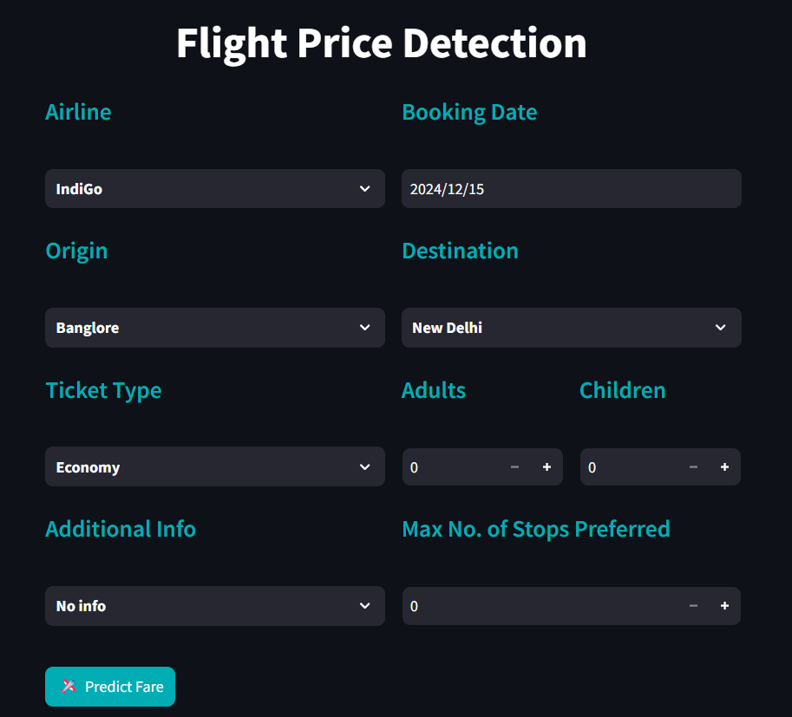

2. Visualization and Output Section:
Position:
- The Visualization and Output Section is positioned below the user input fields, ensuring a clean and organized layout.
- This section is directly above any footer or additional content, allowing the user to easily access and interpret the results.
- The visualizations are displayed in a vertical layout:
  - Flight Duration vs Predicted Fare: A graph that shows the relationship between flight duration and predicted fare for each trip.
  - Airline vs Average Fare: A graph that illustrates how different airlines' fares compare, offering insights into airline-based pricing patterns.
- This layout ensures there’s adequate space for both visualizations, preventing overcrowding and making the results easy to interpret.

Behavior:
- Real-Time Dynamic Updates: The visualizations will update in real time as the user enters their input data, reflecting how the model processes the values and predicts the fare.
- Update Upon Prediction: Once the user clicks the "Predict Fare" button, the system will execute the prediction algorithm and refresh both graphs with the latest data.
- Interactive Legends: Each graph includes a legend to denote different categories, like the airline or flight duration. Users can toggle or adjust these legends to gain deeper insights into how different input variables affect the predictions.
- Responsive Design: The visualizations are designed to be responsive, adjusting to different screen sizes (desktop, tablet, mobile). This ensures a consistent user experience across devices.

Purpose:
- Data-Driven Insights: The visualizations provide users with insights into the factors influencing flight fares.
  - Flight Duration vs Predicted Fare: This graph helps users understand if longer flights tend to have higher fares. It provides an intuitive view of how flight duration correlates with predicted ticket prices.
  - Airline vs Average Fare: This chart displays fare patterns across different airlines, helping users make informed decisions about which airlines might offer better pricing based on historical data.
- User Engagement: By visualizing complex relationships in an interactive format, users can easily identify trends and gain a better understanding of the factors influencing flight prices. This encourages deeper interaction with the tool, improving their decision-making process.

Workflow:
- User Input: The user enters relevant data such as Flight Duration, Airline, Source, Destination, and other travel-related details.
- Prediction Trigger: Upon pressing the "Predict Fare" button, the system processes the user input and generates a flight fare prediction.
- Visualization Generation: After receiving the prediction, the system generates the two visualizations:
  - Flight Duration vs Predicted Fare: Displays how the length of the flight relates to the predicted fare.
  - Airline vs Average Fare: Shows the fare comparison across airlines to assist users in selecting the best option based on price.
- Visualization Update: When the user adjusts the input fields and presses "Predict Fare" again, the visualizations are automatically updated to reflect the new input data, providing real-time insights and offering the user a dynamic experience.
