**CONTENTS**

|  |  |  |
| --- | --- | --- |
| **S.NO** | **EXPERIMENTS** | **PG.NO** |
| 1 | Develop an application that uses GUI components, Font and Colours | 3 |
| 2 | Develop an application that uses Layout Managers and event listeners. | 6 |
| 3 | Develop a native calculator application. | 11 |
| 4 | Write an application that draws basic graphical primitives on the screen. | 16 |
| 5 | Develop an application that makes use of database. | 18 |
| 6 | Develop an application that makes use of RSS Feed. | 25 |
| 7 | Implement an application that implements Multi threading | 31 |
| 8 | Develop a native application that uses GPS location information. | 34 |
| 9 | Implement an application that writes data to the SD card. | 41 |
| 10 | Implement an application that creates an alert upon receiving a message. | 45 |
| 11 | Write a mobile application that creates alarm clock | 49 |

**Date:**

1. **Develop an application that uses GUI components ,Fonts and colors.**

**Description:**

* 1. Open eclipse or android studio and select new android project . 2)Give project name and select next

1. Choose the android version.Choose the lowest android version(Android 2.2) and select next
2. Enter the package name.package name must be two word seprated by comma and click finish 5)Go to package explorer in the left hand side.select our project.

6)Go to res folder and select layout.Double click the main.xml file 7)Now you can see the Graphics layout window.

**Source code:**

<LinearLayout xmlns:android="<http://schemas.android.com/apk/res/android>" android:layout_width="fill_parent"

android:layout_height="fill_parent" android:orientation="vertical" >

<TextView android:id="@+id/textView1" android:layout_width="match_parent" android:layout_height="wrap_content" android:layout_margin="20sp" android:gravity="center" android:text="HELLO WORLD" android:textSize="20sp" android:textStyle="bold" />

<Button

android:id="@+id/button1" android:layout_width="match_parent" android:layout_height="wrap_content" android:gravity="center" android:text="Change font size" android:textSize="20sp" />

<Button android:id="@+id/button2"

android:layout_width="match_parent" android:layout_height="wrap_content" android:gravity="center" android:text="Change color"

android:textSize="20sp" />

<Button android:id="@+id/button3"

android:layout_width="match_parent" android:layout_height="wrap_content" android:gravity="center" android:text="Change font" android:textSize="20sp" />

</LinearLayout>

import android.app.Activity;

import android.graphics.Color; import android.graphics.Typeface; import android.os.Bundle;

import android.view.View; import android.widget.Button; import android.widget.TextView;

public class AndroidActivity extends Activity { float font =24;

int i=1; @Override

public void onCreate(Bundle savedInstanceState) { super.onCreate(savedInstanceState); setContentView(R.layout.main);

final TextView t1=(TextView) findViewById(R.id.textView1); Button b1 = (Button) findViewById(R.id.button1); b1.setOnClickListener(new View.OnClickListener() {

public void onClick(View view) { t1.setTextSize(font);

font=font+4; if(font==40) font=20;

}

});

Button b2 = (Button) findViewById(R.id.button2); b2.setOnClickListener(new View.OnClickListener() { public void onClick(View view) {

switch(i)

{

case 1:

t1.setTextColor(Color.parseColor("#0000FF")); break;

case 2: t1.setTextColor(Color.parseColor("#00FF00")); break;

case 3: t1.setTextColor(Color.parseColor("#FF0000")); break;

case 4: t1.setTextColor(Color.parseColor("#800000")); break;

} i++;

if(i==5) i=1;

}

});

}

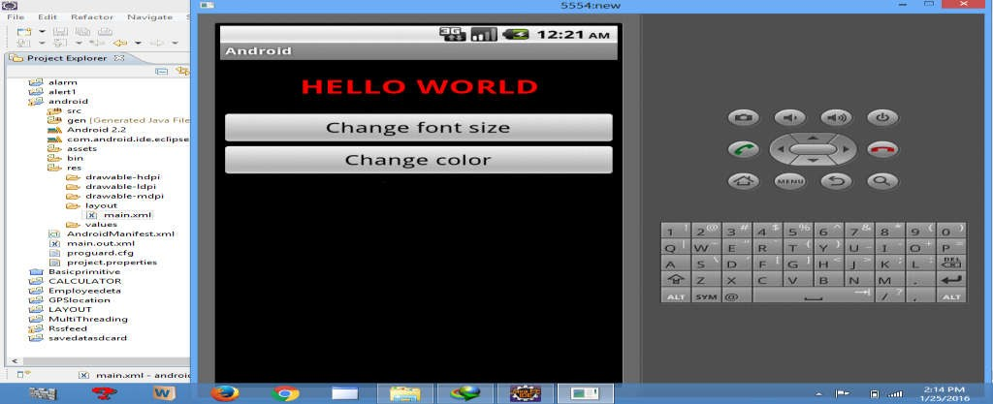} OUTPUT:

* 1. **Develop an application that uses layout managers.**

**Description:**

1)Open eclipse or android studio and select new android project 2) Give project name and select next

1. Choose the android version. Choose the lowest android version (Android 2.2) and select next
2. Enter the package name. Package name must be two word separated by comma and click finish.

5)Go to package explorer in the left hand side. Select our project.

6)Go to res folder and select layout. Double click the main.xml file.

**Source code:**

<RelativeLayout xmlns:android="<http://schemas.android.com/apk/res/android>" android:id="@+id/relativeLayout1"

android:layout_width="fill_parent" android:layout_height="fill_parent" >

<LinearLayout android:id="@+id/linearLayout1" android:layout_width="wrap_content" android:layout_height="wrap_content" android:layout_alignParentLeft="true" android:layout_alignParentRight="true" android:layout_alignParentTop="true" >

<TextView android:layout_width="wrap_content" android:layout_height="wrap_content" android:layout_gravity="center" android:text="ADDITION" android:textSize="20dp" >

</TextView>

</LinearLayout>

<LinearLayout android:id="@+id/linearLayout2" android:layout_width="wrap_content" android:layout_height="wrap_content" android:layout_alignParentLeft="true" android:layout_alignParentRight="true" android:layout_below="@+id/linearLayout1" >

<TextView android:layout_width="wrap_content" android:layout_height="wrap_content" android:text="ENTER NO 1" >

</TextView>

<EditText android:layout_width="wrap_content" android:layout_height="wrap_content" android:layout_weight="0.20" android:id="@+id/edittext1" android:inputType="number">

</EditText>

</LinearLayout>

<LinearLayout android:id="@+id/linearLayout3" android:layout_width="wrap_content" android:layout_height="wrap_content" android:layout_alignParentLeft="true" android:layout_alignParentRight="true" android:layout_below="@+id/linearLayout2" >

<TextView android:layout_width="wrap_content" android:layout_height="wrap_content" android:text="ENTER NO 2" >

</TextView>

<EditText android:layout_width="wrap_content" android:layout_height="wrap_content" android:layout_weight="0.20" android:id="@+id/edittext2" android:inputType="number">

</EditText>

</LinearLayout>

<LinearLayout android:id="@+id/linearLayout4" android:layout_width="wrap_content" android:layout_height="wrap_content" android:layout_alignParentLeft="true" android:layout_alignParentRight="true" android:layout_below="@+id/linearLayout3" >

<Button android:layout_width="wrap_content" android:id="@+id/button1" android:layout_height="wrap_content" android:text="Addition" android:layout_weight="0.50" />

<Button android:layout_width="wrap_content" android:id="@+id/button3" android:layout_height="wrap_content" android:text="subtraction" android:layout_weight="0.50" />

<Button android:layout_width="wrap_content" android:id="@+id/button2" android:layout_height="wrap_content" android:text="CLEAR" android:layout_weight="0.50" />

</LinearLayout>

<View android:layout_height="2px" android:layout_width="fill_parent"

android:layout_below="@+id/linearLayout4" android:background="#DDFFDD"/>

</RelativeLayout>

package layout.ne;

import android.app.Activity; import android.os.Bundle; import android.view.View;

import android.view.View.OnClickListener; import android.widget.Button;

import android.widget.EditText; import android.widget.Toast;

public class LAYOUTActivity extends Activity {

/** Called when the activity is first created. */ EditText txtData1,txtData2;

float num1,num2,result1,result2; @Override

public void onCreate(Bundle savedInstanceState) { super.onCreate(savedInstanceState); setContentView(R.layout.main);

Button add = (Button) findViewById(R.id.button1); add.setOnClickListener(new OnClickListener() { public void onClick(View v) {

try

{

txtData1 = (EditText) findViewById(R.id.edittext1); txtData2 = (EditText) findViewById(R.id.edittext2); num1 = Float.parseFloat(txtData1.getText().toString()); num2 = Float.parseFloat(txtData2.getText().toString()); result1=num1+num2;

Toast.makeText(getBaseContext(),"ANSWER:"+result1,Toast.LENGTH_SHORT).show();

}

catch(Exception e)

{

Toast.makeText(getBaseContext(), e.getMessage(), Toast.LENGTH_SHORT).show();

}

}

});

Button sub = (Button) findViewById(R.id.button3); sub.setOnClickListener(new OnClickListener() { public void onClick(View v) {

try

{

txtData1 = (EditText) findViewById(R.id.edittext1); txtData2 = (EditText) findViewById(R.id.edittext2); num1 = Float.parseFloat(txtData1.getText().toString()); num2 = Float.parseFloat(txtData2.getText().toString()); result2=num1-num2;

Toast.makeText(getBaseContext(),"ANSWER:"+result2,Toast.LENGTH_SHORT).show();

}

catch(Exception e)

{

Toast.makeText(getBaseContext(), e.getMessage(), Toast.LENGTH_SHORT).show();

}

}

});

Button clear = (Button) findViewById(R.id.button2); clear.setOnClickListener(new OnClickListener() { public void onClick(View v) {

try

{

txtData1.setText("");

txtData2.setText("");

}

catch(Exception e)

{

Toast.makeText(getBaseContext(), e.getMessage(), Toast.LENGTH_SHORT).show();

}

} });

} }

**Output:**

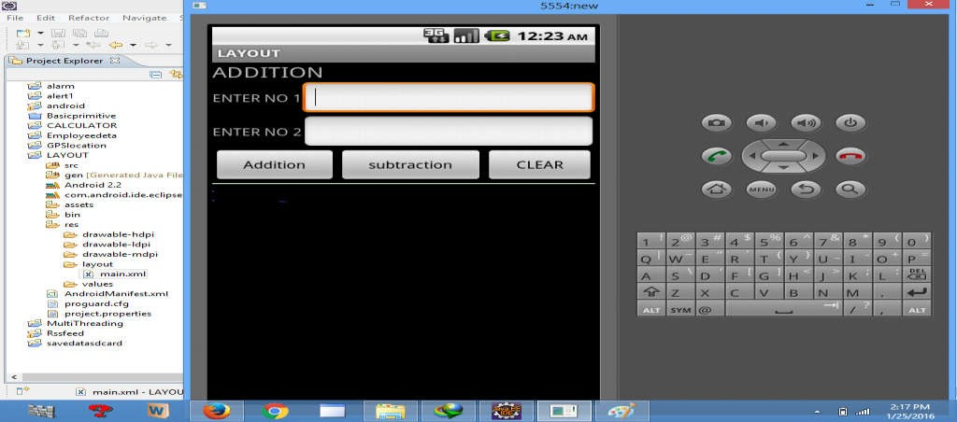

1. **Develop a native calculator application.**

**Source code & Steps::**

Main.xml coding

<?xml version="1.0" encoding="utf-8"?>

<LinearLayout xmlns:android="<http://schemas.android.com/apk/res/android>" android:orientation="vertical" android:layout_width="fill_parent" android:layout_height="fill_parent">

<LinearLayout android:layout_width="match_parent" android:layout_height="wrap_content" android:id="@+id/linearLayout1" android:layout_marginLeft="10pt" android:layout_marginRight="10pt" android:layout_marginTop="3pt">

<EditText android:layout_weight="1"

android:layout_height="wrap_content" android:layout_marginRight="5pt" android:id="@+id/etNum1" android:layout_width="match_parent" android:inputType="numberDecimal">

</EditText>

<EditText android:layout_height="wrap_content" android:layout_weight="1" android:layout_marginLeft="5pt" android:id="@+id/etNum2" android:layout_width="match_parent" android:inputType="numberDecimal">

</EditText>

</LinearLayout>

<LinearLayout android:layout_width="match_parent" android:layout_height="wrap_content" android:id="@+id/linearLayout2"

android:layout_marginTop="3pt" android:layout_marginLeft="5pt" android:layout_marginRight="5pt">

<Button android:layout_height="wrap_content" android:layout_width="match_parent" android:layout_weight="1" android:text="+" android:textSize="15pt" android:id="@+id/btnAdd">

</Button>

<Button android:layout_height="wrap_content" android:layout_width="match_parent" android:layout_weight="1" android:text="-" android:textSize="15pt" android:id="@+id/btnSub">

</Button>

<Button android:layout_height="wrap_content" android:layout_width="match_parent" android:layout_weight="1" android:text="*" android:textSize="15pt" android:id="@+id/btnMult">

</Button>

<Button android:layout_height="wrap_content" android:layout_width="match_parent" android:layout_weight="1" android:text="/" android:textSize="15pt" android:id="@+id/btnDiv">

</Button>

</LinearLayout>

<TextView android:layout_height="wrap_content" android:layout_width="match_parent" android:layout_marginLeft="5pt" android:layout_marginRight="5pt"

android:textSize="12pt" android:layout_marginTop="3pt" android:id="@+id/tvResult" android:gravity="center_horizontal">

</TextView>

</LinearLayout>

MainActivity.java coding package CALCU.CALU; import android.app.Activity; import android.os.Bundle; import android.text.TextUtils; import android.view.View;

import android.view.View.OnClickListener; import android.widget.Button;

import android.widget.EditText; import android.widget.TextView;

public class CALCULATORActivity extends Activity implements OnClickListener { EditText input1;

EditText input2; Button addition; Button subtraction; Button multiplication; Button division; TextView tvResult; String oper = ""; @Override

public void onCreate(Bundle savedInstanceState) { super.onCreate(savedInstanceState); setContentView(R.layout.main);

input1 = (EditText) findViewById(R.id.etNum1); input2 = (EditText) findViewById(R.id.etNum2); addition = (Button) findViewById(R.id.btnAdd); subtraction = (Button) findViewById(R.id.btnSub); multiplication = (Button) findViewById(R.id.btnMult); division = (Button) findViewById(R.id.btnDiv); tvResult = (TextView) findViewById(R.id.tvResult);

// set a listener addition.setOnClickListener(this); subtraction.setOnClickListener(this); multiplication.setOnClickListener(this);

division.setOnClickListener(this);

}

@Override

public void onClick(View v) {

// TODO Auto-generated method stub float num1 = 0;

float num2 = 0; float result = 0;

// check if the fields are empty

if (TextUtils.isEmpty(input1.getText().toString())

|| TextUtils.isEmpty(input2.getText().toString())) { return;

}

// read EditText and fill variables with numbers num1 = Float.parseFloat(input1.getText().toString()); num2 = Float.parseFloat(input2.getText().toString());

// defines the button that has been clicked and performs the corresponding operation

// write operation into oper, we will use it later for output switch (v.getId()) {

case R.id.btnAdd:

oper = "+";

result = num1 + num2; break;

case R.id.btnSub:

oper = "-";

result = num1 - num2; break;

case R.id.btnMult:

oper = "*";

result = num1 * num2; break;

case R.id.btnDiv:

oper = "/";

result = num1 / num2; break;

default:

break;

}

// form the output line

tvResult.setText(num1 + " " + oper + " " + num2 + " = " + result);} }

**OUTPUT:**

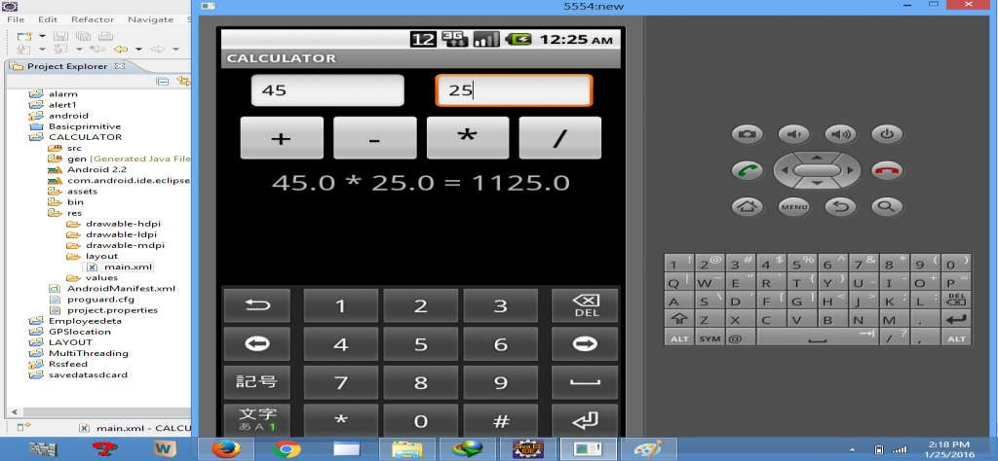

1. **Write an application that draws graphical primitives.**

**Description:**

* 1. Open eclipse or android studio and select new android project
  2. Give project name and select next
  3. Choose the android version.Choose the lowest android version(Android 2.2) and select next
  4. Enter the package name.package name must be two word seprated by comma and click finish
  5. Go to package explorer in the left hand side.select our project.
  6. Go to res folder and select layout.Double click the main.xml file.Don't change anything in layout.Leave as default.
  7. Now select mainactivity.java file and type the following code.

**Source code:**

package Basic.primitive; import android.app.Activity;

import android.content.Context; import android.graphics.Canvas; import android.graphics.Color; import android.graphics.Paint; import android.os.Bundle; import android.view.View;

public class BasicprimitiveActivity extends Activity {

/** Called when the activity is first created. */ @Override

public void onCreate(Bundle savedInstanceState) { super.onCreate(savedInstanceState); setContentView(new myview(this));

}

private class myview extends View

{

public myview(Context context)

{

super(context);

}

@Override

protected void onDraw(Canvas canvas)

{

super.onDraw(canvas); Paint paint=new Paint(); paint.setTextSize(40);

paint.setColor(Color.GREEN);

canvas.drawText("Circle", 55, 30, paint); paint.setColor(Color.RED); canvas.drawCircle(100, 150,100, paint); paint.setColor(Color.GREEN); canvas.drawText("Rectangle", 255, 30, paint); paint.setColor(Color.YELLOW); canvas.drawRect(250, 50,400,350, paint); paint.setColor(Color.GREEN); canvas.drawText("SQUARE", 55, 430, paint); paint.setColor(Color.BLUE); canvas.drawRect(50, 450,150,550, paint); paint.setColor(Color.GREEN); canvas.drawText("LINE", 255, 430, paint); paint.setColor(Color.CYAN); canvas.drawLine(250, 500, 350, 500, paint);

}

}

}

OUTPUT:

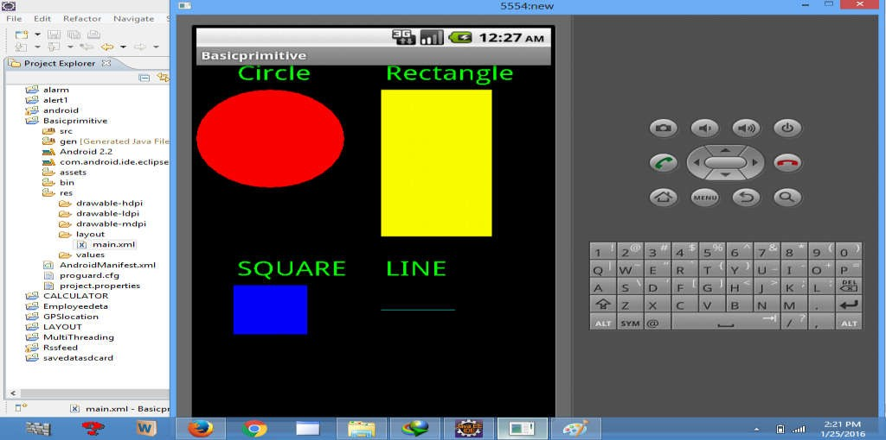

# Develop an application that makes use of database.

**Description:**

1)Open eclipse or android studio and select new android project 2)Give project name and select next

1. Choose the android version.Choose the lowest android version(Android 2.2) and select next
2. Enter the package name.package name must be two word seprated by comma and click finish 5)Go to package explorer in the left hand side.select our project.

6)Go to res folder and select layout.Double click the main.xml file.

**Source code :**

<AbsoluteLayout xmlns:android="<http://schemas.android.com/apk/res/android>" android:id="@+id/myLayout"

android:stretchColumns="0" android:layout_width="fill_parent" android:layout_height="fill_parent">

<TextView android:text="@string/title" android:layout_x="110dp" android:layout_y="10dp" android:layout_width="wrap_content" android:layout_height="wrap_content"/>

<TextView android:text="@string/empid" android:layout_x="30dp" android:layout_y="50dp" android:layout_width="wrap_content" android:layout_height="wrap_content"/>

<EditText android:id="@+id/editEmpid" android:inputType="number" android:layout_x="150dp" android:layout_y="50dp" android:layout_width="150dp" android:layout_height="40dp"/>

<TextView android:text="@string/name" android:layout_x="30dp" android:layout_y="100dp" android:layout_width="wrap_content" android:layout_height="wrap_content"/>

<EditText android:id="@+id/editName" android:inputType="text" android:layout_x="150dp"

<TextView android:text="@string/salary" android:layout_x="30dp" android:layout_y="150dp" android:layout_width="wrap_content" android:layout_height="wrap_content"/>

<EditText android:id="@+id/editsalary" android:inputType="number" android:layout_x="150dp" android:layout_y="150dp" android:layout_width="150dp" android:layout_height="40dp"/>

<Button android:id="@+id/btnAdd" android:text="@string/add" android:layout_x="30dp" android:layout_y="200dp" android:layout_width="130dp" android:layout_height="40dp"/>

<Button android:id="@+id/btnDelete" android:text="@string/delete" android:layout_x="160dp" android:layout_y="200dp" android:layout_width="130dp" android:layout_height="40dp"/>n

<Button android:id="@+id/btnModify" android:text="@string/modify" android:layout_x="30dp" android:layout_y="250dp" android:layout_width="130dp" android:layout_height="40dp"/>

<Button android:id="@+id/btnView" android:text="@string/view" android:layout_x="160dp" android:layout_y="250dp" android:layout_width="130dp" android:layout_height="40dp"/>

<Button android:id="@+id/btnViewAll" android:text="@string/view_all" android:layout_x="85dp"

android:layout_y="300dp" android:layout_width="150dp" android:layout_height="40dp"/>

</AbsoluteLayout>

Go to values folder and select string.xml file.Replace the code below

<?xml version="1.0" encoding="utf-8"?>

<resources>

<string name="app_name">Employee detail1</string>

<string name="hello">Hello World, Employee detail Activity!</string>

<string name="title">Employee Details</string>

<string name="empid">Enter Employee ID: </string>

<string name="name">Enter Name: </string>

<string name="salary">Enter salary: </string>

<string name="add">Add Employee</string>

<string name="delete">Delete Employee</string>

<string name="modify">Modify Employee</string>

<string name="view">View Employee</string>

<string name="view_all">View All Employee</string>

</resources>

8) Now select mainactivity.java file and type the following code.In my coding maniactivity name

is EmployeedetailActivity. package employee.detail;

//import android.R;

import android.app.Activity;

import android.app.AlertDialog.Builder; import android.content.Context;

import android.database.Cursor;

import android.database.sqlite.SQLiteDatabase; import android.os.Bundle;

import android.view.View;

import android.view.View.OnClickListener; import android.widget.Button;

import android.widget.EditText;

public class EmployeedetailActivity extends Activity implements OnClickListener { EditText editEmpid,editName,editsalary;

Button btnAdd,btnDelete,btnModify,btnView,btnViewAll; SQLiteDatabase db;

/** Called when the activity is first created. */ @Override

public void onCreate(Bundle savedInstanceState)

{

super.onCreate(savedInstanceState); setContentView(R.layout.main); editEmpid=(EditText)findViewById(R.id.editEmpid); editName=(EditText)findViewById(R.id.editName); editsalary=(EditText)findViewById(R.id.editsalary); btnAdd=(Button)findViewById(R.id.btnAdd); btnDelete=(Button)findViewById(R.id.btnDelete); btnModify=(Button)findViewById(R.id.btnModify); btnView=(Button)findViewById(R.id.btnView); btnViewAll=(Button)findViewById(R.id.btnViewAll); btnAdd.setOnClickListener(this); btnDelete.setOnClickListener(this); btnModify.setOnClickListener(this); btnView.setOnClickListener(this); btnViewAll.setOnClickListener(this);

db=openOrCreateDatabase("EmployeeDB", Context.MODE_PRIVATE, null); db.execSQL("CREATE TABLE IF NOT EXISTS employee(empid VARCHAR,name VARCHAR,salary VARCHAR);");

}

public void onClick(View view)

{

if(view==btnAdd)

{

if(editEmpid.getText().toString().trim().length()==0|| editName.getText().toString().trim().length()==0|| editsalary.getText().toString().trim().length()==0)

{

showMessage("Error", "Please enter all values"); return;

}

db.execSQL("INSERT INTO employee VALUES('"+editEmpid.getText()+"','"+editName.getText()+ "','"+editsalary.getText()+"');");

showMessage("Success", "Record added"); clearText();

}

if(view==btnDelete)

{

if(editEmpid.getText().toString().trim().length()==0)

{

showMessage("Error", "Please enter Employee id"); return;

}

Cursor c=db.rawQuery("SELECT * FROM employee WHERE empid='"+editEmpid.getText()+"'", null);

if(c.moveToFirst())

{

db.execSQL("DELETE FROM employee WHERE empid='"+editEmpid.getText()+"'"); showMessage("Success", "Record Deleted");

}

else

{

showMessage("Error", "Invalid Employee id");

}

clearText();

}

if(view==btnModify)

{

if(editEmpid.getText().toString().trim().length()==0)

{

showMessage("Error", "Please enter Employee id"); return;

}

Cursor c=db.rawQuery("SELECT * FROM employee WHERE empid='"+editEmpid.getText()+"'", null);

if(c.moveToFirst())

{

db.execSQL("UPDATE employee SET name='"+editName.getText()+"',salary='"+editsalary.getText()+ "' WHERE empid='"+editEmpid.getText()+"'"); showMessage("Success", "Record Modified");

}

else

{

showMessage("Error", "Invalid Rollno");

}

clearText();

}

if(view==btnView)

{

if(editEmpid.getText().toString().trim().length()==0)

{

showMessage("Error", "Please enter Employee id"); return;

}

Cursor c=db.rawQuery("SELECT * FROM employee WHERE empid='"+editEmpid.getText()+"'", null);

if(c.moveToFirst())

{

editName.setText(c.getString(1)); editsalary.setText(c.getString(2));

}

else

{

showMessage("Error", "Invalid Employee id"); clearText();

}

}

if(view==btnViewAll)

{

Cursor c=db.rawQuery("SELECT * FROM employee", null); if(c.getCount()==0)

{

showMessage("Error", "No records found"); return;

}

StringBuffer buffer=new StringBuffer(); while(c.moveToNext())

{

buffer.append("Employee id: "+c.getString(0)+"\n"); buffer.append("Name: "+c.getString(1)+"\n"); buffer.append("salary: "+c.getString(2)+"\n\n");

}

showMessage("Employee details Details", buffer.toString());

}

}

public void showMessage(String title,String message)

{

Builder builder=new Builder(this); builder.setCancelable(true);

builder.setTitle(title); builder.setMessage(message); builder.show();

}

public void clearText()

{

editEmpid.setText(""); editName.setText(""); editsalary.setText(""); editEmpid.requestFocus();

}

}

**OUTPUT**:

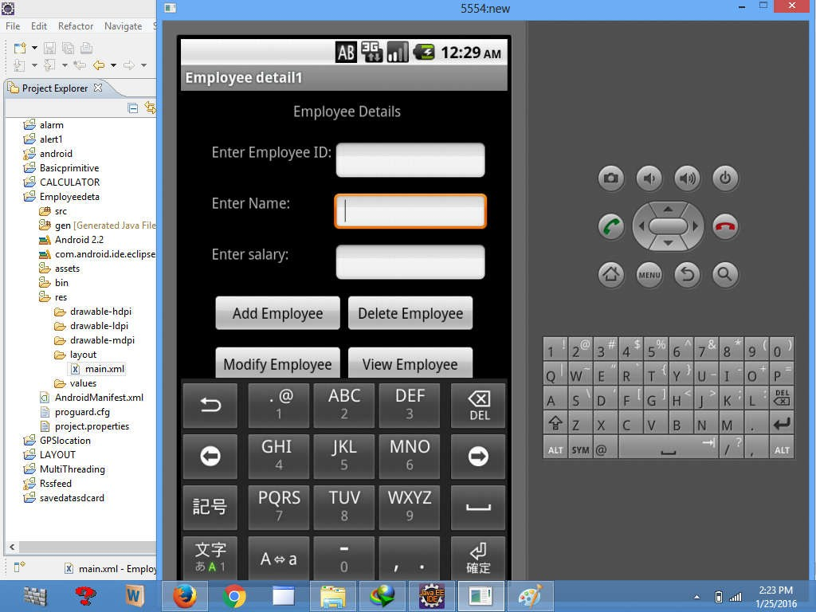

|  |  |  |  |
| --- | --- | --- | --- |
| MOBILE APPLICATION DEVELOPMENT LAB DEPARTMENT OF CS & IT  **6) Develop an application that makes use of RSS Feed.**  **Source code &Steps:**  **RSS** (Rich Site Summary; originally RDF Site Summary; often called Really Simple Syndication) uses a family of standard web **feed** formats to publish frequently updated information: blog entries, news headlines, audio, video.  Open Android Studio and then click on **File -> New -> New project.**  Then type the Application name as “**ex.no.6″** and click **Next.**  Then select the **Minimum SDK** and click **Next**. Then select the **Empty Activity** and click **Next.** Finally click F**inish**.  Designing layout for the Android Application:  Click on **app -> res -> layout -> activity_main.xml**  Then delete the code which is there and type the code as given below.  **Code for Activity_main.xml:** | | |  |
|  | <?xml version="1.0" encoding="utf-8"?>  <LinearLayout xmlns:android="<http://schemas.android.com/apk/res/android>" android:layout_width="fill_parent"  android:layout_height="fill_parent" android:orientation="vertical" >  <ListView android:id="@+id/listView"  android:layout_width="match_parent"  android:layout_height="wrap_content" /> | |  |
|  | ARKA JAIN UNIVERSITY, JAMSHEDPUR | 25 |  |

|  |  |  |  |
| --- | --- | --- | --- |
| MOBILE APPLICATION DEVELOPMENT LAB DEPARTMENT OF CS & IT | | |  |
|  | </LinearLayout> | |  |
| * So now the designing part is completed.   Adding permissions in Manifest for the Android Application:   * Click on **app -> manifests -> AndroidManifest.xml**   + Now include the **INTERNET** permissions in the AndroidManifest.xml file as shown below   **Code for AndroidManifest.xml:** | | |  |
|  | | <?xml version="1.0" encoding="utf-8"?>  <manifest xmlns:android="<http://schemas.android.com/apk/res/android>" package="com.example.exno6" >  ▪  <uses-permission android:name="android.permission.INTERNET"/>  <application android:allowBackup="true" android:icon="@mipmap/ic_launcher" android:label="@string/app_name" android:supportsRtl="true" android:theme="@style/AppTheme" >  <activity android:name=".MainActivity" >  <intent-filter>  <action android:name="android.intent.action.MAIN" />  <category android:name="android.intent.category.LAUNCHER" />  </intent-filter>  </activity>  </application>  </manifest> |  |
| * So now the Permissions are added in the Manifest. Java Coding for the Android Application: * Click on **app -> java -> com.example.exno6 -> MainActivity.**   + Then delete the code which is there and type the code as given below.   ARKA JAIN UNIVERSITY, JAMSHEDPUR 26 | | |  |

|  |  |  |
| --- | --- | --- |
| MOBILE APPLICATION DEVELOPMENT LAB DEPARTMENT OF CS & IT | |  |
|  | package com.example.exno6;  import android.app.ListActivity; import android.content.Intent; import android.net.Uri;  import android.os.AsyncTask; import android.os.Bundle; import android.view.View;  import android.widget.ArrayAdapter; import android.widget.ListView; import org.xmlpull.v1.XmlPullParser;  import org.xmlpull.v1.XmlPullParserException; import org.xmlpull.v1.XmlPullParserFactory; import java.io.IOException;  import java.io.InputStream;  import java.net.MalformedURLException; import java.net.URL;  import java.util.ArrayList; import java.util.List;  public class MainActivity extends ListActivity  {  List headlines; List links;  @Override  protected void onCreate(Bundle savedInstanceState)  {  super.onCreate(savedInstanceState); new MyAsyncTask().execute();  }  class MyAsyncTask extends AsyncTask<Object,Void,ArrayAdapter>  {  @Override  protected ArrayAdapter doInBackground(Object[] params)  {  headlines = new ArrayList(); links = new ArrayList();  try  { |  |
| ARKA JAIN UNIVERSITY, JAMSHEDPUR 27 | |  |

|  |  |  |
| --- | --- | --- |
| MOBILE APPLICATION DEVELOPMENT LAB DEPARTMENT OF CS & IT | |  |
|  | URL url = new URL("<http://www.codingconnect.net/feed>"); XmlPullParserFactory factory = XmlPullParserFactory.newInstance(); factory.setNamespaceAware(false);  XmlPullParser xpp = factory.newPullParser();  // We will get the XML from an input stream xpp.setInput(getInputStream(url), "UTF_8"); boolean insideItem = false;  // Returns the type of current event: START_TAG, END_TAG, etc.. int eventType = xpp.getEventType();  while (eventType != XmlPullParser.END_DOCUMENT)  {  if (eventType == XmlPullParser.START_TAG)  {  if (xpp.getName().equalsIgnoreCase("item"))  {  insideItem = true;  }  else if (xpp.getName().equalsIgnoreCase("title"))  {  if (insideItem)  headlines.add(xpp.nextText()); //extract the headline  }  else if (xpp.getName().equalsIgnoreCase("link"))  {  if (insideItem)  links.add(xpp.nextText()); //extract the link of article  }  }  else if(eventType==XmlPullParser.END_TAG && xpp.getName().equalsIgnoreCase("item"))  {  insideItem=false;  }  eventType = xpp.next(); //move to next element  }  }  catch (MalformedURLException e)  { |  |
| ARKA JAIN UNIVERSITY, JAMSHEDPUR 28 | |  |

|  |  |  |  |
| --- | --- | --- | --- |
| MOBILE APPLICATION DEVELOPMENT LAB | | DEPARTMENT OF CS & IT |  |
|  | e.printStackTrace(); | |  |
| } | |
| catch (XmlPullParserException e) | |
| { | |
| e.printStackTrace(); | |
| } | |
| catch (IOException e) | |
| { | |
| e.printStackTrace(); | |
| } | |
| return null; | |
| } | |
| protected void onPostExecute(ArrayAdapter adapter) | |
| { | |
| adapter = new ArrayAdapter(MainActivity.this, | |
| android.R.layout.simple_list_item_1, headlines); | |
| setListAdapter(adapter); | |
| } | |
| } | |
| @Override | |
| protected void onListItemClick(ListView l, View v, int position, long id) | |
| { | |
| Uri uri = Uri.parse((links.get(position)).toString()); | |
| Intent intent = new Intent(Intent.ACTION_VIEW, uri); | |
| startActivity(intent); | |
| } | |
| public InputStream getInputStream(URL url) | |
| { | |
| try | |
| { | |
| return url.openConnection().getInputStream(); | |
| } | |
| catch (IOException e) | |
| { | |
| return null; | |
| } | |
| } | |
| } | |
| ARKA JAIN UNIVERSITY, JAMSHEDPUR | | 29 |  |

* Now run the application to see the output.

Output:

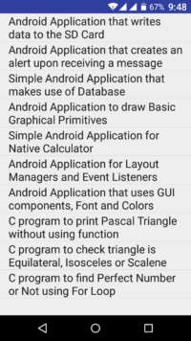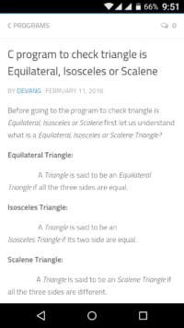

Thus Android Application that makes use of RSS Feed is developed and executed successfully.

**7) Implement an application that implements Multithreading.**

**Description:**

1)Open eclipse or android studio and select new android project 2)Give project name and select next

1. Choose the android version.Choose the lowest android version(Android 2.2) and select next
2. Enter the package name.package name must be two word seprated by comma and click finish 5)Go to package explorer in the left hand side.select our project.
3. Go to res folder and select layout.Double click the main.xml file.

**Source code:**

<LinearLayout xmlns:android="<http://schemas.android.com/apk/res/android>" android:layout_width="match_parent" android:layout_height="match_parent"

android:orientation="vertical" android:id="@+id/info" >

<Button android:id="@+id/button1"

android:layout_width="match_parent" android:layout_height="wrap_content" android:onClick="fetchData" android:text="Start MULTITHREAD" />

<TextView android:id="@+id/textView1" android:layout_width="wrap_content" android:layout_height="wrap_content" android:text="Main thread" />

</LinearLayout>

package multi.threading;

//import your.first.R;

import android.app.Activity; import android.os.Bundle; import android.os.Handler; import android.view.View;

import android.widget.TextView;

public class MultiThreadingActivity extends Activity { private TextView tvOutput;

private static final int t1 = 1; private static final int t2 = 2; private static final int t3 = 3; @Override

public void onCreate(Bundle savedInstanceState) { super.onCreate(savedInstanceState);

setContentView(R.layout.main);

tvOutput = (TextView) findViewById(R.id.textView1);

}

public void fetchData(View v) { tvOutput.setText("Main thread"); thread1.start();

thread2.start(); thread3.start();

}

Thread thread1 = new Thread(new Runnable() { @Override

public void run() {

for (int i = 0; i < 5; i++) { try {

Thread.sleep(1000);

} catch (InterruptedException e) { e.printStackTrace();

}

handler.sendEmptyMessage(t1);

}

}

});

Thread thread2 = new Thread(new Runnable() { @Override

public void run() {

for (int i = 0; i < 5; i++) { try {

Thread.sleep(1000);

} catch (InterruptedException e) { e.printStackTrace();

}

handler.sendEmptyMessage(t2);

}

}

});

Thread thread3 = new Thread(new Runnable() { @Override

public void run() {

for (int i = 0; i < 5; i++) { try {

Thread.sleep(1000);

} catch (InterruptedException e) { e.printStackTrace();

}

handler.sendEmptyMessage(t3);

}

}

});

Handler handler = new Handler() {

public void handleMessage(android.os.Message msg) { if(msg.what == t1) {

tvOutput.append("\nIn thread 1");

}

if(msg.what == t2) { tvOutput.append("\nIn thread 2");

}

if(msg.what == t3) { tvOutput.append("\nIn thread 3");

}

} }; }

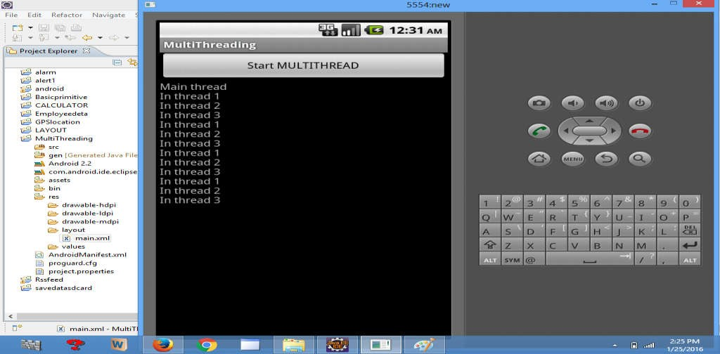

* 1. **Develop an application tha uses GPS location information.**

**Description:**

* + 1. Open eclipse or android studio and select new android project
    2. Give project name and select next
    3. Choose the android version.Choose the lowest android version(Android 2.2) and select next
    4. Enter the package name.package name must be two word seprated by comma and click finish 5)Go to package explorer in the left hand side.select our project.

6)Go to res folder and select layout.Double click the main.xml file.Add the code

**Source code:**

<RelativeLayout xmlns:android="<http://schemas.android.com/apk/res/android>" android:id="@+id/relativeLayout1"

android:layout_width="match_parent" android:layout_height="match_parent" >

<Button android:id="@+id/show_Location" android:layout_width="wrap_content" android:layout_height="wrap_content android:text="Show_Location" android:layout_centerVertical="true" android:layout_centerHorizontal="true"

/>

</RelativeLayout>

package gps.location;

//import android.R;

import android.app.Activity; import android.os.Bundle; import android.view.View; import android.widget.Button; import android.widget.Toast;

public class GPSlocationActivity extends Activity {

/** Called when the activity is first created. */ Button btnShowLocation;

GPStrace gps; @Override

public void onCreate(Bundle savedInstanceState) { super.onCreate(savedInstanceState); setContentView(R.layout.main); btnShowLocation=(Button)findViewById(R.id.show_Location);

btnShowLocation.setOnClickListener(new View.OnClickListener() { @Override

public void onClick(View v) {

// TODO Auto-generated method stub gps=new GPStrace(GPSlocationActivity.this); if(gps.canGetLocation()){

double latitude=gps.getLatitude(); double longitude=gps.getLongtiude();

Toast.makeText(getApplicationContext(),"Your Location is

\nLat:"+latitude+"\nLong:"+longitude, Toast.LENGTH_LONG).show();

}

else

{

gps.showSettingAlert();

}

} }); } }

)Go to src folder and Right Click on your package folder and choose new class and give the class nams as GPStrace

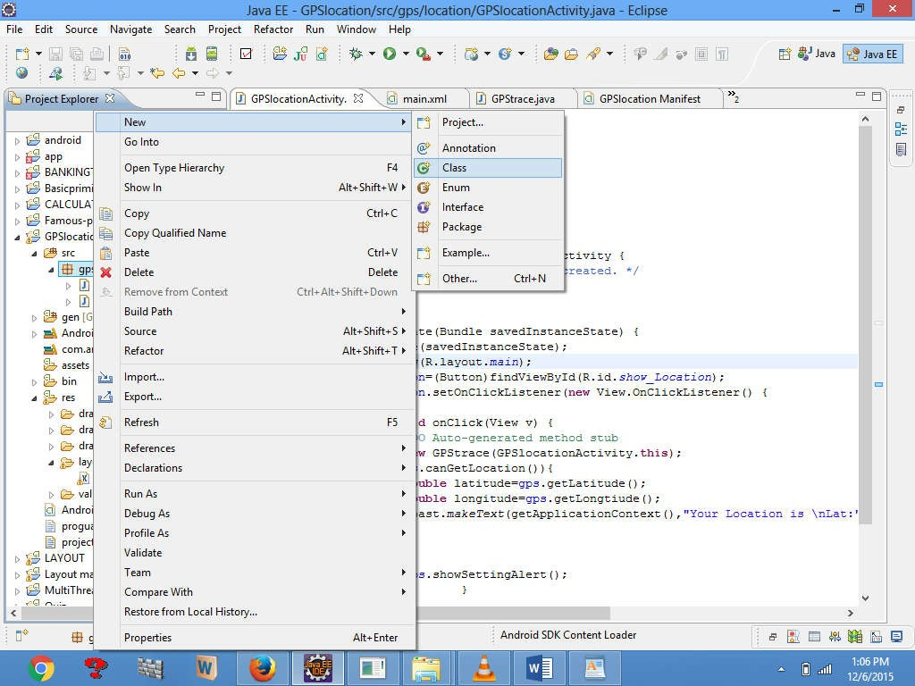

* 1. Select the GPStrace.java file and paste the following code. package gps.location;

import android.app.AlertDialog; import android.app.Service; import android.content.Context;

import android.content.DialogInterface; import android.content.Intent;

import android.location.Location;

import android.location.LocationListener; import android.location.LocationManager; import android.os.Bundle;

import android.os.IBinder; import android.provider.Settings;

public class GPStrace extends Service implements LocationListener{ private final Context context;

boolean isGPSEnabled=false; boolean canGetLocation=false; boolean isNetworkEnabled=false; Location location;

double latitude; double longtitude;

private static final long MIN_DISTANCE_CHANGE_FOR_UPDATES=10; private static final long MIN_TIME_BW_UPDATES=1000*60*1;

protected LocationManager locationManager; public GPStrace(Context context)

{

this.context=context; getLocation();

}

public Location getLocation()

{

try{

locationManager=(LocationManager) context.getSystemService(LOCATION_SERVICE); isGPSEnabled=locationManager.isProviderEnabled(LocationManager.GPS_PROVIDER); isNetworkEnabled=locationManager.isProviderEnabled(LocationManager.NETWORK_PRO VI

DER);

if(!isGPSEnabled && !isNetworkEnabled){

}else{ this.canGetLocation=true; if(isNetworkEnabled){

locationManager.requestLocationUpdates( LocationManager.NETWORK_PROVIDER, MIN_TIME_BW_UPDATES, MIN_DISTANCE_CHANGE_FOR_UPDATES,this);

}

if(locationManager!=null){ location=locationManager.getLastKnownLocation(LocationManager.NETWORK_PROVID ER)

;

if(location !=null){ latitude=location.getLatitude(); longtitude=location.getLongitude();

}

}

}

if(isGPSEnabled){ if(location==null){

locationManager.requestLocationUpdates(LocationManager.GPS_PROVIDER,MIN_TIME_ B

W_UPDATES, MIN_DISTANCE_CHANGE_FOR_UPDATES, this);

if(locationManager!=null){ location=locationManager.getLastKnownLocation(LocationManager.GPS_PROVIDER); if(location!=null){

latitude=location.getLatitude(); longtitude=location.getLongitude();

}

}

}

}

}

catch(Exception e)

{

e.printStackTrace();

}

return location;

}

public void stopUsingGPS(){ if(locationManager!=null){ locationManager.removeUpdates(GPStrace.this);

}

}

public double getLatitude(){ if(location!=null){ latitude=location.getLatitude();

}

return latitude;

}

public double getLongtiude(){ if(location!=null){ longtitude=location.getLatitude();

}

return longtitude;

}

public boolean canGetLocation(){ return this.canGetLocation;

}

public void showSettingAlert(){

AlertDialog.Builder alertDialog=new AlertDialog.Builder(context); alertDialog.setTitle("GPS is settings");

alertDialog.setMessage("GPS is not enabled.Do you want to go to setting menu?");

alertDialog.setPositiveButton("settings", new DialogInterface.OnClickListener() { @Override

public void onClick(DialogInterface dialog,int which){

Intent intent=new Intent(Settings.ACTION_LOCATION_SOURCE_SETTINGS); context.startActivity(intent);

}

});

alertDialog.setNegativeButton("cancel", new DialogInterface.OnClickListener() { @Override

public void onClick(DialogInterface dialog, int which) {

// TODO Auto-generated method stub dialog.cancel();

}

});

alertDialog.show();

}

@Override

public void onLocationChanged(Location location) {

// TODO Auto-generated method stub

}

@Override

public void onProviderDisabled(String provider) {

// TODO Auto-generated method stub

}

@Override

public void onProviderEnabled(String provider) {

// TODO Auto-generated method stub

}

@Override

public void onStatusChanged(String provider, int status, Bundle extras) {

// TODO Auto-generated method stub

}

@Override

public IBinder onBind(Intent intent) {

// TODO Auto-generated method stub return null;

}

}

* 1. Go to manifest.xml file and add the code below

<uses-permission android:name="android.permission.ACCESS_FINE_LOCATION"/>

<uses-permission android:name="android.permission.INTERNET"/>

* Now go to main.xml and right click .select run as option and select run configuration
* Android output is present in the android emulator as shown in below.

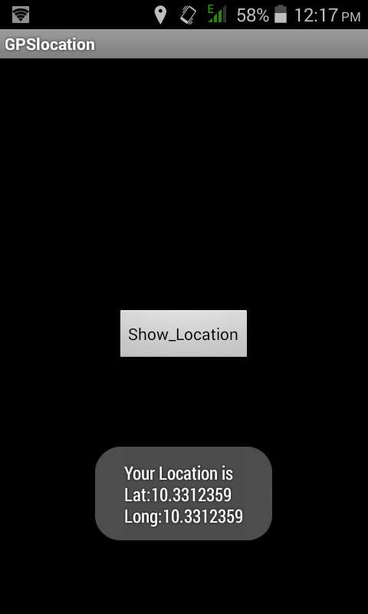

# 9) Implement an application that creates an alert upon receiving a message in Android.

**Description:**

1)Open eclipse or android studio and select new android project 2)Give project name and select next

1. Choose the android version.Choose the lowest android version(Android 2.2) and select next
2. Enter the package name.package name must be two word seprated by comma and click finish 5)Go to package explorer in the left hand side.select our project.
3. Go to res folder and select layout.Double click the main.xml file.Add the code

**Source code:**

<ScrollView xmlns:android="<http://schemas.android.com/apk/res/android>" android:layout_width="fill_parent"

android:layout_height="wrap_content" android:scrollbars="vertical" >

<TableLayout android:layout_width="match_parent" android:layout_height="wrap_content"

android:shrinkColumns="*" android:stretchColumns="*" android:background="#000000">

<TableRow android:layout_height="wrap_content" android:layout_width="match_parent" android:gravity="center_horizontal">

<TextView android:id="@+id/Title" android:layout_width="fill_parent"

android:layout_height="wrap_content" android:layout_margin="5px" android:focusable="false" android:focusableInTouchMode="false" android:gravity="center_vertical|center_horizontal" android:text="QUIZ"

android:textSize="25sp" android:textStyle="bold" />

<View android:layout_height="2px" android:layout_marginTop="5dip"

android:layout_marginBottom="5dip" android:background="#DDFFDD"/>

</TableRow>

<TableRow android:layout_height="wrap_content" android:layout_width="match_parent" android:gravity="center_horizontal">

<TextView android:layout_width="match_parent" android:layout_height="wrap_content" android:textSize="18sp" android:text="1.CAPTIAL OF INDIA" android:layout_span="4" android:padding="18dip" android:textColor="#ffffff"/>

</TableRow>

<TableRow android:id="@+id/tableRow1" android:layout_height="wrap_content" android:layout_width="match_parent">

<RadioGroup android:id="@+id/answer1" android:layout_width="match_parent" android:layout_height="wrap_content" android:layout_weight="0.4" >

<RadioButton android:id="@+id/answer1A" android:layout_width="match_parent" android:layout_height="wrap_content" android:textColor="#ffffff" android:text="CHENNAI" />

<RadioButton android:id="@+id/answer1B" android:layout_width="match_parent" android:layout_height="wrap_content" android:textColor="#ffffff" android:text="NEW DELHI" />

<RadioButton android:id="@+id/answer1C" android:layout_width="match_parent" android:layout_height="wrap_content" android:textColor="#ffffff" android:text="MUMBAI" />

<RadioButton

android:id="@+id/answer1D" android:layout_width="match_parent" android:layout_height="wrap_content" android:textColor="#ffffff" android:text="HYDERBAD" />

</RadioGroup>

</TableRow>

<TableRow android:layout_height="wrap_content" android:layout_width="match_parent" android:gravity="center_horizontal">

<TextView

android:layout_width="match_parent" android:layout_height="wrap_content" android:textSize="18sp"

android:text="2. CAPTIAL OF RUSSIA?" android:layout_span="4" android:padding="18dip"

android:textColor="#ffffff"/>

</TableRow>

<TableRow android:id="@+id/tableRow2" android:layout_height="wrap_content" android:layout_width="match_parent">

<RadioGroup android:id="@+id/answer2" android:layout_width="match_parent" android:layout_height="wrap_content" android:layout_weight="0.4" >

<RadioButton android:id="@+id/answer2A" android:layout_width="match_parent" android:layout_height="wrap_content" android:textColor="#ffffff" android:text="WARSAW " />

<RadioButton android:id="@+id/answer2B" android:layout_width="match_parent" android:layout_height="wrap_content" android:textColor="#ffffff" android:text="BERLIN" />

<RadioButton android:id="@+id/answer2C"

android:layout_width="match_parent" android:layout_height="wrap_content" android:textColor="#ffffff" android:text="MASCOW " />

<RadioButton android:id="@+id/answer2D" android:layout_width="match_parent" android:layout_height="wrap_content" android:textColor="#ffffff" android:text="CANEBRA " />

</RadioGroup>

</TableRow>

<TableRow

<Button android:id="@+id/submit"

android:layout_width="wrap_content" android:layout_height="wrap_content" android:gravity="center" android:text="Submit" />

</TableRow>

</TableLayout>

</ScrollView>

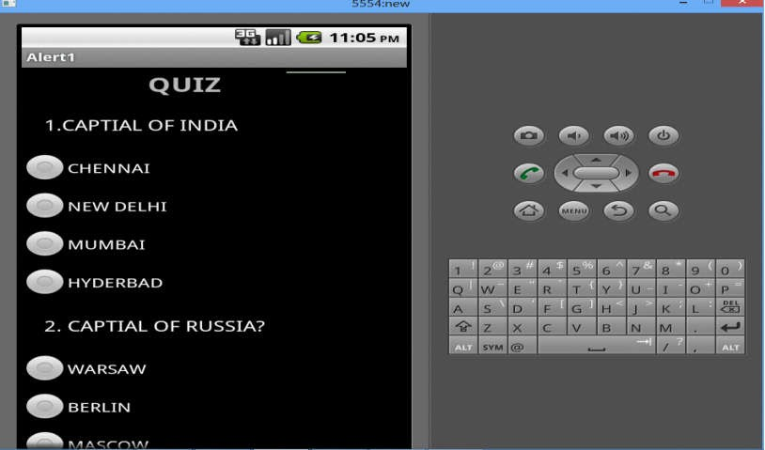

# Write a mobile application that creates alarm clock

**Source code :**

# AndroidManifest.xml

We need to give uses-permission for WAKE_LOCK, other than that the AndroidManifest.xml is

pretty standard one. Just need to include the service and receiver.

<?xml version="1.0" encoding="utf-8"?>

<manifest xmlns:android="<http://schemas.android.com/apk/res/android>" package="com.javapapers.androidalarmclock">

<uses-permission android:name="android.permission.WAKE_LOCK" />

<application android:allowBackup="true" android:icon="@drawable/ic_launcher" android:label="@string/app_name" android:theme="@style/AppTheme">

<activity android:name=".AlarmActivity" android:label="@string/app_name">

<intent-filter>

<action android:name="android.intent.action.MAIN" />

<category android:name="android.intent.category.LAUNCHER" />

</intent-filter>

</activity>

<service android:name=".AlarmService" android:enabled="true" />

<receiver android:name=".AlarmReceiver" />

</application>

</manifest>

# 2. Android Activity activity_my.xml

The Android Activity is designed to be simple. We have a TimePicker component followed by a

ToggleButton. That’s it. Choose the time to set the alarm and toggle the switch to on. The alarm

will work.

<RelativeLayout xmlns:android="<http://schemas.android.com/apk/res/android>" xmlns:tools="<http://schemas.android.com/tools>"

android:layout_width="match_parent" android:layout_height="match_parent" android:paddingLeft="@dimen/activity_horizontal_margin" android:paddingRight="@dimen/activity_horizontal_margin" android:paddingTop="@dimen/activity_vertical_margin" android:paddingBottom="@dimen/activity_vertical_margin" tools:context=".MyActivity">

<TimePicker android:layout_width="wrap_content" android:layout_height="wrap_content" android:id="@+id/alarmTimePicker" android:layout_alignParentTop="true" android:layout_centerHorizontal="true" />

<ToggleButton android:layout_width="wrap_content" android:layout_height="wrap_content" android:text="Alarm On/Off" android:id="@+id/alarmToggle" android:layout_centerHorizontal="true" android:layout_below="@+id/alarmTimePicker" android:onClick="onToggleClicked" />

<TextView android:layout_width="wrap_content" android:layout_height="wrap_content"

android:textAppearance="?android:attr/textAppearanceLarge" android:text=""

android:id="@+id/alarmText" android:layout_alignParentBottom="true" android:layout_centerHorizontal="true" android:layout_marginTop="20dp" android:layout_below="@+id/alarmToggle" />

</RelativeLayout>

# AlarmActivity.java

AlarmActivity uses the AlarmManager to set the alarm and send notification on alarm trigger. package com.javapapers.androidalarmclock;

import android.app.Activity; import android.app.AlarmManager; import android.app.PendingIntent; import android.content.Intent; import android.os.Bundle;

import android.util.Log;

import android.view.View; import android.widget.TextView;

import android.widget.TimePicker; import android.widget.ToggleButton; import java.util.Calendar;

public class AlarmActivity extends Activity { AlarmManager alarmManager;

private PendingIntent pendingIntent; private TimePicker alarmTimePicker; private static AlarmActivity inst; private TextView alarmTextView; public static AlarmActivity instance() { return inst;

}

@Override

public void onStart() { super.onStart();

inst = this;

}

@Override

protected void onCreate(Bundle savedInstanceState) { super.onCreate(savedInstanceState); setContentView(R.layout.activity_my);

alarmTimePicker = (TimePicker) findViewById(R.id.alarmTimePicker); alarmTextView = (TextView) findViewById(R.id.alarmText); ToggleButton alarmToggle = (ToggleButton) findViewById(R.id.alarmToggle);

alarmManager = (AlarmManager) getSystemService(ALARM_SERVICE);

}

public void onToggleClicked(View view) { if (((ToggleButton) view).isChecked()) { Log.d("MyActivity", "Alarm On"); Calendar calendar = Calendar.getInstance(); calendar.set(Calendar.HOUR_OF_DAY, alarmTimePicker.getCurrentHour()); calendar.set(Calendar.MINUTE, alarmTimePicker.getCurrentMinute());

Intent myIntent = new Intent(AlarmActivity.this, AlarmReceiver.class);

pendingIntent = PendingIntent.getBroadcast(AlarmActivity.this, 0, myIntent, 0);

alarmManager.set(AlarmManager.RTC, calendar.getTimeInMillis(), pendingIntent);

} else { alarmManager.cancel(pendingIntent); setAlarmText(""); Log.d("MyActivity", "Alarm Off");

}

}

public void setAlarmText(String alarmText) { alarmTextView.setText(alarmText);

}

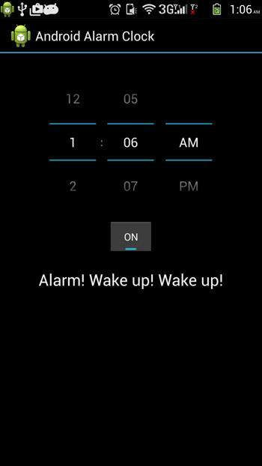} OUTPUT:

* 1. **Implement an application that writes data to the SD card.**

**Decription:**

* + 1. Open eclipse or android studio and select new android project 2)Give project name and select next

1. Choose the android version.Choose the lowest android version(Android 2.2) and select next
2. Enter the package name.package name must be two word seprated by comma and click finish 5)Go to package explorer in the left hand side.select our project.
3. Go to res folder and select layout.Double click the main.xml file.Add the code .

**Source code:**

<LinearLayout xmlns:android="<http://schemas.android.com/apk/res/android>" android:layout_width="fill_parent"

android:layout_height="fill_parent" android:background="#ff0000ff" android:orientation="vertical" >

<EditText android:id="@+id/editText1" android:layout_width="match_parent"

android:layout_height="wrap_content" >

<requestFocus />

</EditText>

<Button android:id="@+id/button1"

android:layout_width="match_parent" android:layout_height="wrap_content" android:text="SAVE DATA" />

<Button android:id="@+id/button2"

android:layout_width="match_parent" android:layout_height="wrap_content" android:text="SHOW DATA" />

<TextView android:id="@+id/textView1" android:layout_width="wrap_content" android:layout_height="wrap_content"

/>

</LinearLayout>

1. Now select mainactivity.java file and type the following code. package save.sd;

import java.io.File;

import java.io.FileInputStream;

import java.io.FileNotFoundException;

import java.io.FileOutputStream; import java.io.IOException; import java.io.InputStreamReader;

import java.io.OutputStreamWriter; import android.app.Activity; import android.os.Bundle;

import android.os.Environment; import android.view.View; import android.widget.Button; import android.widget.EditText; import android.widget.TextView; import android.widget.Toast;

public class SavedatasdcardActivity extends Activity {

/** Called when the activity is first created. */ Button save,load;

EditText message; TextView t1; String Message1; @Override

public void onCreate(Bundle savedInstanceState) { super.onCreate(savedInstanceState); setContentView(R.layout.main);

save=(Button) findViewById(R.id.button1); load=(Button) findViewById(R.id.button2); message=(EditText) findViewById(R.id.editText1); t1=(TextView) findViewById(R.id.textView1); save.setOnClickListener(new View.OnClickListener(){ public void onClick(View v){

//Get message from user store in message1 variable Message1 =message.getText().toString();

try{

//Create a new folder called MyDirectory in SDCard

File sdcard=Environment.getExternalStorageDirectory();

File directory=new File(sdcard.getAbsolutePath()+"/MyDirectory"); directory.mkdirs();

//Create a new file name textfile.txt inside MyDirectory File file=new File(directory,"textfile.txt");

//Create File Outputstream to read the file FileOutputStream fou=new FileOutputStream(file); OutputStreamWriter osw=new OutputStreamWriter(fou); try{

//write a user data to file osw.append(Message1); osw.flush();

osw.close(); Toast.makeText(getBaseContext(),"Data Saved",Toast.LENGTH_LONG).show();

}catch(IOException e){ e.printStackTrace();

}

}catch (FileNotFoundException e){ e.printStackTrace();

}

}

});

load.setOnClickListener(new View.OnClickListener(){ public void onClick(View v){

try{

File sdcard=Environment.getExternalStorageDirectory();

File directory=new File(sdcard.getAbsolutePath()+"/MyDirectory"); File file=new File(directory,"textfile.txt");

FileInputStream fis=new FileInputStream(file); InputStreamReader isr=new InputStreamReader(fis); char[] data=new char[100];

String final_data=""; int size;

try{ while((size=isr.read(data))>0)

{

//read a data from file

String read_data=String.copyValueOf(data,0,size); final_data+=read_data;

data=new char[100];

}

//display the data in output Toast.makeText(getBaseContext(),"Message:"+final_data,Toast.LENGTH_LONG).show();

}catch(IOException e){ e.printStackTrace();

}

}catch (FileNotFoundException e){ e.printStackTrace();

}

}

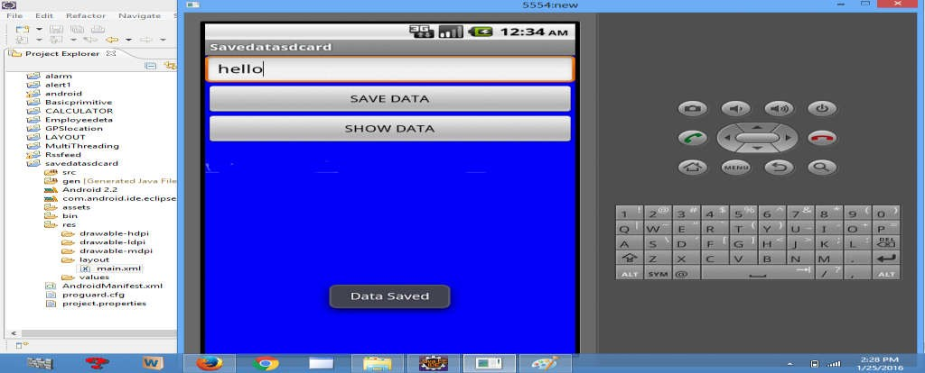}); } } OUTPUT:

