**Ankit Kumar**

**056-266932**

**Final Project – DWD**

**Method 1: Front-end WordPress Post Submissions with WPForms**

* This method allows your users to submit posts from the front-end of your website without visiting the admin area of your WordPress site. You can even accept blog posts from users without asking them to register.
* First thing you need to do is installing and activate the WPForms plugin. For more details, see our step by step guide on how to install a WordPress plugin.
* WPForms is a premium WordPress forms plugin. You will need the Pro version of the plugin to access the post submissions add-on.
* 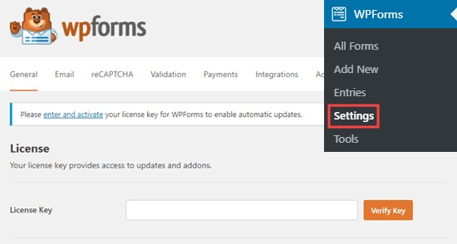Upon activation, you need to visit WPForms » Settings page to enter your license key. You can get this key from your account on the WPForms website.
* Once you’ve entered the key, click the ‘Verify Key’ button.

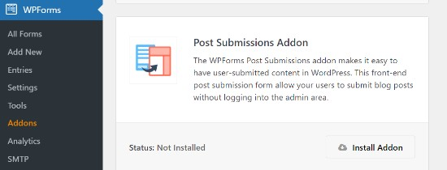After verification, you need to visit WPForms » Add-ons page. Scroll down to ‘Post submissions add-on’ and click on the ‘Install Add-on’ button.

WPForms will now install and activate the post submissions addon for you. You will see the Status as active when it’s installed.

Now, you are ready to create a post submission form on your website.

To start, simply go to WPForms » Add New page, which will launch WPForm’s form builder interface.

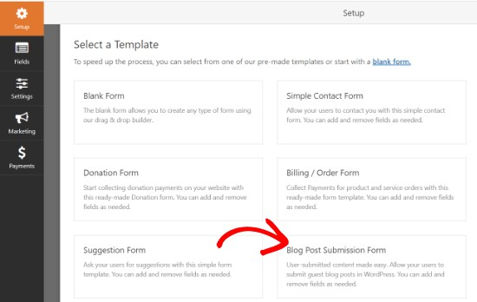First, you need to provide a name for your form and then select the ‘Blog Post Submission Form’ template under the Select a Template section.

WPForms will now load the form template in its form builder.

You can add new fields from the panel on your left, remove existing fields, and rearrange their order using the drag and drop builder.

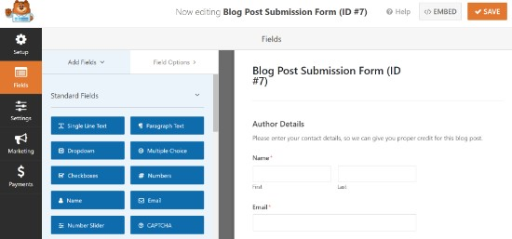

WPForms let your users select post categories, add featured images, post excerpts, and even add custom fields.

You can also edit form fields by clicking on them. This will give you options to rename a field, change its format, add a description, edit its size, enable conditional logic, and more.

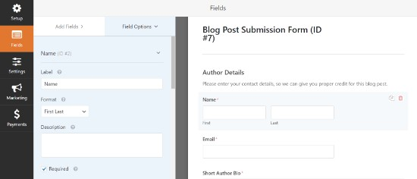

Once you are satisfied with the form, click on the Settings tab in the left menu.

Under the ‘General’ settings, you can rename your form, add a description, edit the text of the submit button, and enable dynamic fields, enable AJAX form submission, and more.

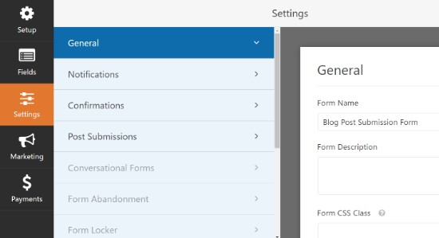By default, WPForms will enable the option of anti-spam protection. This is because it helps prevent people from submitting spam blog posts. However, you can disable this option from the General settings tab.

Next, you can go to the ‘Notifications’ tab and edit the email on which you’ll receive a notification when someone submits a form.

WPForms will use your admin email as default. You can change that to any other email, and if you’d like to receive notifications on multiple emails, then simply separate them using a comma.

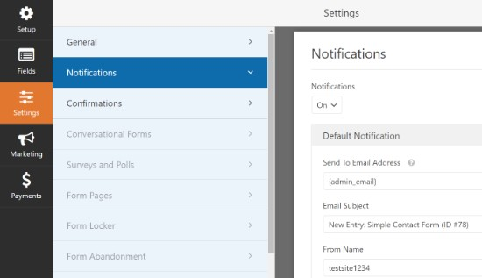

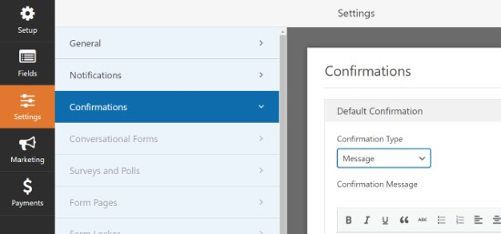After that, go to the ‘Confirmations’ tab to set up a message your users will see when they submit a form. You can show a message, show a page, or direct users to a specific URL.

In the ‘Post Submissions’ tab, you can map each field to the respective post fields in WordPress. WPForms does an excellent job at matching the fields in the form template.

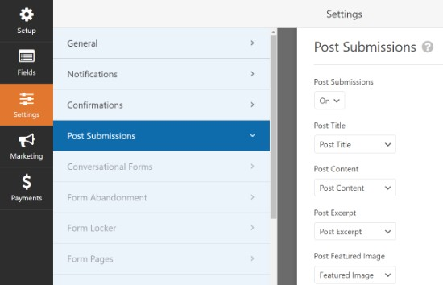By default, user-submitted posts will be saved as ‘Drafts’ pending review. However, you can also change the post type and allow users to submit content to your custom post types.

After that, don’t forget to click on the ‘Save’ button at the top right corner of the screen to save your form.

Now, you can click the close button to exit the form builder and add the form to your website. You can create a new page or edit an existing one. To start, go to your WordPress editor and then click the plus (+) button at the top to add a WPForms block on your page.

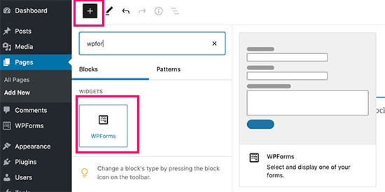

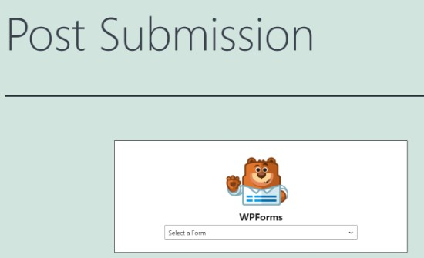Next, you can select your post submission form from the dropdown in the WPForms block.

Now, save or publish your page and then visit your website to see the post submission form in action.

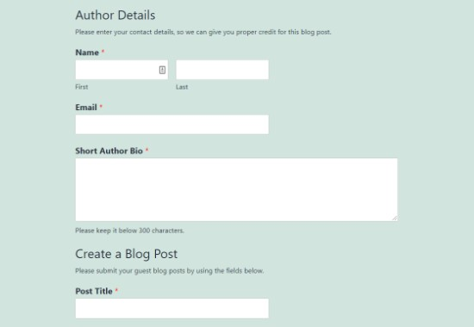

**Method 2: Accept User-Generated Content with User Submitted Posts Plugin**

Another way to accept user-submitted content on your website is by using the User Submitted Posts plugin.

First thing you need to do is installing and activate the User Submitted Posts plugin. For more details, see our step by step guide on how to install a WordPress plugin.

Upon activation, you need to visit Settings » User Submitted Posts and go to the Plugin Settings to configure the plugin.

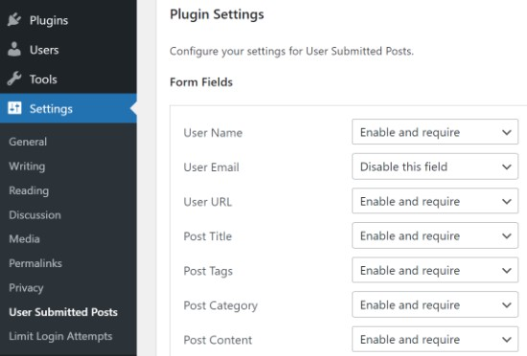

Under the Plugin Settings, you can select the fields you want to display on the post submission form and hide any field you don’t want users to see.

You can choose a default author for all user-submitted content. However, we recommend that you create a new Guest User on your WordPress site and assign all user-submitted posts to that user.

You can also allow users to upload images and set a limit on the number of images and maximum image size. You can even set a user uploaded image as the featured image.

After reviewing all plugin settings, click on the Save Settings button to store your changes.

You are now ready to add the user-submitted posts form to your website.

Simply create a new page in WordPress or edit an existing page where you would like to show the form. In the WordPress block editor, simply add a short code block and then enter this short code:

[user-submitted-posts]

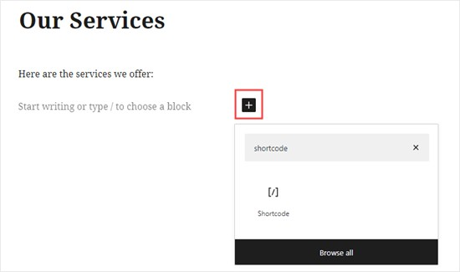

You can now save or publish your page and visit the page to see your user-submitted posts form in action.

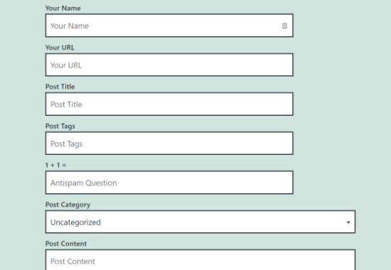

**Method 3: Allowing Users to Register and Submit Posts in WordPress:**

WordPress comes with built in user roles and capabilities which allow you to run a multi-author WordPress site.

You can allow users to register on your site and create content using WordPress admin interface with limited capabilities.

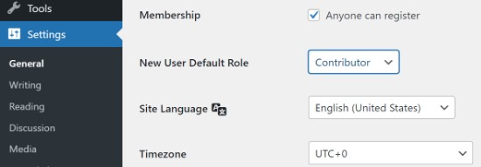First you need to enable user registration on your site. Go to Settings » General page and check ‘Any one can register’ next to Membership option. Choose ‘Author’ or ‘Contributor’ as the default user role.

Don’t forget to click on the ‘Save Changes’ button to store your changes.

Users can now register on your WordPress site by visiting the WordPress login and registration pages. You can even create custom user registration form in WordPress.

Once registered, users can log in to your WordPress site and submit posts.