e-COMMERCE

speed
Security
Which problem solve
Real world example
Who uses
diagram

E-commerce Trade Cycle
- Sabse pehle products ko online search karna.
- Prices compare karna aur reviews padhna.
- Jo pasand aaye usko cart mein add karna.
- Online secure payment karna.
- Order confirm hone ke baad receipt milti hai.
- Product ko achhe se pack karke ship kiya jata hai.
- Delivery status ko track karte rehna.
- Product receive karna aur quality check karna.
- Zarurat pade toh return ya exchange ka option hota hai.
- Aur purchase ke baad feedback aur review dena

How does m-commerce differ from e-commerce ? Explain the various technology components that help to perform commerce transactions using mobile devices
M-Commerce aur E-Commerce mein Antar (Difference):
E-Commerce = Computer se online shopping.
M-Commerce = Mobile se shopping aur payment.
Feature | E-Commerce | M-Commerce
Device | Computer/Laptop par hota hai | Mobile phone ya tablet par hota hai
Mobility | Kam mobility – fixed jagah se access hota hai | High mobility – kahin se bhi access kar sakte ho
Technology | Website aur web browser use karta hai | Mobile apps, QR code, NFC, SMS use karta hai
Internet | Internet zaroori hai | Internet, SMS, ya USSD ke through bhi ho sakta hai
Screen Size | Badi screen ke liye optimized hota hai | Chhoti screen aur touch ke liye optimized hota hai
Examples | Amazon/Flipkart website on laptop | Paytm app, Google Pay, Amazon app on mobile
M-Commerce ke kaam mein aane wale main technology tools:
- Mobile Phone/Tablet – Transaction isi device se hota hai.
- Mobile Apps – Amazon, Paytm, Flipkart jaise apps.
- Internet / Network – 4G, 5G, Wi-Fi ya Bluetooth ka use hota hai
- QR Code & NFC – Scan ya tap karke payment karte hain.
- Mobile Wallet – Paytm Wallet, PhonePe wallet mein paisa store kar sakte hain.
- OTP & Fingerprint – Security ke liye use hota hai.
- SMS/USSD – Internet ke bina bhi payment possible (e.g. *99#).
- Cloud & Payment Gateway – Fast aur secure transaction ke liye backend mein kaam karte hain

Explain the two categories into whom search engines were classified?
1. Crawler-based Search Engine
- Ye automatic software (crawler) use karte hain jo websites ko scan karta hai.
- Jo data milta hai, usse search engine save karta h
- Jab aap kuch search karte ho, to ye wahi data dikhata h
🟢 Example: Google, Bing
Yeh search engines software bots (crawlers/spiders) ka use karte hain jo automatically websites ko visit karte hain aur unki information ko index kar lete hain
2. Human-powered Directory
- Isme log (humans) manually websites ko check karke category mein daalte hain.
- Search results humans ke banaye gaye list par depend karte hain.
🟢 Example: DMOZ, purana Yahoo Directory

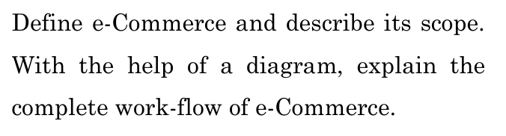
e-Commerce (Internet commerce)
- internet se goods aur services kharidna ya bechna.
- e-commerce me kapde, mobile, gadgets, grocery, or services sab kuch online milta h
- e-Commerce me payment aur data transfer bhi hota h
- Example: amazon, flipkart se log online products kharidte aur bechte hain.
- e-Commerce alag-alag business models ko cover karta h : B2B, B2C, C2C, G2B, etc
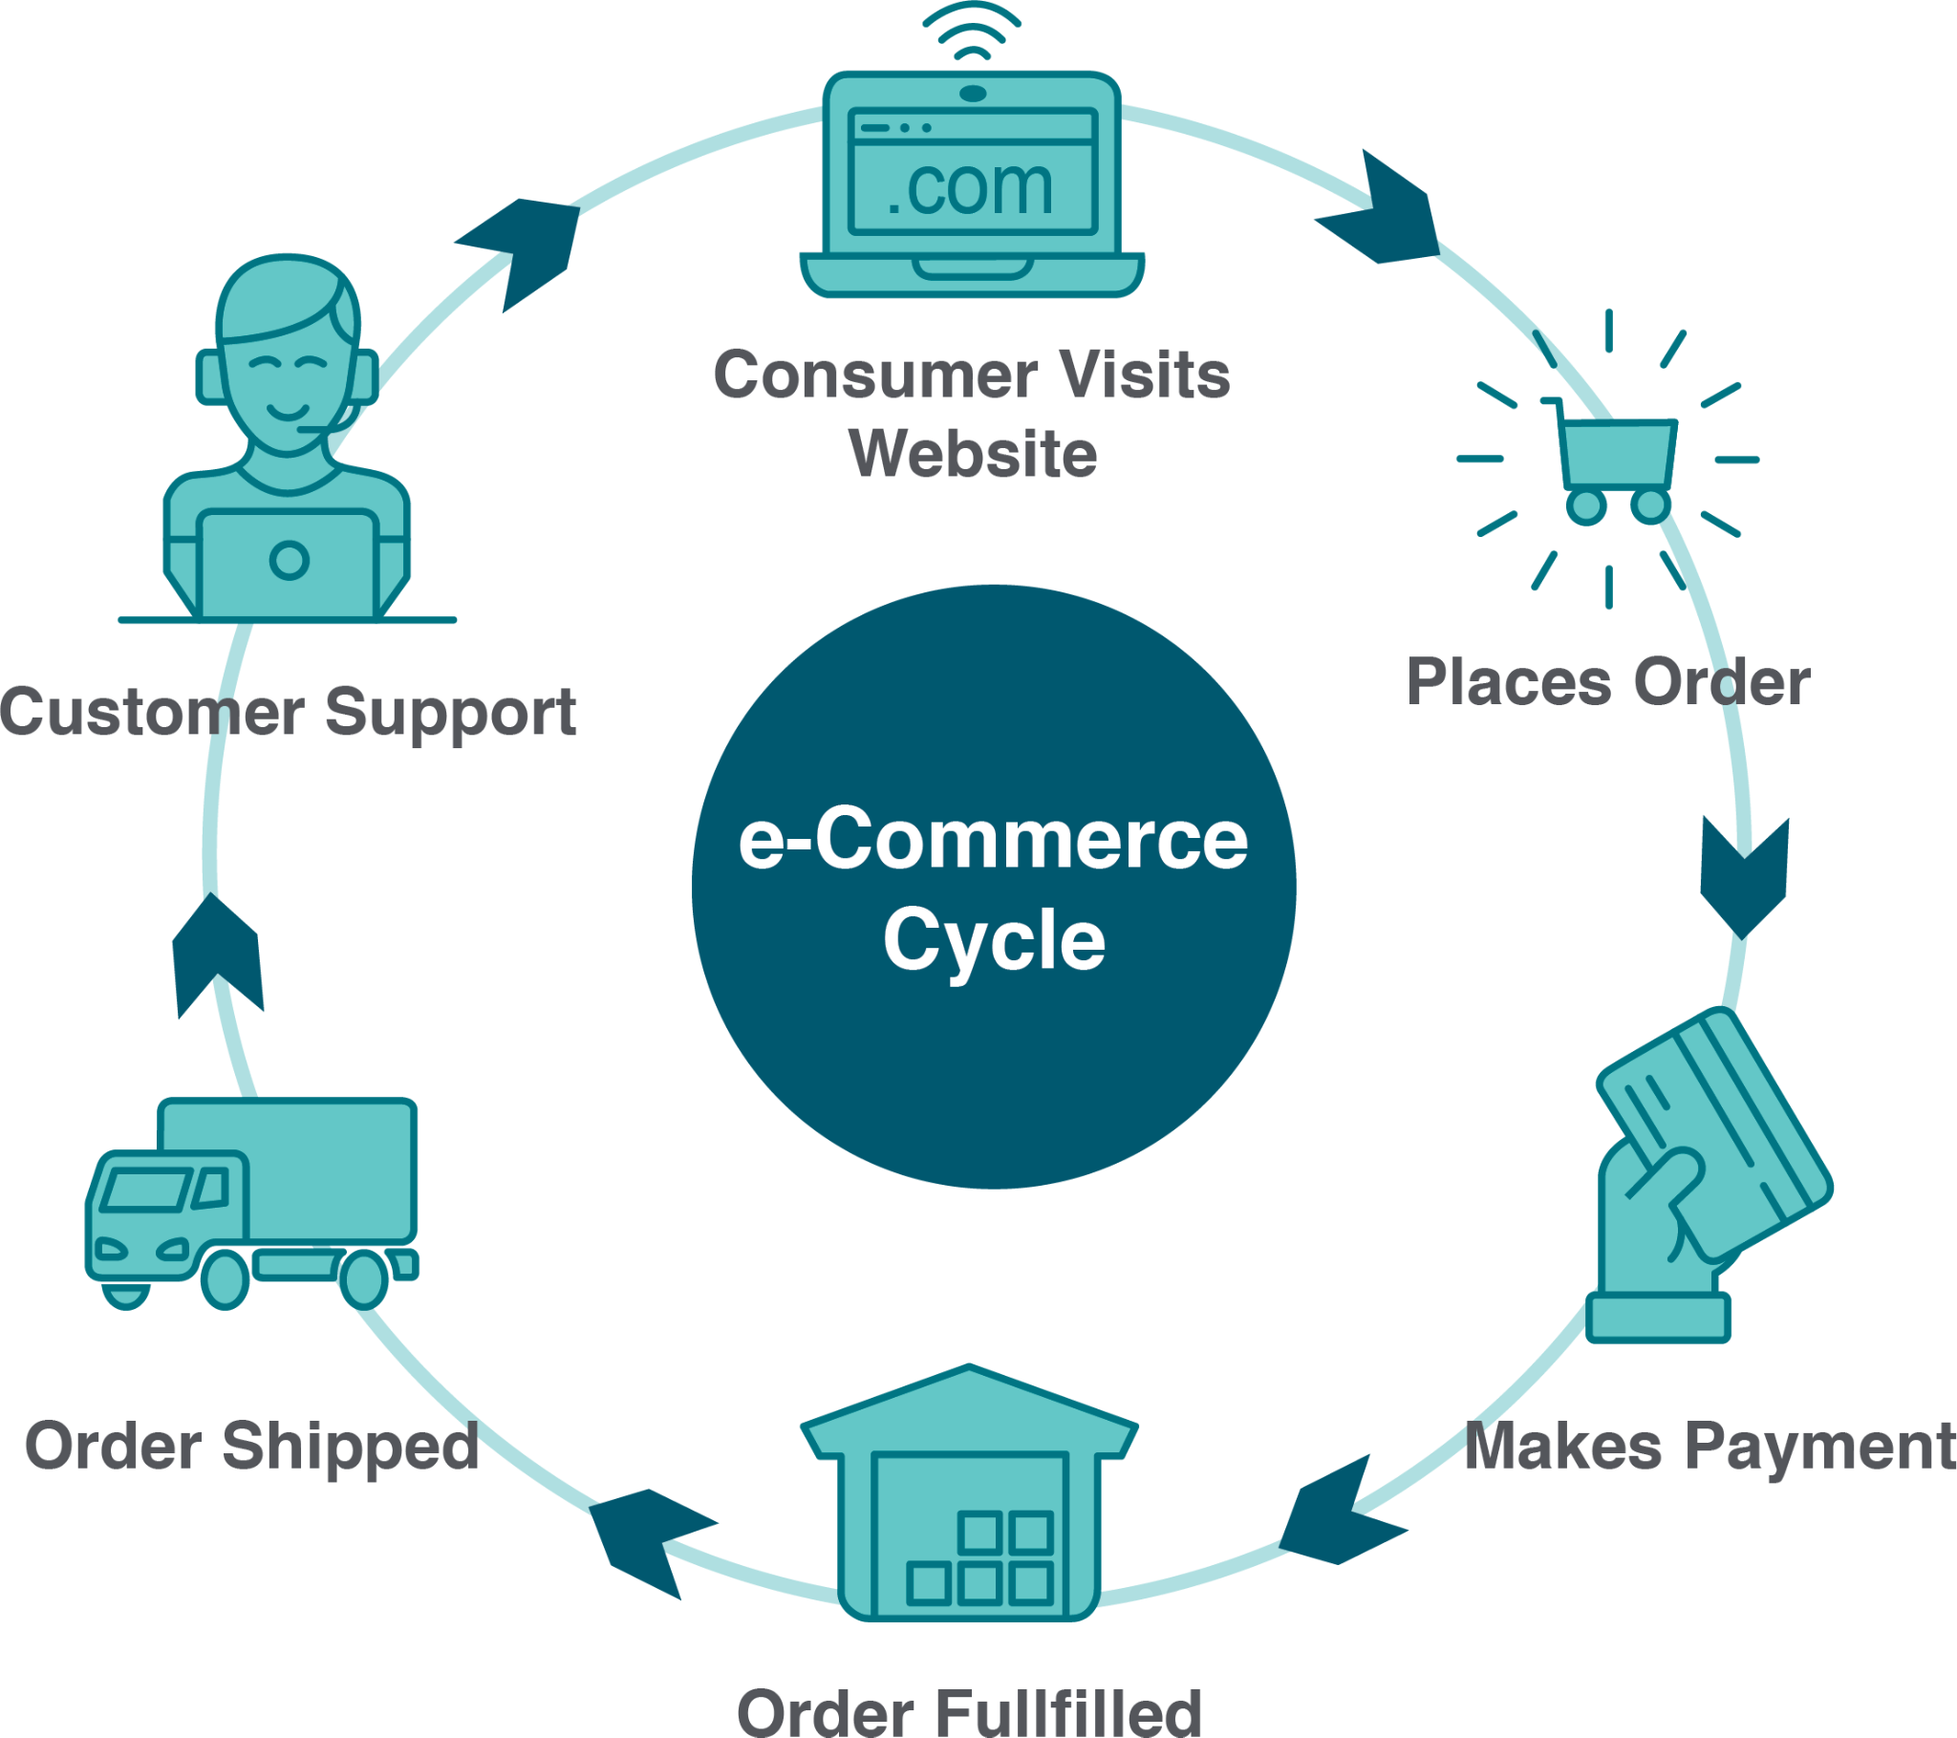
e-Commerce Scope:
- Online Shopping
- Online Payment
- Digital Marketing
- Global Reach
- Customer Support
e-Commerce Workflow:
- Product Dekhna
- Product Select Karna
- Order Place Karna
- Order Process
- Shipping & Delivery
- Feedback Dena

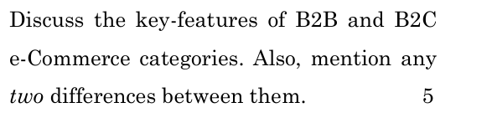
Differences:
- B2B
  - ek company doosri company ko cheezein bechti hai
  - B2B businesses aur professionals ko target karta hai.
  - People buy or sell products in bulk
  - People have trust and relationship
  - Long term
  - Ex. Alibaba, IndiaMART (wholesale deals)
- B2C
  - company apne products ya services directly customers ko bechti hai.
  - B2C individual consumers ko target karta hai.
  - People buy or sell individual product
  - People dont have trust and relationship
  - Short term
  - EX. Amazone, Flipkart
C2B
- ek customer apne product ya services business ko bechta hai
- C2B business owners ko target karta h
- Example: Freelancer, YouTuber brand deals, Fiverr.
C2C
- log ek dusre ko saman ya service bechte hain.
- C2C consumers ko target karta h
- Example: OLX, eBay,
G2B Category of e-Commerce
- government aur businesses ke beech len den hota h,
- jaise tax file karna, license lena, ya government se koi cheez kharidna.
- Ex. telecommunication business start karne k liye gov. Licence lena

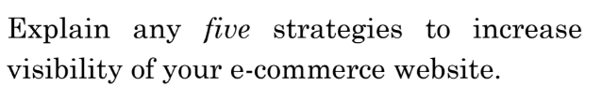
1. (SEO)
2. Use Social Media
3. Advertisements
4. Call by Email
5. Make Interesting Content

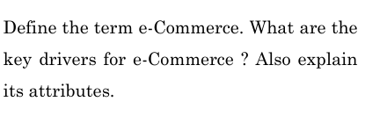
e-Commerce
Key Drivers of e-Commerce: (offline shift to online)
- Easy
- availability
- Online Payment
- Fast Delivery
- Easy return
- Social Media Marketing
- Offers aur Discounts
e-Commerce Ke Attributes ya features (offline se hatke)
- Shopping from anywhere
- Shopping from anytime
- Reviews aur Ratings
- Personalized Suggestions
- Secure Payment

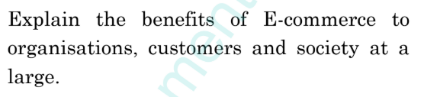
E-commerce se Organizations ko fayde (Business Owners)
- Running business at low cost
- Expand business
- 24 hours Business open
- Get Customers data
- Start business easily
Ecommerce se Customers ko fayde
- Shopping anywhere
- Get different products at one place
- compare price
- Time saving
- Offers, discounts and deals
Ecommerce se Society ko fayde
- Creates new jobs in delivery & IT
- Use Very less papers
- Sell anywhere
- Get better deals from reviews
- Participate in E-commerce

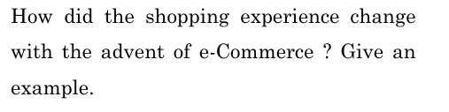
E-Commerce aane se shopping ka tareeka badal gaya.
Pehle log dukaano mein jaake saman kharidte the,
lekin ab ghar baithe mobile ya computer se shopping kar sakte hain.
Kisi bhi time order karna aur delivery ghar tak milna bahut convenient ho gaya hai.
Example:
Amazon jaise websites pe log review padke aur prices compare karke asani se saman kharid sakte hain. Dukaanon ke chakkar lagane ki zaroorat nahi padti.

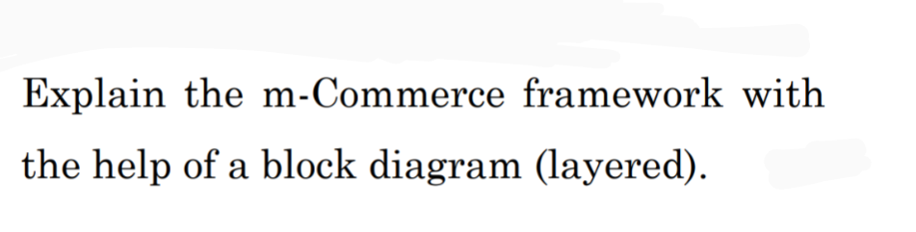
M commerce
mobile devices (jaise smartphone aur tablet) se internet par products aur services ko buying ya selling karna.
Example jab aap apne smartphone se Amazon ya Flipkart app par shopping karte hain.
m-Commerce Framework
M-commerce ek simple system hai jo m-commerce ko chalata hai.
M-commerce me 7 layers hoti h
M-commerce me Har layer ka alag kaam hota hai aur sab ek saath milke kaam karte h
- User Layer : m-commerce me user ka interaction hota h
Ex: user visit m-commerce apps like Amazon, Flipkart, Google Pay.
- Mobile Application Layer: user use m-commerce apps
Ex: Shopping apps, payment apps, ticket booking apps
- Middleware Layer: m-commerce Apps aur backend services k beech connection banta h
Ex. User Login, payment process karna, aur location services dena karta h
- Network Layer: m-commerce apps network par data transfer karte h
Ex. user Mobile network or Wi-Fi se data transfer karta h
- Service Layer: mcommerce ki payment Services handle aur secure karta h
Ex: user use Payment gateways (jaise Paytm, Razorpay), aur security services
- Business Logic Layer: mcommerce k rules and process ko handle karta h
Ex: user see Order process, product stock, out for delivery
- Database Layer: mcommerce ka saara important data, information, ko store karta h
Ex. store users: User data, product details, aur transactions

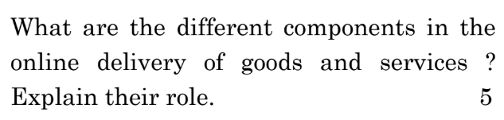
- E-commerce Platform
Role: customers products dekhte aur kharidte hain.
Features: Products, shopping cart, aur payment options.
- Payment Gateway
Role: Online payment ko secure banata hai.
Features: Credit card, UPI, aur wallet se payment.
- Customer Support System
Role: Customers ke questions aur complaints ko solve karta hai.
Tools: Chatbots, call centers.
- Feedback and Review System
Role: Customers ko apne experiences share karne aur products ko rate karne ka option deta h
Impact: Future customers ko trust milta hai aur businesses ko apne products improve karne ka idea milta hai.
- Order Management System (OMS)
Role: Orders process karta hai aur shipping ko manage karta hai.
Features: Order status check karna aur refunds handle karna
- Logistics and Delivery Network
Role: Products ko customer tak pohchata hai.
Components: Shipping carriers (FedEx, UPS) aur delivery partners.

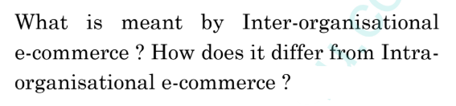
Inter-organisational e-commerce
- jab do ya do se zyada companies apas me online transactions ya data exchange karti hain.
- Do ya zyada companies ke beech
- Dusri companies aur logo saath
- Dusri company ke logon ke saath business karna.
- Ex. bbk
Intra-organisational e-commerce
- ek hi company ke andar online systems ka use karna
- Ek hi company ke andar
- Apne company aur logo k saath
- Apne company k logo k saath kaam karna
- Ex. Specific company xiaomi

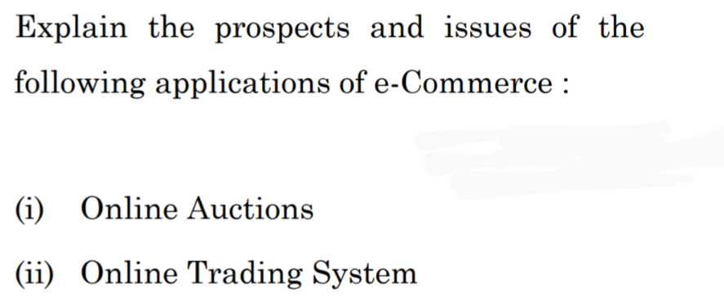
(i) Online Auctions
Ex. ipl auction
Fayde, Prospect
1. Anyone can participate
2. Anytime
3. cheap
4. Get best price through the Bidding
5. Sell Rare aur unique things easily
Problems (Issues):
1. fake bidders and products can do fraud.
2. Payment not secure
3. tax aur rules issues in the International deals
4. Platform can be crash or slow trough the internet
5. Wrong price through Fake bidding
(ii) Online Trading System
Ex. Groww, AngelOne
Fayde (Prospects):
1. 24 hour trading
2. Less Brokerage fees
3. Stocks, forex, crypto on one platform
4. Take good decision by Real-time data
5. Time save by Automatic trading tools
Problems (Issues):
1. Hacking aur data risk
2. Market up down problem
3. Loss by System crash.
4. Loss of Beginners.
5. follow Rules aur laws

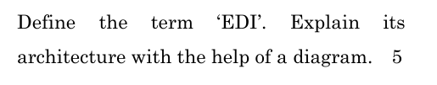
- EDI (Electronic Data Interchange):
- EDI me ek computer se dusre computer me business documents ka transfer hota h bina paper k
- business documents (jaise Purchase Order, Invoice, etc.) ko electronically exchange kiya jata hai.
- EDI se process fast, accurate, error-free aur paperless hota h
- EDI se documents manually banane aur bhejne ki zarurat nahi hoti
EDI Architecture
- Sender: sender data bhejta hai.
- Application: Data ko process karta h aur tayar hota h
- EDI Translator: Data ko standard format mein badalta hai.
- Communication: data ko Secure tariqe se bhejta h
- EDI Mailbox: Data ko temporarily store karta hai.
- Receiver: Data ko receive karke samajhta hai aur kaam karta h
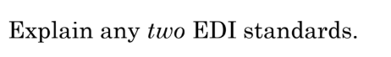
*ANSI ASC X12 (X12 Standard):
- Accredited Standards Committee (ASC) X12
- Ansi asc ek US ka standard hai
- Ansi asc alag-alag industries (jaise healthcare, retail, logistics) mein use hota hai.
- Ansi asc orders, invoices, shipping notice inventory me use hota h
- transactions ke liye alag codes hote hain, jaise Purchase Order (850), Invoice (810), Shipping Notice (856)
EDIFACT (UN/EDIFACT):
- Electronic Data Interchange for Administration, Commerce, and Transport
- EDIFACT ek international standard h jo zyada tar Europe aur Asia me use hota h
- EDIFACT alag-alag industries (jaise healthcare, retail, logistics) me in use hota h
- EDIFACT orders, invoices, shipping notice inventory me use hota h
- Edifact Transaction k liye alag alag codes use karta h

(c) PayPal Payment Method
Ex. paypal money transaction app
Online wallet hai.

Safe & secure payment.

International payments easy.

Fast checkout option.

Card details share nahi karni padti. ✅
(d) Digital Certificate
Ex. digilocker documents
(e) e-Commerce Portal Architecture
E-commerce website ke 4 parts hote hain:
- User Interface: Jaha aap products dekhte aur kharidte ho.
- Logic System: Jo orders aur payments ko process karta hai.
- Data Storage: Jaha customer aur product ki details store hoti h
- Security: Jo aapki payment aur data ko safe rakhta h

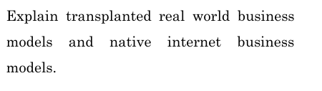
Transplanted Real-World Business Models:
Jo pehle offline hote the, par ab online bhi aa gaye hain
- Online shopping (Amazon, Flipkart) – Pehle dukan se kharidte the, ab mobile se.
- Online banking
- E-newspaper
- online complaints
- e-mail
Native Internet Business Models:
Jo sirf internet par hi bana hain, offline duniya mein unka koi vajud nahi tha.
- Social media (Facebook, Instagram)
- Google search
- YouTube, Netflix
- Freelancing websites (Upwork, Fiverr)
- AI

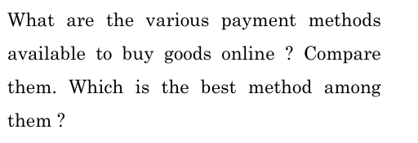
Online Shopping Ke Payment Methods :
- customer apni online kharidari ka paisa chukane k liye online payment k methods use karta h
- Best method - UPI sabse acha hai kyunki ye fast, secure aur easy hota hai
Methods:
- Credit/Debit Cards
  - Security: High
  - Speed: Fast
  - Convenience: Moderate
  - Best Use: High-value payments
- Net Banking, Best Use: Traditional users
- UPI, Best Use: Daily transactions
- Mobile Wallets, Best Use: Cashback/Offers
- COD (Cash on Delivery), Best Use: Risky buyers
- EMI, Best Use: Expensive purchases
- Cryptocurrencies, Best Use: Tech-savvy users
- BNPL (Buy Now Pay Later), Best Use: Limited budget users

E-credit Accounts
- Online account hota hai jo credit par shopping karne deta hai.
- Customer abhi saman leta h aur baad mein ya installments me pesa deta h
- Ye Secure aur fast hota hai.
- Late payment par interest lagta hai.
- Cashback aur rewards bhi milte hain.
- Aapka credit history ban jata hai.
- Jaise Amazon Pay Later, Paytm Postpaid.

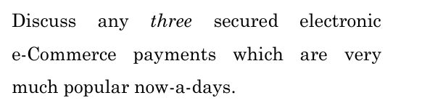
Credit/Debit Cards (OTP ke saath)
Digital Wallets (jaise Paytm, Google Pay, PhonePe)
UPI Payments (jaise BHIM, Google Pay, Paytm)
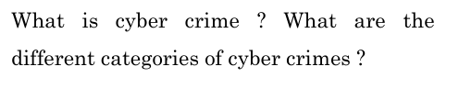
- Cybercrime woh crimes hain jo computer aur internet ke through hote hain.
- Cybercrime se logon, companies, ya governments ko nuksaan pahunchta hain
- Cybercrime hacker, anonymous se hota h
Cybercrime ke kuch common types hain:
- Identity Theft
- Cyberstalking
- Intellectual Property Theft
- Cyberterrorism
- Hacking:
- Phishing:
- Virus or Malware:
- Online Scams: Internet par fake schemes ya offers dekar paise churana.
- DoS Attacks

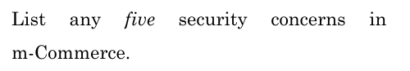
- Data Chori
- Fake Websites aur Apps
- Unsafe Payments
- Hacking
- Fraud in delivery

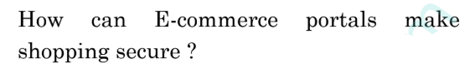
- Secure Payment
- Extra Security (2FA)
- Stop Fraud
- Secure Data
- Help to Customer
- Privacy care

What precautions are taken while making on-line payment.for on-line transactions ?
🔐 1. Secure Website ka use karo
📶 2. Public Wi-Fi mat use karo
🧾 3. Trusted Payment Apps ya Gateways ka use karo
📲 4. OTP ya 2FA ka use karo
❌ 5. Personal details kabhi share na karein
🛡️ 6. Device secure rakho
📄 7. Bank statement check karte raho
📧 8. Fake messages/email se bacho (Phishing)

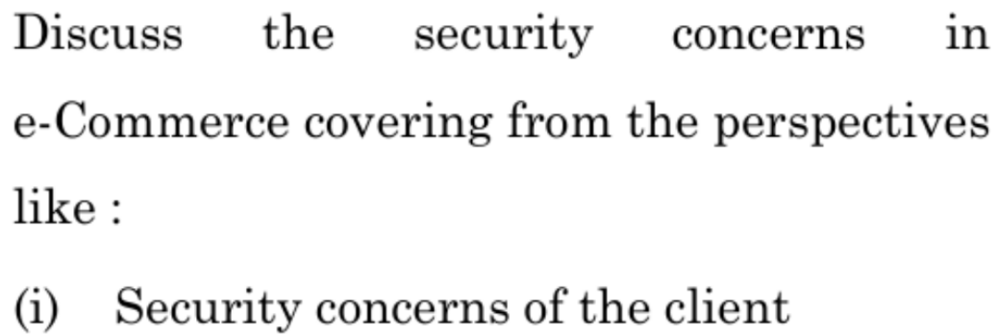
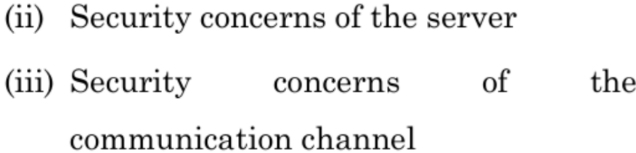
(i) Client ki security concerns
Client log shopping karte hain to Unhe yeh problems ho sakti hain:
- Data stolen:
- Fake emails aur websites:
- Identity chori:
- Viruses/Malware:
- Fraud transactions:
Sol. Strong password lagao aur verified website par shopping karo.
Antivirus install karo aur suspicious links avoid karo.
(ii) Server ki security concerns
Server wo jagah hai jahan website ka data store hota hai. Uske problems:
- Hack
- Data leak
- Dos attack
- Weak password
- Harmful code
Sol. System update rakho aur firewalls lagao. Data ko secure rakhne ke liye encryption use karo
(iii) Communication channel ki concerns
Communication channel matlab data exchange ka raasta (internet). Problems hain:
- Data chori
- Middleman attacks
- Encryption na hona
- Public Wi-Fi
Sol. Hamesha HTTPS website ka use karo. Secure network pe hi shopping karo, public Wi-Fi avoid karo

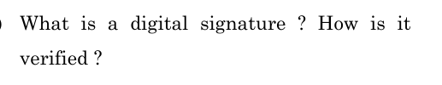
Digital Signature
Ds online documents ya messages ko secure banata hai.
Ds me document original hota hai aur usme koi change nahi hota h
Ex. Digilocker Documents
How verified :
- Sign Karna ( sender ka process )
  - Sender document me ek special code (hash) generate karta hai.
  - Sender ees code ko private key se lock (encrypt) karta hai.
  - jisse digital signature ban jata hai.
  - Aur fir Sender receiver ko bhejta hai.
- Verify Karna ( Receiver ka process )
  - Receiver sender ki public key se digital signature ko unlock karta hai.
  - jisse document ka ek naya code hash generate hota hai.
  - Agar dono codes match hote hain, toh document original hai, nhi to change h
Digital Signature Ke Fayde
✅ Originality – Yeh proof hai ki document real hai.
✅ Security – Koi bhi document ko bina pata chale badal nahi sakta.
✅ Trust – Sender baad mein mana nahi kar sakta ki usne sign nahi kiya

*Architecture of EDI
- Data ko standard format mein badla jaata hai.
- Documents secure tarike se bheje jaate hain.
- Data check aur galti sudhar hoti hai.

Electronic markets
- online platforms hote hain jahan buyers aur sellers goods aur services ka exchange electronically karte hain.
- Ex. Amazon electronic market ka, jahan buyers aur sellers online products aur services ka exchange karte hain
- Ex. Amazone, Flipkart market h

E visibility
- internet par kisi product ya service ki online visibility ya dikhai dene ki capacity.
- Ex. "Jab aap Flipkart pe product order karte hain aur uska delivery status 'Out for Delivery' dikhata hai,
- Ex. order failed, order confirmed, out for delivery, deliver in 2 days, etc

E shops
- E-shops wo online dukaane hoti hain jahan log internet par products dekh kar kharidte h
- E shop website ya app par hoti h virtually
- Ex. Flipkart aur Amazon jaise online platforms e-shops h

Delivery of Goods and Services
- Company goods aur services ko customer ko pahuchaati h
- Order k saath maintenance, customer support, repair, warranty milta h
- Ex. Amazon ka apne customers ko online order ke bad services provide karti h

Smart card
- Smart card ek physical chip wala card hota hai jo data ko store karta hai
- Smart card secure transactions ke liye use hota h
- Ex. debit ya credit card, electronic transactions ke liye hote h

Eft (Electronic Fund Transfer)
- ek digital process hai jisme paise ek bank account se doosre bank account mein electronically transfer kiye jaate hain
- Ex. jab aap apne bank account se online shopping karte waqt payment transfer karte hain,
- jaise Amazon par credit card ya debit card ke through.

After Sales Service ASS
- kisi product ko kharidne ke baad company apne customers ko provide karti hai,
- jaise repair, maintenance, aur support.
- example "Agar aapne kisi mobile phone ko kharida aur uske baad company aapko free repair service ya software updates deti hai, toh yeh after sales service hai

Electronic Payment Systems
- digital platforms hote hain jinse hum online transactions kar sakte hain,
- jaise ki netbanking, upi, debit card, wallet,
- shopping, bill payments, ya money transfer me use hota h
- EX. Paytm, jahan log apne mobile phones se bills, shopping, aur money transfer kar sakte hain.

E money
- electronic money
- digital form mein store aur transfer kiya jaata h,
- jaise online wallets ya bank accounts mein.
- example: Paytm ya Google Pay jahan aap apne phone se paisa transfer karte ho bina physical currency ka use kiye

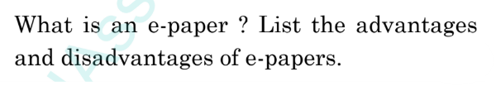
E-paper
- E-paper ek digital newspaper hai
- E paper mobile, computer, ya tablet par padh sakte hai.
- E paper newspaper ki news deta h
- E paper online available hota hai
- E paper me links, videos aur photos hoti hai.
E-paper ke Fayde:
- Paper ki bachat:
- Har jagah available:
- Sasta & free
- portable:
- Turant update:
- Jagah nahi lagti:
E-paper ke Nuksan:
- Internet chahiye:
- Aankhon ka dard:
- Mobile ya computer zaruri hai:
- Personal data ka risk:
- Feel ka farq:

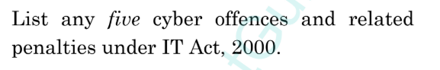
Yeh 5 cyber crimes aur unki saza simple language mein:
- Hacking (Section 66):
  - Kya hai: Bina permission ke kisi ke computer ko todna ya nuksan pahunchana.
  - Saza: 3 saal tak jail ya ₹5 lakh tak ka fine, ya dono.
- Identity Theft (Section 66C):
  - Kya hai: Kisi aur ka password ya digital identity chura ke use karna.
  - Saza: 3 saal tak jail aur ₹1 lakh tak ka fine.
- Phishing (Section 66D):
  - Kya hai: Galat identity banakar kisi ko ullu banana aur paisa ya information lena.
  - Saza: 3 saal tak jail aur ₹1 lakh tak ka fine.
- Obscene Content Post Karna (Section 67):
  - Kya hai: Internet par ganda ya inappropriate content dalna.
  - Saza: Pehli baar 3 saal tak jail aur ₹5 lakh tak ka fine.
- Offensive Messages (Cyberstalking) (Section 66A):
  - Kya hai: Offensive ya gande messages bhejna.
  - Saza: 3 saal tak jail aur fine.
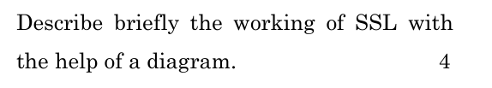
- SSL (Secure Sockets Layer) ek protocol hai
- SSL client (browser) aur server (website) ke beech ek secure connection banata hai.
Steps:
- Handshake aur Server Authentication:
  - Server Client ko secure connection request bhejta hai.
  - Server apna SSL certificate bhejta hai, server public key rakhta hai.
- Certificate Verification:
  - Client SSL certificate ko trusted CA (Certificate Authority) se verify karta hai, taaki uski authenticity confirm ho
- Session Key Generation:
  - Client ek session key (symmetric key) generate karta hai
  - Aur client public key se encrypt karke server ko bhejta hai.
- Making Secure Connection:
  - Server apni private key se session key ko decrypt karta hai.
  - Ab dono (client aur server) is session key ka use karke encrypted communication shuru karte hain.
- Data Encryption aur Transfer:
  - Jo bhi data exchange hota hai, wo session key ka use karke encrypt hota hai, jo privacy aur security ensure karta hai.
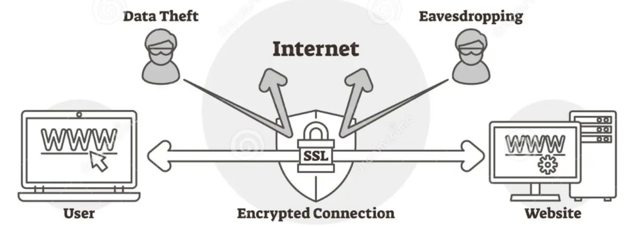

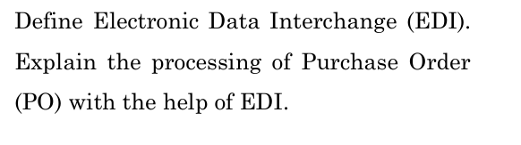
Electronic Data Interchange (EDI)
EDI ke zariye Purchase Order (PO) ka Process:
- PO Banana:
Buyer apne system mein Purchase Order banata hai
aur usko EDI format mein convert karta h
- PO Bhejna:
EDI system se PO ko supplier ke system par electronically bheja jata h
- Supplier PO Receive karta hai:
Supplier k system mein PO receive hota hai aur readable format mein convert hota h
aur supplier order accept karta h
- Confirmation (Agar zarurat ho):
Supplier ek message bhej kar confirm karta hai ki PO receive ho gaya hai.
- Order Process aur Delivery:
Supplier order prepare karta hai, goods ship karta hai, aur invoice ya shipment details EDI format mein bhejta hai.
- System Update:
Buyer aur supplier ka system automatically updated ho jata hai, taaki sab kuch smooth chale.
Fayde:
- Time bachta hai.
- Galtiyan kam hoti hain.
- Process fast aur asaan ho jata hai.

50 marks
June 2023 checked
Dec 2023 checked
June 2024 checked

Notes by Ankit Kumar 9389715277

