TOP 50 EXCEL FORMULAE FOR DATA Enthusiasts BY ANKIT KUMAR

Data Cleaning Tools
- Remove Duplicates
- Text to Columns
- Find & Replace (Ctrl + H)
- Trim – remove extra spaces
- Flash Fill (Ctrl + E)

Charts for Analysts
- Bar / Column → Comparison
- Line → Trend
- Pie → Percentage share

Data Analysis Tools
- Pivot Table (MOST IMPORTANT)
- Sort & Filter
- Conditional Formatting
- Data Validation (Dropdowns)
- Charts (Bar, Line, Pie)

Spreadsheet: An application, like Microsoft Excel, where you can store data, perform calculations, and organize information.

Workbook: A file containing a collection of one or more worksheets

Cell: A rectangular box in a worksheet that can store a data value, a formula, or other content

Formula: A piece of code to perform a calculation. Formulas start with an equals sign (=), and contain functions, mathematical operators, values, and cell references.

Cell reference
A cell reference is the address of a cell in Excel, like A1, which tells where the data is located.

Cell range

Add comment

Specifying absolute cell references with $ prefixes
A1 → Relative
$A$1 → Absolute
A$1 / $A1 → Mixed

=C5% Convert a value to a percentage with %. This example returns 3.25
=B1 ^ C1 Raise a value to power with ^. This example returns 2 ^ 6 = 64

SUM - Adds up all the numbers in a specified range.
Auto sum – Alt + =

AVERAGE - Calculates the average of numbers in a range.
AVERAGEIF
=AVERAGEIF(A:A, “Yes”)

IF - =IF(A1>10, "Yes", "No")
Returns one value if a condition is true, and another value if it’s false.

VLOOKUP
=VLOOKUP(A1, B1:C10, 2, FALSE)
VLOOKUP Excel ka ek function hai jo ek column mein di gayi value ko doosre column ki corresponding value ke saath match karta hai.
Vlookup me 4 argument hote h
vlookup(lookup_value, table_array, col_index_num, [range_lookup])
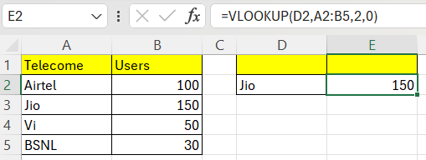

HLOOKUP
=HLOOKUP(A1, A1:D4, 2, FALSE) - Similar to VLOOKUP but searches horizontally

XLOOKUP
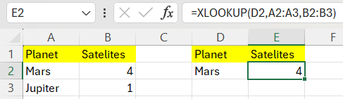

MATCH
=MATCH(A1, B1:B10, 0) - Returns the relative position of an item in a range.
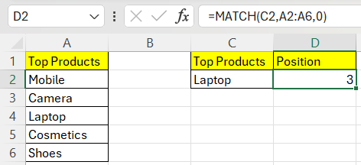

CONCATENATE (or CONCAT)
=CONCATENATE(A1, " ", B1) / =concat(A1,A2) - Combines multiple values into one string.without space

COUNTIF
COUNTIF(A1:A10, ">5") - Counts the number of cells in a range that meet a single criterion.
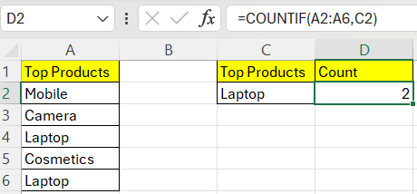

SUMIF
=SUMIF(A1:A10, ">5") - Adds the cells in a range that meet a specified condition.
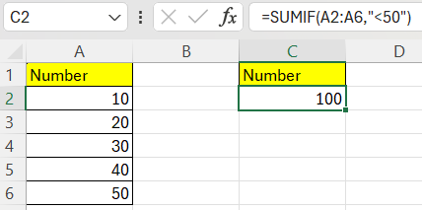

COUNTIFS
=COUNTIFS(A1:A10, ">5", B1:B10, "<10") - Counts the number of cells that meet multiple criteria.
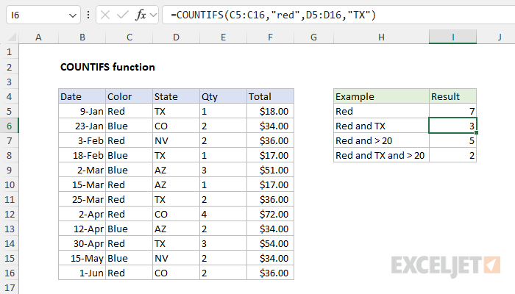

SUMIFS
=SUMIFS(A1:A10, B1:B10, ">5") - Adds the cells that meet multiple conditions.
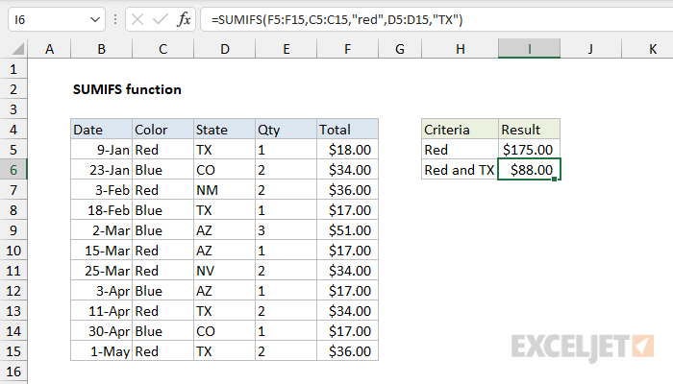

LEFT
=LEFT(A1, 3) - Returns a specified number of characters from the start of a text string.
A1 - 84111-10001 - Result - 841

RIGHT
=RIGHT(A1, 3) - Returns a specified number of characters from the end of a text string.

Ctrl + t -> table formatting

LEN
=LEN(A1) - Returns the number of characters in a text string.

TRIM
=TRIM(A1) - Removes all extra spaces from text except for single spaces between words.
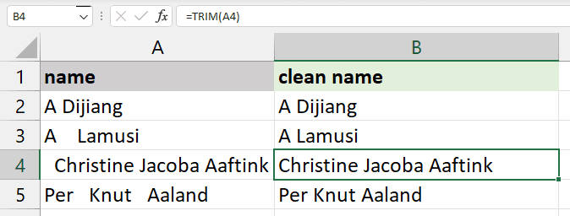

TEXT
TEXT(A1, "dd/mm/yyyy") - Formats a number or date into a text string with a specified format.

PROPER
=PROPER(A1) - Capitalizes the first letter of each word in a text string. ankit -> Ankit

NOW
Now() – current date and time
=SECOND(NOW()) 12
=TODAY() 12/12/2012
=DAY(TODAY()) 12
=MONTH(A1) MONTH
=YEAR(A1) YEAR

RANK
=RANK(A1, A1:A10) - Returns the rank of a number in a list of numbers.
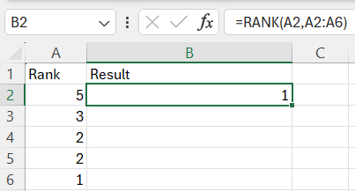

textsplit
`TEXTSPLIT` function kisi text ko alag-alag parts mein tod ke alag cells mein daalne ke kaam aata hai, jaise agar words ko comma ya space se alag karna ho.
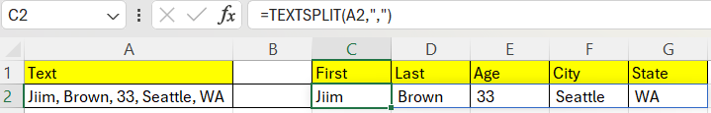

EXACT
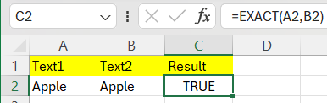

SUM PRODUCT - =SUMPRODUCT(A2:A5,B2:B5)
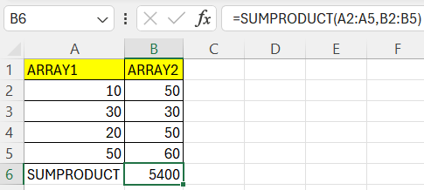

SUBSTITUDE
Word or character ko replace karta h
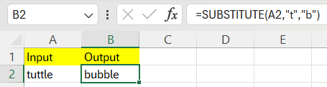

IF ERROR
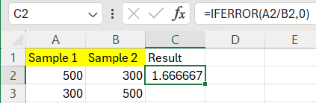

COUNTA() – count cell elements and ignored empty cells
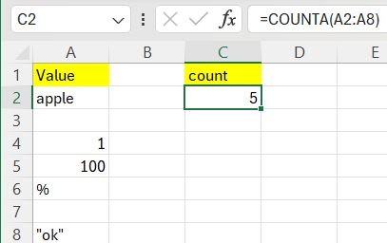

INDEX()
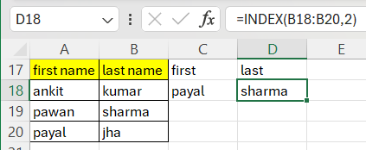
=INDEX(A1:J9,5,7)
5 for row
7 for column
=INDEX(C:C,MATCH(A2,A:A,0))

MID()
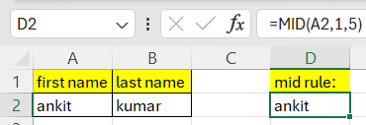

Textjoin
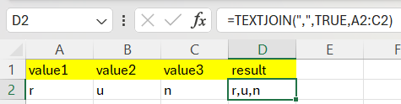

Upper() – convert in uppercase
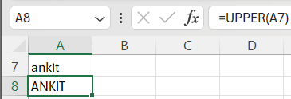

Lower - convert in lowercase

Round - =ROUND(number, num_digits)
=ROUND(12.5678, 2)
Result: 12.57

Roundup - =roundup(b5, c5) -
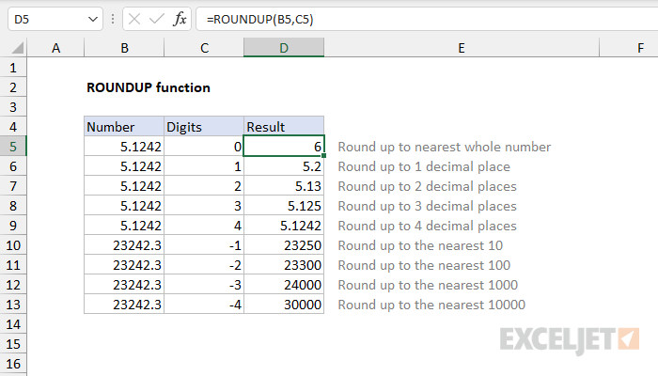

Roundown – roundown(a1, b1)
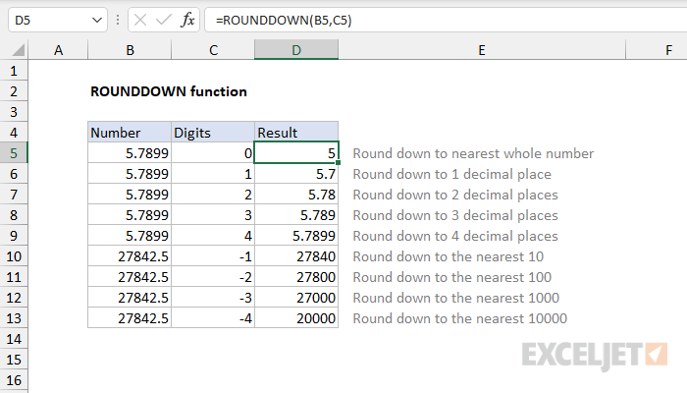

Datedif – datedif(a1,b1,”y”) - difference between two dates in years – result: 2
Y means year, d, m
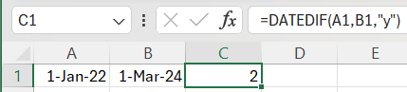

DIFFERENCE IN DAYS
=B1-A1

Ifs - =IFS(C5<60,"F", C5<70,"D", C5<80,"C", C5<90,"B", C5>=90,"A")

Power(a1, b1) – a raise to power b

CEILING
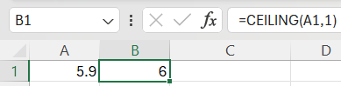

Floor
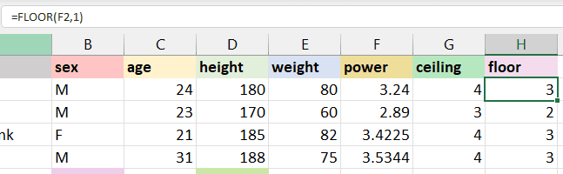

Replace
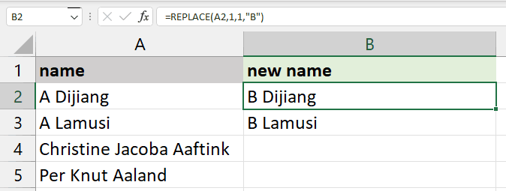

=CONCATENATE($B3," ",TEXT($C3,"0%"))
B3: Sales Growth
C3: 0.25
Sales Growth 25%

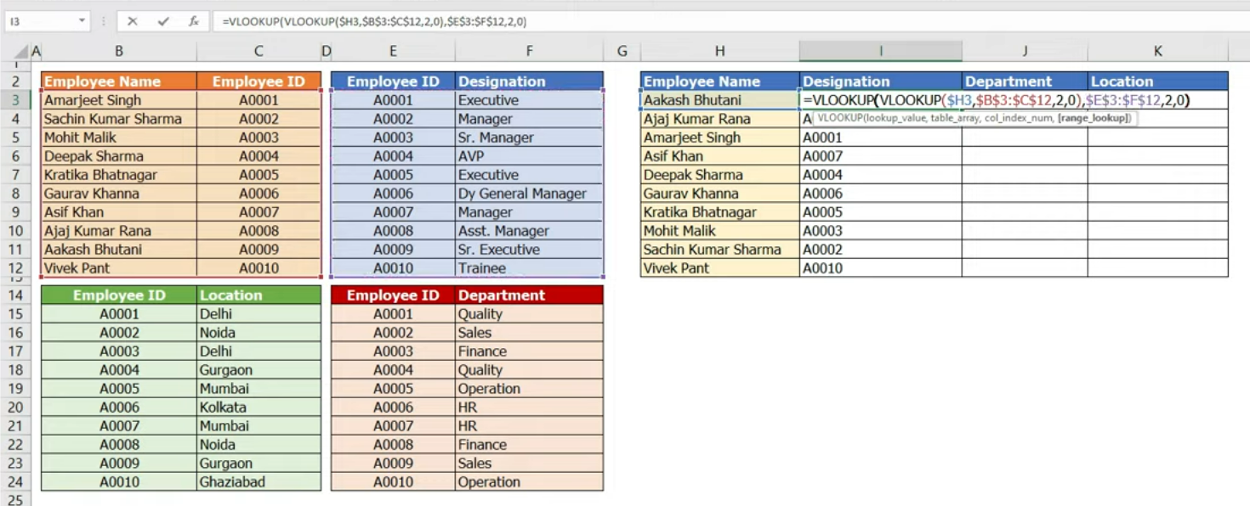

Remove extra spaces forcefully
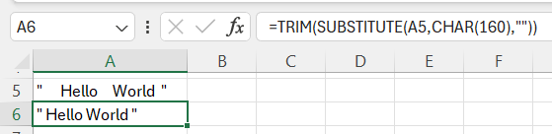

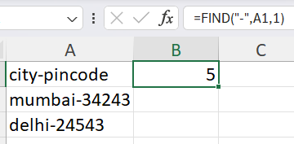

SORT =SORT(A1:A5)

Filter =FILTER(A2:C6,B2:B6="Delhi")
Ctrl + Shift + L
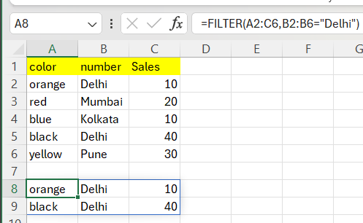

Name Manager
Ctrl + fn + f3 Selected data ko naame deta h aur change karta h
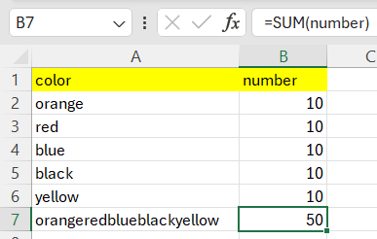

Freeze panes
View – freese top panes
Specific row, coloumn ko freeze kardeta h jisse screen ko scroll karne ki need h

Fixed value by Data validation
Select range -> Data validation -> settings -> allow: -> Text length -> minimum -> maximum -> ok

Dropdown list by Data validation
Data validation -> settings -> allow: -> list -> source (select range) -> ok
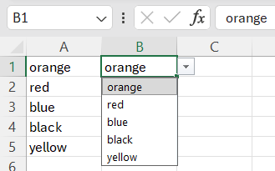

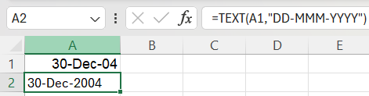
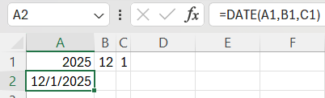
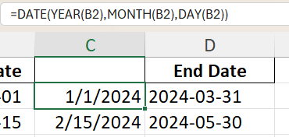

Insert pivot table Alt + n + v + t
Used for summarizing large data
- Drag fields to:
Insert → Pivot Table
Rows → Category
Values → Sum / Count / Average
Filters → Region / Date

Abs(number)

Sqrt

And() / Or()
=AND(A1>50, B1<100)

Not()

Handles errors gracefully IFERROR(value, value_if_error)

Offset

Weekday()

PERCENTILE / QUARTILE

UNIQUE

PMT(B4/12, B3,-B2)
