Week 6 - Git Exercise 3 Lab Report

Name: Ankit Pandey
Week No :6
Exercise No:1
Course : Cognizant Digital Nurture 5.0 - Java FSE
College Name : GLA University,Mathura

Objective
To create and manage Git branches, perform merging, inspect history, and delete merged branches using Git and GitLab.
Step 1: Create new branch
Created GitNewBranch and listed available branches.
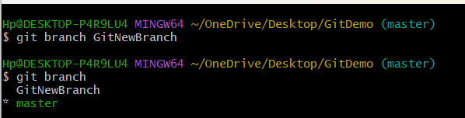

Step 2: Switch to branch
Checked out GitNewBranch.
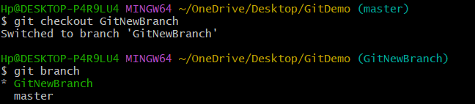

Step 3: Create file
Created branch.txt and verified status.
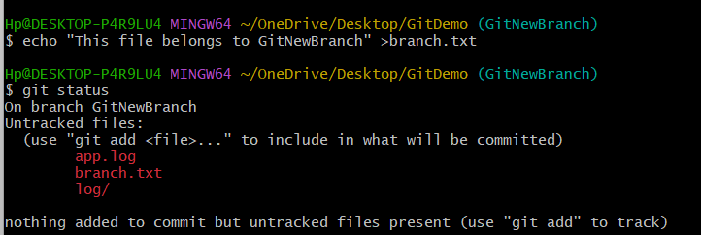

Step 4: Stage file
Added branch.txt to staging area.
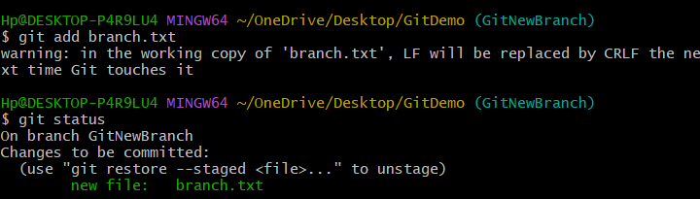

Step 5: Commit
Committed changes with message 'Added branch file'.

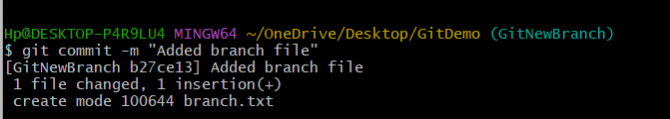

Step 6: Verify
Working tree clean.
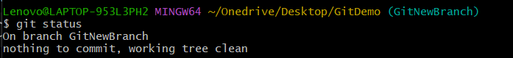

Step 7: Checkout master
Returned to master branch.
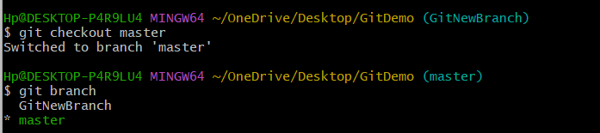

Step 8: Compare
Compared master and GitNewBranch using git diff.
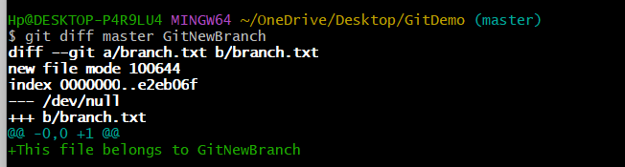

Step 9: Merge
Merged GitNewBranch into master.
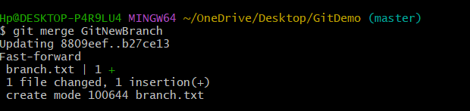

Step 10: History
Viewed commit graph.
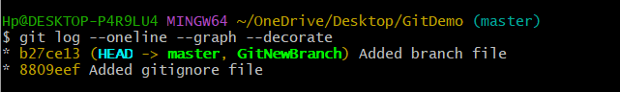

Step 11: Delete branch
Deleted merged branch and verified.
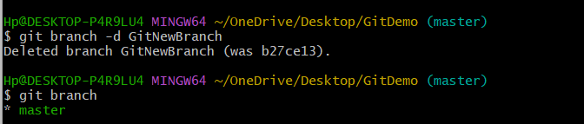

Step 12: GitLab Verification
Verified branch.txt present in GitLab.
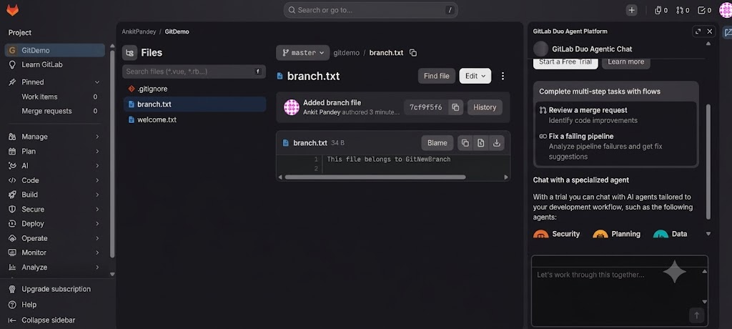

Result
Successfully created a branch, committed changes, merged the branch into master, deleted the merged branch, and verified the final repository on GitLab

