Week 6 - Git Exercise 1 Lab Report

Name: Ankit Pandey
Week No :6
Exercise No:1
Course : Cognizant Digital Nurture 5.0 - Java FSE
College Name : GLA University,Mathura

Objective
To learn Git configuration, repository creation, file tracking, committing changes, and connecting a local repository with GitLab.
Verify Git Installation
Executed: git –version

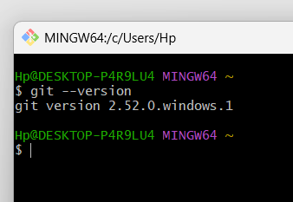

Configure Username and Email
Executed git config commands.
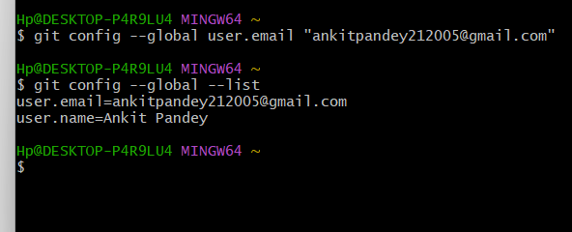
Verify Git Configuration
Executed git config --global --list.
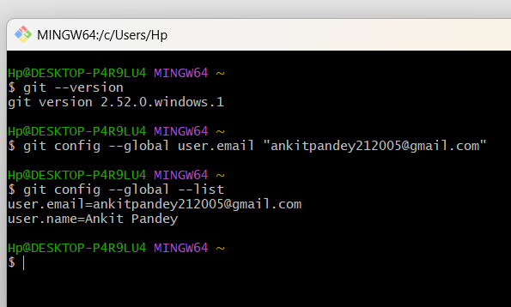

Configure Notepad++
Configured Notepad++ as default editor.
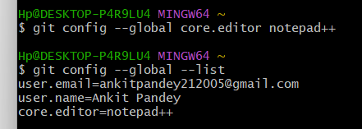

Navigate to Desktop
Verified location using pwd.
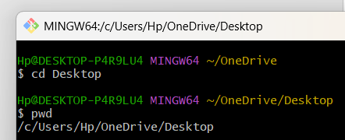

Create GitDemo Folder
Created directory using mkdir.
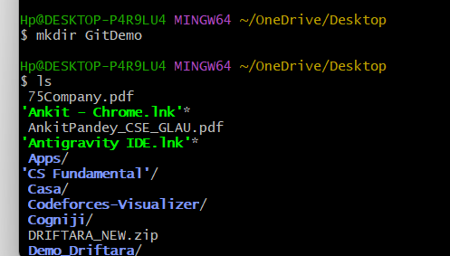

Open GitDemo
Changed directory and verified path
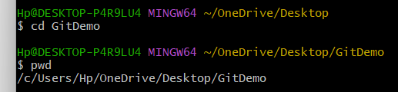

Initialize Repository
Executed git init.
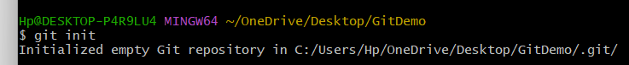

Verify .git
Executed ls -la.
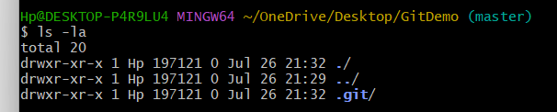
Create welcome.txt
Created and viewed welcome.txt.
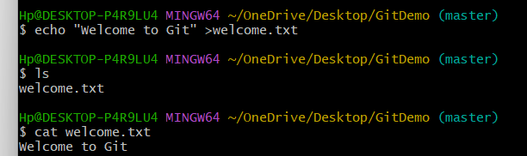

Git Status
Verified untracked file.
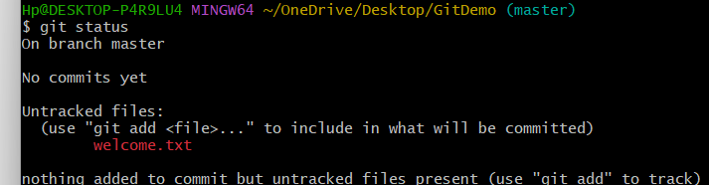

Stage File
Executed git add welcome.txt.
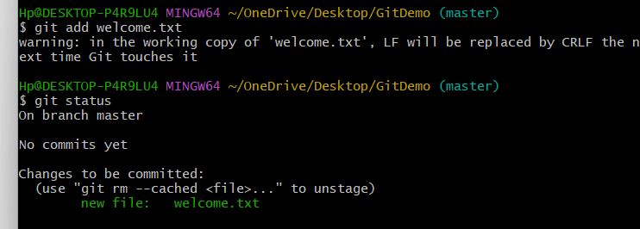

Initial Commit
Executed git commit.
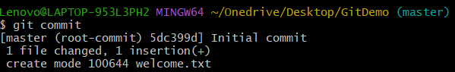

Create GitLab Project
Created blank GitLab project.
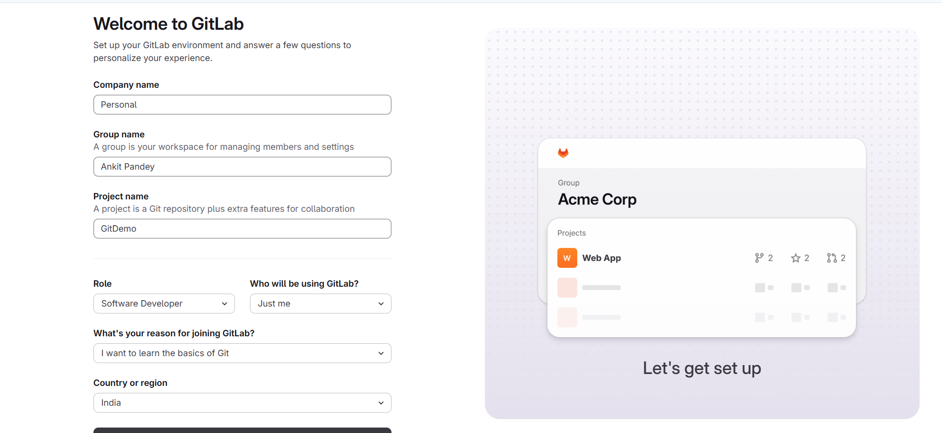

Add Remote
Executed git remote add origin.
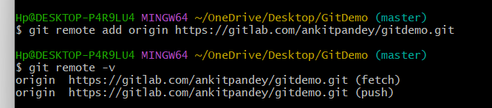

Verify Remote and Project
Verified remote URL and project.
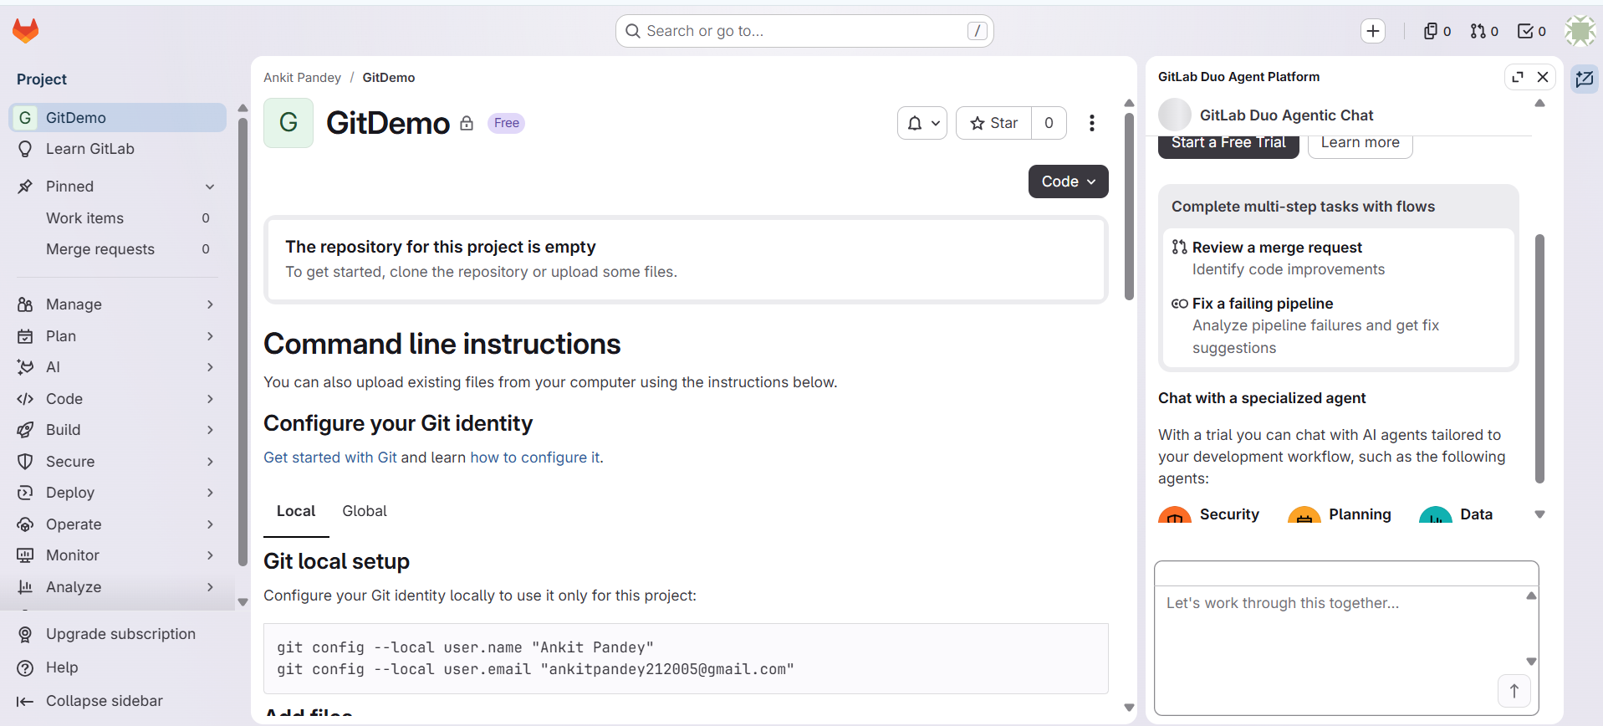

Result
Successfully configured local Git credentials, initialized and committed files to a repository, created a remote project on GitLab, and linked the local workflow to push code changes.

