COGNIZANT DEEP SKILLING – WEEK 6

Name: Ankit Pandey
Week No :6
Exercise No:2
Course : Cognizant Digital Nurture 5.0 - Java FSE
College Name : GLA University, Mathura

Exercise 2: Git Ignore

Objective
Understand how to utilize the .gitignore configuration to exclude specific files and directories from Git tracking.

Requirements
- A fully installed and configured Git environment.
- Notepad++ set as the primary text editor for Git.
- An active local repository named GitDemo.
- A remote GitLab repository linked to your local setup.

Instructions
- Navigate to your existing GitDemo repository.
- Generate a file named app.log alongside a log folder that contains an error.log file.
- Run a status check to confirm Git flags these new items as untracked.
- Generate a new .gitignore file.
- Insert the exclusion rules *.log and log/ into the document.
- Run another status check to confirm the specified files are now successfully hidden from Git.
- Add the .gitignore file to the staging area and commit the change.
- Upload the commit to your remote GitLab server and confirm the repository update online.

Visual Evidence

Screenshot 1: git status showing app.log and log/ as untracked files.
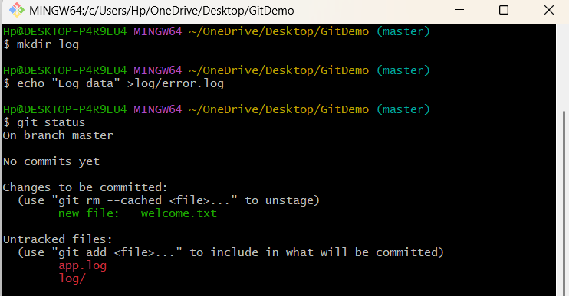

Screenshot 2: Contents of the .gitignore file.
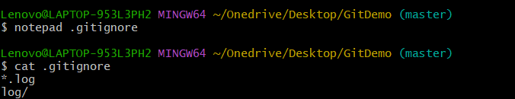

Screenshot 3: git status showing only .gitignore.
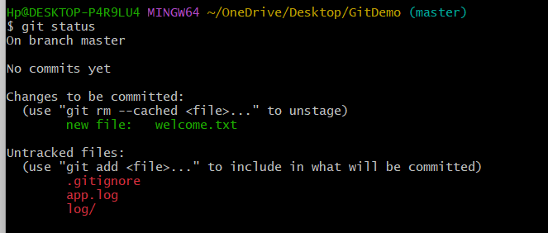

Screenshot 4: Staging .gitignore using git add.
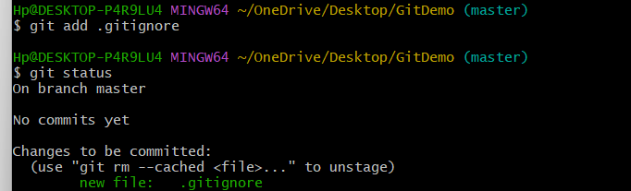

Screenshot 5: Successful commit of .gitignore.
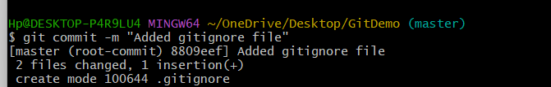

Screenshot 6: GitLab repository after pushing the changes.
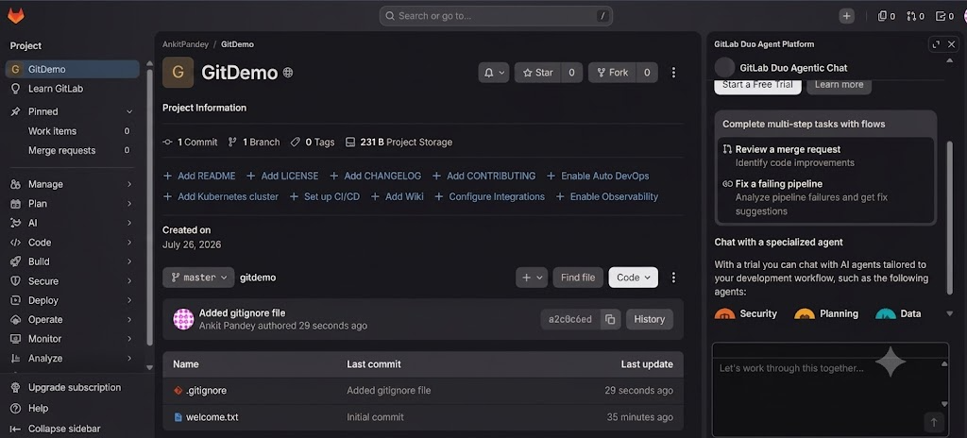

Outcome The .gitignore file successfully blocked all .log files and the log folder from being tracked. As a result, only essential project files were committed.

Conclusion This exercise showed how a .gitignore file effectively maintains a clean repository by filtering out unwanted files and directories from version control.

