**Lab no 1: Write program in C to test whether given entered string within valid comment section or not.**

**Source Code:**

#include <stdio.h>

#include <conio.h>

void main()

{

char text[100];

int i = 2, a = 0;

printf("\n\nEnter Text : ");

gets(text);

if (isComment(text))

printf("It is a comment");

else

printf("It is not a comment");

getch();

}

int isComment(char cmt[])

{

int i = 2, a = 0;

if (cmt[0] == '/')

{

if (cmt[1] == '/')

{

return 1;

}

else if (cmt[1] == '*')

{

for (i = 2; i <= 100; i++)

{

if (cmt[i] == '*' && cmt[i + 1] == '/')

{

return 1;

a = 1;

break;

}

else

{

continue;

}

}

if (a == 0)

{

return 0;

}

}

else

{

return 0;

}

}

else

{

return 0;

}

}

**Output:**

**Run1:**

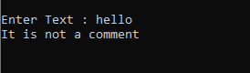

**Run2:**

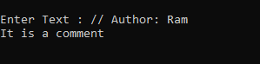

**Run3:**

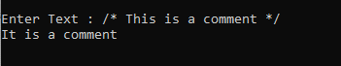

**Lab no 2: Write a C program to recognize strings under 'a*', 'a*b+', 'abb'**

**Source Code:**

#include <stdio.h>

#include <string.h>

#include <stdlib.h>

int main()

{

char s[20], c;

int state = 0, i = 0;

printf("\n Enter a string:");

gets(s);

while (s[i] != '\0')

{

switch (state)

{

case 0:

c = s[i++];

if (c == 'a')

state = 1;

else if (c == 'b')

state = 2;

else

state = 6;

break;

case 1:

c = s[i++];

if (c == 'a')

state = 3;

else if (c == 'b')

state = 4;

else

state = 6;

break;

case 2:

c = s[i++];

if (c == 'a')

state = 6;

else if (c == 'b')

state = 2;

else

state = 6;

break;

case 3:

c = s[i++];

if (c == 'a')

state = 3;

else if (c == 'b')

state = 2;

else

state = 6;

break;

case 4:

c = s[i++];

if (c == 'a')

state = 6;

else if (c == 'b')

state = 5;

else

state = 6;

break;

case 5:

c = s[i++];

if (c == 'a')

state = 6;

else if (c == 'b')

state = 2;

else

state = 6;

break;

case 6:

printf("\n %s is not recognized", s);

exit(0);

}

}

if (state == 1)

printf("\n %s is accepted under rule 'a'", s);

else if ((state == 2) || (state == 4))

printf("\n %s is accepted under rule 'a*b+'", s);

else if (state == 5)

printf("\n %s is accepted under rule 'abb'", s);

return 0;

}

**Output:**

**Run1:**

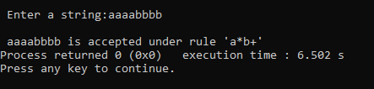

**Run2:**

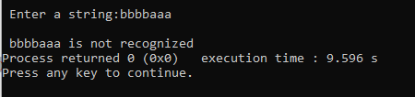

**Run3:**

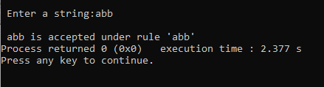

**Lab no 3: Write a C program to test whether a given identifier is valid or not**

**Source Code:**

#include <stdio.h>

#include <conio.h>

#include <ctype.h>

int main()

{

char a[10];

int flag, i = 1;

printf("\n Enter an identifier:");

gets(a);

if (isalpha(a[0]) || a[0] == '_')

flag = 1;

else

printf("\n Not a valid identifier");

while (a[i] != '\0')

{

if (!isdigit(a[i]) && !isalpha(a[i]) && a[i] != '_')

{

flag = 0;

break;

}

i++;

}

if (flag == 1)

printf("\n Valid identifier");

else

printf("Not a valid identifier");

return 0;

}

**Output:**

**Run1:**

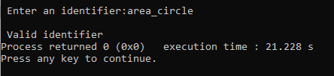

**Run2:**

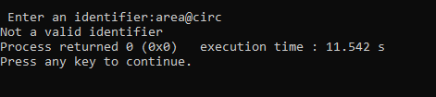

**Lab no 4: Program for Lexical Analyzer in C**

**Source Code:**

#include <stdio.h>

#include <stdlib.h>

#include <string.h>

#include <ctype.h>

int isKeyword(char buffer[])

{

char keywords[32][10] = {"auto", "break", "case", "char", "const", "continue", "default", "do", "double", "else", "enum", "extern", "float", "for", "goto", "if", "int", "long", "register", "return", "short", "signed", "sizeof", "static", "struct", "switch", "typedef", "union",

"unsigned", "void", "volatile", "while"};

int i, flag = 0;

for (i = 0; i < 32; ++i)

{

if (strcmp(keywords[i], buffer) == 0)

{

flag = 1;

break;

}

}

return flag;

}

int main()

{

char ch, buffer[15], operators[] = "+-*/%=";

FILE *fp;

int i, j = 0;

fp = fopen("aa.txt", "r");

if (fp == NULL)

{

printf("error while opening the file\n");

exit(0);

}

while ((ch = fgetc(fp)) != EOF)

{

for (i = 0; i < 6; ++i)

{

if (ch == operators[i])

printf("%c is operator\n", ch);

}

if (isalnum(ch))

{

buffer[j++] = ch;

}

else if ((ch == ' ' || ch == '\n') && (j != 0))

{

buffer[j] = '\0';

j = 0;

if (isKeyword(buffer) == 1)

printf("%s is keyword\n", buffer);

else

printf("%s is identifier\n", buffer);

}

}

fclose(fp);

return 0;

}

**Input:**

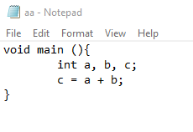

**Output:**

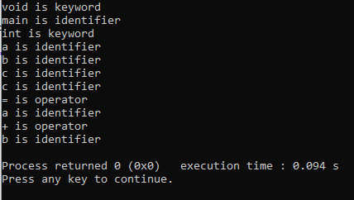

**Lab no 5: C- program to implement first of a given grammar**

**Source Code:**

#include <stdio.h>

#include <ctype.h>

void FIRST(char[], char);

void addToResultSet(char[], char);

int numOfProductions;

char productionSet[10][10];

int main()

{

int i;

char choice;

char c;

char result[20];

printf("How many number of productions ? :");

scanf(" %d", &numOfProductions);

for (i = 0; i < numOfProductions; i++) //read production string e.g.: E=E+T

{

printf("Enter productions Number %d : ", i + 1);

scanf(" %s", productionSet[i]);

}

do

{

printf("\n Find the FIRST of :");

scanf(" %c", &c);

FIRST(result, c); //Compute FIRST; Get Answer in 'result' array

printf("\n FIRST(%c)= { ", c);

for (i = 0; result[i] != '\0'; i++)

printf(" %c ", result[i]); //Display result

printf("}\n");

printf("press 'y' to continue : ");

scanf(" %c", &choice);

} while (choice == 'y' || choice == 'Y');

}

void FIRST(char *Result, char c)

{

int i, j, k;

char subResult[20];

int foundEpsilon;

subResult[0] = '\0';

Result[0] = '\0';

//If X is terminal, FIRST(X) = {X}

if (!(isupper(c)))

{

addToResultSet(Result, c);

return;

}

//If X is non terminal then read each production

for (i = 0; i < numOfProductions; i++)

{

//Find production with X as LHS

if (productionSet[i][0] == c)

{

if (productionSet[i][2] == '$')

addToResultSet(Result, '$');

//If X is a non-terminal, and X → Y1 Y2 … Yk is a production, then add a to FIRST(X)

else

{

j = 2;

while (productionSet[i][j] != '\0')

{

foundEpsilon = 0;

FIRST(subResult, productionSet[i][j]);

for (k = 0; subResult[k] != '\0'; k++)

addToResultSet(Result, subResult[k]);

for (k = 0; subResult[k] != '\0'; k++)

{

if (subResult[k] == '$')

{

foundEpsilon = 1;

break;

}

}

//No e found, no need to check next element

if (!foundEpsilon)

break;

j++;

}

}

}

}

return;

}

void addToResultSet(char Result[], char val)

{

int k;

for (k = 0; Result[k] != '\0'; k++)

if (Result[k] == val)

return;

Result[k] = val;

Result[k + 1] = '\0';

}

**Output:**

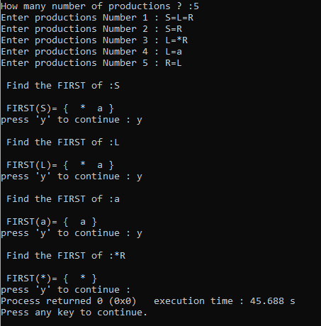

**Lab no 6: C-Program to Calculate Follow(A)**

**Source Code:**

#include <stdio.h>

#include <string.h>

#include <ctype.h>

int n, p, i = 0, j = 0;

char a[10][10], Result[10];

char subResult[20];

void follow(char *Result, char c);

void first(char *Result, char c);

void addToResultSet(char[], char);

int main()

{

int i;

int choice;

char c, ch;

printf("Enter the no. of productions: ");

scanf("%d", &n);

printf(" Enter %d productions\n Production with multiple terms should be give as separate productions \n", n);

for (i = 0; i < n; i++)

scanf("%s", a[i]);

do

{

printf("Find FOLLOW of -->");

scanf(" %c", &c);

follow(Result, c);

printf("FOLLOW(%c) = { ", c);

for (i = 0; Result[i] != '\0'; i++)

printf(" %c ", Result[i]);

printf(" }\n");

printf("Do you want to continue(Press 1 to continue....)?");

scanf("%d", &choice);

} while (choice == 1);

}

void follow(char *Result, char c)

{

int k;

subResult[0] = '\0';

Result[0] = '\0';

if (a[0][0] == c)

addToResultSet(Result, '$');

for (i = 0; i < n; i++)

{

for (j = 2; j < strlen(a[i]); j++)

{

if (a[i][j] == c)

{

if (a[i][j + 1] != '\0')

first(subResult, a[i][j + 1]);

if (a[i][j + 1] == '\0' && c != a[i][0])

follow(subResult, a[i][0]);

for (k = 0; subResult[k] != '\0'; k++)

addToResultSet(Result, subResult[k]);

}

}

}

}

void first(char *R, char c)

{

int k, m;

if (!(isupper(c)) && c != '#')

addToResultSet(R, c);

for (k = 0; k < n; k++)

{

if (a[k][0] == c)

{

if (a[k][2] == '#' && c != a[i][0])

follow(R, a[i][0]);

else if ((!(isupper(a[k][2]))) && a[k][2] != '#')

addToResultSet(R, a[k][2]);

else

first(R, a[k][2]);

for (m = 0; R[m] != '\0'; m++)

addToResultSet(Result, R[m]);

}

}

}

void addToResultSet(char Result[], char val)

{

int k;

for (k = 0; Result[k] != '\0'; k++)

{

if (Result[k] == val)

return;

}

Result[k] = val;

Result[k + 1] = '\0';

}

**Output:**

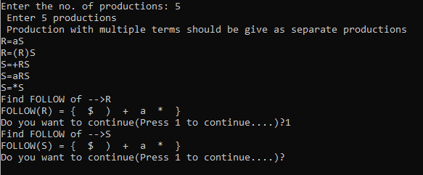

**Lab no 7: Write a C program for constructing of LL (1) parsing**

**Source Code:**

#include <stdio.h>

#include <string.h>

#include <process.h>

char s[20], stack[20];

int main()

{

char m[5][6][4] = {"tb", " ", " ", "tb", " ", " ", " ", "+tb", " ", " ", "n", "n", "fc", " ", " ", "fc", " ", " ", " ", "n", "*fc", " a", "n", "n", "i", " ", " ", "(e)", " ", " "};

int size[5][6] = {2, 0, 0, 2, 0, 0, 0, 3, 0, 0, 1, 1, 2, 0, 0, 2, 0, 0, 0, 1, 3, 0, 1, 1, 1, 0, 0, 3, 0, 0};

int i, j, k, n, str1, str2;

printf("\n Enter the input string: ");

scanf("%s", s);

strcat(s, "$");

n = strlen(s);

stack[0] = '$';

stack[1] = 'e';

i = 1;

j = 0;

printf("\nStack Input\n");

printf("__________________\n");

while ((stack[i] != '$') && (s[j] != '$'))

{

if (stack[i] == s[j])

{

i--;

j++;

}

switch (stack[i])

{

case 'e':

str1 = 0;

break;

case 'b':

str1 = 1;

break;

case 't':

str1 = 2;

break;

case 'c':

str1 = 3;

break;

case 'f':

str1 = 4;

break;

}

switch (s[j])

{

case 'i':

str2 = 0;

break;

case '+':

str2 = 1;

break;

case '*':

str2 = 2;

break;

case '(':

str2 = 3;

break;

case ')':

str2 = 4;

break;

case '$':

str2 = 5;

break;

}

if (m[str1][str2][0] == '\0')

{

printf("\nERROR");

exit(0);

}

else if (m[str1][str2][0] == 'n')

i--;

else if (m[str1][str2][0] == 'i')

stack[i] = 'i';

else

{

for (k = size[str1][str2] - 1; k >= 0; k--)

{

stack[i] = m[str1][str2][k];

i++;

}

i--;

}

for (k = 0; k <= i; k++)

printf(" %c", stack[k]);

printf(" \t\t");

for (k = j; k <= n; k++)

printf("%c", s[k]);

printf(" \n ");

}

printf("\n SUCCESS");

return 0;

}

**Output:**

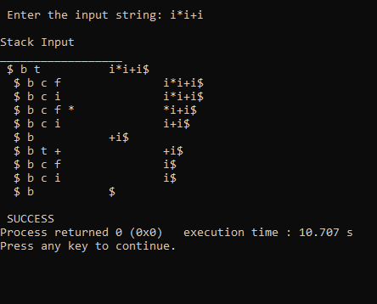

**Lab no 8: C Program to Implement Shift Reduce Parser**

**Source Code:**

#include <stdio.h>

#include <stdlib.h>

#include <conio.h>

#include <string.h>

char ip_sym[15], stack[15];

int ip_ptr = 0, st_ptr = 0, len, i;

char temp[2], temp2[2];

char act[15];

void check();

void main()

{

printf("\n\t\t SHIFT REDUCE PARSER\n");

printf("\n GRAMMER\n");

printf("\n E->E+E\n E->E/E");

printf("\n E->E*E\n E->a/b");

printf("\n enter the input symbol:\t");

gets(ip_sym);

printf("\n\t stack implementation table");

printf("\n stack\t\t input symbol\t\t action");

printf("\n______\t\t ____________\t\t ______\n");

printf("\n $\t\t%s$\t\t\t--", ip_sym);

strcpy(act, "shift ");

temp[0] = ip_sym[ip_ptr];

temp[1] = '\0';

strcat(act, temp);

len = strlen(ip_sym);

for (i = 0; i <= len - 1; i++)

{

stack[st_ptr] = ip_sym[ip_ptr];

stack[st_ptr + 1] = '\0';

ip_sym[ip_ptr] = ' ';

ip_ptr++;

printf("\n $%s\t\t%s$\t\t\t%s", stack, ip_sym, act);

strcpy(act, "shift ");

temp[0] = ip_sym[ip_ptr];

temp[1] = '\0';

strcat(act, temp);

check();

st_ptr++;

}

st_ptr++;

check();

}

void check()

{

int flag = 0;

temp2[0] = stack[st_ptr];

temp2[1] = '\0';

if ((!strcmpi(temp2, "a")) || (!strcmpi(temp2, "b")))

{

stack[st_ptr] = 'E';

if (!strcmpi(temp2, "a"))

printf("\n $%s\t\t%s$\t\t\tE->a", stack, ip_sym);

else

printf("\n $%s\t\t%s$\t\t\tE->b", stack, ip_sym);

flag = 1;

}

if ((!strcmpi(temp2, "+")) || (strcmpi(temp2, "*")) || (!strcmpi(temp2, "/")))

{

flag = 1;

}

if ((!strcmpi(stack, "E+E")) || (!strcmpi(stack, "E\E")) || (!strcmpi(stack, "E*E")))

{

strcpy(stack, "E");

st_ptr = 0;

if (!strcmpi(stack, "E+E"))

printf("\n $%s\t\t%s$\t\t\tE->E+E", stack, ip_sym);

else if (!strcmpi(stack, "E\E"))

printf("\n $%s\t\t %s$\t\t\tE->E\E", stack, ip_sym);

else

printf("\n $%s\t\t%s$\t\t\tE->E*E", stack, ip_sym);

flag = 1;

}

if (!strcmpi(stack, "E") && ip_ptr == len)

{

printf("\n $%s\t\t%s$\t\t\tACCEPT", stack, ip_sym);

getch();

exit(0);

}

if (flag == 0)

{

printf("\n%s\t\t\t%s\t\t reject", stack, ip_sym);

exit(0);

}

return;

}

**Output:**

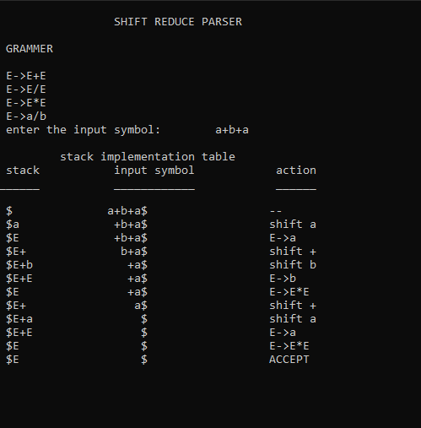

**Lab no 9: C-program for intermediate Code Generation**

**Source Code:**

#include <stdio.h>

#include <string.h>

#include <process.h>

int i = 1, j = 0, no = 0, tmpch = 90;

char str[100], left[15], right[15];

void findopr();

void explore();

void fleft(int);

void fright(int);

struct exp

{

int pos;

char op;

} k[15];

int main()

{

printf("\t\t INTERMEDIATE CODE GENERATION\n\n");

printf("Enter the Expression :");

scanf("%s", str);

printf("The intermediate code:\t\t Expression\n");

findopr();

explore();

return 0;

}

void findopr()

{

for (i = 0; str[i] != '\0'; i++)

if (str[i] == ':')

{

k[j].pos = i;

k[j++].op = ':';

}

for (i = 0; str[i] != '\0'; i++)

if (str[i] == '/')

{

k[j].pos = i;

k[j++].op = '/';

}

for (i = 0; str[i] != '\0'; i++)

if (str[i] == '*')

{

k[j].pos = i;

k[j++].op = '*';

}

for (i = 0; str[i] != '\0'; i++)

if (str[i] == '+')

{

k[j].pos = i;

k[j++].op = '+';

}

for (i = 0; str[i] != '\0'; i++)

{

if (str[i] == '-')

{

k[j].pos = i;

k[j++].op = '-';

}

}

}

void explore()

{

i = 1;

while (k[i].op != '\0')

{

fleft(k[i].pos);

fright(k[i].pos);

str[k[i].pos] = tmpch--;

printf("\t%c := %s%c%s\t\t", str[k[i].pos], left, k[i].op, right);

for (j = 0; j < strlen(str); j++)

if (str[j] != '$')

printf("%c", str[j]);

printf("\n");

i++;

}

fright(-1);

if (no == 0)

{

fleft(strlen(str));

printf("\t%s := %s", right, left);

exit(0);

}

printf("\t%s := %c", right, str[k[--i].pos]);

}

void fleft(int x)

{

int w = 0, flag = 0;

x--;

while (x != -1 && str[x] != '+' && str[x] != '*' && str[x] != '=' && str[x] != '\0' && str[x] != '-' && str[x] != '/' && str[x] != ':')

{

if (str[x] != '$' && flag == 0)

{

left[w++] = str[x];

left[w] = '\0';

str[x] = '$';

flag = 1;

}

x--;

}

}

void fright(int x)

{

int w = 0, flag = 0;

x++;

while (x != -1 && str[x] != '+' && str[x] != '*' && str[x] != '\0' && str[x] != '=' && str[x] != ':' && str[x] != '-' && str[x] != '/')

{

if (str[x] != '$' && flag == 0)

{

right[w++] = str[x];

right[w] = '\0';

str[x] = '$';

flag = 1;

}

x++;

}

}

**Output:**

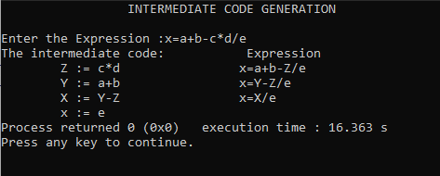

**Lab no 10: C-program for Final Code Generation**

**Source Code:**

#include <stdio.h>

#include <string.h>

char op[2], arg1[5], arg2[5], result[5];

int main()

{

FILE *fp1, *fp2;

fp1 = fopen("input.txt", "r");

fp2 = fopen("output.txt", "w");

while (!feof(fp1))

{

fscanf(fp1, "%s%s%s%s", op, arg1, arg2, result);

if (strcmp(op, "+") == 0)

{

fprintf(fp2, "\n MOV R0,%s", arg1);

fprintf(fp2, "\n ADD R0,%s", arg2);

fprintf(fp2, "\n MOV %s,R0", result);

}

if (strcmp(op, "*") == 0)

{

fprintf(fp2, "\n MOV R0,%s", arg1);

fprintf(fp2, "\n MUL R0,%s", arg2);

fprintf(fp2, "\n MOV %s, R0", result);

}

if (strcmp(op, "-") == 0)

{

fprintf(fp2, "\n MOV R0,%s", arg1);

fprintf(fp2, "\n SUB R0,%s", arg2);

fprintf(fp2, "\n MOV %s,R0", result);

}

if (strcmp(op, "/") == 0)

{

fprintf(fp2, "\n MOV R0,%s", arg1);

fprintf(fp2, "\n DIV R0,%s", arg2);

fprintf(fp2, "\n MOV %s,R0", result);

}

if (strcmp(op, "=") == 0)

{

fprintf(fp2, "\n MOV R0,%s", arg1);

fprintf(fp2, "\n MOV %s,R0", result);

}

}

fclose(fp1);

fclose(fp2);

return 0;

}

**Input:**

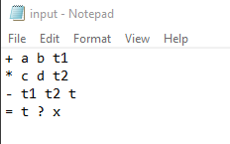

**Output:**

