Authentication

Stateful vs Stateless

<https://stackoverflow.com/questions/4506241/stateful-beans-and-stateless-beans-in-spring-context>

Stateful and Stateless protocol

<https://www.google.com/search?q=what+is+stateless+and+stateful+application+with+example&sxsrf=APwXEdcCod7k_L8K3KNaVN-9hyvZT-lowg:1683401376335&source=lnms&tbm=vid&sa=X&ved=2ahUKEwjy4rPotuH-AhUv-jgGHewmB3AQ_AUoAnoECAEQBA&biw=1536&bih=746&dpr=1.25#fpstate=ive&vld=cid:3989fc2a,vid:H5-kLQ4WZ7Y>

Spring Security

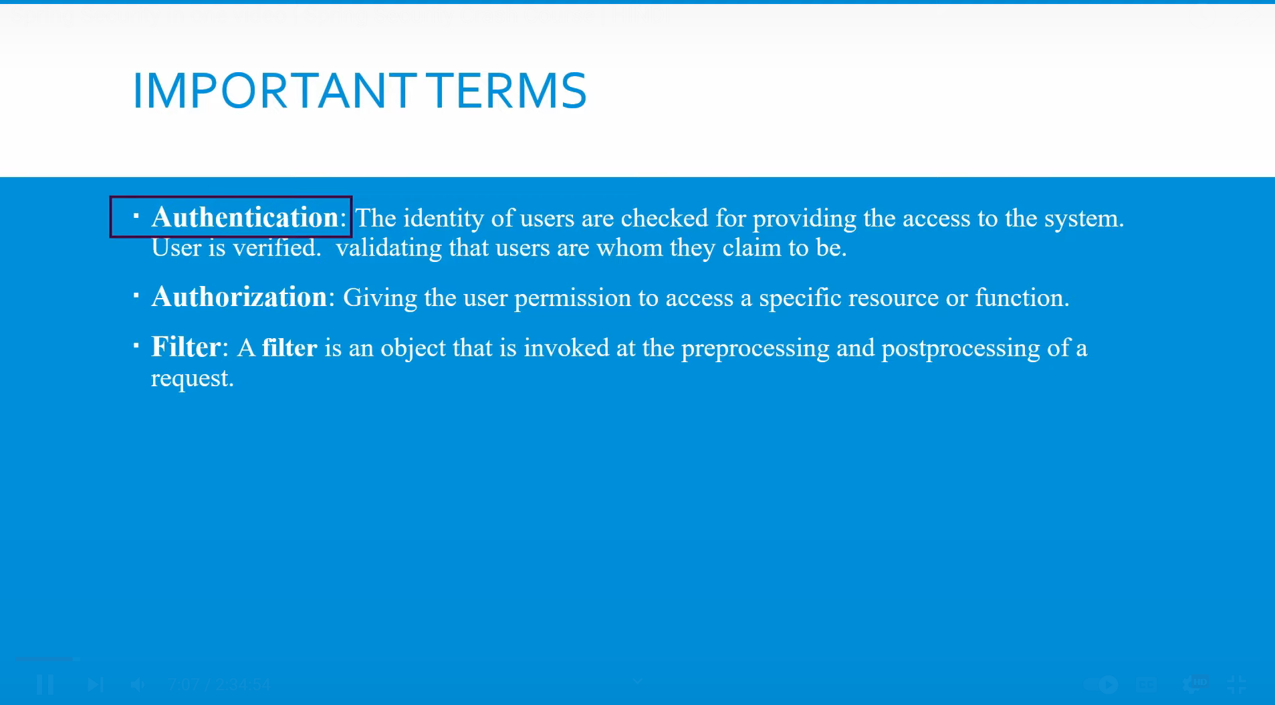

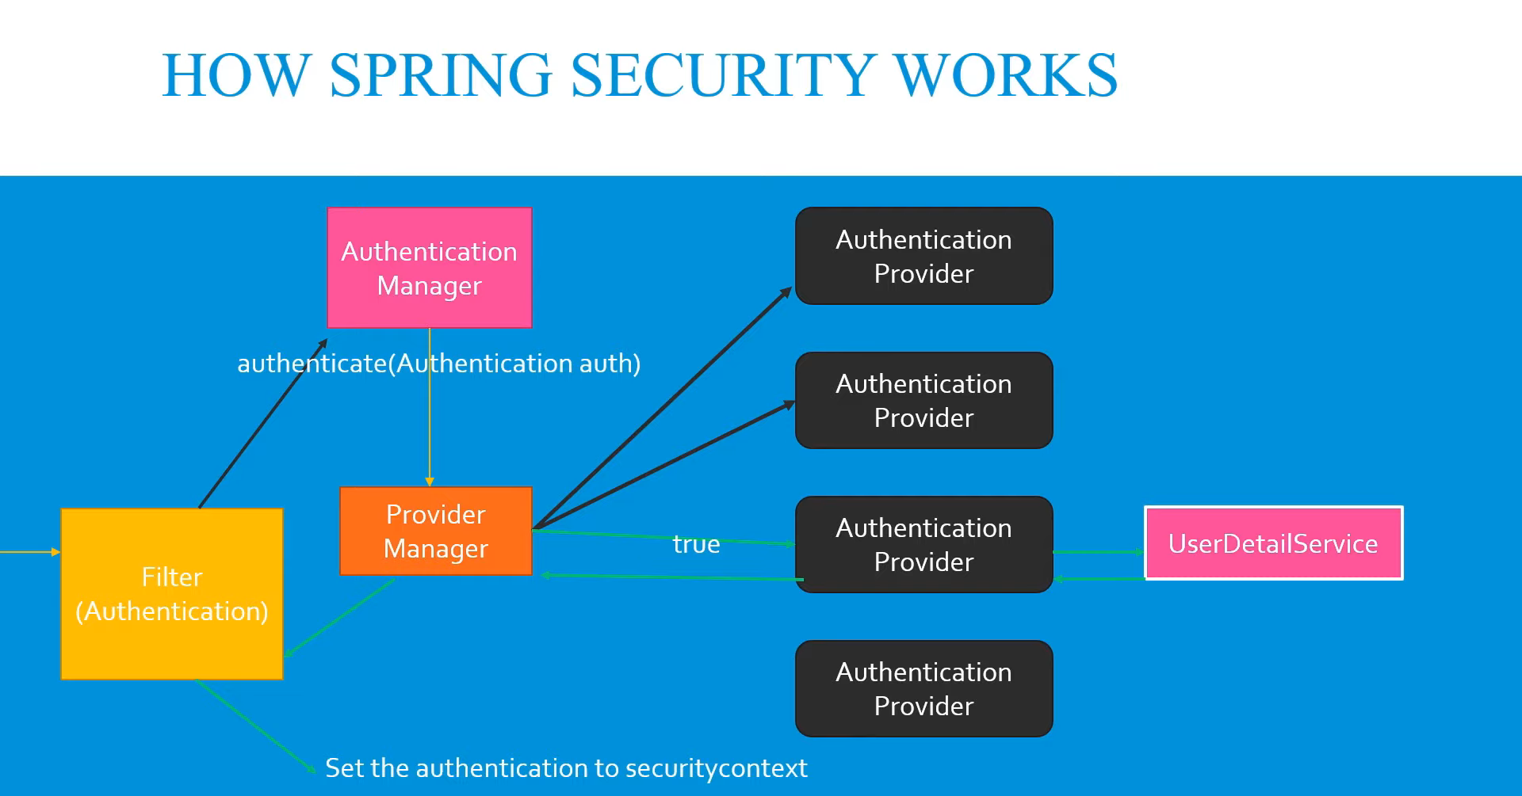

Filter acts as an interceptor it create an authentication object then it call the Authenticate method of authentication manager which is an interface which ask provider manager for appropriate implementation

After finding appropriate provider, provider call UserDetailService for getting user info if authentication is successful returns successful response.

By default spring boot provide form based authentication

It means that when you try to access tha api for first time then you have get the login page where we need to put username and password by default it is user and password we get on console

Once we do that we can access all the APIs we also have logout page after logginout we cannot access the api

We can change the authentication to basic authentication in which we need to send username and password with every APi call here we don’t have logout as we have send login credential everytime while hitting apis