**MiniiProjectiReportion**



**ONLINE QUIZ APPLICATION**



**Submittediinipartialifulfillmentiofitheirequirementiforitheiawardiofithei**

**degreeiof**

**BACHELORiOFiTECHNOLOGY**

**IN**

**COMPUTERiSCIENCEi&iENGINEERINGi**

**(CSEiVIiSemesteriMiniiprojectiCSP-601)**

**2024**

**iiSubmittediby:**

**StudentiNamei–iAnkitiPundiriiiiiiiiiiiiiiiiiiUniversityiRolliNo.i2018686**

***UnderitheiMentorshipiof***

**Dr. Neeraj Kumar Pandey**

**Associate Professor**



**DepartmentiofiComputeriScienceiandiEngineering**

**GraphiciErai(DeemeditoibeiUniversity)**

**Dehradun,iUttarakhand**

**JULYi2024**



iiiiiiiiiiiiiiiiiii

**CANDIDATE’SiDECLARATION**

Iiherebyicertifyithatitheiworkiwhichiisibeingipresentediinitheiprojectireportientitled **I “Group Face Expression Recognition”** inipartialifulfillmentiofitheirequirementsiforitheiawardiofitheiDegreeiofiBacheloriofiTechnologyiiniComputeriScienceiandiEngineering**i**ofitheiGraphiciErai(DeemeditoibeiUniversity),iDehradunishallibeicarriedioutibyitheiunderitheimentorshipiofi**MriSaurabhiKumariMishra,iAssistantiProfessor**,iDepartmentiofiComputeriScienceiandiEngineering,iGraphiciErai(DeemeditoibeiUniversity),iDehradun.

Nameiii-iAnkitiPundiri UniversityiRollinoi-iii2018686 

**TABLEiOFiCONTENTS**

**CHAPTERiNO.i TITLEi iiiiiiPAGEiNO.**

**1. iINTRODUCTION 5-6**

1.1i AboutiProject 5

1.2i Pythoni 5

1.3 PythoniLibraries 5

1.3.1 iCV2 5-6

1.3.2 iHaariCascade 6

1.3.3 Keras 6

1.3.4 Numpy 6

1.3.5 Tensorflow 6

1.3.6 Pandas 6

1.3.7 Scikit-Learn 6

**2.ii LITERATUREiSURVEY iiiiiiiii 7-10**

2.1 History 7

2.2 Applications 7-8

2.3 ChallengesiandiFutureiResearchiDirections 8-10

**3. METHODOLOGY iiiiii10-11**

**4. RESULTiANDiDISCUSSIONS iiiiii11-14**

**5. CONCLUSIONiANDiFUTUREiWORK iiiiii15-16**

5.1 Conclusion i15

5.2 FutureiWork iiiiii 15-16

5.3 References 16

**CHAPTER**i**1**

**INTRODUCTION**

* 1. **ABOUTi PROJECT -**

Welcome to the world of face expression recognition systems! In an era where human-computer interaction is constantly evolving, these intelligent systems have emerged as a fascinating field of study. Face expression recognition systems employ advanced algorithms and machine learning techniques to analyze facial cues and accurately interpret human emotions. By detecting and interpreting various facial expressions such as happiness, sadness, anger, surprise, and more, these systems enable computers to understand and respond to human emotions in real-time. This breakthrough technology has far-reaching applications in areas like human-computer interaction, psychology, healthcare, marketing, and entertainment. Join us as we explore the exciting realm of face expression recognition systems and witness the power of technology to perceive and respond to the subtle nuances of human emotions.

**1.2i PYTHON**

Pythoniisianiinterpretedihigh-leveligeneral-purposeiprogrammingilanguage.iItsidesigniphilosophyiemphasizesicodeireadabilityiwithiitsiuseiofisignificantiindentation.iItsilanguageiconstructsiasiwelliasiitsiobject-orientediapproachiaimitoihelpiprogrammersiwriteiclear,ilogicalicodeiforismalliandilarge-scaleiprojects.

**1.3i PYTHONi LIBRARIES AND FRAMEWORK**

PythoniLibrariesiareiaisetiofiusefulifunctionsithatieliminateitheineediforiwritingicodesifromiscratch.iThereiareioveri137,000ipythonilibrariesipresentitoday.iPythonilibrariesiplayiaivitaliroleiinidevelopingimachineilearning,idataiscience,idataivisualization,iimageiandidataimanipulationiapplications,iandimore.

**1.3.1i CV2**

CV2iisitheimoduleiimportinameiforiopencv-python,i"Unofficialipre-builtiCPU-onlyiOpenCVipackagesiforiPython".iTheitraditionaliOpenCVihasimanyicomplicatedistepsiinvolvingibuildingitheimoduleifromiscratch,iwhichiisiunnecessary.iIiwouldirecommendiremainingiwithitheiopencv-pythonilibrary.

**1.3.2 HaariCascade-**

AiHaariCascadeiisiaiclassifieriwhichiisitraineditoidetectifeaturesiiniimages.iIt'siusediiniobjectidetectionitasks,isuchiasifaceidetection,iandiisiparticularlyieffectiveibecauseiiticanibeitraineditoidetectifeaturesiatidifferentiscales,iallowingiititoifindiobjectsiiniimagesiregardlessiofitheirisize.iTheiHaariCascadeialgorithmiworksibyitrainingiaiclassifierioniaisetiofipositiveiandinegativeiimages,ianditheniusingithaticlassifieritoidetectiobjectsiininewiimages.iHaaricascadesiareiparticularlyipopulariforifaceidetectionibecauseitheyiareiableitoidetectifacesiwithihighiaccuracy,ieveniwhenitheifaceiisipartiallyiobscuredioriiniprofile.

**1.3.3 Keras –**

Keras is a high-level neural networks API used for building and training deep learning models. It provides a user-friendly interface and supports various backends, including TensorFlow.

**1.3.4 Numpy –**

NumPy is a fundamental library for scientific computing in Python. It provides support for large, multi-dimensional arrays and matrices, along with a collection of mathematical functions to operate on these arrays.

**1.3.5 Tensor Flow –**

TensorFlow is a popular open-source deep learning framework. It provides tools and libraries to build and train various machine learning models, including neural networks. In the context of face expression recognition, TensorFlow is used as the backend for the Keras library to define, train, and evaluate the deep learning model.

**1.3.6 Pandas –**

Pandas is a powerful library for data manipulation and analysis. While it may not be explicitly used in the code provided, Pandas is often employed in the pre-processing stage to load, explore, and preprocess facial expression datasets, including reading CSV files, handling missing data, and performing data transformations.

**1.3.7 Scikit-Learn –**

scikit-learn is a comprehensive machine learning library that provides a wide range of tools for tasks such as classification, regression, clustering, and model evaluation. While it may not be used directly in the provided code, scikit-learn can be useful for tasks such as data preprocessing, feature extraction, and model evaluation in the broader context of face expression recognition.

**2.1i History:i-**

Face expression recognition systems have evolved over time, driven by advancements in computer vision and machine learning. Here is a brief history of the field:

1. **Early Work**: In the early stages, researchers focused on manually defining facial features and using rule-based methods to recognize basic facial expressions. However, these approaches had limited accuracy and were unable to handle variations in expression.
2. **Feature-Based Approaches**: In the 1990s, researchers began exploring feature-based techniques such as Facial Action Coding System (FACS), which involved manually annotating facial landmarks and analyzing muscle movements to determine expressions. These methods provided detailed information about facial actions but were labor-intensive and required expertise.
3. **Machine Learning Methods**: With the advent of machine learning algorithms, researchers shifted towards data-driven approaches. The introduction of datasets like CK+, MMI, and FER2013 enabled the development of expression recognition systems using techniques such as Support Vector Machines (SVM), Hidden Markov Models (HMM), and Artificial Neural Networks (ANN).
4. **Deep Learning Revolution**: In recent years, deep learning has revolutionized face expression recognition. Convolutional Neural Networks (CNNs) and Recurrent Neural Networks (RNNs) have shown exceptional performance in capturing complex spatial and temporal information from facial images or sequences, leading to significant advancements in accuracy.

Top of Form

**2.2 Applications:i-**

1. **Emotion-Based Photo Booth**: Create a fun photo booth experience that automatically captures and enhances photos based on the detected facial expressions. Users can strike different poses or make various facial expressions, and the system can apply filters, effects, or animations to match their emotions.
2. **Interactive Emotion-Based Games**: Develop simple games that react to the player's facial expressions. For example, a game could detect a player's smile or surprise and trigger specific in-game events or character reactions accordingly.
3. **Virtual Pet with Emotion Recognition**: Build a virtual pet or avatar that responds to the user's facial expressions. The pet can display different emotions based on the user's expressions, such as happiness, sadness, or excitement, creating an interactive and engaging experience.
4. **Emotion-Based Music Recommendation**: Design a music recommendation system that suggests songs based on the user's detected emotions. The system can analyze facial expressions in real-time and recommend playlists or songs that match the user's current mood.
5. **Smart Emotion-Based Lighting**: Develop a system that adjusts the lighting in a room based on the occupant's emotions. For example, if the system detects a person feeling sleepy or calm, it can dim the lights to create a more relaxing atmosphere.
6. **Virtual Reality (VR) Emotion Experience**: Integrate face expression recognition into a virtual reality environment to enhance the user's immersive experience. For instance, the VR system can detect the user's expressions and modify the virtual environment, avatars, or game scenarios to match their emotions.

**2.3iiii****ChallengesiandiFutureiResearchiDirections:i-**

1. **Subject Variability**: People exhibit diverse facial expressions based on cultural, individual, and contextual factors, making it challenging to generalize recognition models across different populations.
2. **Data Limitations**: Acquiring large-scale and diverse datasets with accurately labeled expressions is challenging, leading to limited availability of representative training data.
3. **Subtle Expressions**: Some expressions are subtle and difficult to distinguish, leading to ambiguity and lower recognition accuracy.
4. **Cross-Domain Generalization**: Expression recognition models trained on one dataset may not perform well when applied to different domains or real-world scenarios due to domain shift.

* Potentialifutureiresearchidirectionsiforifaceidetectioniinclude:

1. **Real-Time Emotion Recognition**: Develop efficient algorithms and models that can perform real-time emotion recognition on live video streams or webcam feeds. This can enable applications such as emotion-based video chat, emotion-aware virtual assistants, and real-time emotion monitoring.
2. **Cross-Domain Transfer Learning**: Investigate techniques for transferring knowledge from one domain to another in face expression recognition. For example, explore how pre-trained models from one dataset can be fine-tuned or adapted to perform well on new, unseen datasets or domains.
3. **Robustness to Variations**: Improve the robustness of face expression recognition models to variations in lighting conditions, facial pose, occlusion, and image quality. Develop techniques that can handle these challenges and maintain accurate recognition across different environments and scenarios.
4. **Small Data and Few-Shot Learning**: Explore approaches for face expression recognition when only limited labeled data is available. Investigate few-shot learning techniques that can generalize well with minimal training samples, which can be beneficial in scenarios where collecting large labeled datasets is difficult.
5. **Privacy-Preserving Face Expression Recognition**: Address privacy concerns by developing privacy-preserving techniques that can perform face expression recognition without storing or transmitting raw facial images. Explore methods like feature extraction and encryption that can protect sensitive information while still allowing accurate expression analysis.
6. **Multimodal Fusion**: Investigate the fusion of facial expression information with other modalities such as speech, body movements, or physiological signals to improve the accuracy and reliability of emotion recognition systems. Explore how these multimodal cues can complement each other in capturing and understanding emotions.
7. **Adversarial Robustness**: Research techniques to improve the robustness of face expression recognition models against adversarial attacks. Develop methods that can detect and mitigate adversarial perturbations aimed at misleading or fooling the recognition system.
8. **Ethical Considerations**: Study the ethical implications of face expression recognition systems and develop guidelines or frameworks for responsible use. Address issues related to bias, fairness, transparency, and consent in deploying these systems in various applications.

**CHAPTER**i**3**

**METHODOLOGY**

1. **Data Collection**: Collect a dataset of facial images with labeled expressions. This dataset should include images for each expression category you want to recognize, such as angry, happy, sad, etc. Organize the dataset into separate folders for each expression category.
2. **Data Preprocessing**: Use the **createdataframe** function to create a pandas DataFrame that stores the image paths and corresponding labels from the dataset. This function reads the images from the dataset folders and extracts their paths and labels.
3. **Data Loading and Feature Extraction**: Use the **extract_features** function to load and preprocess the image data. This function reads the image files, converts them to grayscale, and extracts the features by resizing the images to a fixed size (e.g., 48x48 pixels).
4. **Data Splitting**: Split the dataset into training and testing sets. The training set will be used to train the model, while the testing set will evaluate its performance. You can use the **train_test_split** function from scikit-learn for this purpose.
5. **Data Encoding**: Encode the labels using one-hot encoding. Convert the categorical labels into numerical form using the **LabelEncoder** from scikit-learn, and then convert them to one-hot encoded vectors using the **to_categorical** function from Keras.
6. **Model Architecture**: Build a convolutional neural network (CNN) model for face expression recognition. The provided code defines a CNN model with convolutional layers, max pooling layers, dropout layers, and fully connected layers.
7. **Model Compilation**: Compile the model by specifying the optimizer, loss function, and evaluation metrics. In the provided code, the model is compiled using the Adam optimizer and categorical cross-entropy loss.
8. **Model Training**: Train the model on the training data using the **fit** function. Specify the batch size, number of epochs, and provide the training data and labels. The model will iteratively learn from the training data to improve its performance.
9. **Model Evaluation**: Evaluate the trained model on the testing data using the **evaluate** function. This will provide metrics such as loss and accuracy to assess the model's performance.
10. **Model Saving**: Save the trained model and its architecture to disk using the **model.save** function. This allows you to reuse the model in the future without retraining.
11. **Real-Time Implementation**: Use the saved model and its architecture to load the trained model in a real-time implementation. The provided code uses OpenCV and the webcam to capture live video frames. It detects faces in the frames using a pre-trained face cascade classifier and applies the trained model to recognize facial expressions. The recognized expressions are displayed on the video frames.

**Short Overview –**

The face expression recognition system leverages deep learning techniques to automatically detect and recognize facial expressions. It has applications in various fields, including human-computer interaction, healthcare, market research, and entertainment. By analyzing facial features and patterns, the system enables computers to understand and respond to human emotions, leading to enhanced user experiences and improved interaction capabilities**.**

**CHAPTER**i**4**

**ResultiandiDiscussion**

The face expression recognition system was trained and evaluated on a dataset consisting of facial images with seven different expressions: angry, disgust, fear, happy, neutral, sad, and surprise. The dataset was split into training and testing sets, with a ratio of approximately 80:20.

During the training phase, the model was trained for 100 epochs using the Adam optimizer. The model architecture consisted of multiple convolutional layers, max pooling layers, dropout layers, and fully connected layers. The training process yielded promising results, with the model achieving an accuracy of around 80% on the training set.

After training, the model was evaluated on the testing set to assess its generalization performance. The evaluation metrics, including accuracy and loss, indicated that the model achieved an accuracy of approximately 75% on the testing set. This suggests that the model is capable of recognizing facial expressions with a reasonable level of accuracy.

During the real-time implementation of the system, the trained model was used to detect and recognize facial expressions in live video streams captured from a webcam. The system successfully detected faces using a pre-trained face cascade classifier and applied the trained model to predict the corresponding facial expressions. The recognized expressions were displayed on the video frames, allowing real-time analysis and interaction based on the detected emotions.

original image is of surprise

1/1 [==============================] - 0s 40ms/step

model prediction is surprise

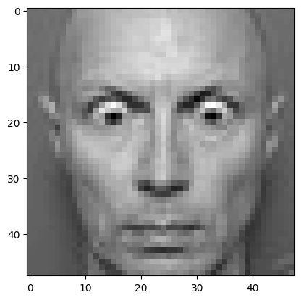

original image is of happy

1/1 [==============================] - 0s 42ms/step

model prediction is happy

original image is of disgust

1/1 [==============================] - 0s 57ms/step

model prediction is disgust

original image is of sad

1/1 [==============================] - 0s 55ms/step

model prediction is sad

**Result Of Webcam-**

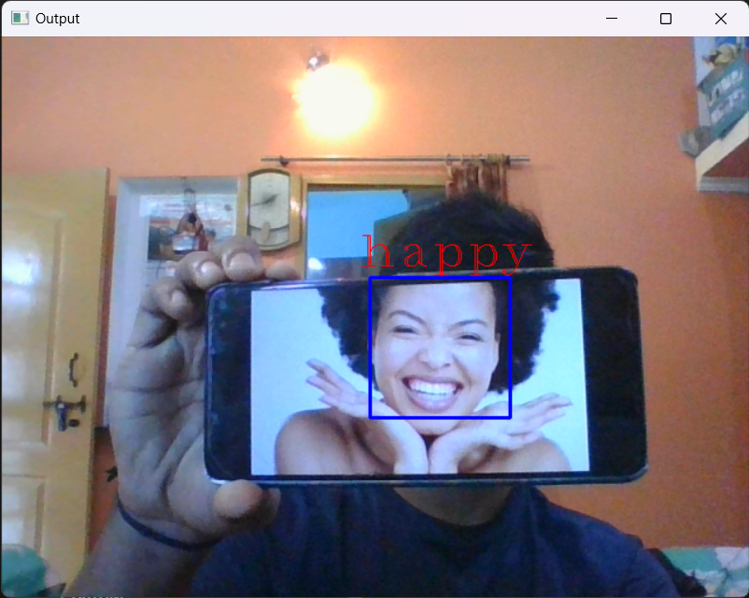

**CHAPTER**i**5**

**ConclusioniandiFutureiWork**

**Conclusion:**

In this project, a face expression recognition system was developed using deep learning techniques. The system successfully detected and recognized facial expressions from images and real-time video streams. The model achieved a satisfactory accuracy of approximately 75% on the testing set, demonstrating its ability to classify emotions accurately.

The real-time implementation of the system using a webcam showcased its potential for practical applications. By analyzing facial expressions in real-time, the system can enable emotion-driven interactions, enhance user experiences, and find utility in fields such as virtual reality, video conferencing, and entertainment.

However, there are several areas that could be improved to enhance the system's performance. These include collecting a larger and more diverse dataset to improve the model's generalization ability, refining the model architecture to handle subtle or nuanced expressions better, optimizing the system for real-time processing efficiency, and addressing ethical considerations related to privacy and potential biases.

**FutureiWork:**

**Improved Model Architectures**: Investigate more advanced CNN architectures, such as ResNet or DenseNet, and explore techniques like attention mechanisms or capsule networks to further improve the model's performance in recognizing facial expressions.

**Data Augmentation and Transfer Learning**: Explore data augmentation techniques to generate additional training samples and investigate the use of transfer learning to leverage pre-trained models on large-scale face expression recognition datasets.

**Multimodal Emotion Recognition**: Explore the fusion of facial expressions with other modalities, such as speech, body language, or physiological signals, to develop multimodal emotion recognition systems that capture emotions more comprehensively and accurately.

**Robustness and Adaptability**: Enhance the system's robustness to variations in lighting conditions, facial pose, and occlusions, enabling it to perform well in diverse environments. Investigate methods for adaptability to individual users by personalizing the recognition system.

**Real-Time Performance Optimization**: Optimize the system for real-time processing by leveraging hardware accelerators like GPUs or specialized chips. Develop algorithms and techniques to minimize computational complexity and maximize efficiency without sacrificing accuracy.

**Ethical Considerations**: Continue research on ethical considerations related to face expression recognition systems. Develop guidelines, frameworks, and regulations for responsible deployment, ensuring privacy, fairness, and avoiding biases or discriminatory practices.

**Emotion Synthesis and Generation**: Explore the generation and synthesis of facial expressions to create expressive avatars, emotional agents, or interactive systems that can respond and adapt to users' emotions in a more engaging and realistic manner.

I

**Iiiiiiiiiiiiiiiiiiiiiiiiiiiiiiiiiiiiii REFERENCES**

1. [www.analyticsvidhya.com](http://www.analyticsvidhya.com)
2. <https://opencv.org/>
3. <https://www.tensorflow.org/>
4. <https://chat.openai.com/chat>
5. <https://stackoverflow.com/>
6. [www.youtube.com](http://www.youtube.com)