Week-1

In Supervised Learning the learner has access to labeled examples. In RL the reward gives the agent some idea how good or bad the recent actions were. Supervised Learning – learning with teacher; RL uses rewards which tells the model how good the result looks like but it tell you how to do it.

Unsupervised Learning is about extracting underlying structure in data, it’s about data representation, it can be used to construct representations that make a supervised or RL system better. Techniques from both SL and UL can be used to aid generalization in RL.
We can’t have our agents get everything correct in the first trial itself. An agent learning from the most recent trial performs better than the one which tries to memorize everything.

Week-2

Chapter-2, Multi-armed Bandits (Notes)

Most important feature of RL is that it uses training information that evaluates the actions rather than instructs by giving correct action. This creates the need for active exploration, for an explict search of good behavior. When we evaluate a feedback it indicates how good the action was, but it doesn’t give us the best and worst possible actions.
IN THIS CHAPTER WE’LL SEE HOW EVALUATIVE ASPECT OF RL WORKS, IN A SIMPLIFIED SETTING WHERE IT SHOULD LEARN TO WORK IN ONE SITUATION. This is known as nonassociative setting where complexity is avoided by doing evaluative feedback is done beforehand. Studying this helps us distinguish evaluative feedback from instructive feedback.
We’ll see k-armed bandits problem in this chapter which will help us a lot of basic learning methods which we’ll use in later chapters to apply full RL. At the end of the chapter we’ll discuss a associative case of this problem, i.e., where we’ll have actions taken for more than one situation.

2.1 A k-armed Bandit Problem

In this problem statement we are faced with k different actions and after each choice we are given a numerical reward depending on the action which we selected. Our objective is to maximize the expected total reward over a time period or time steps.
A famous analogy is the slot machine with k levers and our action of selecting levers such that we hit the maximum jackpot in a given number of moves so we have to maximize our winning by concentrating our actions on the best lever.

In our k-bandit problem, each action has an expected reward , let us call it value. We denote many keywords as follows :

- At – selected action at time t.
- Rt – corresponding reward.
- q*(a) – reward for an arbitrary selected action ‘a’.
- We assume that we don’t know the action values with certainity, and denote them with Qt(a). We would like it to be close to q*(a).

q*(a) = E|Rt|At = a|

Now there are two ways to perform these actions. First is to perform actions and note down the greatest value at any given time stamp. We call these actions as greedy actions. When we select one of these actions, we say that we are exploiting our our current knowledge of the value of the actions. If we select of nongreedy actions then we are exploring. We have a conflict of selecting between exploration and exploitation, and there are many complex ways of balancing them for particular cases of k-armed bandits or other related problems.
We won’t worry about balancing exploration and exploitation in a sophisticated way; we worry only about balancing them at all. We will go through various methods in this chapter which will show us how it is better than always exploiting.

2.2-ACTION-VALUE METHOD
In this method we begin by looking closely at methods for estimating the values of actions and for using the estimates to make action selection decisions, which we collectively call action-value methods. One natural way to estimate the values is by using the mean values.
Qt(a)=(sum of rewards when a taken prior to t)/(number of times a taken prior to t)
Now if number of times a taken prior to time t is zero and then the action-value goes to infinity, to overcome this we set action-value to zero if no cases containing a were taken before time t. Now, of course there are other ways but since this is the simple one we will use this.
Now the simplest action selection methods is to use greedy actions with the highest estimated value and if there are more than one greedy actions possible then we pick up one randomly. We write the greedy action selection method as
At = argmaxQt(a)
where argmax denotes the action a for which the expression that follows is maximized. Greedy action exploits current knowledge and does no sampling at all to check other actions. A simple way is to behave greedily most of the time, but once in a while, with small probability ε , instead select randomly from among all the actions with equal probability, independently of the action-value estimates. We call it near-greedy action selection rule(ε-greedy action selection). An advantage of this method is that, in the limit as the number of steps increases, every action will be sampled an infinite number of times, thus ensuring that all the Qt(a) converges to q*(a). This implies that the probability of selecting the optimal action converges to greater than 1 – ε, that is, to near certainity.
2.3 – The 10-armed Testbed
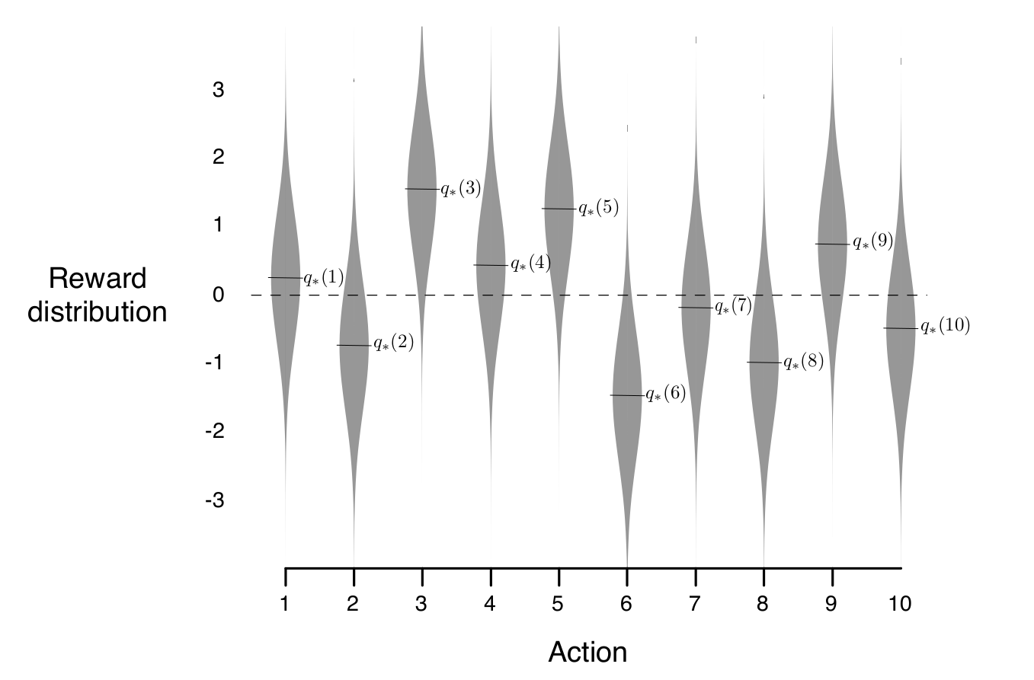
Now we’ll see the effectivness of ε-greedy action-value to greedy action-value methods. We do this for 2000 randomly generated k-armed bandit problems with k=10. Now for each value from of q*(a), for a = 1,..., 10, we have the graph below :
with mean 0 and variance of 1. Then the learning method is applied to that problem selected action At at time step t, the actual reward, Rt, was selected from a normal distribution with mean q*(At) and variance 1. The distributions are shown in the graph above. Now this test is known as the 10-armed testbed. Now we perform the greedy method and the ε-greedy method. And we can have a look at the experience for 1000 time steps, take a look at the result below :
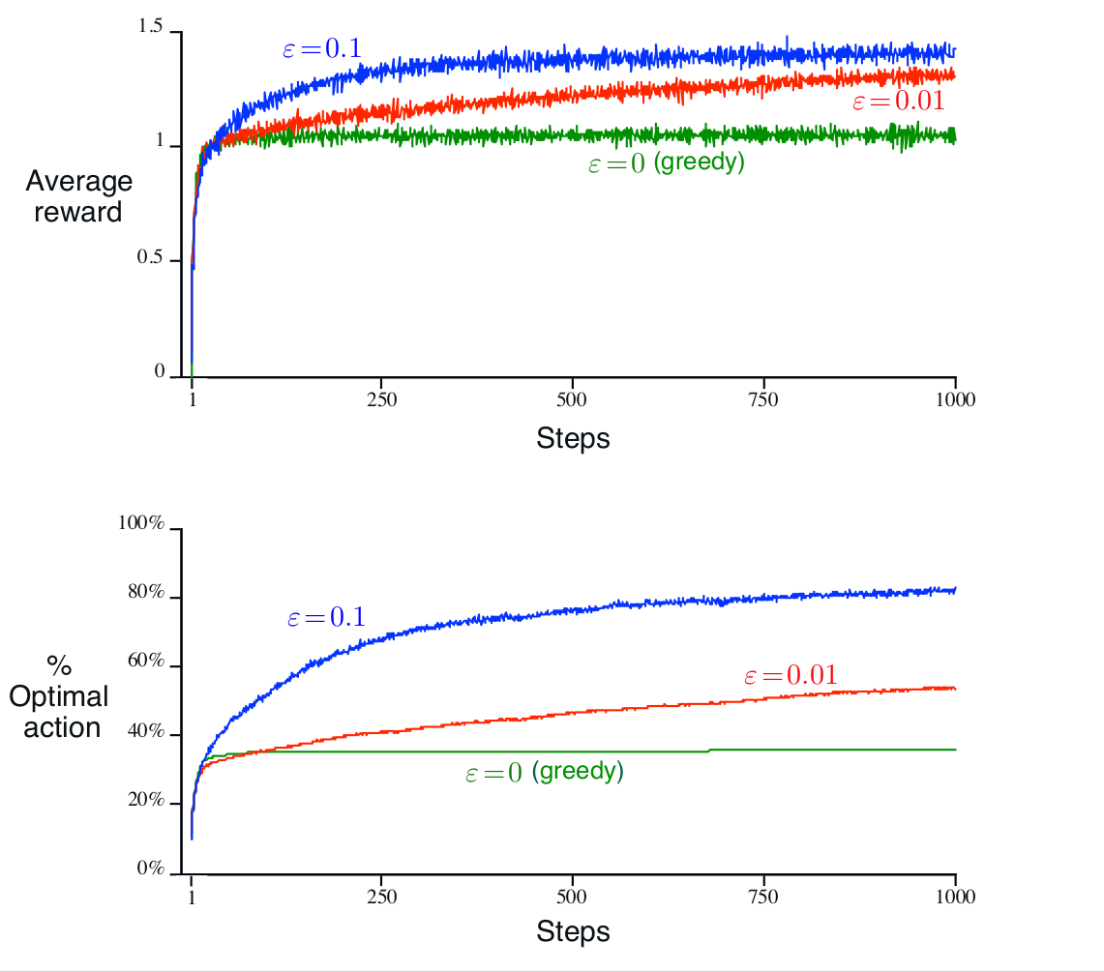
This shows a clear performance difference b/w greedy and ε-greedy methods. Greedy method performs better when the reward variance is really low(close to zero). The ε-greedy method prevails in non-stationary cases where the value of each task is not fixed.

