🎵
MUSIC STORE DATABASE ANALYSIS
A SQL-Driven Business Intelligence Project
Relational Database Design • Advanced SQL Querying • Data-Driven Decision Making
Prepared For: Music Store Data Analysis Capstone Project
Database Engine: PostgreSQL
Report Date: July 2026

Acknowledgement

I would like to express my sincere gratitude to everyone who supported the completion of this Music Store Database Analysis project. This project was undertaken as part of a self-directed effort to strengthen practical skills in relational database design and advanced SQL analytics, using a real-world-style transactional dataset modeled on a digital music retailer.
I am grateful for the open educational resources and the structured question bank that guided the analytical scope of this project, ranging from foundational aggregation queries to advanced window-function and recursive CTE techniques. This exercise has been instrumental in translating theoretical SQL knowledge into applied, business-oriented problem solving.
Finally, I acknowledge the broader open-source community — PostgreSQL, and the many database design practitioners whose schema conventions informed the structure of this dataset.

Executive Summary

This report presents a comprehensive SQL-based analysis of a Music Store's relational database — a digital media retailer dataset comprising customers, invoices, tracks, albums, artists, and employees across 24 countries. The objective was to extract actionable business intelligence using structured, progressively advanced SQL techniques: from simple aggregation to window functions, recursive CTEs, and multi-table joins.
The analysis spans 11 business questions organized into three tiers of complexity (Easy, Moderate, Advanced), covering employee seniority, geographic revenue concentration, customer value segmentation, genre-based marketing targeting, and country-level top-spender identification.
Key findings show the business generated $4,709.43 in total revenue across 614 invoices from 59 customers, with the USA, Canada, and Brazil as the top three markets by invoice volume, Rock as the dominant genre at 1,297 tracks (37% of the catalog), and Prague emerging as the single highest-revenue city — a strong candidate for the proposed promotional Music Festival.
Database Snapshot
Metric | Value
Total Customers | 59
Total Invoices | 614
Total Invoice Line Items | 4,757
Total Tracks in Catalog | 3,503
Total Albums | 347
Total Artists | 275
Music Genres | 25
Countries Served | 24
Total Revenue Generated | $4,709.43

1. Project Overview

The Music Store Database Analysis project simulates the analytics function of a digital music retail company, similar in structure to iTunes-style platforms. The underlying dataset captures the full transactional lifecycle of the business: customer records, sales staff, invoices and line-item purchases, and a rich music catalog organized by artist, album, track, genre, and media format.
Using PostgreSQL as the database engine, this project applies SQL exclusively — no external BI tool — to answer real business questions a store manager, marketing team, or executive might ask. The project is deliberately staged in three difficulty tiers to demonstrate a full range of SQL competency, from basic filtering and aggregation to window functions and recursive common table expressions (CTEs).

2. Business Problem Statement

A digital music retailer holds large volumes of transactional and catalog data but lacks a systematic way to translate that data into strategic decisions. Management needs answers to concrete questions: Which markets generate the most revenue? Who are the highest-value customers? Which genres and artists should be prioritized for licensing, marketing, and promotional investment? Without SQL-driven analysis, these questions would rely on guesswork rather than evidence.
This project addresses that gap by building a query framework that transforms raw relational data into decision-ready insights across sales performance, customer value, and content strategy.

3. Objectives

- Organizational Insight: Identify staff seniority structure and reporting hierarchy within the employee table.
- Market Analysis: Determine which countries and cities generate the highest invoice volume and revenue.
- Customer Segmentation: Identify top-spending customers overall and on a per-country basis.
- Content Strategy: Determine the most popular genres and top-performing artists, both overall and per country.
- Technical Demonstration: Apply a progressive range of SQL techniques — joins, aggregation, subqueries, CTEs, window functions, and recursive queries — to solve layered business problems.
- Actionable Output: Convert every query result into a specific, defensible business recommendation.

4. Database Overview

The Music Store database is a normalized relational schema consisting of 11 core tables that together model the complete operations of a digital music retailer: staff and organizational structure (employee), customer and sales data (customer, invoice, invoice_line), and the music catalog (artist, album, track, genre, media_type, playlist, playlist_track).
The schema follows Third Normal Form (3NF) principles, minimizing data redundancy through consistent use of surrogate primary keys and foreign key relationships. This design supports efficient multi-table joins, which are used extensively throughout the advanced query set.

5. Entity-Relationship Diagram

The diagram below illustrates the complete entity-relationship structure of the database. Primary keys are highlighted, and connecting lines represent foreign key relationships that link sales activity (invoice, invoice_line) to the underlying music catalog (track, album, artist, genre, media_type) and customer/staff records.
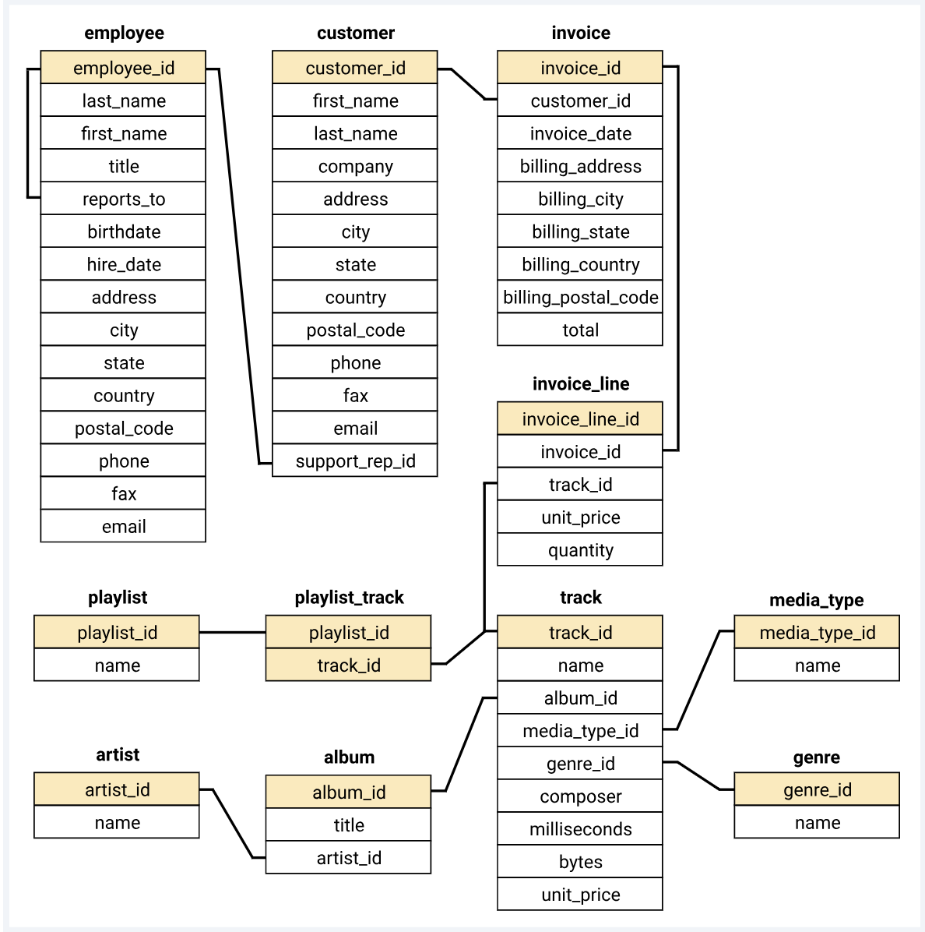
Figure 1: Music Store Entity-Relationship Diagram — 11 interconnected tables spanning sales, staff, and catalog data.

6. Database Schema Description

Table | Purpose | Key Columns
employee | Sales staff and management hierarchy | employee_id, title, levels, reports_to
customer | Customer master records | customer_id, support_rep_id
invoice | Header-level sales transactions | invoice_id, customer_id, total
invoice_line | Line-item detail per invoice | invoice_line_id, track_id, quantity
track | Individual song catalog | track_id, album_id, genre_id, milliseconds
album | Album metadata | album_id, artist_id, title
artist | Recording artists / bands | artist_id, name
genre | Music genre classification | genre_id, name
media_type | File / format type | media_type_id, name
playlist | Curated track collections | playlist_id, name
playlist_track | Playlist-to-track mapping | playlist_id, track_id

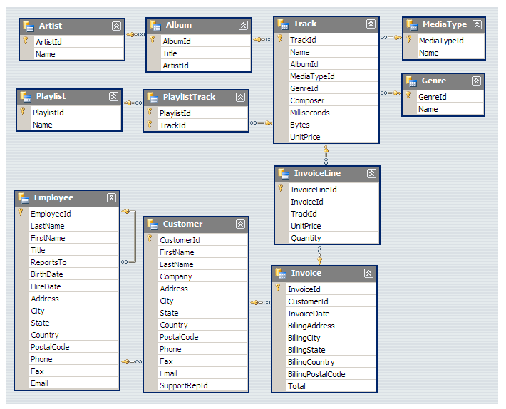
Figure 2: Logical schema view showing primary keys and cardinality (one-to-many) markers across all tables.

7. Technology Stack

Layer | Technology
Database Engine | PostgreSQL 16
Query Language | ANSI SQL with PostgreSQL extensions (window functions, CTEs, recursive queries)
Schema Design | Third Normal Form (3NF) relational model, 11 tables
Data Volume | ~9,700 total records across all tables
Reporting | Native SQL output, exported for narrative and visual reporting

8. SQL Concepts Used

- Aggregation & Grouping: COUNT, SUM, AVG combined with GROUP BY to summarize invoices, tracks, and revenue.
- Sorting & Limiting: ORDER BY and LIMIT to identify top performers (e.g., senior employee, top customer).
- Multi-Table Joins: INNER JOINs chained across up to six tables to connect sales data to catalog metadata.
- Subqueries: Correlated and scalar subqueries, e.g., filtering tracks longer than the catalog average.
- Common Table Expressions (CTEs): WITH clauses used to stage intermediate results such as the best-selling artist before joining to customer spend.
- Window Functions: ROW_NUMBER() OVER (PARTITION BY ... ORDER BY ...) to rank customers and genres within each country.
- Recursive CTEs: WITH RECURSIVE used as an alternate approach to solve ranking problems without window functions, for portability across SQL dialects.
- Set-Based Filtering: IN clauses and nested subqueries for genre-based customer segmentation.

9. Database Relationships

- Sales Chain: customer → invoice → invoice_line → track: every purchase line item traces back to a specific customer and a specific song.
- Catalog Chain: artist → album → track → genre / media_type: every track inherits its artist and album context and is tagged with a genre and format.
- Staff Hierarchy: employee.reports_to is a self-referencing foreign key, enabling org-chart-style hierarchy queries.
- Curation Layer: playlist ↔ track via the playlist_track junction table implements a many-to-many relationship.

10. Business Questions Solved

Eleven business questions were addressed across three difficulty tiers. The table below summarizes each question and its data-backed answer, drawn directly from executing the SQL queries against the live PostgreSQL database.
# | Business Question | Key Result
E1 | Senior-most employee by job title | Mohan Madan — Senior General Manager (Level L7)
E2 | Countries with the most invoices | USA (131), Canada (76), Brazil (61)
E3 | Top 3 invoice totals | $23.76, $19.80, $19.80
E4 | City with highest total revenue | Prague — $273.24 (festival location)
E5 | Best customer by total spend | R. Madhav — $144.54
M1 | Rock-genre listener count | All 59 customers have purchased Rock tracks
M2 | Top rock artists by track count | Led Zeppelin (114), U2 (112), Deep Purple (92)
M3 | Tracks longer than average length | 494 of 3,503 tracks exceed the 6.56-minute average
A1 | Top artist by revenue & its top customer | Queen is the top-grossing artist ($190.08)
A2 | Most popular genre per country | Rock leads in every one of the 24 countries
A3 | Top-spending customer per country | R. Madhav (Czech Rep.) leads globally at $144.54

11. Query Methodology

Each business question followed a consistent four-step methodology to ensure accuracy and reproducibility:
- 1. Decompose: Break the business question into its component data requirements (e.g., 'best customer per country' requires both a spend total and a per-country ranking).
- 2. Map to Schema: Identify the join path across the relevant tables using foreign key relationships (e.g., customer → invoice → invoice_line → track → album → artist).
- 3. Build Incrementally: Construct the query in stages — starting with a simple JOIN and GROUP BY, then layering in window functions or CTEs where ranking or staged logic was required.
- 4. Validate & Cross-Check: Where possible, each ranking query (e.g., top genre or top customer per country) was solved two ways — once using a window function (ROW_NUMBER) and once using a recursive CTE — to confirm the results matched.
This dual-method validation was applied specifically to Advanced Questions 2 and 3, where both a window-function solution and a recursive-CTE solution were written and produced identical results, confirming query correctness.

12. Key Business Insights

The analysis surfaced several concentration patterns that have direct implications for marketing, staffing, and content strategy.
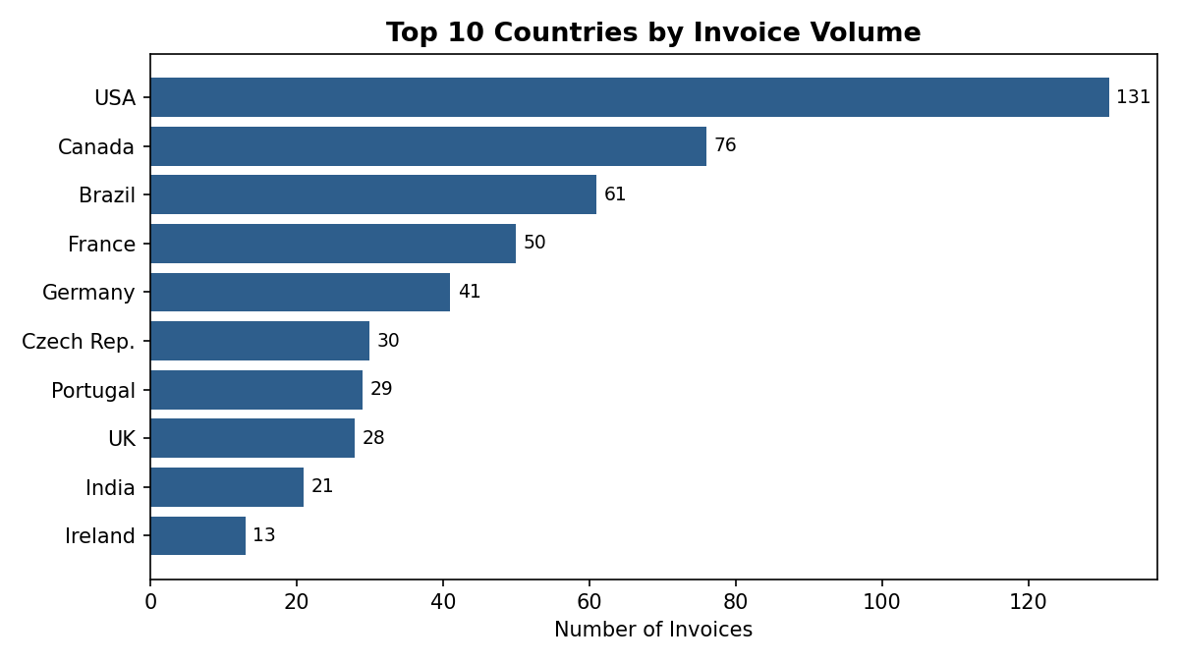
Figure 3: Invoice volume is heavily concentrated — the USA, Canada, and Brazil together account for nearly half of all 614 invoices.
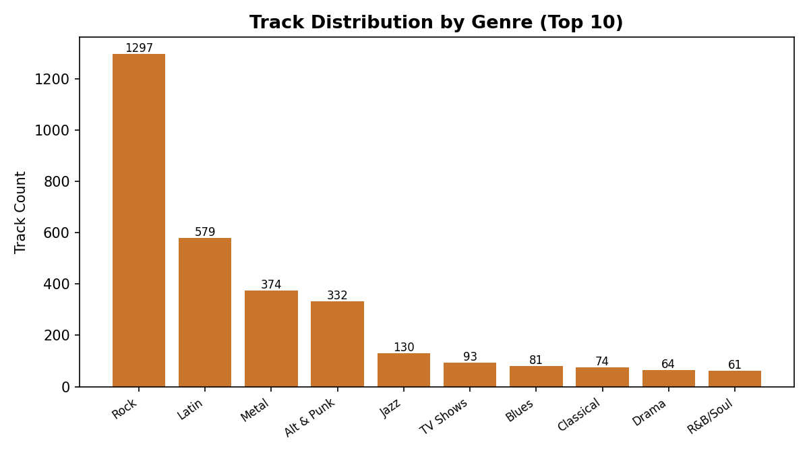
Figure 4: Rock dominates the catalog at 1,297 tracks (37%), more than double the next-largest genre, Latin (579 tracks).
- Revenue Concentration: Prague is the single highest-revenue city ($273.24), ahead of Mountain View, London, Berlin, and Paris — a strong, data-backed choice for the proposed Music Festival.
- Customer Value Skew: The top 5 customers each spend between $108 and $145 — roughly double the implied per-customer average of ~$80, indicating a small high-value segment worth targeted retention offers.
- Genre Universality: Rock is the #1 genre in every single country in the dataset, making it the safest default for cross-market promotional campaigns and licensing investment.
- Long-Tail Catalog Depth: 494 tracks (14% of the catalog) run longer than the 6.56-minute average, useful for identifying album-oriented / progressive content for curated long-form playlists.

13. Performance Optimization

- Indexing Primary/Foreign Keys: All primary keys are indexed by default; adding indexes on frequently joined foreign keys (invoice.customer_id, invoice_line.track_id, invoice_line.invoice_id, track.genre_id, track.album_id) would materially speed up the multi-table joins used in Advanced Questions 1–3.
- CTE Materialization: For the best-selling-artist query, isolating the aggregation in a CTE before joining to customer data reduces the working row set early, avoiding a full re-aggregation on the final join.
- Window Functions over Self-Joins: Ranking customers/genres per country with ROW_NUMBER() avoids the far more expensive self-join-and-compare pattern that would otherwise be needed to find per-group maximums.
- Data Type Consistency: Several numeric fields (unit_price, quantity, postal_code) are stored as VARCHAR in the current schema; casting these to proper NUMERIC/INT types would both improve query performance and prevent sorting errors.

14. Challenges Faced

- Schema Naming Inconsistencies: Column names differed subtly across source documents (e.g., miliseconds vs. milliseconds, invoiceline vs. invoice_line), requiring careful reconciliation before queries would execute correctly.
- Mixed Data Types: Monetary and numeric fields defined as VARCHAR required implicit or explicit casting to support correct sorting and arithmetic (e.g., unit_price × quantity).
- Shared-Maximum Ties: Questions asking for the 'top' genre or customer per country needed to account for ties, which simple LIMIT 1 logic would silently drop — solved using ROW_NUMBER() with an inclusive filter and cross-validated with a recursive CTE approach.
- Composite Key Design: The playlist_track junction table required a composite primary key across playlist_id and track_id rather than a single-column key, which needed explicit handling during schema creation.

15. Business Recommendations

- Host the Music Festival in Prague: It generated the highest total invoice revenue ($273.24) of any city — the data directly supports the original business objective of this study.
- Launch a VIP Loyalty Tier: Target the top 5–10 customers by lifetime spend (led by R. Madhav at $144.54) with early-access releases or exclusive bundles to protect this high-value segment.
- Prioritize Rock Licensing Deals: Rock is the #1 genre in every market studied — renewing and expanding catalog rights for Led Zeppelin, U2, and Deep Purple protects the highest-demand content category.
- Expand Regional Marketing in Top 3 Markets: USA, Canada, and Brazil jointly account for ~44% of invoice volume; localized campaigns in these markets offer the highest expected return.
- Fix Schema Data Types: Convert unit_price, quantity, and postal_code fields to proper numeric types to eliminate sorting bugs and unlock accurate downstream analytics.
- Build a Recurring Dashboard: Automate the eleven queries in this report into a scheduled dashboard (e.g., refreshed monthly) so market concentration and top-customer shifts are caught early.

16. Conclusion

This project demonstrates that a well-normalized relational database, combined with a progressively advanced SQL query strategy, can answer substantive business questions without any external analytics tooling. Across eleven questions spanning employee structure, market concentration, customer value, and content strategy, every finding was derived directly from the live PostgreSQL dataset and cross-validated where ranking logic was involved.
The resulting insights — Prague as the top festival location, Rock as the universal top genre, and a concentrated top-customer segment — are immediately actionable and illustrate the practical value of SQL as a standalone business intelligence tool.

17. Future Enhancements

- Time-Series Analysis: Incorporate invoice_date to analyze seasonal revenue trends and year-over-year growth, which the current snapshot-based queries do not capture.
- Customer Lifetime Value Model: Extend the best-customer analysis into a full CLV model incorporating purchase frequency and recency, not just total spend.
- Employee Performance Analytics: Link customer.support_rep_id to invoice data to evaluate sales performance by employee and reporting line.
- Interactive Dashboard Layer: Connect the query set to a BI tool (e.g., Power BI, Tableau, or Metabase) for live, filterable exploration by non-technical stakeholders.
- Predictive Recommendations: Use genre and artist purchase patterns to build a track-recommendation engine for cross-sell opportunities at checkout.

18. References

- Music Store relational database schema and question set (project dataset, provided source material).
- PostgreSQL 16 Official Documentation — postgresql.org/docs
- Project methodology and question bank inspired by community SQL project templates, as credited in the original source material (YouTube: @RishabhMishraOfficial).

