ASSIGNMENT-1

ANALYSIS AND DESIGN
OF
ALGORITHMS
[COMPLEXITY ANALYSIS]
COURSE CODE: CS1401

NAME: ANKIT RUPAL
SID: 20103035
Q1. What is the asymptotic relationship between the functions n³log ₂ n and 3nlog ₈ n?
Ans: We know that,
3nlog ₈ n = 3nlog ₂³ n
3nlog ₈ n = $\frac{3nlog n}{3}$
3nlog ₈ n = n log ₂ n
Now,
n³ < n
n³ log ₂ n < n log ₂ n
n³ log ₂ n < 3n log ₈ n
Thus,
n³ log ₂ n = Ω ( 3n log ₈ n )
or, n³ log ₂ n = Ω ( n log n )

3n log ₈ n = O (n³ log ₂ n)
3n log ₈ n = O (n³ log n)

Answer : n³ log ₂ n = Ω ( n log n )
3n log ₈ n = O (n³ log n)
Q2. For the functions, 8^{n} and 4^{n} , what is the asymptotic relationship between these functions?
Ans: We know that,
8^{n} > 4^{n}
Thus,
8^{n} = Ω (4^{n})
And, 4^{n} = O (8^{n})

Answer: 8^{n} = Ω (4^{n})
4^{n} = O (8^{n})

Q3. For the functions, n^{k} and c^{n}, what is the asymptotic relationship between these functions?
Assume that k>=1 and c>1 are constants.
Ans: Let f(x) = n^{k} and g(x) = c^{n} be two functions.
f(x) = n^{k} g(x) = c^{n}
Taking log on both sides
log(f(x)) = k log(n) log(g(x)) = n log(c)
[Since, constants can be ignored in asymptomatic notation]
log(f(x)) = k₁ log(n) log(g(x)) = k₂ n
[where k₁ and k₂ are positive constants]
Since, log (n) < n
k₁ log(n) < k₂ n
Thus, we can infer that,
log (f(x)) < log (g(x))
f(x) < g(x)
Hence,
f(x) = O(g(x))
or, g(x) = Ω (f(x))

Q4. What is the complexity of the following code snippet?
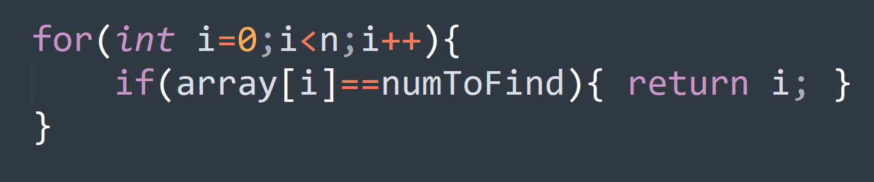
Ans: Given the code,

The code contains a single for loop which runs
n times. Thus, the time complexity of the code
is O(n)
Answer: O(n)

Q5. What is the complexity of push and pop for a stack implemented using singular linked list? Explain with example.
Ans: The push and pop function of a stack require insertion and deletion at the top. Using a singular linked list we can add and delete the node at the beginning which can be done in constant time.
Thus, the time complexity of both push and pop function for the stack implemented using a singular linked list will be O(1).

Q6. What is the big O notation of the following?
f(x) = log n + 3n
Ans: We have,
f(x) = log n + 3n
Since the more dominant term in the expression is n,
f(x) ≈ 3n
Thus, f(x) will grow at the order of n,
Answer : f(x) = O(n)

Q7. Assume that each of the expressions below gives the processing time T(n) spent by an algorithm for solving a problem of size n. Select the dominant term(s) having the steepest increase in n and specify the lowest Big-Oh complexity of each algorithm?

