## Over-fitting and Regularization

In supervised machine learning, models are trained on a subset of data aka training data. The goal is to compute the target of each training example from the training data.



Now, overfitting happens when model learns signal as well as noise in the training data and wouldn’t perform well on new data on which model wasn’t trained on. In the example below, you can see underfitting in first few steps and overfitting in last few.

Now, there are few ways you can avoid overfitting your model on training data like cross-validation sampling, reducing number of features, pruning, regularization etc.

Regularization basically adds the penalty as model complexity increases. Regularization parameter (lambda) penalizes all the parameters except intercept so that model generalizes the data and won’t overfit.

*A regression model that uses L1 regularization technique is called****Lasso Regression****and model which uses L2 is called****Ridge Regression****.*

## The key difference between these two is the penalty term.

Ridge regression(L2) adds “squared magnitude” of coefficient as penalty term to the loss function. Here the highlighted part represents L2 regularization element.

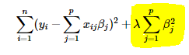

Here, if *lambda* is zero then you can imagine we get back OLS. However, if *lambda* is very large then it will add too much weight and it will lead to under-fitting. Having said that it’s important how *lambda* is chosen. This technique works very well to avoid over-fitting issue.

**Lasso Regression(L1)** (Least Absolute Shrinkage and Selection Operator) adds “*absolute value of magnitude*” of coefficient as penalty term to the loss function.

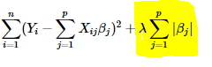

The **key difference** between these techniques is that Lasso shrinks the less important feature’s coefficient to zero thus, removing some feature altogether. So, this works well for **feature selection** in case we have a huge number of features.



## What is bias?

Bias is the difference between the average prediction of our model and the correct value which we are trying to predict. Model with high bias pays very little attention to the training data and oversimplifies the model. It always leads to high error on training and test data.

## What is variance?

Variance is the variability of model prediction for a given data point or a value which tells us spread of our data. Model with high variance pays a lot of attention to training data and does not generalize on the data which it hasn’t seen before. As a result, such models perform very well on training data but has high error rates on test data.

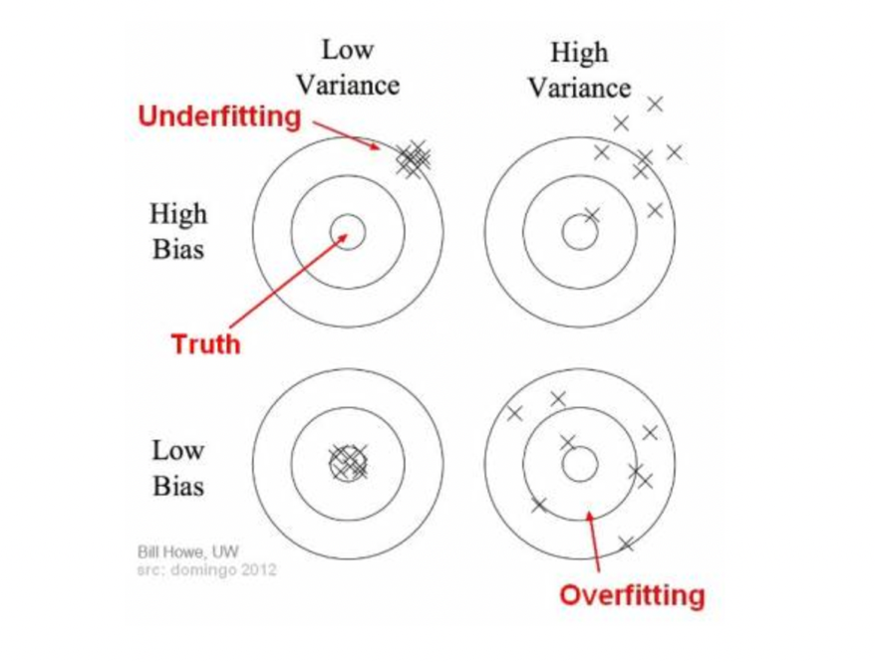

In the above diagram, center of the target is a model that perfectly predicts correct values. As we move away from the bulls-eye our predictions become get worse and worse. We can repeat our process of model building to get separate hits on the target.

In supervised learning, **underfitting** happens when a model unable to capture the underlying pattern of the data. These models usually have high bias and low variance. It happens when we have very less amount of data to build an accurate model or when we try to build a linear model with a nonlinear data. Also, these kind of models are very simple to capture the complex patterns in data like Linear and logistic regression.

In supervised learning, **overfitting** happens when our model captures the noise along with the underlying pattern in data. It happens when we train our model a lot over noisy dataset. These models have low bias and high variance. These models are very complex like Decision trees which are prone to overfitting.

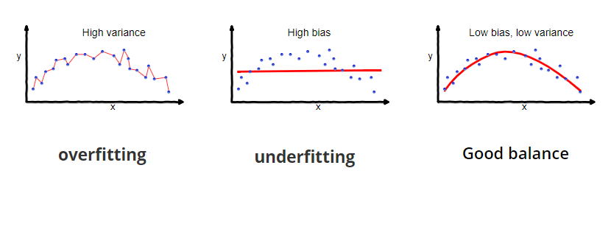

A model that exhibits small variance and high bias will underfit the target, while a model with high variance and little bias will overfit the target.