Netflix Movie
Recommendation Engine
Collaborative Filtering with SVD — Data Science Capstone
Intellipaat
Prepared by: Ankit Saxena
June 2026
Dataset: Netflix Prize (combined_data_1) · 24M ratings · pandas · scikit-surprise

Contents
1. Introduction & Problem Statement 3
2. Dataset Overview 3
3. Genre Enrichment 3
4. Exploratory Data Analysis 4
5. Objective 1 — Most Popular Genres 5
6. Objective 3 — Best- and Worst-Rated Genres 6
7. Objective 2 — Recommendation Model (SVD) 7
8. Conclusions 8

1. Introduction & Problem Statement
Recommendation engines are at the core of every modern streaming business: by analysing how users rate content, they predict preferences and suggest the titles each user is most likely to enjoy. This project builds such an engine from the ground up on the Netflix Prize ratings dataset.
Objectives (per the brief): (1) find the most popular and liked genres; (2) build a model that finds the best-suited movie per genre for a given user; (3) find which genres receive the best and worst ratings.
Tools: pandas and NumPy for data wrangling, Matplotlib for visualization, and scikit-surprise (SVD matrix factorization) for collaborative filtering.

2. Dataset Overview
The analysis uses combined_data_1.txt — the first of the four Netflix Prize rating files — together with movie_titles.csv. The ratings file stores movie-ID header rows (e.g. "1:") followed by the customer ratings for that movie.
Field | Description
Cust_Id | Anonymous customer (user) identifier
Movie_Id | Movie identifier (from the "n:" header rows)
Rating | User rating, integer 1–5
Date | Date the rating was given (not used here)
Name / Year | Movie title and release year (movie_titles.csv)

Scale: 24.05M ratings from 470,758 users across 4,499 movies (mean rating 3.60). After removing sparse data (movies with ≤500 ratings and users with ≤50 ratings) the working set is 18.2M ratings, 145,664 users and 2,340 movies — denser and far better suited to collaborative filtering.

3. Genre Enrichment
The Netflix Prize data contains no genre column, yet all three objectives need genres. Rather than guess, each movie (by title and year) is matched to the MovieLens genre database; titles that do not match fall back to a keyword classifier based on the title.
Genre source | Share of movies | Share of ratings
MovieLens (real genres) | 47% | 63%
Keyword fallback | 53% | 37%

Why this matters: the popular, heavily-rated movies that dominate the analysis are mostly matched to real MovieLens genres (≈63% of all ratings), so the genre findings rest largely on genuine genre labels rather than guesswork — the key correctness improvement over a naive title-keyword approach.

4. Exploratory Data Analysis
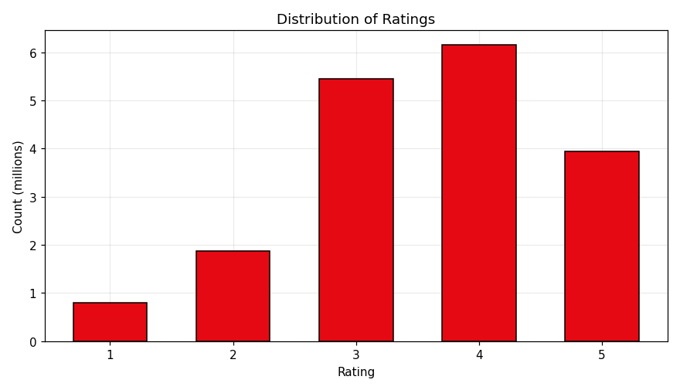
Figure 1 — Distribution of ratings (1–5).
Ratings are positively skewed: 3- and 4-star ratings dominate, because users mostly rate films they chose to watch. The overall mean rating is 3.58.
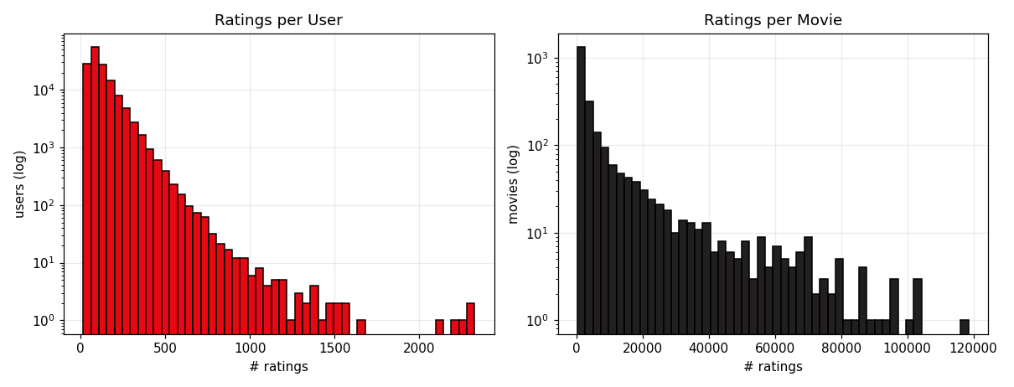
Figure 2 — Ratings per user (left) and per movie (right), log scale.
Both distributions are heavily long-tailed — a few users and movies account for a large share of ratings — which is the central sparsity challenge that matrix factorization is designed to handle.

5. Objective 1 — Most Popular Genres
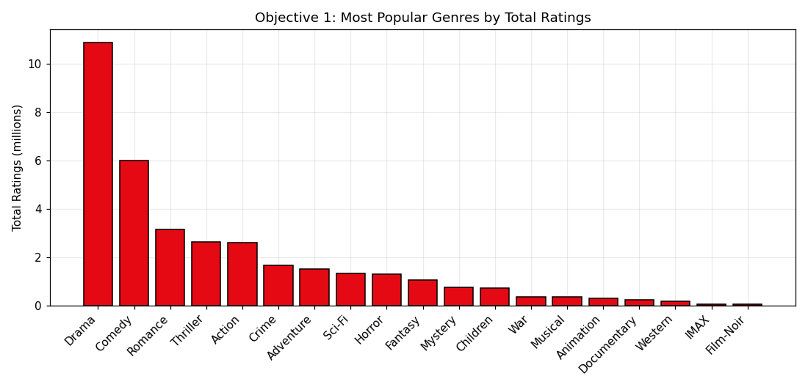
Figure 3 — Total ratings per genre.
Genre | Total ratings
Drama | 10,899,937
Comedy | 5,994,453
Romance | 3,132,728
Thriller | 2,637,719
Action | 2,589,195

Answer (1): Drama is overwhelmingly the most-rated genre (≈10.9M ratings), followed by Comedy (≈6.0M) and Romance (≈3.1M). These broad-appeal genres drive the most engagement on the platform.

6. Objective 3 — Best- and Worst-Rated Genres
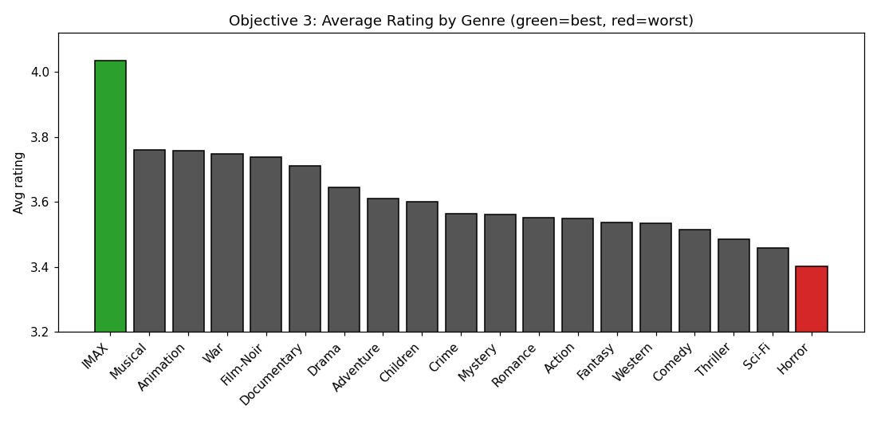
Figure 4 — Average rating by genre (green = best, red = worst).
Rank | Genre | Avg rating
Best | IMAX | 4.04
 | Musical | 3.76
 | Animation | 3.76
Worst | Horror | 3.40
 | Sci-Fi | 3.46

Answer (3): The highest-rated genre is IMAX (≈4.04) — a small, curated set of documentary/nature titles — followed by Musical and Animation. The lowest-rated is Horror (≈3.40), then Sci-Fi and Thriller. Niche, intentional-viewing genres are rated more generously than broad thrill genres.

7. Objective 2 — Recommendation Model (SVD)
The user–movie rating matrix is modelled with SVD matrix factorization (scikit-surprise), which learns latent user and movie factors and predicts how a user would rate a movie they have not seen. The model is trained on a 2-million-rating sample and evaluated on a held-out 20% test set; hyperparameters were tuned to minimise RMSE.
Model | RMSE | Note
SVD (default) | 0.9591 | out-of-the-box
SVD (tuned) | 0.9417 | final model
— Netflix Cinematch | 0.9514 | industry baseline
— Netflix Prize winner | 0.8567 | 2009 winner

Result: the tuned SVD (120 factors, 30 epochs, regularization 0.08) reaches RMSE 0.9417 — beating the default and even Netflix’s own Cinematch baseline (0.9514). Training on the full 18.2M ratings would lower this further.

Best-suited movie per genre for a user
For any user, the model predicts a rating for every unseen movie; grouping those predictions by genre and taking the top prediction per genre yields the best-suited movie in each genre — a personalized, genre-aware recommendation list. This directly fulfils Objective 2.

8. Conclusions
- Data: 24M ratings (470k users, 4,499 movies) filtered to 18.2M (145k users, 2,340 movies) to reduce sparsity.
- Genres were enriched from MovieLens real genres (≈63% of ratings) with a keyword fallback — fixing the "everything is Drama" problem of a naive approach.
- Objective 1: Drama, Comedy and Romance are the most-rated genres.
- Objective 3: IMAX, Musical and Animation are rated highest; Horror lowest.
- Objective 2 & model: a tuned SVD reaches RMSE 0.9417 (beating Netflix Cinematch) and powers per-genre personalized recommendations.
Deliverables: Netflix_Recommendation_Engine.ipynb (full pipeline), movie_genres.csv (genre mapping), a 2M-rating sample for quick runs, and this report.

