Analyzing the Trends of COVID-19
Impact Analysis & Time-Series Forecasting with Python
Python for Data Science — Capstone Project
Intellipaat
Prepared by: Ankit Saxena
June 2026
Dataset: 187 countries · 22 Jan – 27 Jul 2020 · pandas · Plotly · Prophet

Contents

1. Introduction & Problem Statement
The COVID-19 pandemic produced one of the largest public-health datasets in modern history. This project analyses the daily progression of confirmed cases, deaths and recoveries to understand the impact and trajectory of the pandemic, and then builds time-series models to forecast the number of cases expected in the near future.
Goals (per the brief): (1) visualize the impact and analyse the trend of the rate of infection and recovery; (2) predict the number of cases expected about a week into the future based on current trends.
Tools (per the brief): pandas for data wrangling, Plotly for interactive visualizations, and Facebook Prophet for time-series forecasting.

2. Dataset Overview
The analysis uses covid_19_clean_complete.csv — one record per province/country per day, covering 187 countries from 22 January to 27 July 2020 (188 daily snapshots; 49,068 rows).
Column | Description
Province/State | Sub-national region (often blank — national reporting)
Country/Region | Country or region name
Lat, Long | Geographic coordinates
Date | Observation date (daily)
Confirmed | Cumulative confirmed cases
Deaths | Cumulative deaths
Recovered | Cumulative recoveries
Active | Active cases (Confirmed − Deaths − Recovered)
WHO Region | World Health Organization region

3. Data Cleaning & Feature Engineering
The four numeric measures are fully populated; only Province/State is sparse (expected, as many countries report nationally), so no imputation of case counts is required. Dates were parsed to datetime. Records were then aggregated into daily time series (global and per country), and the following features were derived: daily new cases (the first difference of the cumulative columns), the mortality rate (Deaths ÷ Confirmed) and the recovery rate (Recovered ÷ Confirmed).

4. Global Infection & Recovery Trends
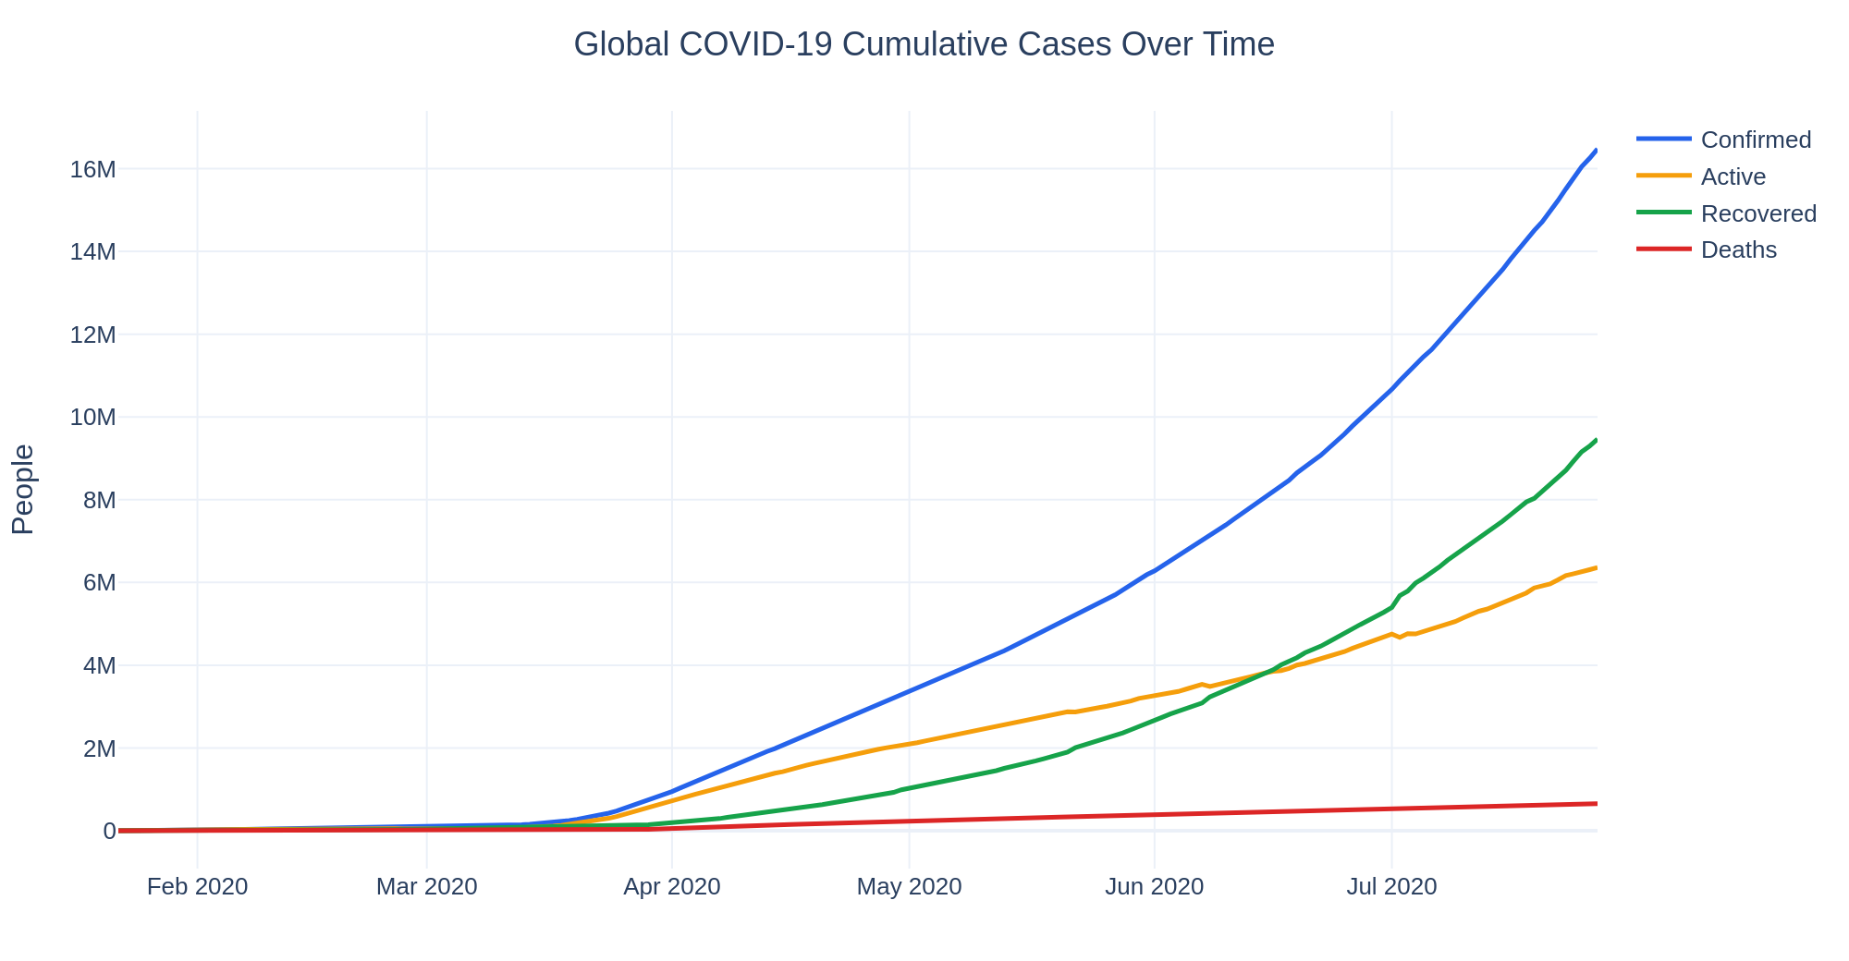
Figure 1 — Global cumulative confirmed, active, recovered and deaths over time.
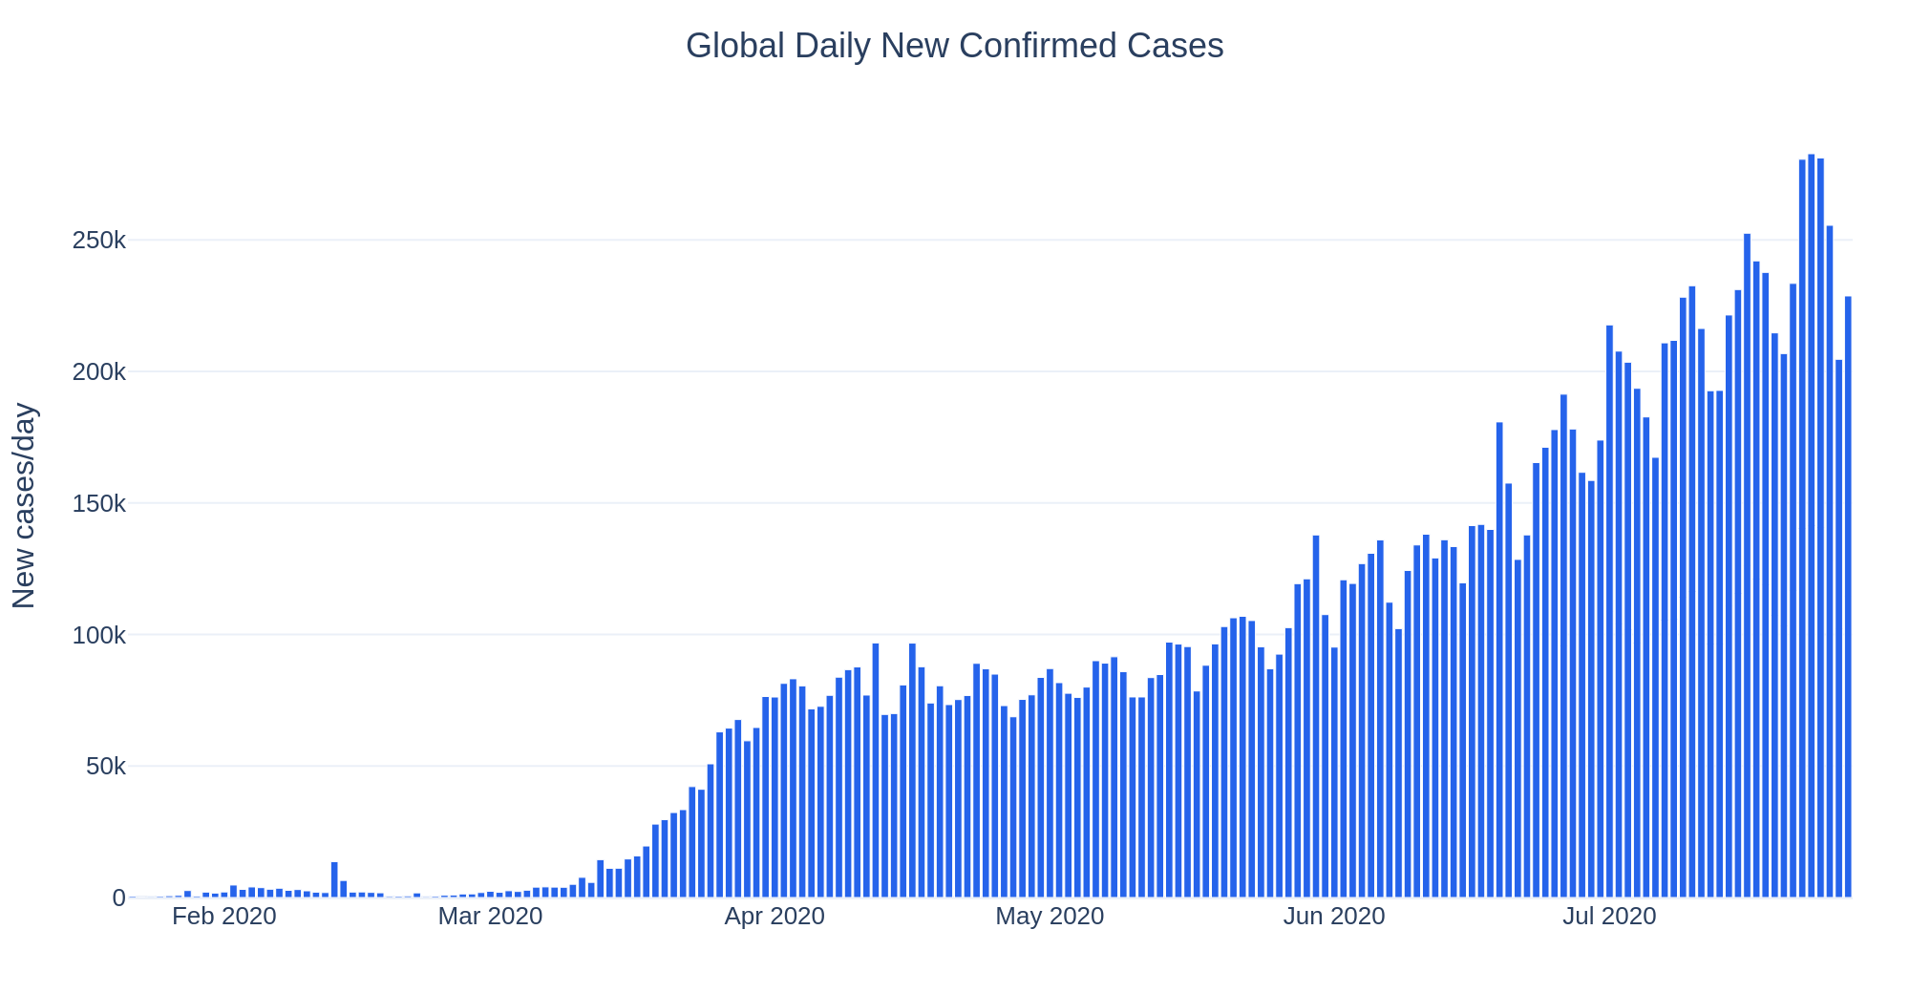
Figure 2 — Global daily new confirmed cases.
Impact: Confirmed cases grew exponentially to 16.5M by 27 July 2020. Daily new cases rose throughout, peaking at ~282,800 on 23 July 2020 — the pandemic was still accelerating at the end of the data, with no plateau.
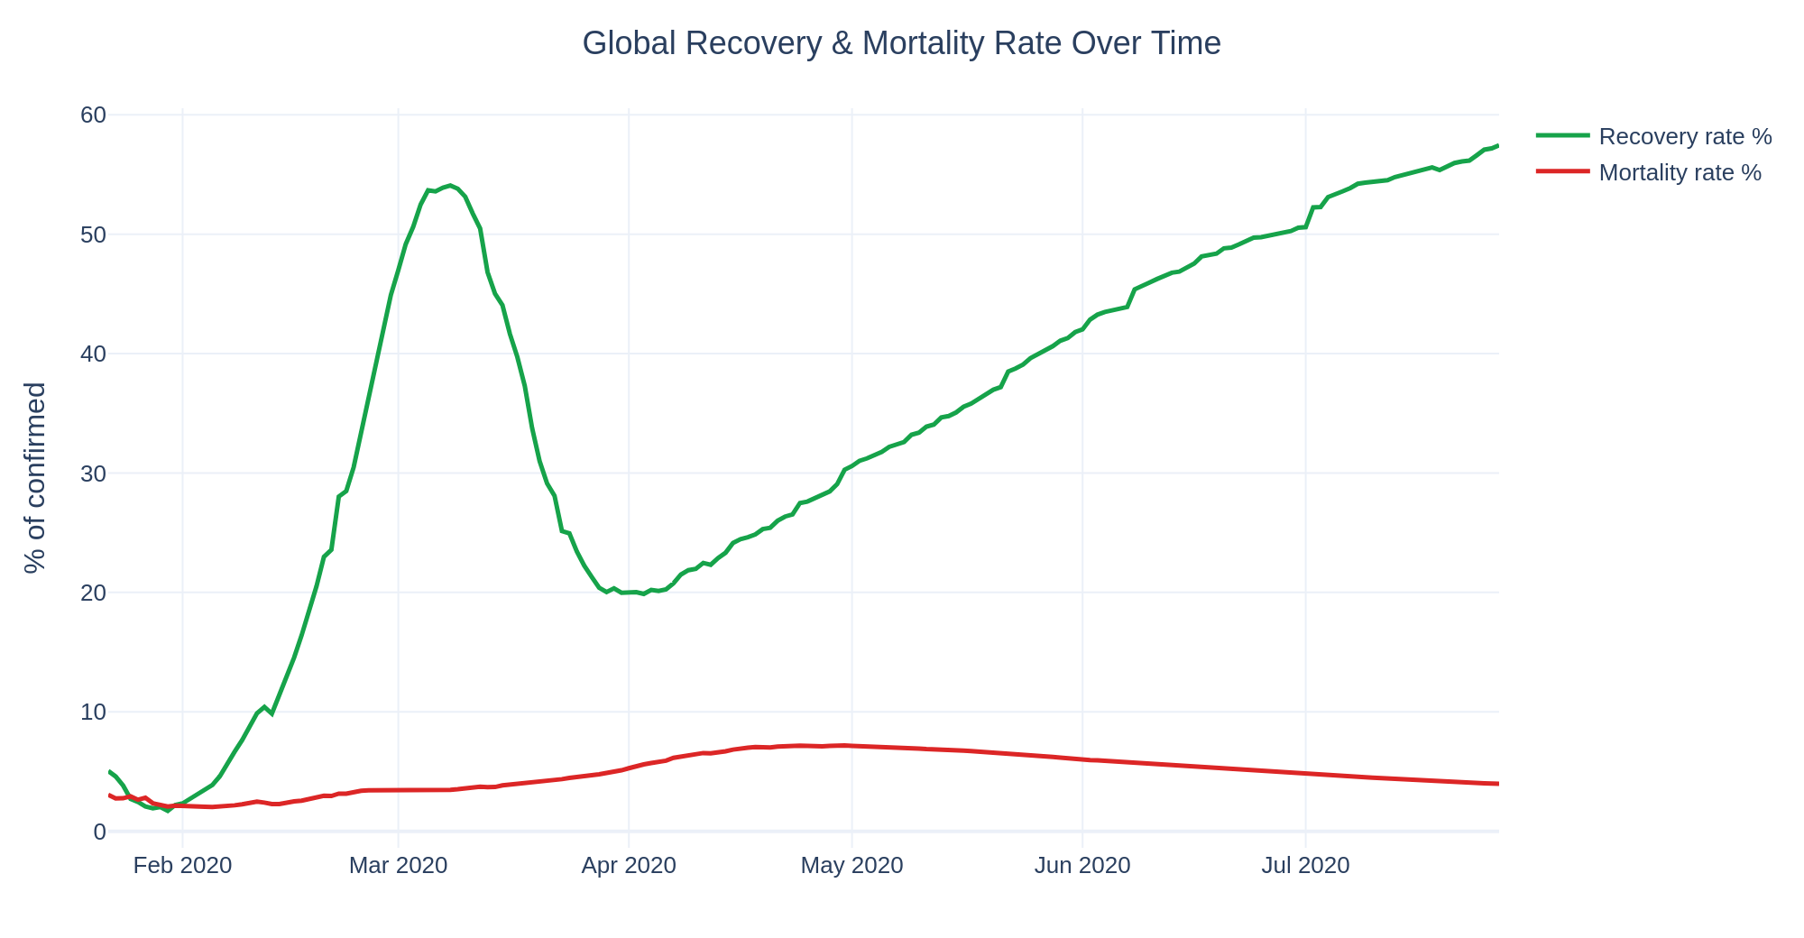
Figure 3 — Global recovery and mortality rate over time.
Recovery vs mortality: The recovery rate climbed steadily to ~57%, while the mortality rate spiked early (when testing was limited) and then settled to ~4% as testing and treatment improved. The widening gap between recoveries and deaths is the clearest evidence of improving outcomes over time.

5. Geographic Distribution
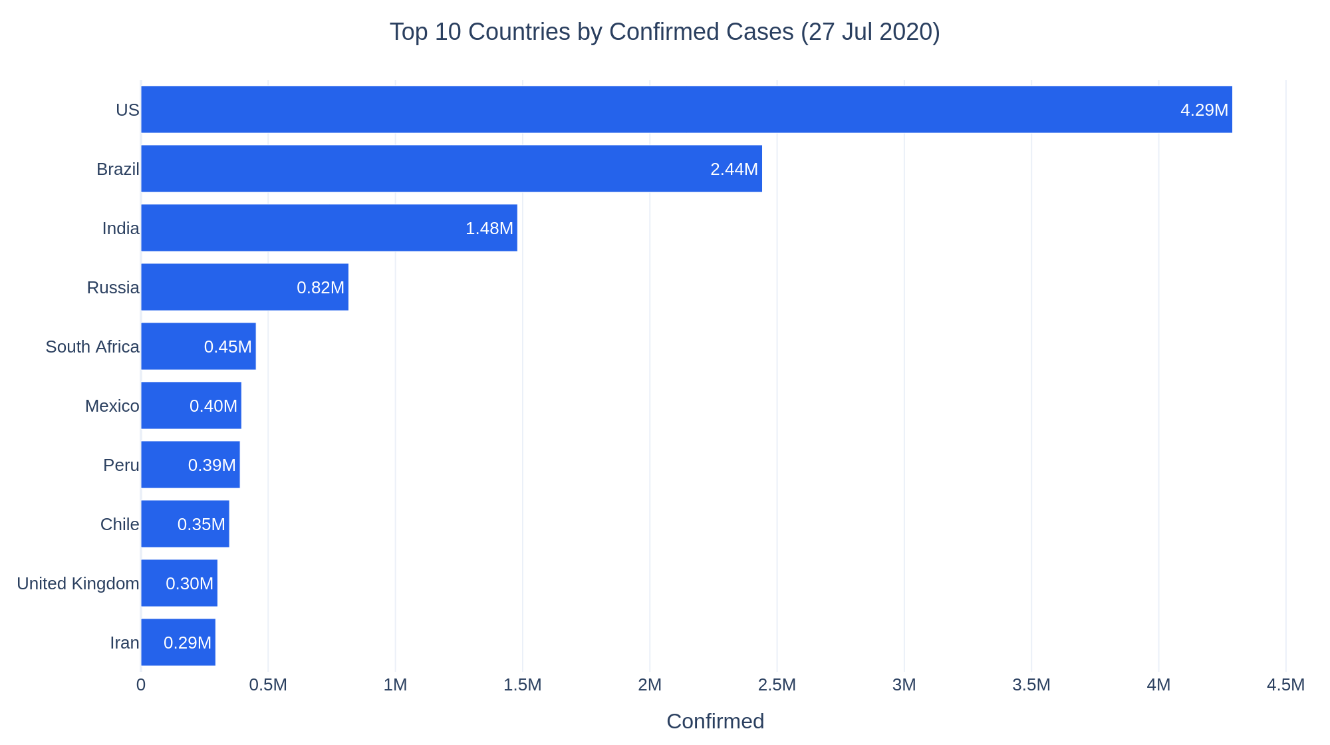
Figure 4 — Top 10 countries by confirmed cases (27 Jul 2020).
The case load is highly concentrated. The table below shows the ten worst-affected countries with their case-fatality rate (CFR = deaths ÷ confirmed).
Country | Confirmed | Deaths | CFR
United States | 4,290,259 | 148,011 | 3.45%
Brazil | 2,442,375 | 87,618 | 3.59%
India | 1,480,073 | 33,408 | 2.26%
Russia | 816,680 | 13,334 | 1.63%
South Africa | 452,529 | 7,067 | 1.56%
Mexico | 395,489 | 44,022 | 11.13%
United Kingdom | 301,708 | 45,844 | 15.19%
Iran | 293,606 | 15,912 | 5.42%

Note on fatality rates: CFR varied enormously — the UK (15.2%) and Mexico (11.1%) were far higher than India (2.3%) or Russia (1.6%). This largely reflects differences in testing coverage (more testing finds milder cases, lowering CFR), demographics and health-system load, rather than the virus itself.
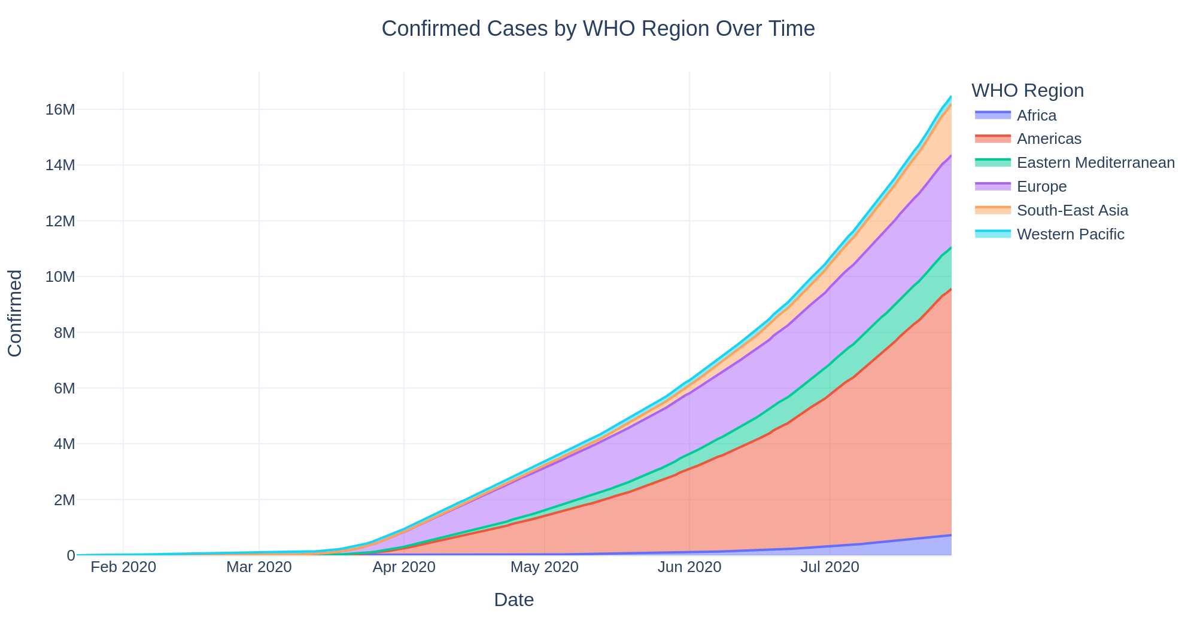
Figure 5 — Confirmed cases by WHO region over time.
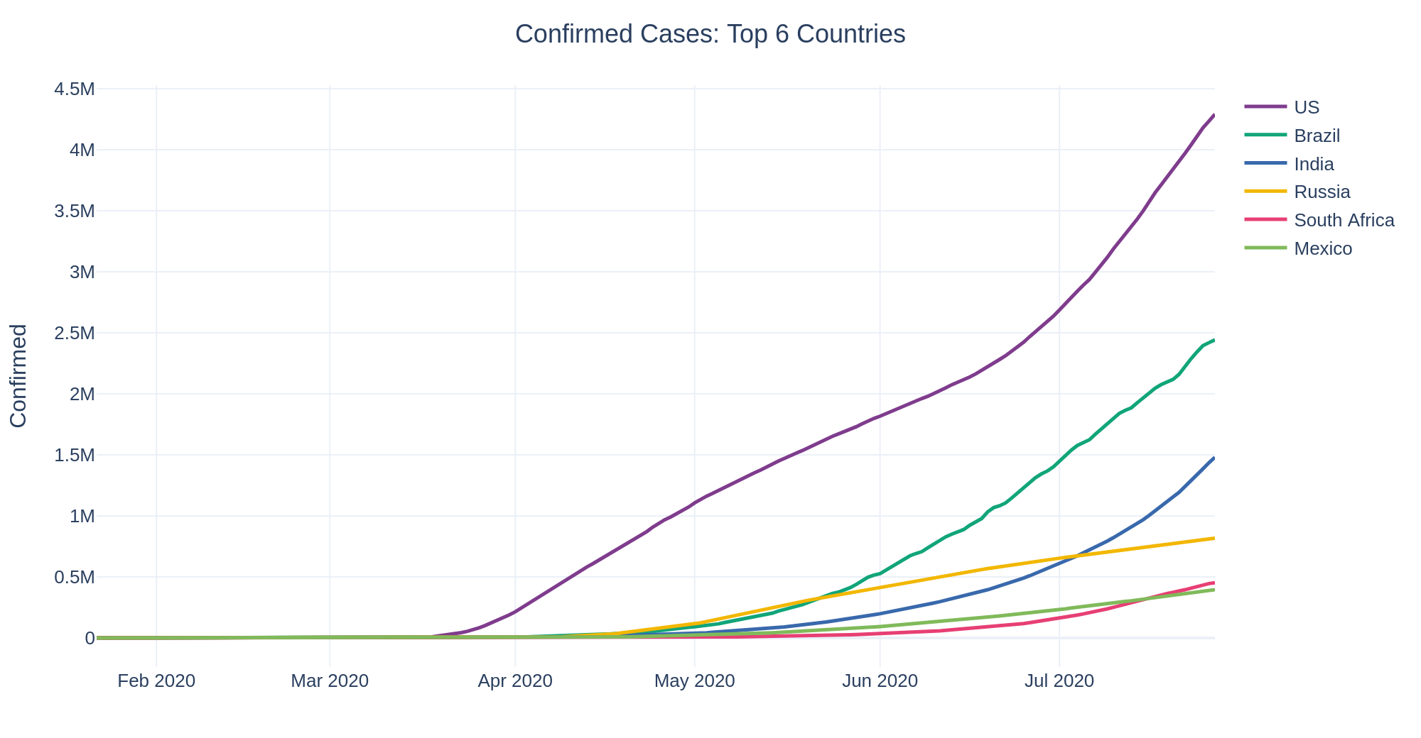
Figure 6 — Confirmed-case trajectories of the six largest countries.
The Americas dominated the global case load (8.8M), followed by Europe (3.3M) and South-East Asia (1.8M, driven by India). The US and Brazil were on the steepest trajectories, while India accelerated rapidly in the final two months.

6. India Deep-Dive
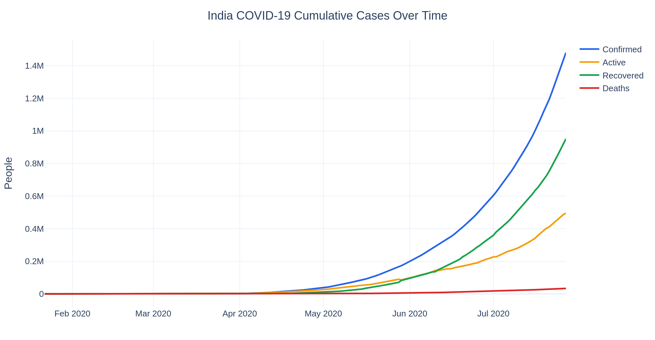
Figure 7 — India cumulative cases over time.
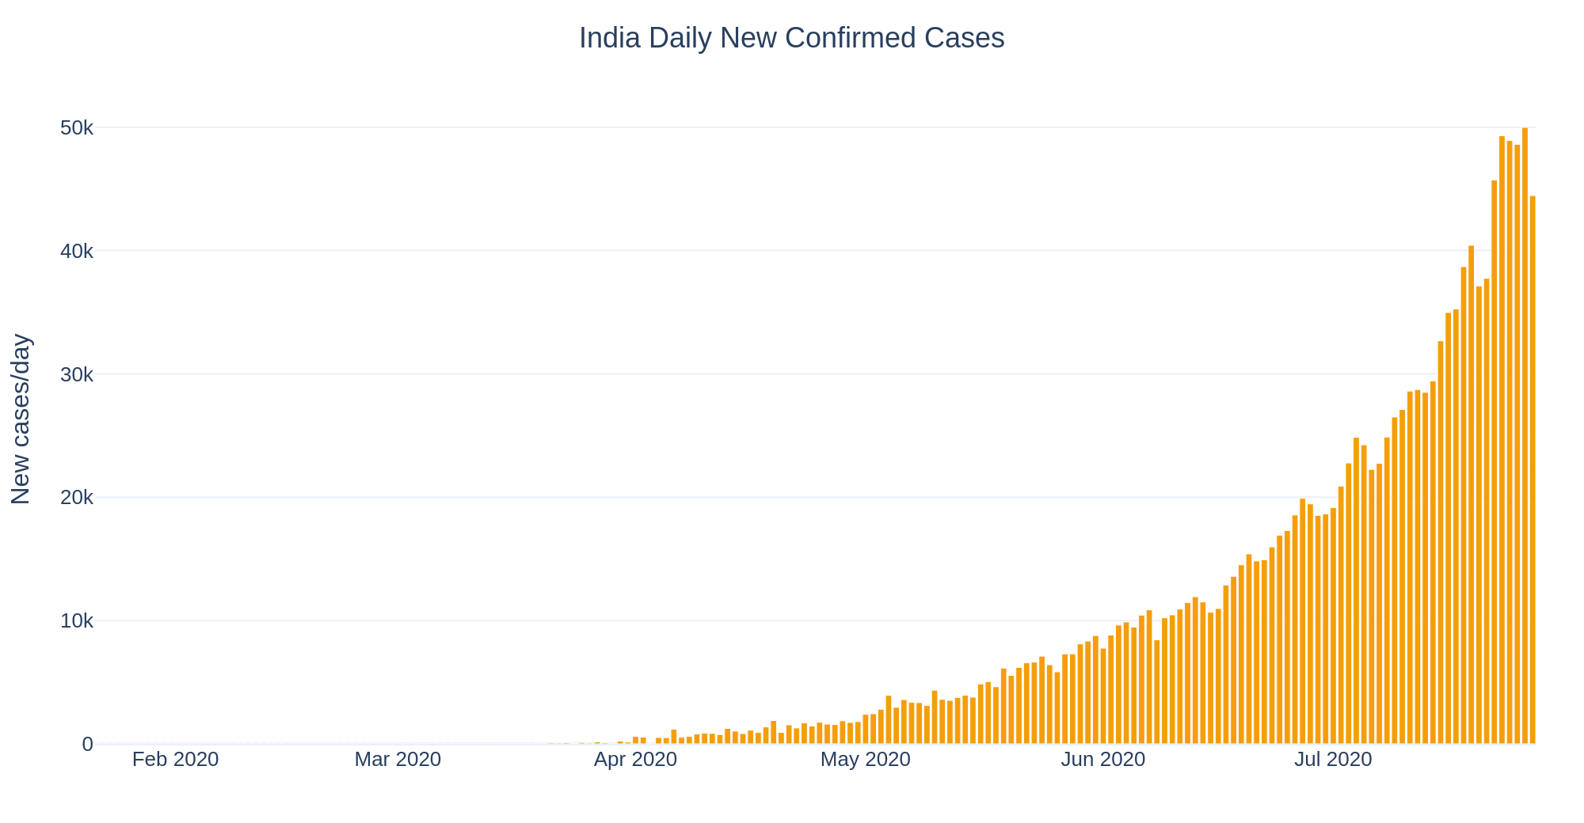
Figure 8 — India daily new confirmed cases.
India: The first case was recorded on 30 January 2020. After a flat spring, cases entered steep exponential growth from June. By 27 July 2020 India had 1.48M confirmed cases, 33,408 deaths and 951,166 recoveries — a recovery rate of ~64% (above the global average) and a comparatively low mortality rate of ~2.3%. Daily new cases were still climbing sharply, peaking near 50,000/day at the end of the data.

7. Forecasting Confirmed Cases with Prophet
Cumulative confirmed cases were modelled as a time series using Facebook Prophet (piecewise-linear trend with changepoints and weekly seasonality). Each model forecasts 30 days ahead, with the 7-day-ahead value highlighted to match the brief. Accuracy was validated by holding out the last 7 days and computing the mean absolute percentage error (MAPE).
Region | Last actual (27 Jul) | Forecast +7 days | 7-day MAPE
Global | 16,480,485 | 17,598,852 | 3.76%
Brazil | 2,442,375 | 2,680,543 | 1.93%
United States | 4,290,259 | 4,582,593 | 5.65%
India | 1,480,073 | 1,531,948 | 14.29%

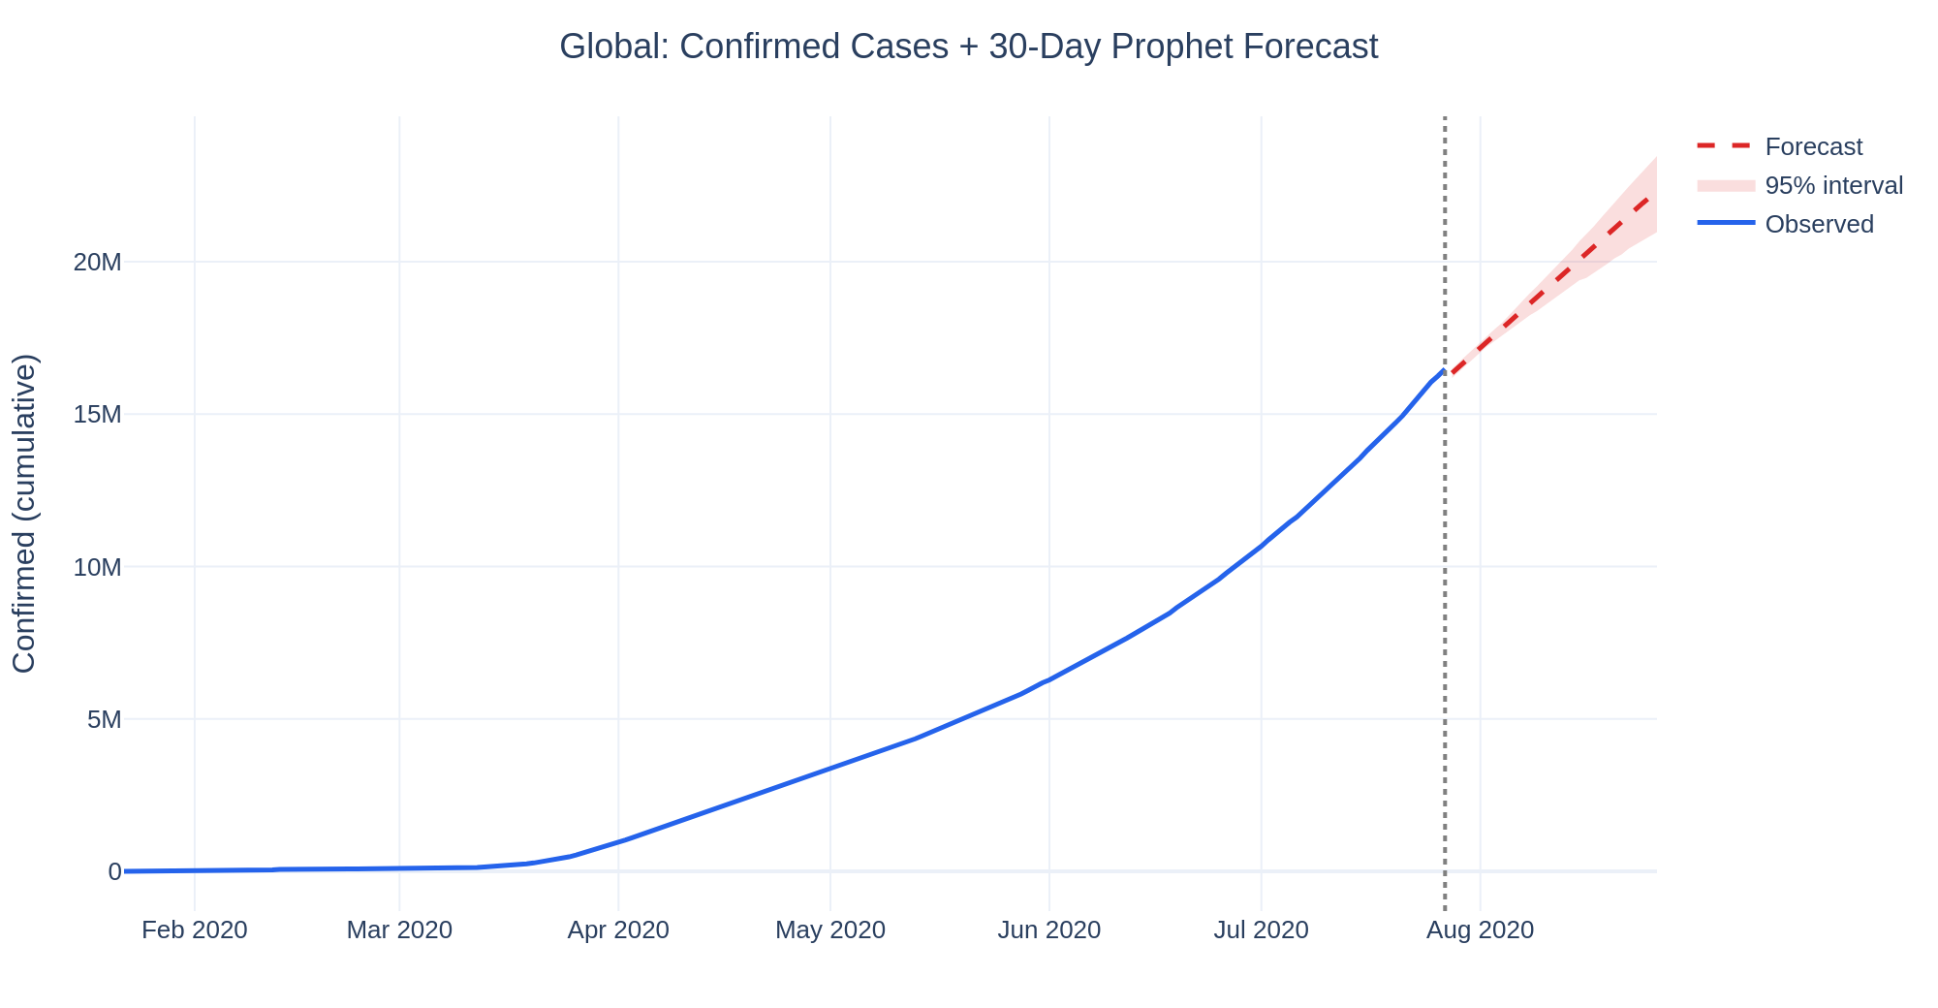
Figure 9 — Global confirmed cases with 30-day Prophet forecast and 95% interval.
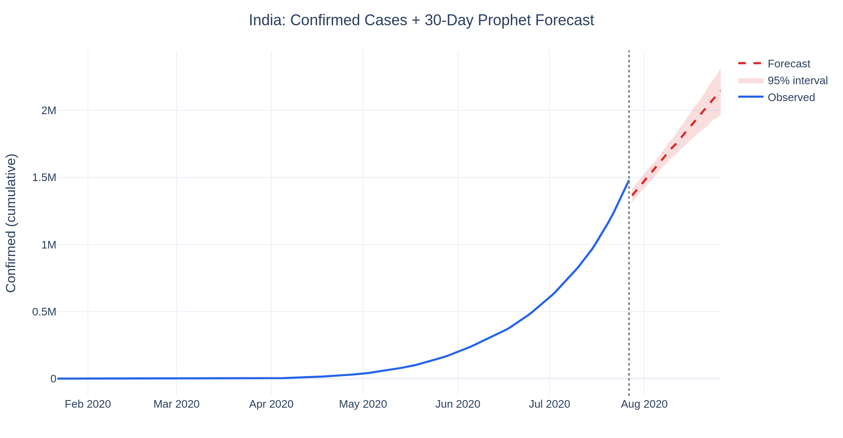
Figure 10 — India confirmed cases with 30-day Prophet forecast and 95% interval.
Results: The global model is accurate at the one-week horizon (~3.8% MAPE) and projects cases rising to ~17.6M within a week and ~22.3M within a month if the trend held. Brazil (1.9%) and the US (5.7%) also validate well. India is the hardest to forecast (~14% MAPE) precisely because it was in its steepest acceleration phase — short-term linear extrapolation lags a curve that is still bending upward, so the model slightly under-predicts India’s near-term cases. Full forecasts (with 95% bands) are exported to covid_<region>_forecast.csv.

8. Conclusions
- Infection trend: global cases grew exponentially to 16.5M by 27 Jul 2020, with daily new cases still peaking (~283k/day) — no plateau yet.
- Recovery vs mortality: recovery rate rose to ~57% globally; mortality settled around ~4% after an early, testing-driven spike.
- Geography: the Americas led the case load (US, Brazil); India drove South-East Asia with fast late-stage growth but a low fatality rate (~2.3%).
- Fatality rates varied widely by country (UK ~15%, Mexico ~11% vs India ~2.3%), reflecting testing coverage and demographics more than the virus itself.
- Forecasting: Prophet predicts the next 7–30 days well for stable trajectories (Global ~3.8%, Brazil ~1.9%, US ~5.7% MAPE); rapidly accelerating curves like India’s are inherently harder (~14%).
Tools used: pandas (wrangling), Plotly (interactive visualization) and Facebook Prophet (forecasting) — exactly as specified in the brief.
Deliverables: COVID19_Analysis_Forecasting.ipynb (full interactive analysis & models), covid_<region>_forecast.csv (global, India, US, Brazil forecasts with confidence bands), and this report.

