House Price Prediction
King County, Seattle — Regression with Classical ML & Deep Learning
Best model: XGBoost · R² = 0.908 · RMSE ≈ $119k
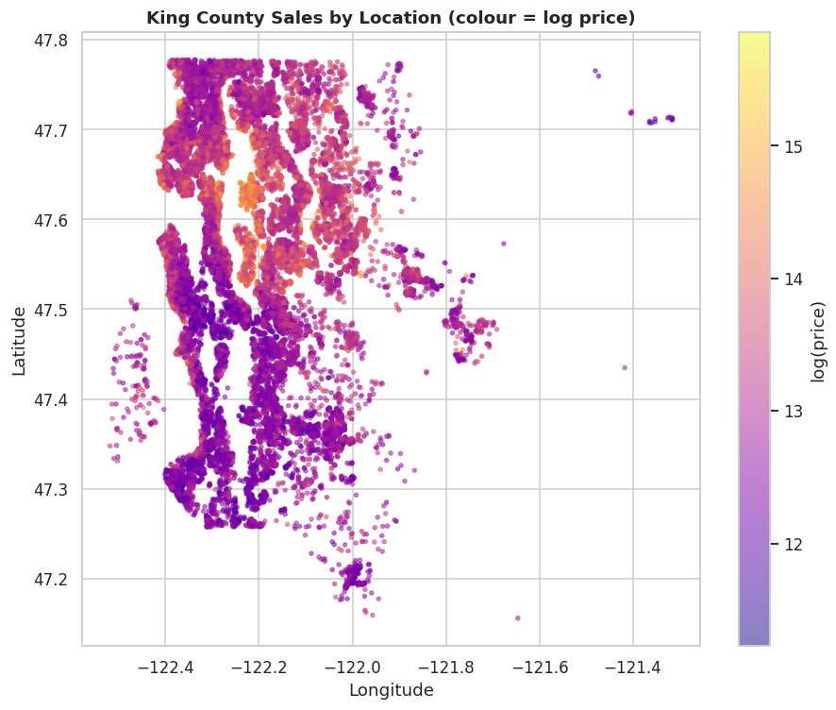
Ankit Saxena
Portfolio Project · Regression / Tabular ML
Dataset: 21,613 home sales · May 2014 – May 2015

Table of Contents
Executive Summary 3
1. Problem Statement & Objectives 4
2. Dataset Overview 5
3. Data Cleaning & Feature Engineering 6
4. Exploratory Data Analysis 7
5. Modelling Approach 9
6. Model Comparison & Results 10
7. What Drives Price 11
8. Interactive Demo 12
9. Conclusions 13

Executive Summary
This project builds an automated valuation model (AVM) for residential real estate using 21,613 home sales in King County, Washington — the area around Seattle — recorded between May 2014 and May 2015. From a home's size, quality, condition and location, the model predicts its sale price and surfaces the factors that move that price.
Headline result: after log-transforming the right-skewed price and engineering location and age features, XGBoost explains ~91% of the variance (R² = 0.908) with a typical error of about $119,000. Tree ensembles outperform both linear models and a neural network — the expected outcome on tabular data. The strongest price drivers are construction grade, living area and location.

Key numbers
Metric | Value
Home sales analysed | 21,613
Features (after engineering) | 18
Median sale price | $450,000
Best model | XGBoost
Best R² (log-price) | 0.908
Best RMSE | $118,694
Best MAE | $65,181

1. Problem Statement & Objectives
Pricing a home accurately is central to real-estate marketplaces, mortgage lenders and investors. Manual appraisal is slow and inconsistent; an automated valuation model gives a fast, data-driven estimate. The objectives are twofold:
- Predictive: estimate a home's sale price from its attributes as accurately as possible.
- Explanatory: identify which attributes drive price, so the estimate is interpretable and trustworthy.

2. Dataset Overview
The King County House Sales dataset contains 21,613 sales and 20 attributes per home. Key fields:
Feature | Description
price | Sale price (USD) — the target
sqft_living | Interior living area (sq ft)
grade | Construction & design grade (1–13)
condition | Overall condition (1–5)
bedrooms / bathrooms | Room counts
floors | Number of floors
waterfront / view | Waterfront flag; view quality (0–4)
sqft_lot | Lot size (sq ft)
yr_built / yr_renovated | Construction & renovation years
lat / long / zipcode | Location
The data is complete (no missing values) and spans a single year of sales, so macro market drift is minimal.

3. Data Cleaning & Feature Engineering
A few targeted steps sharpen the signal:
- Fixed a data-entry typo: one 1,620 sqft home listed 33 bedrooms — corrected to 3.
- Parsed the sale date and engineered house_age, a renovated flag, and a has_basement flag.
- Target-encoded zipcode into a single zip_price_level (its mean training log-price), computed on the training split only to avoid leakage — a compact, powerful way to capture location.
The target (price) is heavily right-skewed, so all models predict log(price), which is approximately normal.

4. Exploratory Data Analysis
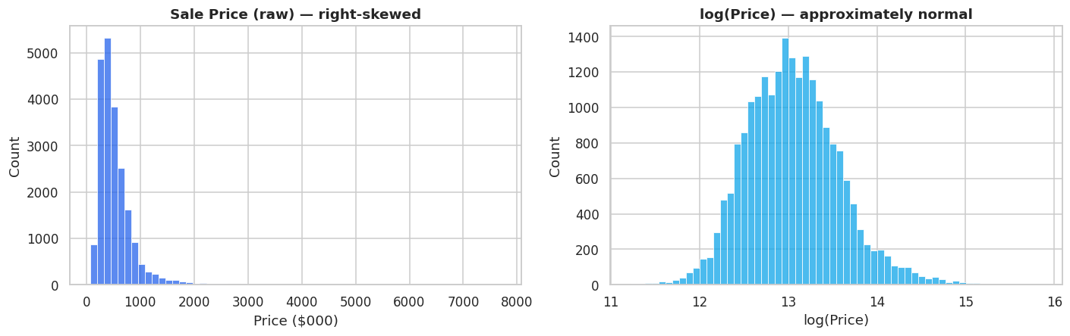
Figure 1 — Sale price is right-skewed (left); log(price) is approximately normal (right).
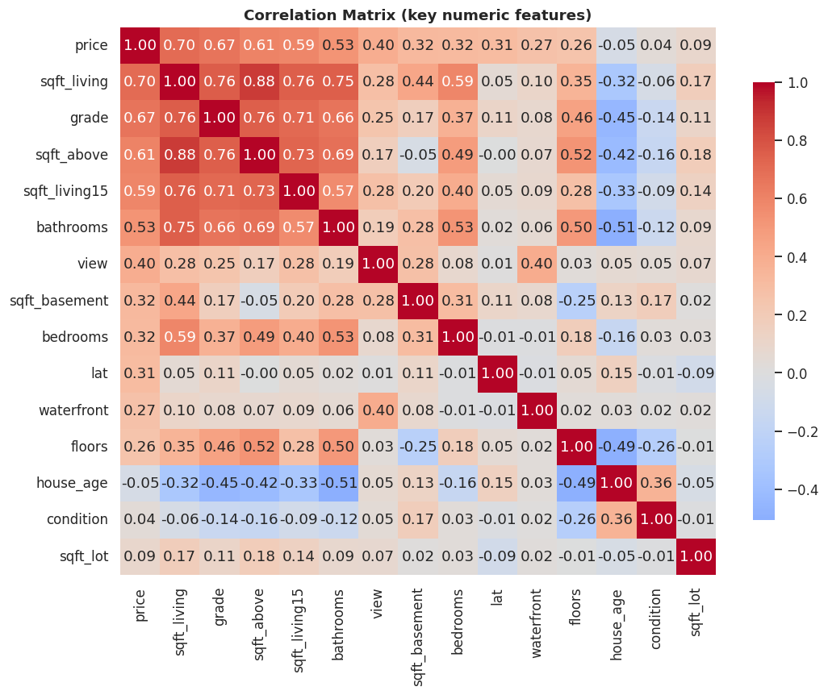
Figure 2 — Correlation of key numeric features with price.
Living area and construction grade are the strongest numeric correlates of price (r ≈ 0.70 and 0.67).
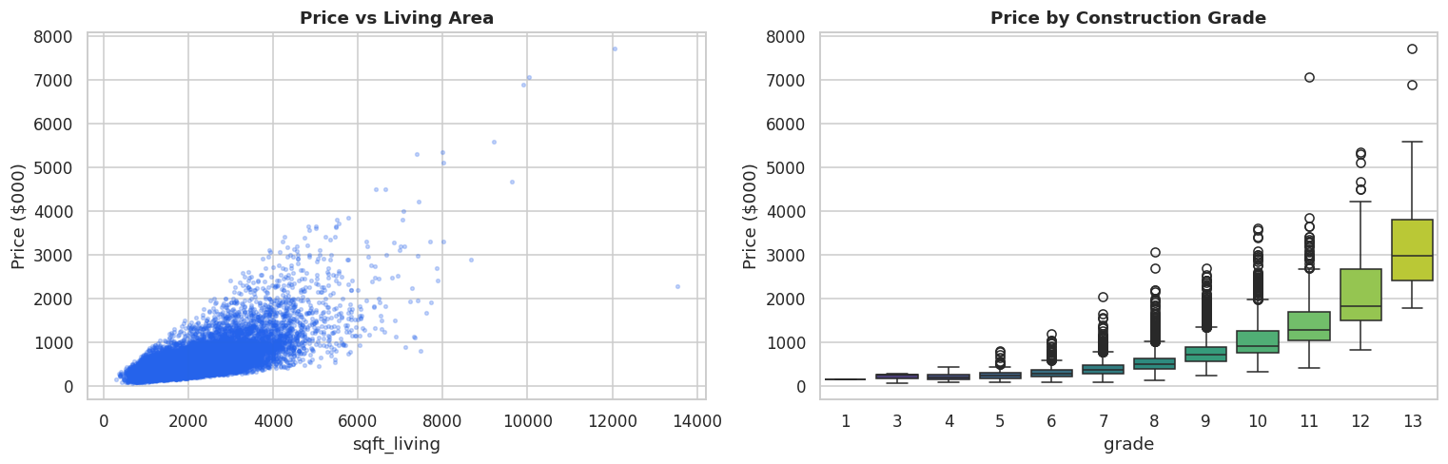
Figure 3 — Price rises with living area (left) and steeply with construction grade (right).

Figure 4 — Location dominates: a clear premium around Seattle, Bellevue and the waterfront.
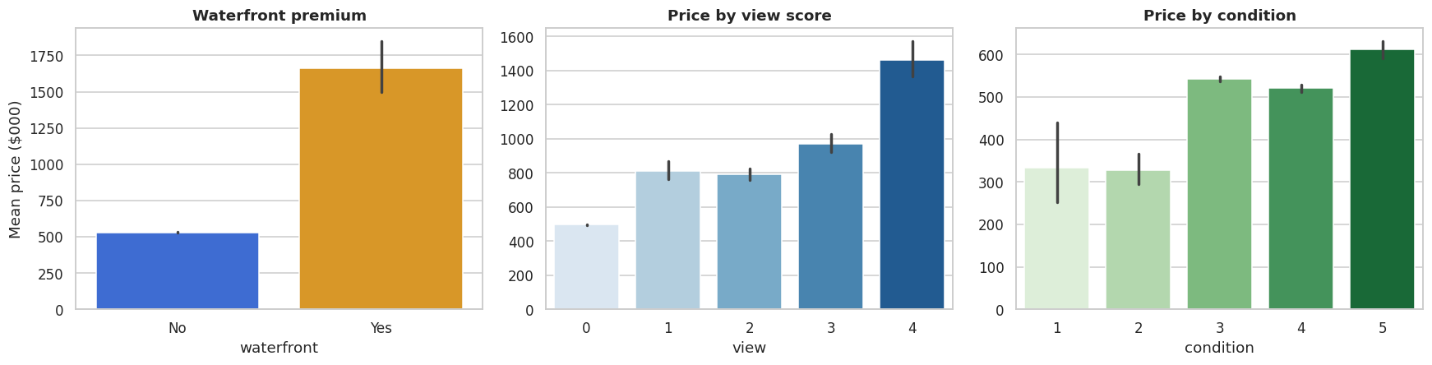
Figure 5 — Waterfront homes and high view scores command large premiums; condition matters less than grade.
Takeaways: price is right-skewed (model log-price); living area and grade are the dominant attributes; and location is decisive — latitude alone correlates with price more strongly than most house features.

5. Modelling Approach
Every model is trained and judged on one shared 80/20 split. The 18-feature matrix combines the house attributes, engineered age/renovation flags, location (latitude, longitude, neighbourhood sizes) and the target-encoded zipcode level. Linear models and the neural network use standard-scaled inputs; the tree models use the raw matrix.
- Linear baselines: Linear Regression, Ridge, Lasso.
- Tree ensembles: Random Forest and XGBoost.
- Deep learning: a Keras neural network (128-64-32 with dropout), with the target standard-scaled so it converges quickly.
Performance is reported as R² (in log space) plus RMSE and MAE back-transformed to dollars for interpretability.

6. Model Comparison & Results
Model | R² | RMSE | MAE
XGBoost | 0.908 | $118,694 | $65,181
Random Forest | 0.893 | $138,702 | $71,142
Neural Network | 0.862 | $167,143 | $85,822
Lasso | 0.856 | $226,538 | $89,392
Ridge | 0.856 | $229,915 | $89,580
Linear Regression | 0.856 | $230,035 | $89,593
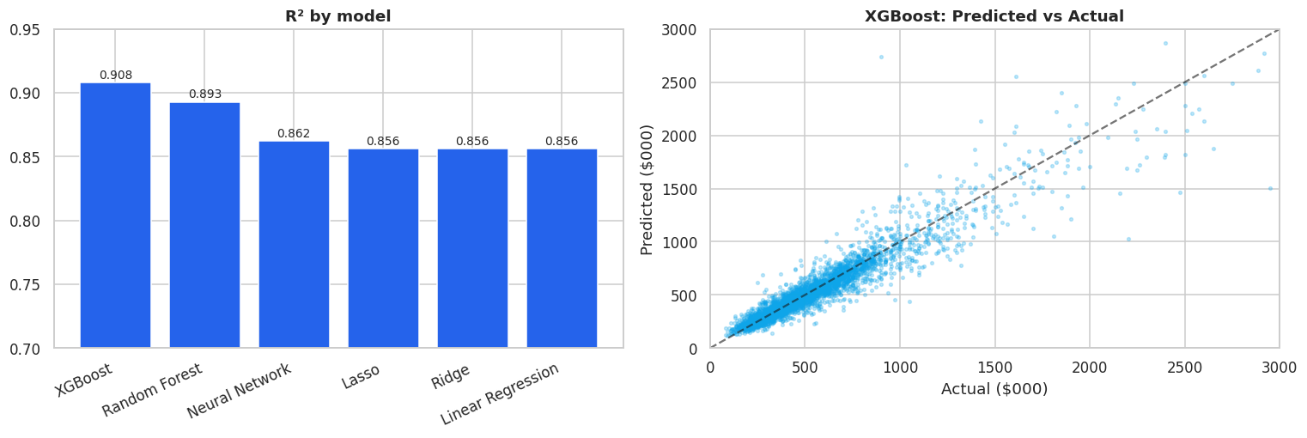
Figure 6 — R² by model (left); XGBoost predicted vs actual price (right).
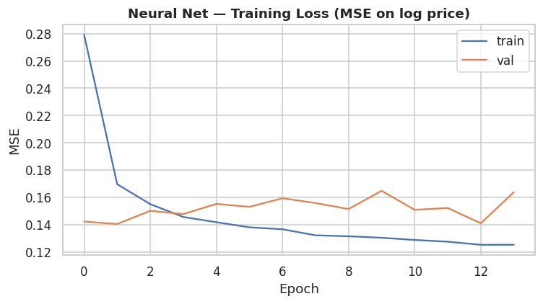
Figure 7 — Neural-network training/validation loss (converges in a few epochs once the target is scaled).
XGBoost wins clearly. It explains ~91% of the variance with a typical error near $119k. The tree ensembles beat the linear models by a wide margin and edge out the neural network — the standard result for structured/tabular data, where gradient-boosted trees are hard to beat.

7. What Drives Price
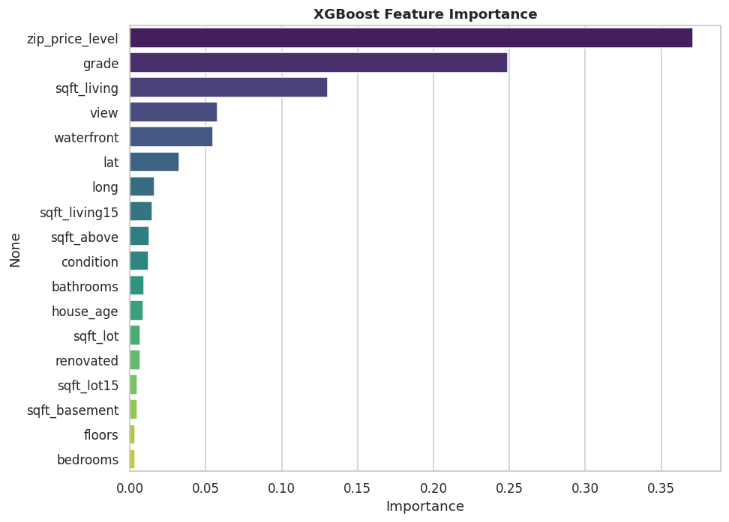
Figure 8 — XGBoost feature importance.
The model's drivers match the EDA and intuition: construction grade, living area and location (the target-encoded zipcode level, latitude and neighbourhood home sizes) dominate, with waterfront and view adding sharp premiums. House age and lot size matter at the margin. Because the location signal is so strong, an accurate AVM must capture neighbourhood effects — which the target-encoded zipcode does compactly.

8. Interactive Demo
The trained XGBoost model is serialised and served through an interactive Streamlit app. A user enters a home's details — living area, grade, condition, bedrooms, bathrooms, zipcode, year built and so on — and receives an instant price estimate with a typical-error range. Location features (latitude/longitude, neighbourhood sizes and the zipcode price level) are inferred automatically from the selected zipcode, so the user only supplies what they actually know about the house.
The app runs locally with one command and deploys free on Streamlit Community Cloud (see the project's STEPS guide). Spot checks are sensible: a Wallingford (98103) mid-size home prices near $590k, a Medina (98039) waterfront estate near $4.4M, and a small SeaTac (98168) home near $155k — correctly reflecting the dominant role of location.

9. Conclusions
A disciplined pipeline — log-target, leakage-safe location encoding, and a fair six-model benchmark — yields a strong, interpretable valuation model. XGBoost is the clear winner (R² = 0.908, RMSE ≈ $119k), and the drivers of price are unambiguous: build quality, size and location. The model is packaged behind a live demo, turning the analysis into a usable tool.
Next steps: add property-tax and school-district features, calibrate prediction intervals, and retrain on rolling recent sales to track the market over time.

