Walmart Sales Analysis
& 12-Week Sales Forecasting
Data Science Capstone Project
Intellipaat • Problem Statement 1
Prepared by: Ankit Saxena
June 2026
Dataset: 45 stores · 143 weeks · Feb 2010 – Oct 2012

Contents

1. Introduction & Problem Statement
A retail chain operating multiple outlets across the country is struggling to manage inventory — specifically, to match supply with demand. The objective of this project is to analyse three years of historical weekly sales data and convert it into actionable insight, then build a model that forecasts demand for each store over the coming weeks so inventory can be planned ahead.
The work is delivered in two parts, as set out in the capstone brief:
Part 1 — Analysis & Insights: using statistical analysis, exploratory data analysis (EDA), outlier analysis and missing-value handling, answer six business questions covering the effect of unemployment, seasonality, temperature and the Consumer Price Index on sales, and identify the best- and worst-performing stores.
Part 2 — Predictive Modelling: forecast weekly sales for each of the 45 stores for the next 12 weeks.

2. Dataset Overview
The dataset (walmart.csv) contains 6,435 rows and 8 columns — one record per store per week. The fields are:
Feature | Description
Store | Store number (1–45)
Date | Week of sales (weekly, ending Friday)
Weekly_Sales | Sales for the given store in that week (USD)
Holiday_Flag | 1 if the week contains a major holiday, else 0
Temperature | Average temperature in the region (°F)
Fuel_Price | Cost of fuel in the region (USD/gallon)
CPI | Consumer Price Index
Unemployment | Regional unemployment rate (%)

Span: 45 stores across 143 consecutive weeks, from 5 February 2010 to 26 October 2012. Weekly sales range from about $0.21M to $3.82M, averaging $1.05M.

3. Data Cleaning & Missing-Value Treatment
Data quality was checked before analysis. The dataset is complete and clean:
Missing values: none — all 8 columns are fully populated across all 6,435 rows.
Duplicate rows: none.
Type correction: the Date field was parsed from the dd-mm-yyyy text format into a proper datetime and the records were sorted by store and date to form a clean weekly time series for each store.
Because there are no missing values, no imputation was required. (Had values been missing, the appropriate treatment here would be time-aware interpolation within each store, since every store is an ordered weekly series.)

4. Exploratory Data Analysis
Weekly sales are right-skewed: most weeks cluster around $1M, with a long tail of very large holiday weeks.
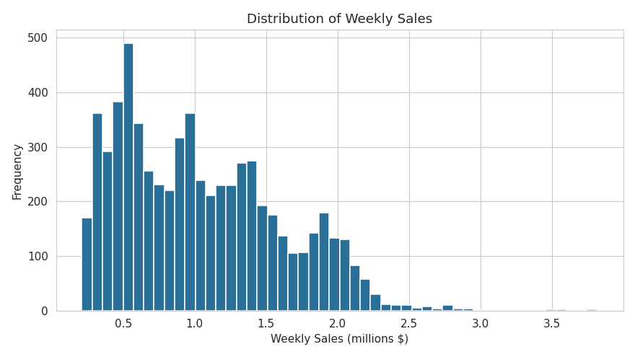
Figure 1 — Distribution of weekly sales across all stores.
A correlation matrix shows that, pooled across all stores, the external economic and seasonal factors are only weakly related to sales. The strongest associations are with unemployment and CPI, both mildly negative.
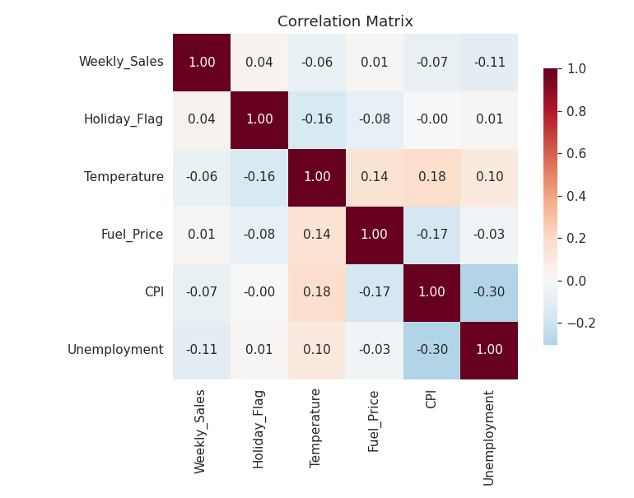
Figure 2 — Correlation between weekly sales and the economic / seasonal drivers.
Factor | Correlation | Interpretation
Unemployment | -0.11 | Weak negative (strong for a few stores)
CPI | -0.07 | Weak negative (strong for a few stores)
Temperature | -0.06 | Negligible
Holiday_Flag | +0.04 | Small positive, but significant
Fuel_Price | +0.01 | No meaningful relationship

The key message: macro variables are not strong linear predictors when all stores are pooled. Their real influence is store-specific and seasonal, which the next sections examine.

5. Outlier Analysis
Outliers in weekly sales were identified using the inter-quartile range (IQR) rule. Only 34 rows (0.53%) fall outside the fence, and the most extreme are all late-November and late-December weeks — the Thanksgiving and Christmas shopping peaks.
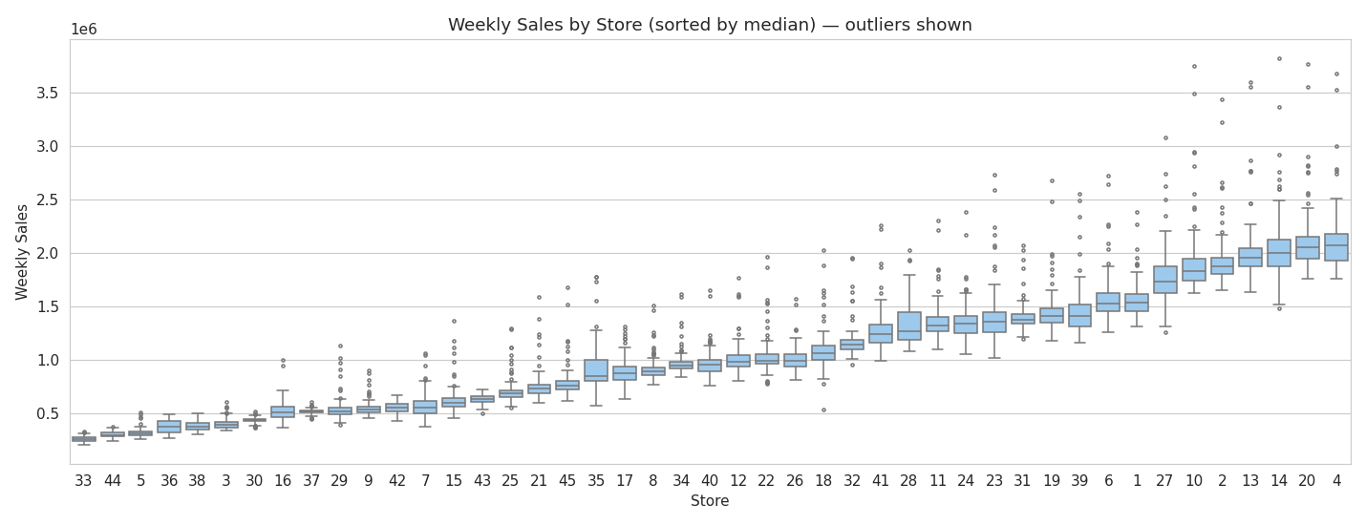
Figure 3 — Weekly sales by store (sorted by median); points beyond the whiskers are outliers.
Decision: outliers were retained. These are genuine seasonal peaks, not data-entry errors. Removing them would erase exactly the holiday demand signal the business needs to plan inventory for. They were therefore flagged and kept.

6. Business Insights

(a) Does unemployment affect sales — and which stores suffer most?
Across all stores the effect is weak and negative (r = -0.11), so unemployment is not a universal driver. But the relationship is highly store-specific: a handful of stores are very sensitive to local unemployment.
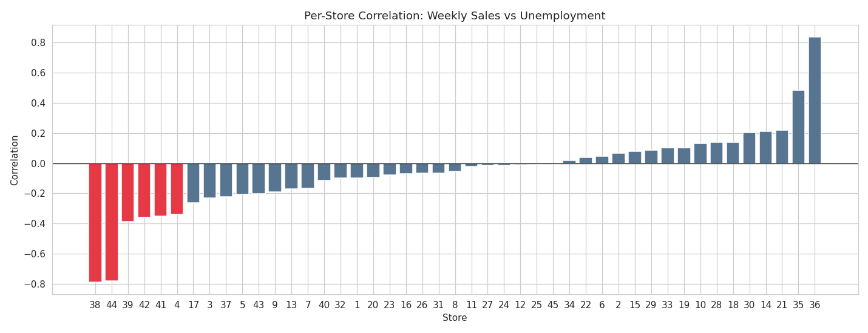
Figure 4 — Per-store correlation between weekly sales and unemployment.
Store | Corr. with Unemployment | Sensitivity
Store 38 | -0.79 | Very high
Store 44 | -0.78 | Very high
Store 39 | -0.39 | Moderate
Store 42 | -0.36 | Moderate
Store 41 | -0.35 | Moderate
Store 4 | -0.34 | Moderate

Answer: Stores 38 and 44 suffer the most when unemployment rises, followed by 39, 42, 41 and 4. These should be protected with targeted promotions and leaner inventory during economic downturns.

(b) Is there a seasonal trend — when, and why?
Yes — a strong, repeatable annual cycle. Chain-wide sales sit around $45–48M per week for most of the year, then spike sharply every November and December.
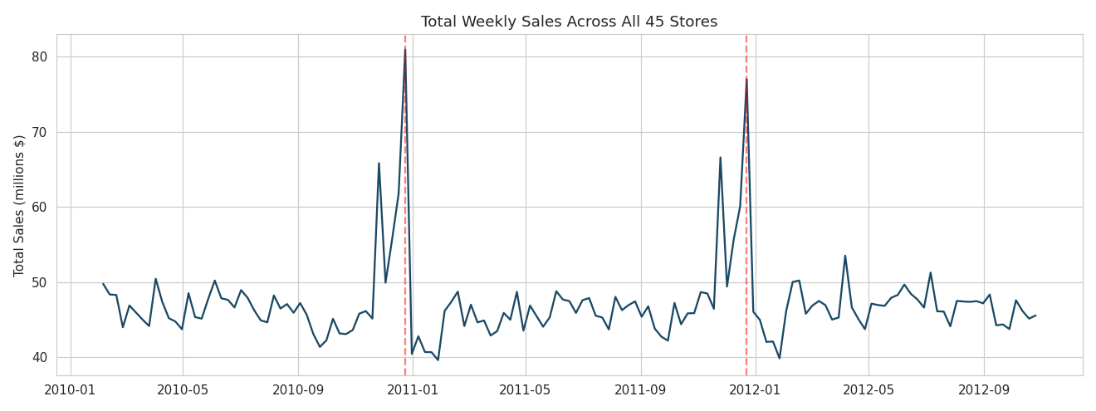
Figure 5 — Total weekly sales across all stores (red lines mark Christmas weeks).
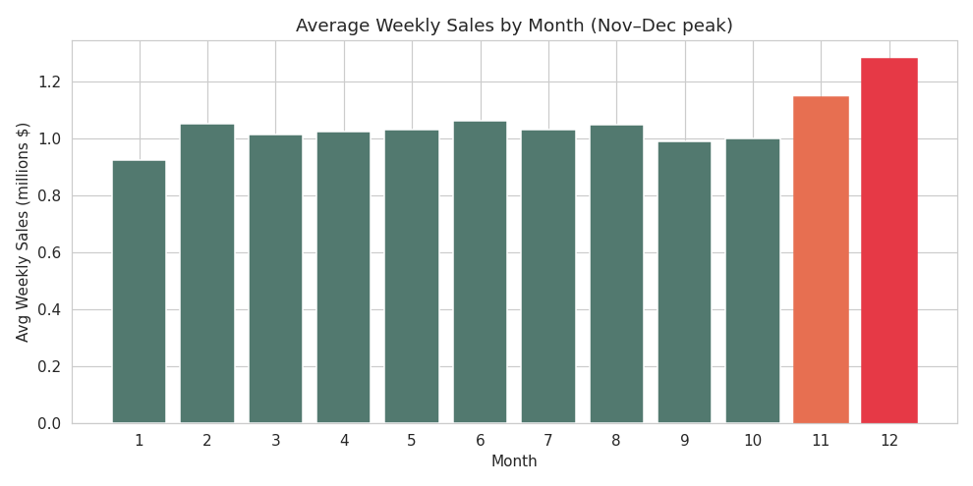
Figure 6 — Average weekly sales by month; November and December dominate.
Holiday-flagged weeks average significantly higher sales than ordinary weeks ($1.12M vs $1.04M per store; Welch t-test p = 0.008). The single biggest weeks are the week before Christmas (24 Dec 2010, 23 Dec 2011) and Thanksgiving week.
Answer: Sales peak every November–December. The reason is year-end holiday shopping — Thanksgiving / Black Friday and Christmas. Inventory must be built up ahead of Q4.

(c) Does temperature affect sales?
Answer: Almost no effect. The correlation is -0.06 and average sales are essentially flat across temperature bands, dipping only slightly in extreme heat. Day-to-day temperature is not a useful predictor of weekly sales for this chain — the calendar matters far more than the weather.

(d) How does the Consumer Price Index (CPI) affect sales?
Pooled, CPI is weakly negative (r = -0.07) — rising prices slightly depress sales. As with unemployment, the impact is concentrated in particular stores.
Store | Corr. with CPI | Sensitivity
Store 36 | -0.92 | Very high
Store 35 | -0.42 | High
Store 14 | -0.42 | High
Store 30 | -0.30 | Moderate

Answer: CPI matters as a store-level factor rather than a chain-wide one. Stores 36, 35 and 14 are strongly price-sensitive — sales there fall noticeably as CPI rises — pointing to more price-conscious customer bases. Most other stores show little CPI sensitivity.

(e) Top-performing stores
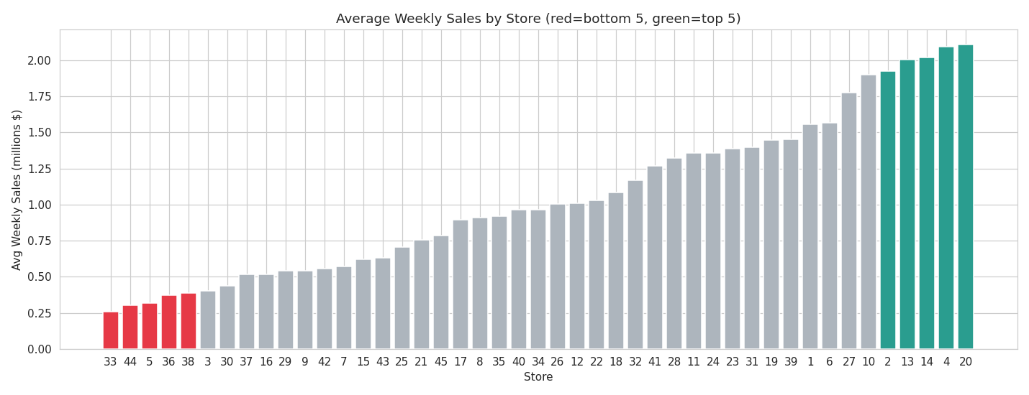
Figure 7 — Average weekly sales by store (green = top 5, red = bottom 5).
Store | Avg Weekly Sales | Total Sales (3 yrs)
Store 20 | $2,107,677 | $301,397,792
Store 4 | $2,094,713 | $299,543,953
Store 14 | $2,020,978 | $288,999,911
Store 13 | $2,003,620 | $286,517,704
Store 2 | $1,925,751 | $275,382,441

Answer: The top-performing stores are 20, 4, 14, 13 and 2. Store 20 leads with roughly $301M in total sales. These flagship outlets should be prioritised for stock availability, especially in Q4.

(f) Worst-performing store and the gap vs the best
Store | Avg Weekly Sales | Total Sales (3 yrs)
Store 33 (worst) | $259,862 | $37,160,222
Store 44 | $302,749 | $43,293,088
Store 5 | $318,012 | $45,475,689

Answer: The worst-performing store is Store 33 (~$37.2M total, ≈$0.26M/week). The best, Store 20, sells about 8.1× more — a difference of roughly $264M, or 711% higher. A Welch t-test confirms the gap is highly statistically significant (t ≈ 80, p ≈ 3.5 × 10⁻¹²¹), so it reflects a real structural difference in store size, format or location rather than random week-to-week variation. The smallest stores (33, 44, 5, 36, 38) are candidates for format review or right-sized inventory.

7. Predictive Modelling — 12-Week Forecast for Every Store
The goal of Part 2 is to forecast weekly sales for each of the 45 stores for the next 12 weeks. The horizon runs from November 2012 into January 2013 — which includes the holiday peak — so the model must capture the strong annual seasonality identified in Part 1.

Method
Each store is treated as its own weekly time series with a roughly flat trend and a 52-week seasonal cycle. A Holt-Winters Exponential Smoothing model (additive trend + additive seasonality, seasonal period = 52) is fitted per store. This method is robust, fits reliably for all 45 stores, and captures the year-end surge.
To validate accuracy, the last 12 weeks of each store were held out, predicted, and compared against the actual values (and against a seasonal-naïve baseline that simply repeats the same week one year earlier).

Backtest accuracy
Model | Mean MAPE | Median MAPE
Holt-Winters (chosen) | 4.33% | 3.01%
Seasonal-naïve (baseline) | 8.77% | 7.14%

Holt-Winters more than halves the baseline error and is more accurate on 42 of the 45 stores — a dependable model. It was then refitted on each store’s full history to produce the final 12-week forecast.
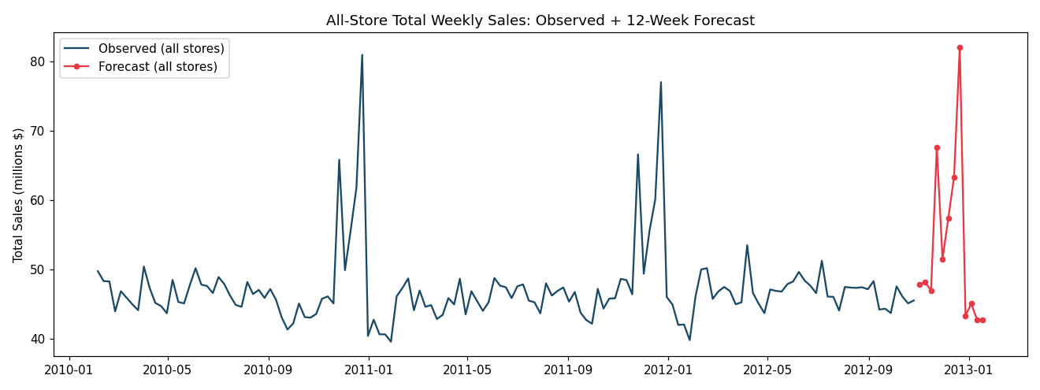
Figure 8 — All-store total weekly sales: observed history and 12-week forecast (the model reproduces the holiday peak).
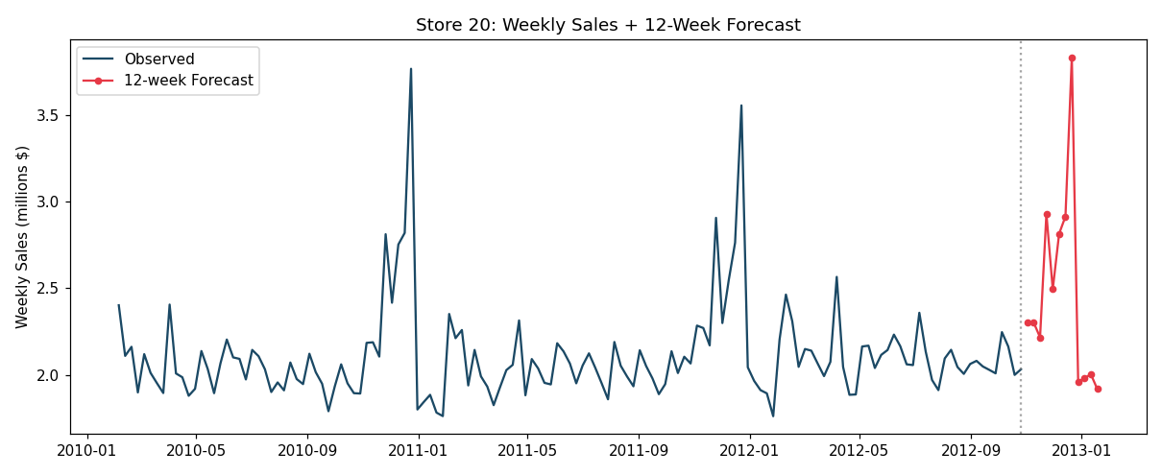
Figure 9 — Store 20 (top performer): history and 12-week forecast.

Forecast output
The full results — 45 stores × 12 weeks = 540 forecasts, each with a 95% confidence band — are exported to walmart_12week_forecast.csv. As an example, the forecast for Store 20 is shown below.
Week Ending | Forecast Sales | Note
2012-11-02 | $2,300,801
2012-11-09 | $2,301,804
2012-11-16 | $2,216,175
2012-11-23 | $2,930,191 | Thanksgiving
2012-11-30 | $2,493,704
2012-12-07 | $2,814,149
2012-12-14 | $2,914,229
2012-12-21 | $3,832,744 | Christmas peak
2012-12-28 | $1,961,055
2013-01-04 | $1,980,207
2013-01-11 | $2,003,091
2013-01-18 | $1,918,485

8. Conclusions & Recommendations
The dataset was clean and complete (no missing values or duplicates); the only anomalies were genuine holiday peaks, which were retained. The analysis produced clear, actionable findings:
- Unemployment has a weak chain-wide effect (r = -0.11) but hits specific stores hard — Stores 38 and 44 most of all.
- Sales follow a strong annual pattern, peaking every November–December due to holiday shopping — the clearest planning signal in the data.
- Temperature has a negligible effect on sales (r = -0.06).
- CPI is weakly negative overall (r = -0.07) but strongly affects price-sensitive Stores 36, 35 and 14.
- The top stores are 20, 4, 14, 13 and 2; Store 20 leads at roughly $301M.
- The weakest store is Store 33; the best store sells about 8.1× more, a statistically significant structural gap.
- Per-store Holt-Winters models forecast the next 12 weeks at a backtested mean error of about 4.3% (MAPE), correctly capturing the holiday surge.

Recommendations
Build inventory ahead of the November–December peak across the chain; protect unemployment- and CPI-sensitive stores with targeted promotions during downturns; and use the per-store 12-week forecasts (walmart_12week_forecast.csv) to allocate stock, prioritising the flagship stores. The forecasting pipeline can be re-run weekly as new data arrives to keep the 12-week outlook current.
Deliverables: Walmart_Capstone_Solution.ipynb (full reproducible analysis & model), walmart_12week_forecast.csv (forecasts with confidence bands), forecast_accuracy_by_store.csv (per-store accuracy), and this report.

