Crime Investigation & Case Registry API

HTTP Methods and Database Operations Mapping
HTTP Method | CRUD Action | MongoDB Operation | System Description
POST | Create | insertOne() | Registers new resources in MongoDB collections (e.g. Detectives, Suspects)
GET | Read | find() / findOne() | Queries and retrieves document sets (e.g. list cases, preloaded dossiers)
PUT | Replace | replaceOne() / save() | Performs full update/replacement of an existing case document
PATCH | Update | updateOne() / save() | Modifies specific document fields (e.g. updating a case status to Solved)
DELETE | Delete | deleteOne() | Permanently purges a record from the database (e.g. evidence records)

REST API Output Demonstration

1. POST — Resource Registration (Write Operation)
Endpoint: POST /detectives
Action: Inserts a new detective 'Inspector Lestrade' into the detectives collection. The response returns 201 Created and includes the generated MongoDB ObjectId.
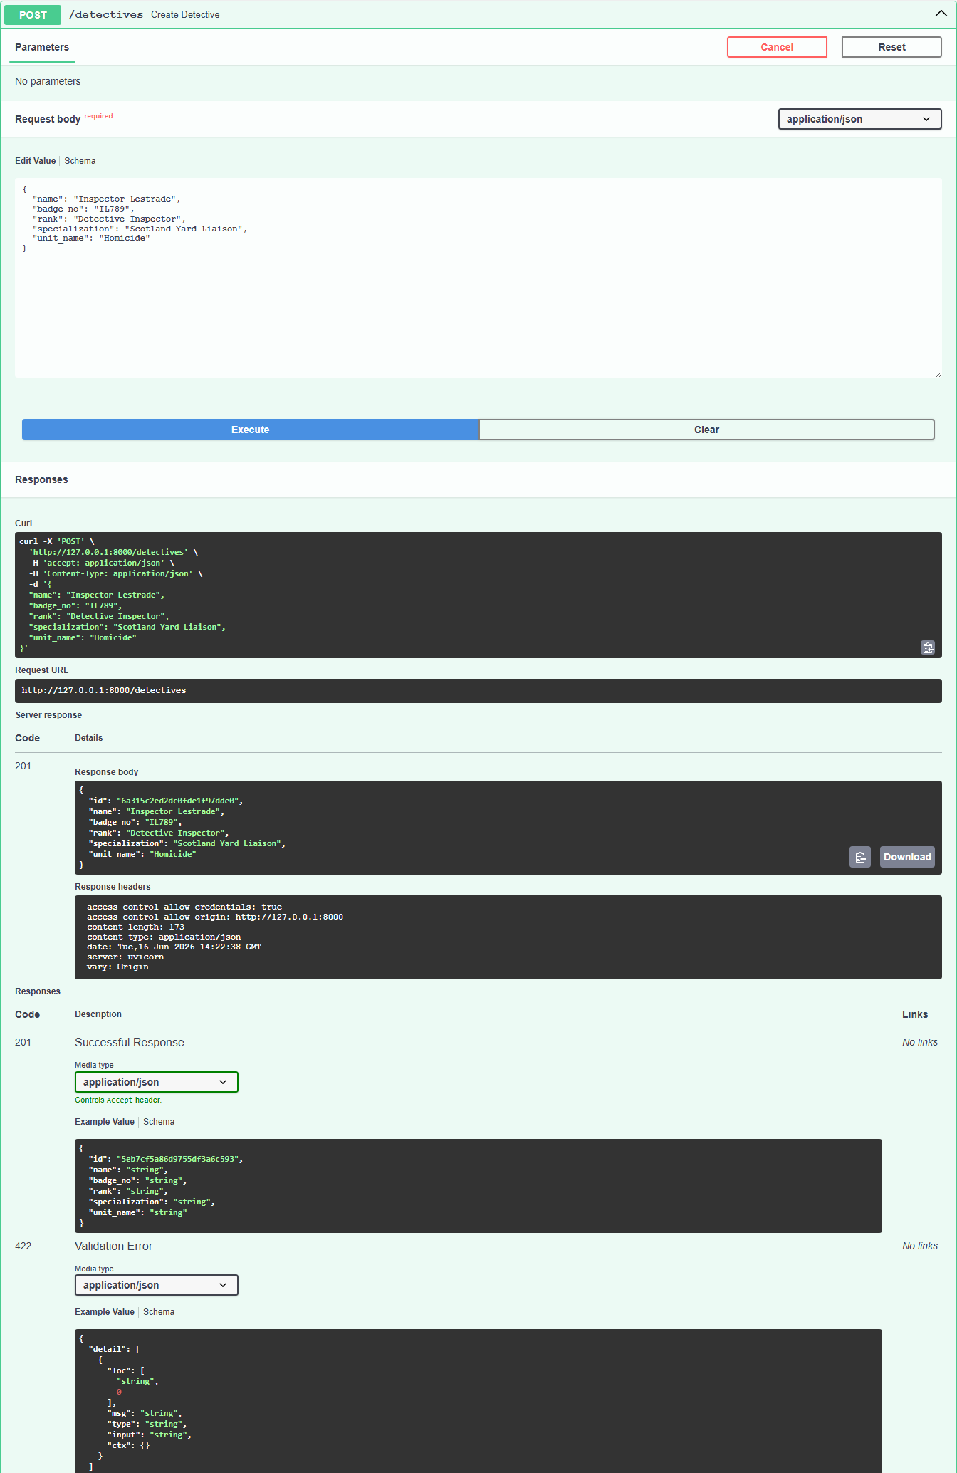
Figure 1: POST /detectives — 201 Created response containing the MongoDB document representation

2. GET — Case Retrieval (Read Operation)
Endpoint: GET /cases
Action: Queries the cases collection in MongoDB and returns all cases. This confirms database read operations are functional.
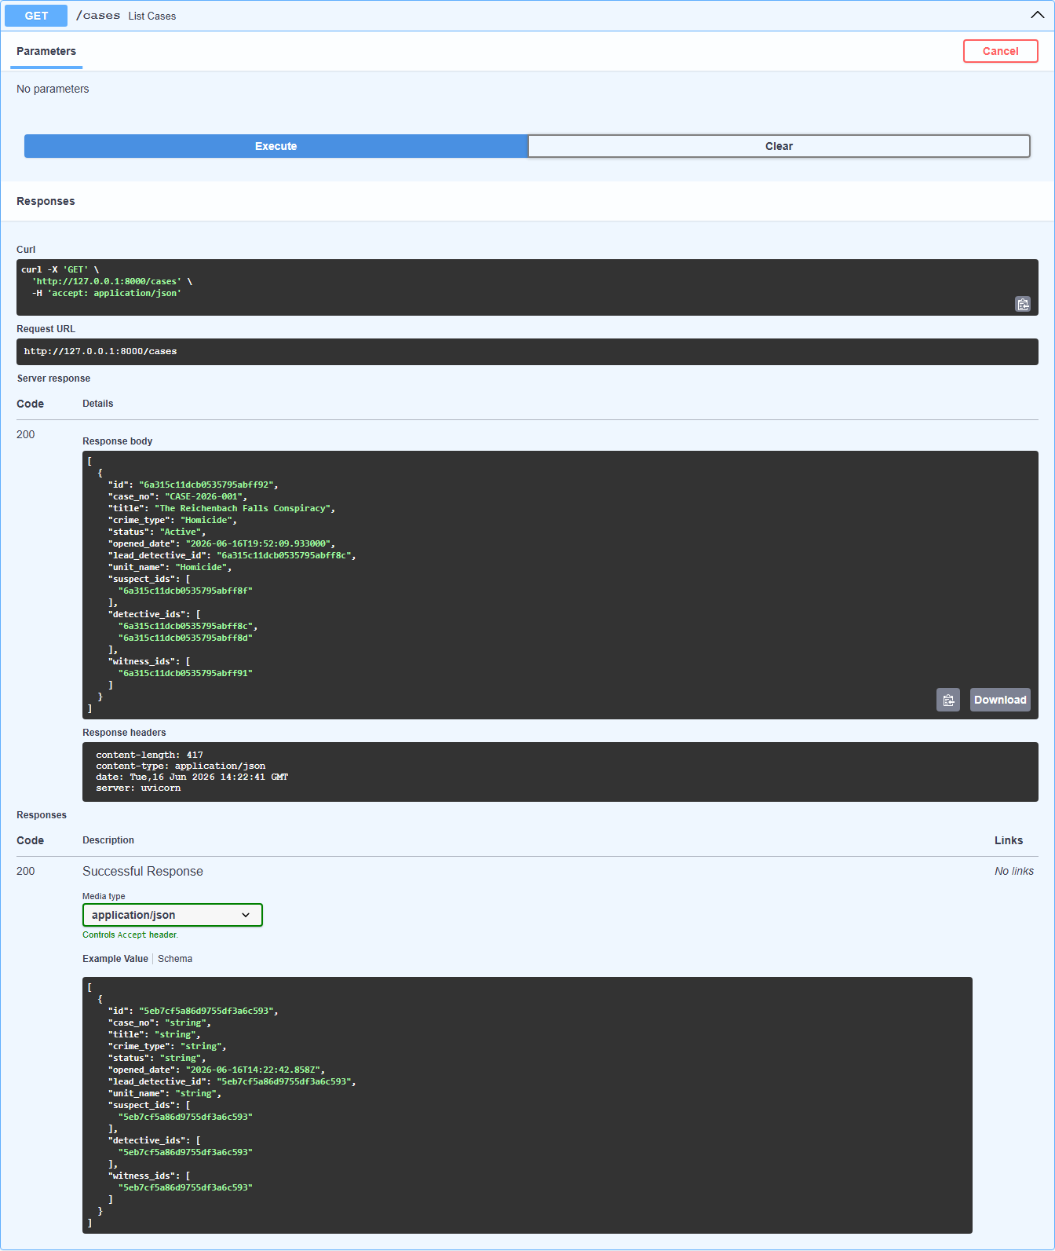
Figure 2: GET /cases — 200 OK list response showing seeded cases retrieved from MongoDB

3. PUT — Full Case Update (Replacement)
Endpoint: PUT /cases/{id}
Action: Replaces the specified case document with updated values (title, description, and status). This ensures resource consistency for full updates.
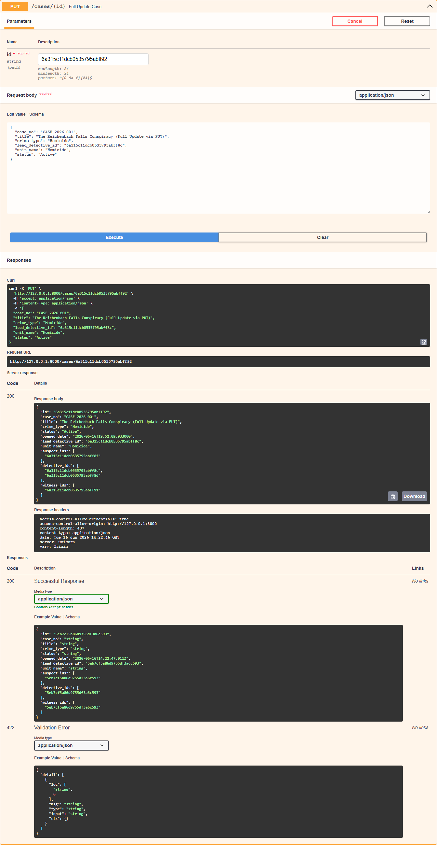
Figure 3: PUT /cases/{id} — 200 OK response displaying the updated case payload

4. PATCH — Partial Case Update (Field Modification)
Endpoint: PATCH /cases/{id}/status
Action: Modifies only the status field (e.g. changing from 'Active' to 'Solved') of a case document in MongoDB.
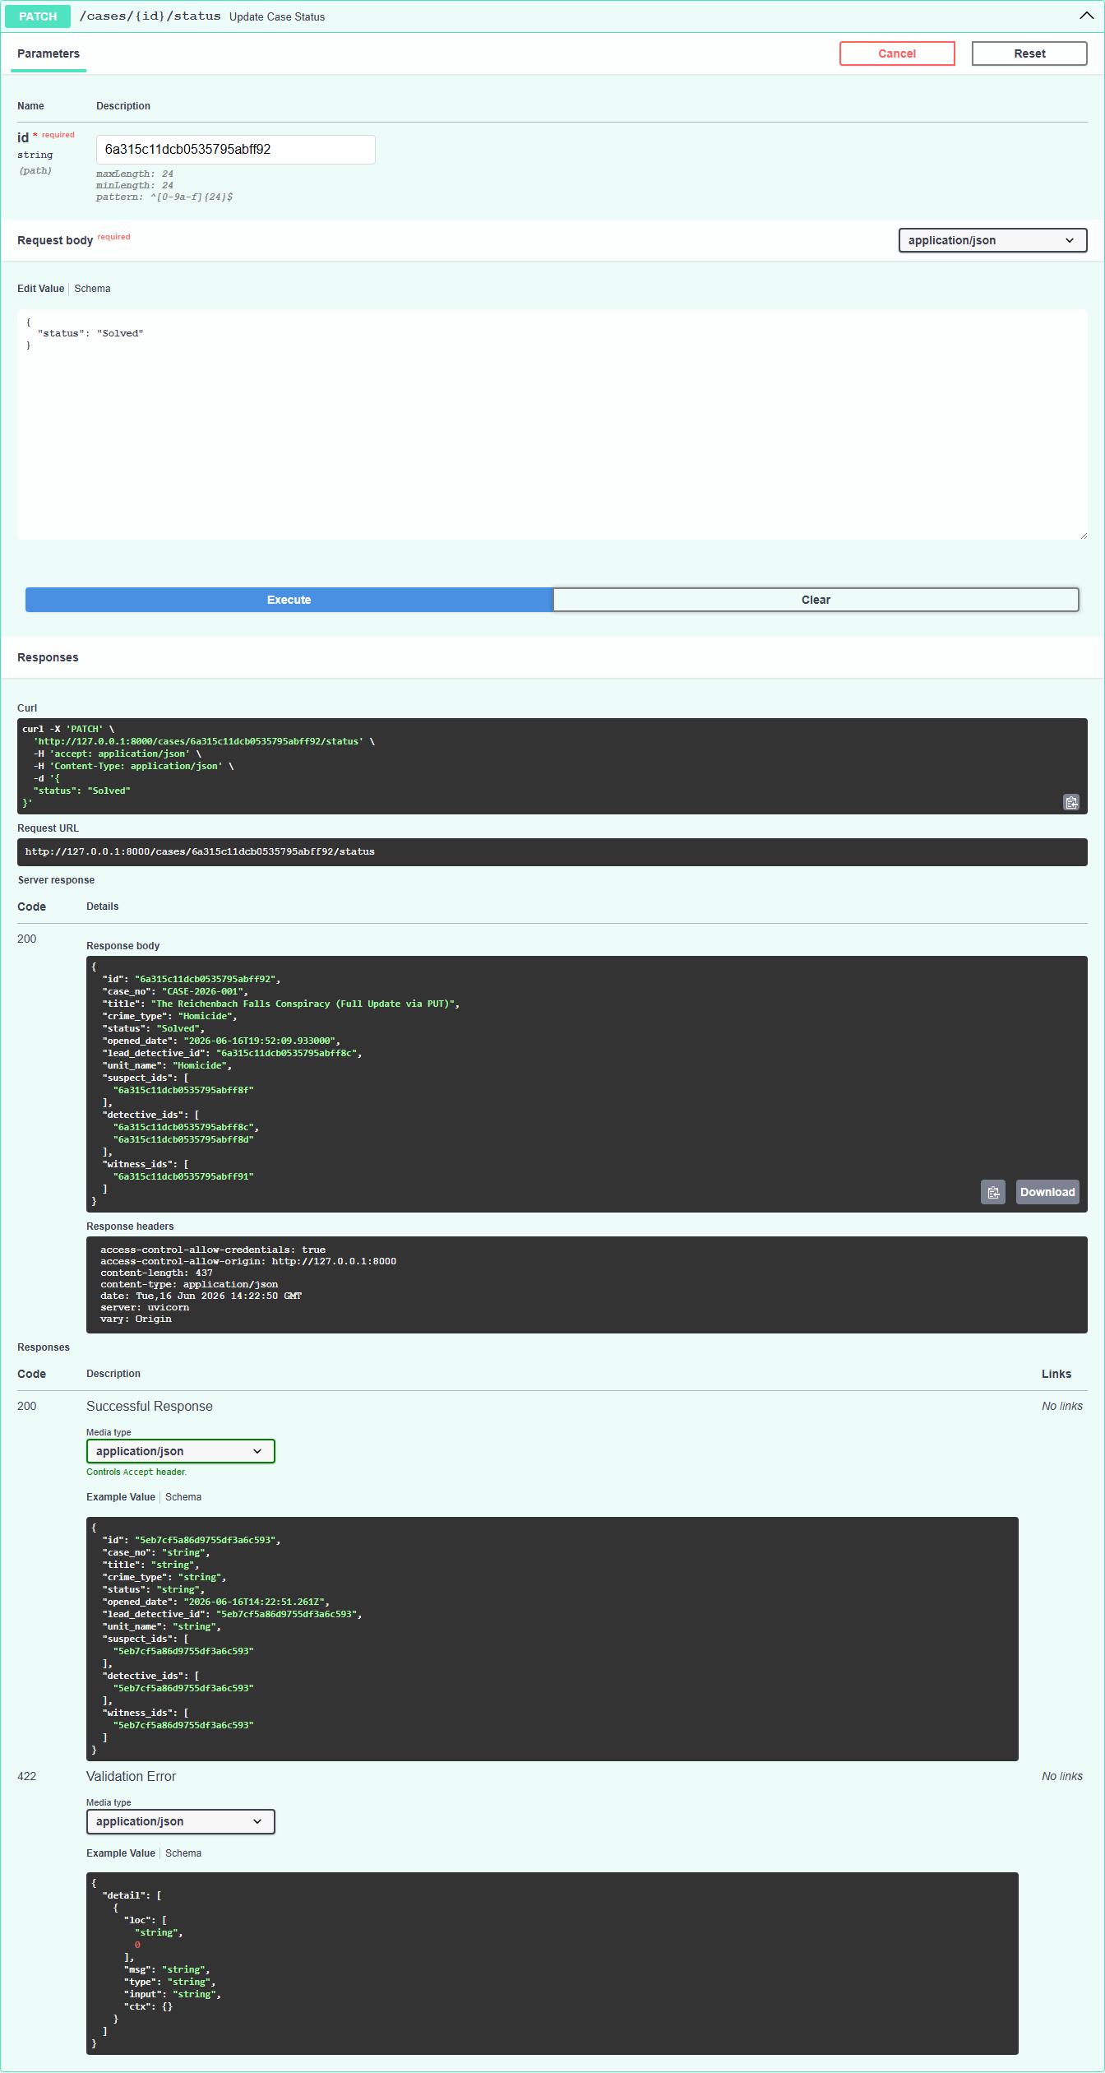
Figure 4: PATCH /cases/{id}/status — 200 OK response showing partial update applied to status field

5. DELETE — Invalidate Evidence (Removal Operation)
Endpoint: DELETE /evidence/{id}
Action: Deletes a specific evidence record from MongoDB. The response confirms that the resource has been purged.
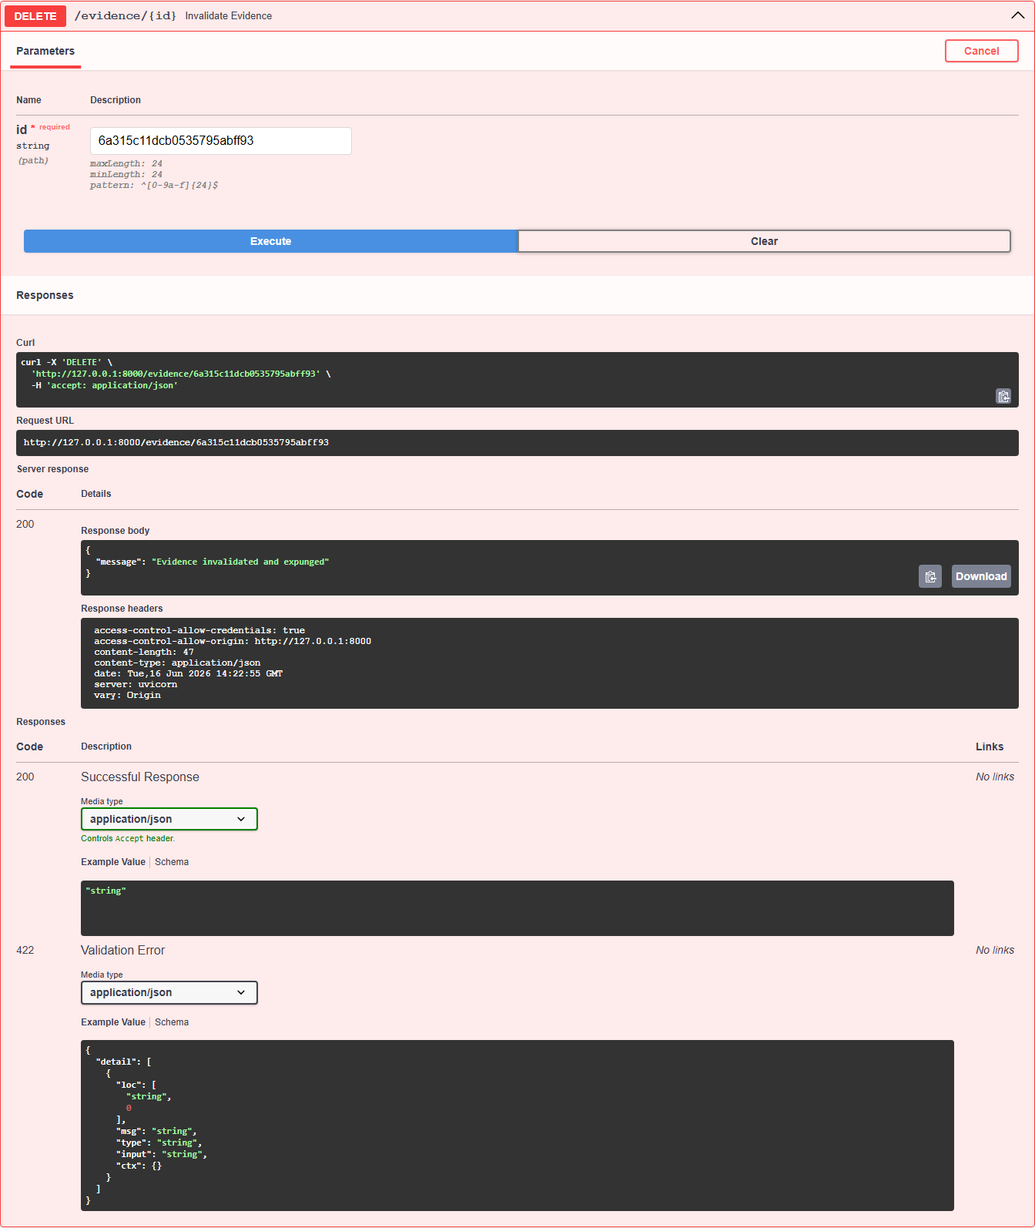
Figure 5: DELETE /evidence/{id} — 200 OK response confirming document deletion from MongoDB

