Crime Investigation & Case Registry API

Output Screenshots (Swagger UI)
The following screenshots were captured from the Swagger UI at http://127.0.0.1:8000/docs demonstrating live API calls to the MongoDB backend.

5.1 Swagger UI — Full API Overview
The auto-generated Swagger documentation lists all available REST endpoints grouped by entity. This confirms the FastAPI server is running and connected to MongoDB.
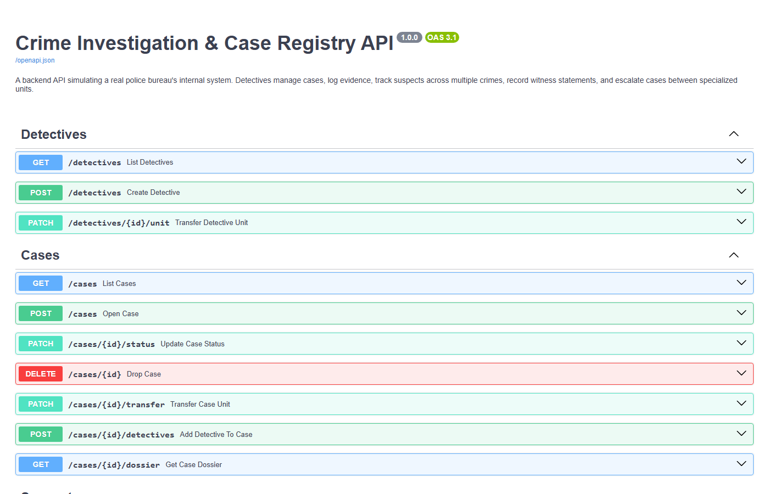
Figure 1: Swagger UI at http://127.0.0.1:8000/docs showing all Crime Registry API endpoints

5.2 GET /cases — Reading Cases from MongoDB
This GET request retrieves all cases stored in the MongoDB crime_registry_db database. The response confirms a seeded record: Case No. CASE-2026-001 'The Reichenbach Falls Conspiracy' with status Active, demonstrating successful database READ operation.
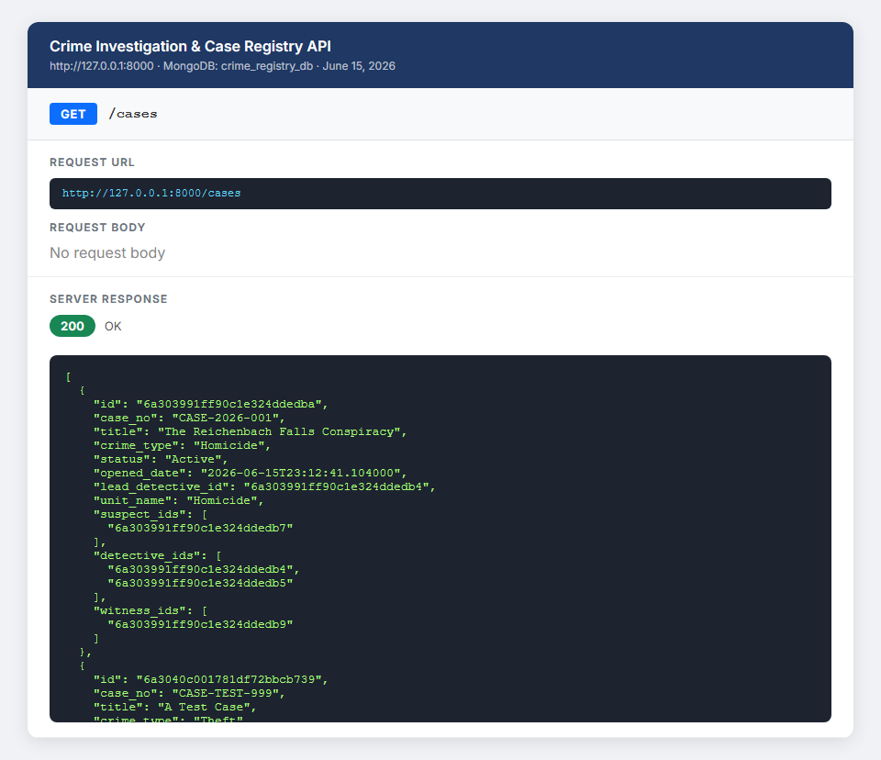
Figure 2: GET /cases — 200 OK response showing CASE-2026-001 retrieved from MongoDB

5.3 GET /cases/{id}/dossier — Full Case Dossier (Cross-Collection Query)
This endpoint returns the complete case dossier by joining data across multiple MongoDB collections: detectives (Sherlock Holmes & John Watson), suspects (James Moriarty), witnesses (Mrs. Hudson), and physical/testimony evidence. This demonstrates cross-collection querying via Beanie ODM — equivalent to SQL JOINs in a NoSQL database.
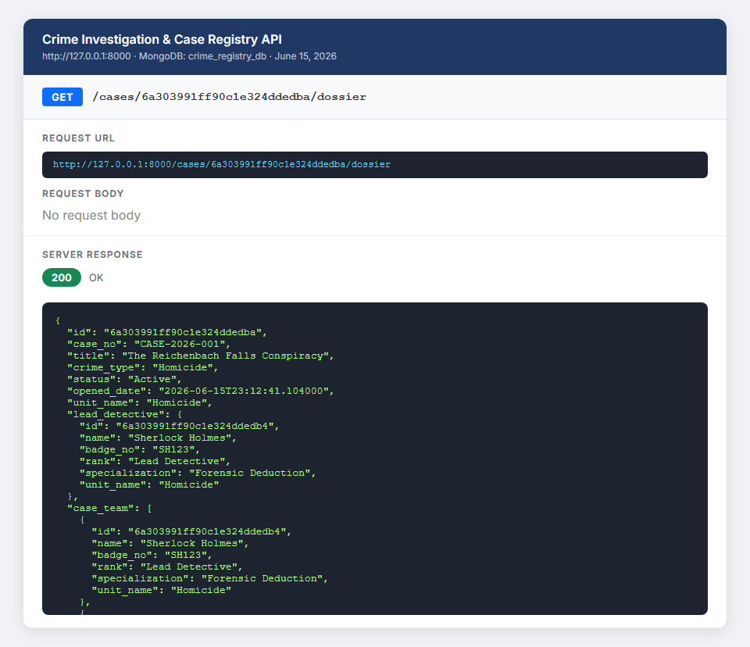
Figure 3: GET /cases/{id}/dossier — Full dossier response with linked detectives, suspects, witnesses and evidence

5.4 POST /suspects — Creating a New Suspect (Database WRITE)
A new suspect 'Victor Savage (alias: The Cobra)' is registered with criminal history. The 201 Created response includes the MongoDB-assigned ObjectId, confirming data is written and persisted in the suspects collection in real time.
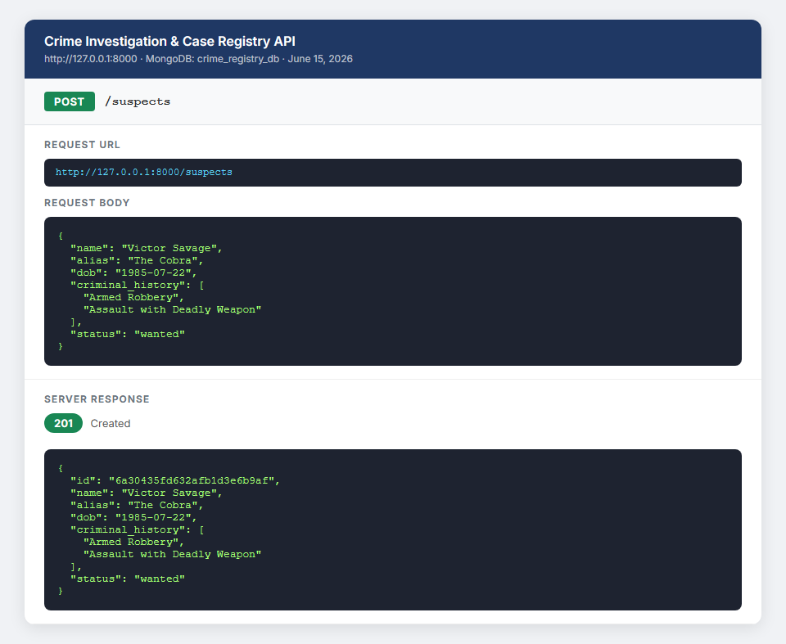
Figure 4: POST /suspects — 201 Created response showing suspect record written to MongoDB

5.5 POST /witnesses — Registering a Witness
A new witness 'Dr. Stamford' is registered. The API returns 201 Created with a newly assigned MongoDB ObjectId, confirming the WRITE operation to the witnesses collection.
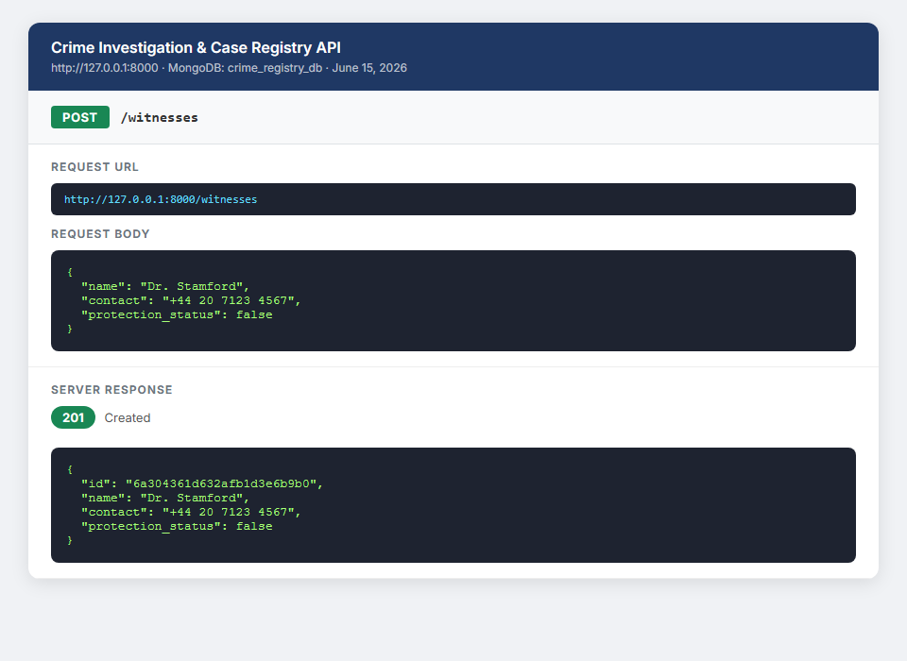
Figure 5: POST /witnesses — 201 Created response showing new witness record in MongoDB

5.6 GET /suspects/{id}/history — Criminal Record Lookup
This endpoint retrieves a suspect's full criminal case history by finding all cases where the suspect_id appears in the case's suspect_ids list. This demonstrates the Many-to-Many relationship between Suspects and Cases in MongoDB.
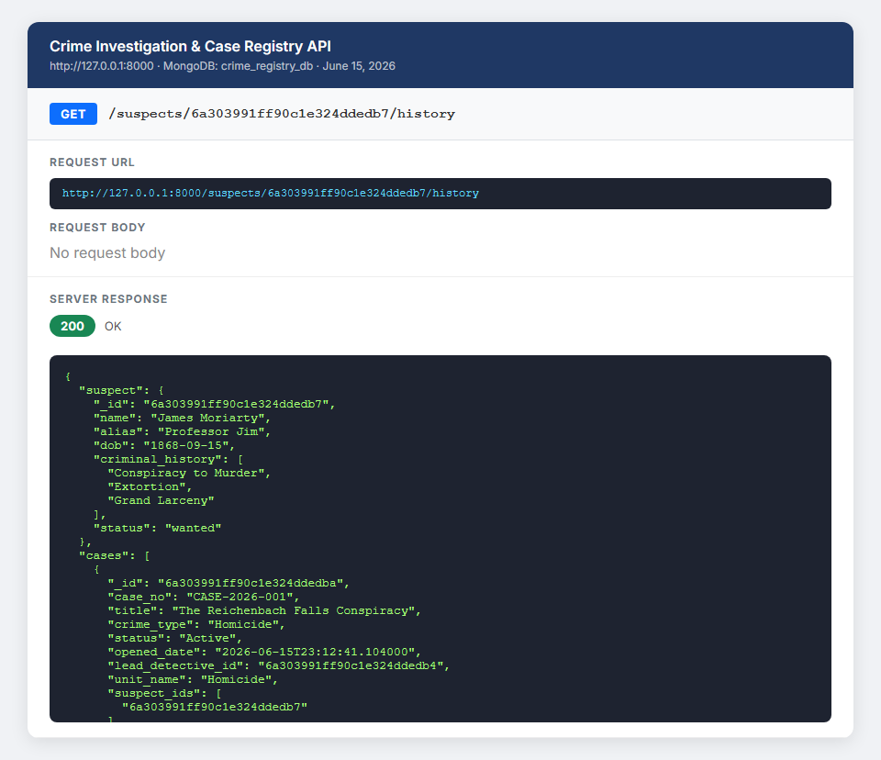
Figure 6: GET /suspects/{id}/history — 200 OK response showing suspect's case history from MongoDB

6. Seeded Database Records
The following records were inserted into crime_registry_db via a seeding script before the API was demonstrated:
Collection | Record | MongoDB ID
units | Homicide Unit | 6a303990ff90c1e324ddedb0
detectives | Sherlock Holmes (Lead – SH123) | 6a303991ff90c1e324ddedb4
suspects | James Moriarty (wanted) | 6a303991ff90c1e324ddedb7
witnesses | Mrs. Hudson (protected) | 6a303991ff90c1e324ddedb9
cases | CASE-2026-001 – Reichenbach Falls | 6a303991ff90c1e324ddedba

