HRMS Platform
System Design & Database Documentation
Multi-tenant, group-enabled Human Resource Management System

Version: 1.1 — For Review Status: Final submission draft
Prepared by: Tech Prizm Date: 2 July 2026
Audience: Engineering leadership & senior review
Stack: Node.js · Express / NestJS · PostgreSQL · Sequelize · JWT + RBAC · React / Next.js · Redis

Ver. | Date | Author | Summary of change
1.0 | 02-Jul-2026 | Tech Prizm | Initial full system & database design for review
1.1 | 02-Jul-2026 | Tech Prizm | Added admin-invitation flow, group hierarchy, end-to-end provisioning flows

Table of Contents

1. Introduction

1.1 Purpose
This document is the complete system and database design for the HRMS platform. It specifies the architecture, the organisational and access-control model, the full database schema, per-role permissions, module workflows, and entity state machines. It is written to be reviewed by senior engineering leadership and to serve as the build reference for the development team.

1.2 Scope
The platform is a multi-tenant, group-enabled SaaS HRMS used both internally across our own companies and sold externally to other organisations. Scope covers the organisation hierarchy, employee lifecycle, attendance, leave, payroll, recruitment, performance, exit management, employee self-service, subscription billing, and platform administration.

1.3 Definitions & Glossary
Term | Meaning
Tenant | A company account — the boundary for data isolation and billing.
Direct company | A tenant that uses the HRMS only for its own employees.
Group | A tenant created only by the Super Admin; contains one or more Companies. A Group Admin cannot create Companies themselves — they request the Super Admin.
Brand | A location/brand unit within a Company. Requires at least one Roster before employees can be added (brand_id set).
RBAC | Role-Based Access Control — permissions granted via roles.
resource:action | The permission code format, e.g. employee:create, leave:approve.
Scope | The data slice a role can act on: tenant, company, or brand.
ESS | Employee Self-Service portal.
Soft delete | Rows are flagged deleted_at, never physically removed (paranoid).
F&F | Full & Final settlement on employee exit.

2. Executive Summary
The HRMS is a single product with a dual purpose: it digitises HR operations across our own companies and is sold to external organisations as a subscription service. Its defining feature is a group model — a Group is created by the Super Admin and can contain multiple companies, each created only by the Super Admin on the group's behalf — implemented through a self-referencing company tree so the structure supports any depth without database redesign.
The design rests on four pillars: strict multi-tenancy (every row carries a tenant identifier), role-based access control on resource:action codes, scope-aware authorisation (the same role sees different data at tenant / company / brand level), and soft deletes with full audit. The Phase-1 schema comprises 58 tables across 10 functional domains.

3. System Overview & Approach

3.1 Architectural approach
- Shared-database multi-tenancy. One database, every business row tagged with company_id; isolation enforced at the ORM layer, not per-controller. Large enterprise clients can later be moved to dedicated schemas.
- Self-referencing company tree. A single companies table with parent_company_id models Super Admin → Group → Company → Brand, a fixed four-level tenancy (no recursive sub-companies).
- Stateless auth. Identity, roles and scope travel in a signed JWT; a middleware pipeline validates them on every request.
- Soft deletes & audit. All tables carry deleted_at; sensitive actions are written to an audit log.

3.2 High-level architecture
The platform is organised into five layers — client portals, an API & security layer, application services, the data layer, and external integrations:
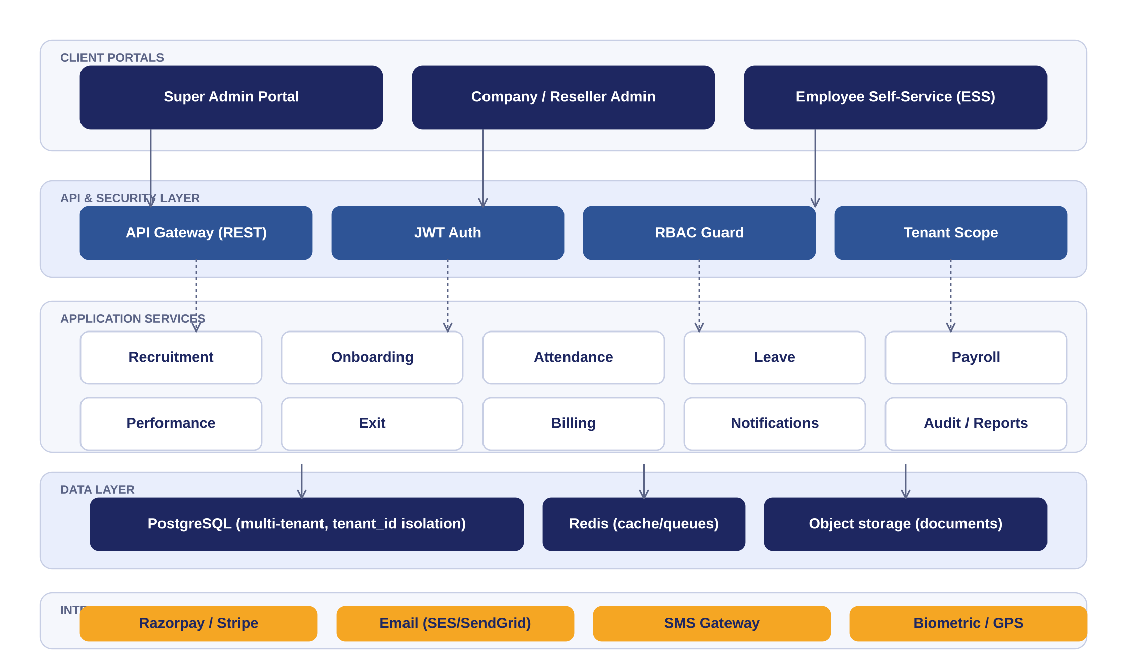
Figure 1. High-level system architecture (five layers).

3.3 Technology stack
Layer | Technology
Backend | Node.js with Express / NestJS; modular services with multi-tenant middleware
ORM | Sequelize (paranoid soft deletes) on PostgreSQL
Database | PostgreSQL — shared DB, company_id row isolation; dedicated schema option later
Frontend | React / Next.js — separate portals for Super Admin, Company Admin, ESS
Auth | JWT + OAuth2, RBAC middleware, optional SSO for enterprise
Async / jobs | Redis + Bull — payroll runs, notifications, report generation
Payments | Razorpay / Stripe for subscription billing
Notifications | Email (SES / SendGrid), SMS gateway, in-app
Hosting | AWS / Azure, auto-scaling, region-wise for data residency

4. Organizational Hierarchy & Multi-Tenancy

4.1 Entity types & the tenancy hierarchy
The tenancy is a fixed four-level hierarchy: Super Admin → Group → Company → Brand. A Group is a top-level tenant that can contain multiple Companies; each Company can contain multiple Brands (the old “Branch”). Unlike the old self-referencing reseller tree, this is not recursive — there is no company-inside-a-company nesting. Only the Super Admin can create a Group, a Company, or a Brand (and their respective admins); Group Admins and Company Admins cannot self-serve these creations — they request the Super Admin, who provisions them directly.
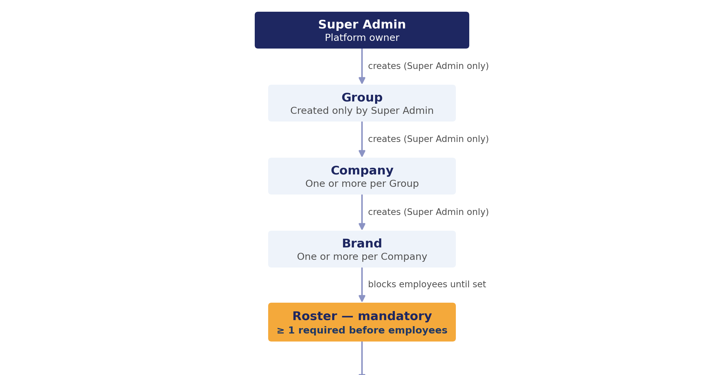
Figure 2. Tenancy hierarchy — Super Admin → Group → Company → Brand → Roster (mandatory) → Department / Employees.
Level | Entity | Scope
0 | Super Admin (platform) | Every group, company, plan, and platform setting
1 | Group | Its own Companies only — cannot create them itself
2 | Company | Its own Brands only — cannot create them itself
3 | Brand + roster | Scoped strictly to itself; needs ≥ 1 roster before employees
4 | Employees (ESS) | Self-service only

4.2 Company entity vs admin user
A company and its administrator are separate records. Onboarding a company creates a companies row and a users row holding the admin role scoped to that company. A company may have several admins; an admin can be replaced without deleting the company; billing is tied to the company.

4.3 Structure inside a company
Within a company, Brand (location) and Department (function) are independent dimensions — an employee belongs to exactly one of each. Designation is the job title. This mirrors how enterprise HR systems are structured and keeps cross-location reporting clean.
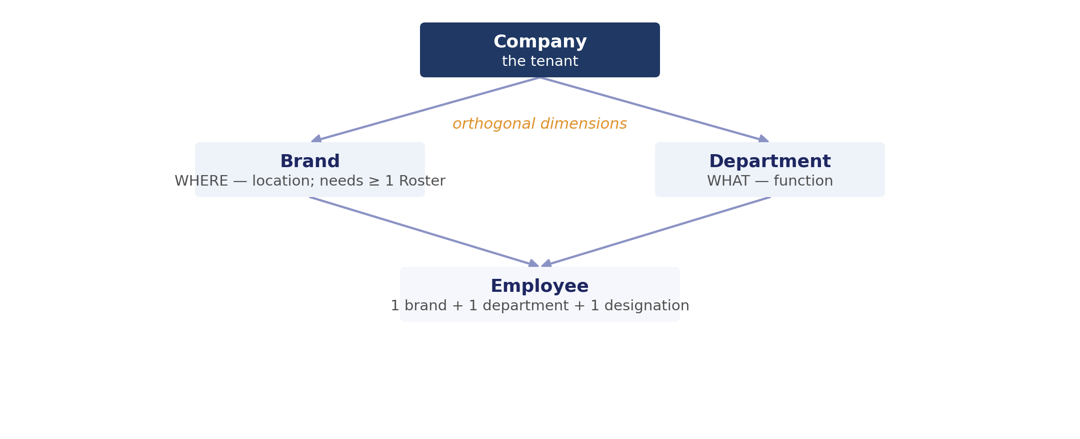
Figure 3. Intra-company structure — brand and department as orthogonal dimensions.

4.4 Tenant isolation
- company_id is applied to every business query, mandatorily, at the ORM layer.
- A Brand Admin is further scoped to a brand_id; a Company Admin to a company_id; a Group Admin to a group_id (its own Companies); the Super Admin operates on the platform plane.
- No company can read another's data — even in the event of a UI bug or API misuse.

4.5 Company provisioning & admin invitation
Creating a company and creating its admin are one linked action but two records. When a company is onboarded, the platform creates the companies row and, from the admin's email, a users row (status = invited) with the Company Admin role scoped to that company. The admin is not given a password directly; instead the system generates a one-time activation link and emails it. The admin opens the link, sets their own password, and the account becomes active. This avoids storing or emailing a readable password.
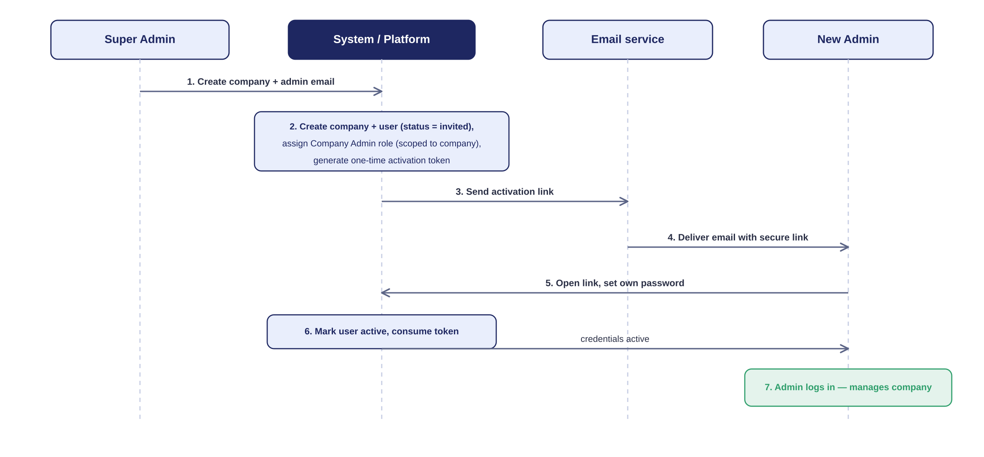
Figure 4. Admin invitation & credential activation sequence.
Worked example — Snow Village. The Super Admin creates the company “Snow Village” and enters the admin's email. The system creates Snow Village, creates the admin user (invited), assigns the Company Admin role scoped to Snow Village, and emails an activation link. The admin clicks it, sets a password, logs in, and now manages Snow Village.
Simpler fallback. If preferred, the system can instead email a system-generated one-time password that must be changed on first login. The activation-link method above is recommended as the more secure default.

4.6 Who can create a Group, Company, or Brand
Creation of a Group, a Company, or a Brand is Super Admin only. There is no self-service flag or API path for a Group Admin or Company Admin to create the tier below them; every groups, companies and brands row (and its first admin) is inserted directly by the Super Admin. A Group Admin who needs a new Company, or a Company Admin who needs a new Brand, contacts the Super Admin — there is no in-app request queue for this in Phase 1.
Within their own scope, admins keep full control: a Group Admin manages its Companies’ policies and views roll-up reports; a Company Admin manages its Brands, departments, designations and employees; a Brand Admin manages employees within the Brand — but a Brand cannot receive its first employee until at least one Roster exists for it (see 6.4 Domain 3 and 7.4.3).

5. Roles & Permissions

5.1 Role catalog
Role | Level / scope | Summary
Super Admin | Platform | Owns the platform: tenants, plans, billing, security.
Group Admin | Tenant (own Companies) | Manages its own Companies’ policies and views roll-ups; requests the Super Admin to create a new Company.
Company Admin | One company | Full HR control of one company: structure, policy, payroll, reports.
Brand Admin | One brand | Employees, attendance and leave approvals within a brand.
HR Manager | Company / brand | Onboarding, records, recruitment, leave approvals.
Accountant | Company | Payroll, statutory deductions, payslips, reimbursements.
Recruiter | Company | Job postings, candidates, interviews, offers.
Manager (derived) | Own team | Approves own team's leave / attendance — derived from having reports.
Employee | Self | Self-service: attendance, leave, payslips, documents.
Note on Group Admin. Unlike the old reseller-flag model, a Group is a genuine separate tenant, not a flag on a Company. A Group Admin is a distinct account tied to a group_id, created only by the Super Admin. It does not itself run any one Company’s day-to-day HR — that stays with each Company’s own Company Admin — it sees roll-up reports across the Companies in its Group and cannot create new Companies or Brands on its own.

5.2 Permission model
Permissions are resource:action codes (e.g. employee:create). A role is a set of codes; a user holds one or more roles; the effective permission set is the union. Middleware asserts the required code rather than checking a role name. Paid tiers allow composing custom roles from existing codes; platform-plane codes such as tenant:manage are never assignable inside a tenant.

5.3 Per-role capability breakdown
Each table below lists what the role may do per resource. Legend: ✓ = allowed, — = not allowed, and scope words (Own / Scope / All) qualify the boundary.

Super Admin
Platform owner. Manages tenants and billing; never touches employee HR data except via audited impersonation.
Resource | Create | Read | Update | Delete | Special actions
Companies / tenants | ✓ All | ✓ All | ✓ All | ✓ (suspend) | Activate, suspend, terminate, impersonate
Company admins | ✓ | ✓ All | ✓ | ✓ | Force logout, reset password
Subscription plans | ✓ | ✓ | ✓ | ✓ | Set pricing, module gating
Roles / permissions | ✓ (system) | ✓ | ✓ | ✓ | Global role templates
Platform settings | ✓ | ✓ | ✓ | ✓ | Security, feature flags, gateways
Audit logs | — | ✓ All | — | — | Global visibility
Employee HR data | — | Impersonation only | — | — | Audited support access

Group Admin
Manages its own Companies’ policies and billing only — cannot create a new Company or Company Admin; requests the Super Admin.
Resource | Create | Read | Update | Delete | Special actions
Companies (own group) | — | ✓ Own group | ✓ (policies) | — | Configure shared policy defaults; request Super Admin to add a Company
Company admins | — | ✓ Own group | — | — | Requested via Super Admin, not self-service
Subscription plans | — | ✓ (assignable) | — | — | Assign platform plans only
Billing | ✓ | ✓ Own group | ✓ | — | Manage invoices/billing for own group (moved from Super Admin dashboard)
Roles | ✓ Own (custom) | ✓ Own | ✓ Own | ✓ Own | Compose from allowed codes
Employee HR data | — | ✓ Own group (reports) | — | — | Aggregate reports only
Audit logs | — | ✓ Own scope | — | — | Own group only

Company Admin
Full HR control of a single company. Cannot access other companies.
Resource | Create | Read | Update | Delete | Special actions
Brands / departments / designations | ✓ | ✓ | ✓ | ✓ | Company structure
Employees | ✓ | ✓ Company | ✓ | ✓ | Assign roles, transfer, deactivate
Company admins / roles | ✓ | ✓ | ✓ | ✓ | Delegate roles within company
Leave / attendance policy | ✓ | ✓ | ✓ | ✓ | Configure policies, shifts, holidays
Shift roster | ✓ | ✓ | ✓ | ✓ | Define shift types (Morning/Day/Night), configure OD policy
Payroll | ✓ (run) | ✓ Company | ✓ | — | Approve payroll runs
Reports | — | ✓ Company | — | — | All company reports
Billing | — | ✓ Own company | — | — | View invoices

Brand Admin
Scoped to one brand. Cannot change company-level settings.
Resource | Create | Read | Update | Delete | Special actions
Brand employees | ✓ Brand | ✓ Brand | ✓ Brand | — (deactivate) | Onboard within brand
Attendance | — | ✓ Brand | ✓ (regularize) | — | Approve regularisation
Leave | — | ✓ Brand | ✓ (approve) | — | Approve / reject brand leave; approves Comp-Off credits
Shift roster | ✓ Brand | ✓ Brand | ✓ Brand | — | Build & publish brand roster
OD requests | — | ✓ Brand | ✓ (approve) | — | Approve / reject brand OD
Assets / documents | ✓ Brand | ✓ Brand | ✓ Brand | — | Assign assets
Reports | — | ✓ Brand | — | — | Brand reports
Company settings | — | — | — | — | Not permitted

HR Manager
People operations across company or assigned brands.
Resource | Create | Read | Update | Delete | Special actions
Employees | ✓ | ✓ Scope | ✓ | — (deactivate) | Onboarding, offboarding
Recruitment | ✓ | ✓ | ✓ | ✓ | Postings, candidates, offers
Leave | — | ✓ Scope | ✓ (approve) | — | Approvals, balances; approves Comp-Off credits
Shift roster | ✓ Scope | ✓ Scope | ✓ Scope | — | Build & publish roster
OD requests | — | ✓ Scope | ✓ (approve) | — | Approvals
Attendance | — | ✓ Scope | ✓ | — | Regularisation review
Documents / performance | ✓ | ✓ | ✓ | — | Records, appraisals
Payroll | — | ✓ (assist) | — | — | Assist, not approve

Accountant
Payroll and statutory finance for the company.
Resource | Create | Read | Update | Delete | Special actions
Payroll runs | ✓ | ✓ Company | ✓ | — | Process runs
Salary structures | ✓ | ✓ | ✓ | ✓ | Define components / CTC
Statutory settings | ✓ | ✓ | ✓ | — | PF, ESI, PT, TDS
Payslips | ✓ (generate) | ✓ Company | — | — | Bank file export
Reimbursements / bonus | ✓ | ✓ | ✓ | — | Approve claims
Employee master | — | ✓ Company | — | — | Read-only

Recruiter
Hiring pipeline only.
Resource | Create | Read | Update | Delete | Special actions
Job postings | ✓ | ✓ | ✓ | ✓ | Open / close
Candidates | ✓ | ✓ | ✓ | — | Track applications
Interviews | ✓ | ✓ | ✓ | — | Schedule, record feedback
Offers | ✓ (draft) | ✓ | ✓ | — | Send offers (HR approval)
Employee records | — | — | — | — | Handoff to Onboarding

Manager (derived)
Not a stored role — capabilities unlocked for any employee who has direct reports.
Resource | Create | Read | Update | Delete | Special actions
Team attendance | — | ✓ Team | ✓ (approve) | — | Approve regularisation
Team leave | — | ✓ Team | ✓ (approve) | — | Approve / reject; approves Comp-Off credits
Team roster | ✓ (draft) | ✓ Team | ✓ | — | Draft & publish team roster
Team OD requests | — | ✓ Team | ✓ (approve) | — | Approve / reject
Team performance | ✓ (goals) | ✓ Team | ✓ | — | Set goals, rate appraisals
Team reports | — | ✓ Team | — | — | Team dashboards

Employee
Self-service on own records only.
Resource | Create | Read | Update | Delete | Special actions
Own attendance | ✓ (check-in) | ✓ Own | ✓ (regularize req.) | — | Mark attendance
Own leave | ✓ (apply) | ✓ Own | ✓ (cancel) | — | Apply / cancel; Comp-Off auto-credited from worked holidays/weekoffs
Own roster | — | ✓ Own | — | — | View assigned shift by day
Own OD requests | ✓ (apply) | ✓ Own | ✓ (cancel) | — | Apply / cancel
Own payslips / documents | ✓ (upload) | ✓ Own | — | — | Download payslips
Own profile | — | ✓ Own | ✓ (limited) | — | Update contact details
Helpdesk | ✓ | ✓ Own | — | — | Raise tickets

5.4 Master permission matrix
A condensed cross-role view of the most security-relevant actions:
Action | S.Admin | Group | Co.Admin | Br.Admin | HR | Acct. | Emp.
Create / suspend companies | All | — | — | — | — | — | —
Create company admins | ✓ | — | ✓ | — | — | — | —
Define plans & pricing | ✓ | — | — | — | — | — | —
Create employees | — | — | ✓ | ✓ Br. | ✓ | — | —
Configure leave / payroll policy | Default | — | ✓ | — | Suggest | — | —
Approve leave | — | — | Escal. | ✓ Br. | ✓ | — | —
Run payroll | — | — | ✓ | — | Assist | ✓ | —
View own payslip | — | — | — | — | — | — | ✓
Global audit logs | ✓ | Scope | Company | — | — | — | —
Platform security settings | ✓ | — | — | — | — | — | —

5.5 Role vs Designation vs Reporting line
- Permission role — what a user can access (drives RBAC).
- Designation — job title for the org chart; no permissions (designation_id).
- Reporting line — manager_id; managerial powers derive from having direct reports. “Manager” is therefore not a peer permission role.

6. Database Design

6.1 Design principles & conventions
- Multi-tenant keying. Every business table carries company_id; queries are filtered by it automatically.
- Common columns. Every table also carries id (PK, bigint), created_at, updated_at, and deleted_at (soft delete). These are omitted from the per-table specs below to avoid repetition.
- Naming. snake_case tables (plural) and columns; foreign keys named <entity>_id.
- Keys & integrity. Foreign keys enforced; composite unique constraints where noted (e.g. one balance per employee + leave type + year).
- Enumerations. Status fields use constrained enums, listed in each column's description.

6.2 Entity-relationship diagrams
The core access/structure model and the HR-operations model are shown below; full column specifications follow in §6.4.
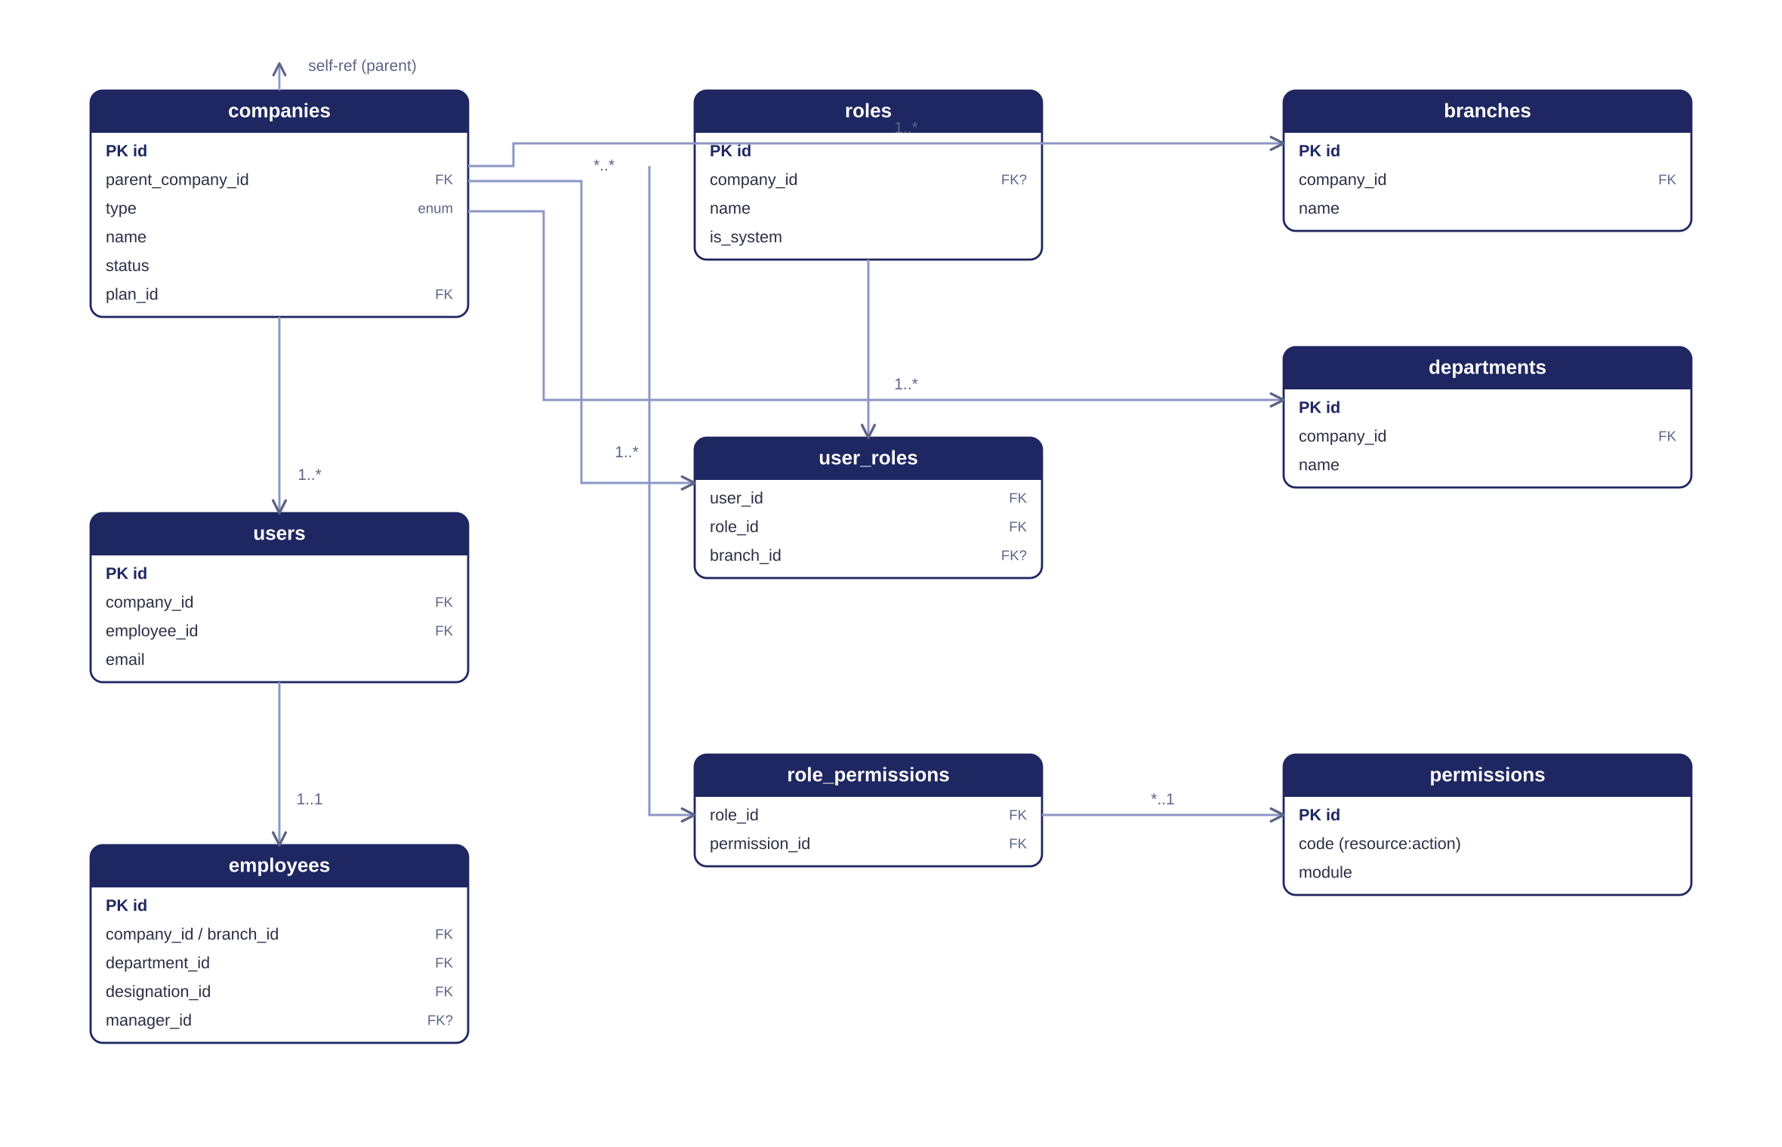
Figure 5. Core ER — tenancy, access control, and organisation structure.
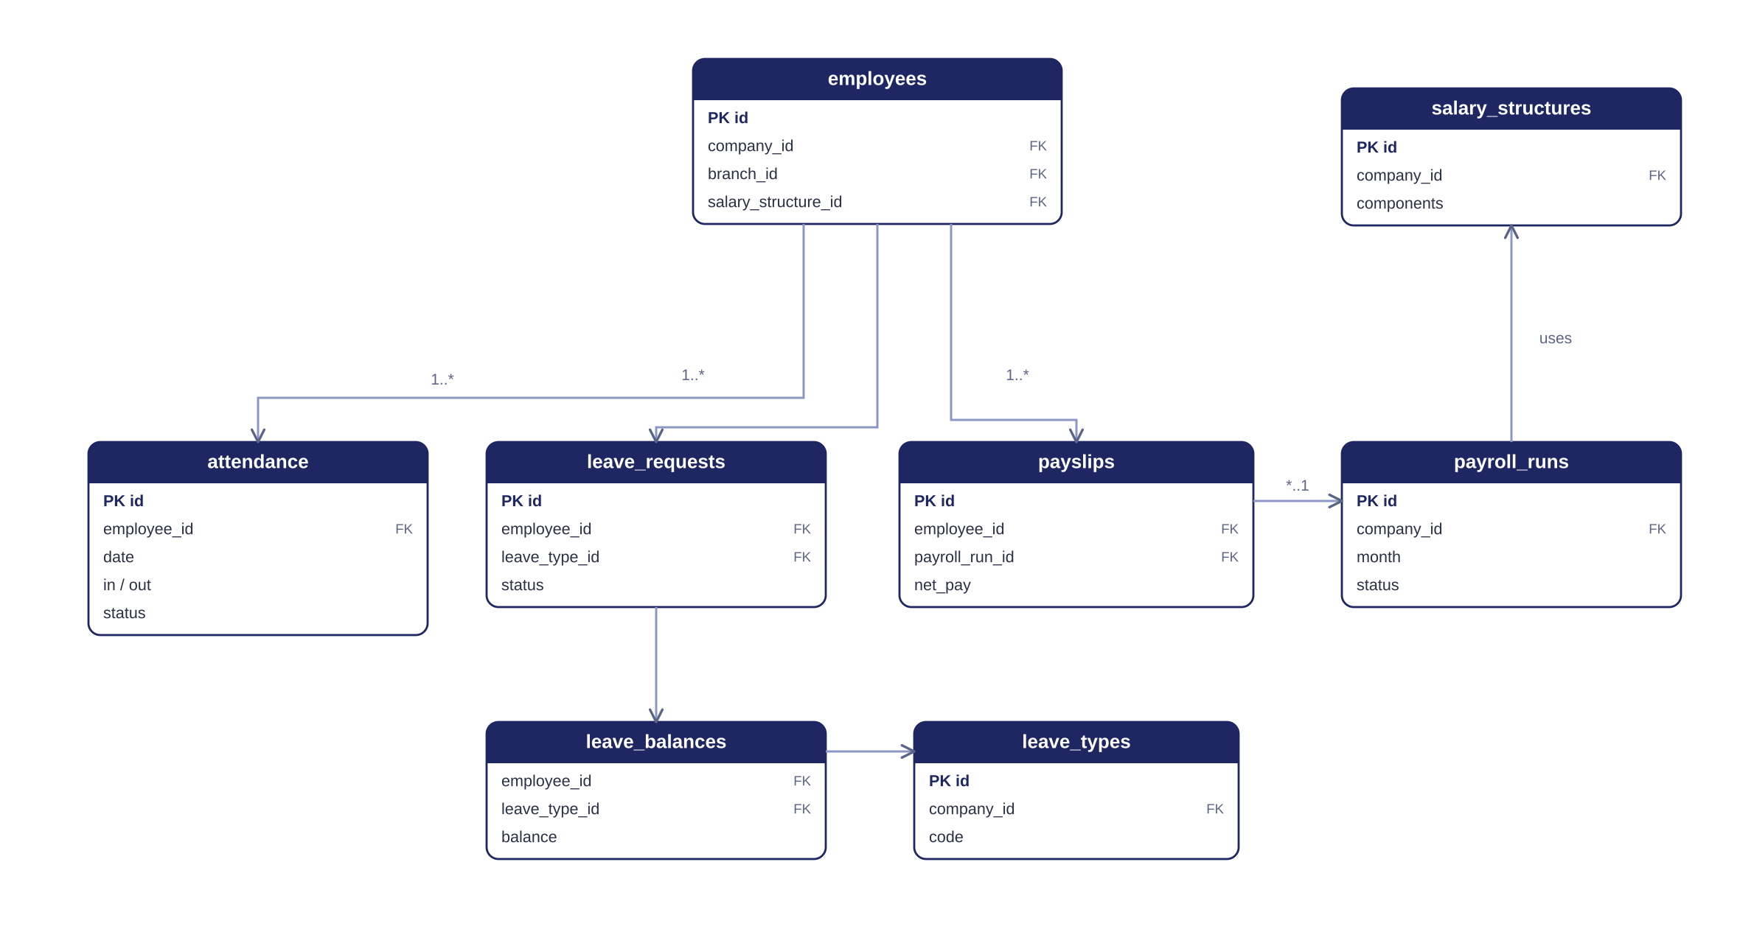
Figure 6. HR-operations ER — attendance, leave, and payroll around the employee.

6.3 Table inventory
The Phase-1 schema defines 58 tables across 10 functional domains. The inventory below groups them; detailed specifications follow.
# | Domain | Tables | Count
1 | Tenancy & Access Control | groups, companies, users, roles, permissions, role_permissions, user_roles, refresh_tokens, password_resets, invitations | 10
2 | Organization Structure | brands, departments, designations, employees, employee_documents | 5
3 | Attendance & Time | shifts, employee_shifts, attendance, attendance_regularizations, employee_devices, qr_attendance_terminals, shift_rosters, od_requests | 8
4 | Leave | leave_types, leave_policies, leave_balances, leave_requests, comp_off_credits, holidays | 6
5 | Payroll | salary_structures, salary_components, employee_salary, payroll_runs, payslips, payslip_items, statutory_settings | 7
6 | Recruitment (ATS) | job_postings, candidates, applications, interviews, offers | 5
7 | Performance | review_cycles, goals, appraisals, appraisal_ratings | 4
8 | Exit | resignations, clearance_items, fnf_settlements | 3
9 | Billing & Subscription | plans, subscriptions, invoices, payments, group_commissions | 5
10 | Platform & System | audit_logs, notifications, feature_flags, settings, activity_logs | 5

6.4 Detailed table specifications

Domain 1 — Tenancy & Access Control
groups — Top-level tenant. Created only by the Super Admin; contains one or more Companies.
Column | Type | Key | Description
name | varchar |  | Display name
status | enum |  | active | suspended
plan_id | bigint | FK | → plans.id (default plan for new Companies in this Group)
created_by | bigint | FK | → users.id (Super Admin who created it)

companies — Belongs to exactly one Group; no self-nesting (the old reseller/sub-company tree is gone).
Column | Type | Key | Description
group_id | bigint | FK | → groups.id (every Company belongs to exactly one Group)
name | varchar |  | Display name
legal_name | varchar |  | Registered legal entity name
gst_number | varchar |  | Tax registration
status | enum |  | trial | active | grace | suspended | terminated
plan_id | bigint | FK | → plans.id
created_by | bigint | FK | → users.id (Super Admin who created it)

users — Login identities; may or may not be linked to an employee.
Column | Type | Key | Description
company_id | bigint | FK | → companies.id (tenant)
employee_id | bigint | FK | → employees.id; NULL for admin-only users
email | varchar | UQ | Unique per company
password_hash | varchar |  | Bcrypt/Argon2 hash; NULL until activated
status | enum |  | invited | active | disabled
invited_at | timestamp |  | When the invite was sent
activated_at | timestamp |  | When the admin set a password
is_active | boolean |  | Login enabled
two_fa_enabled | boolean |  | 2FA flag
last_login_at | timestamp |  | Audit

roles — Named permission sets; system roles or per-company custom roles.
Column | Type | Key | Description
company_id | bigint | FK | → companies.id; NULL = system role
name | varchar |  | e.g. Company Admin, HR
is_system | boolean |  | Non-editable platform role
description | varchar |  | Optional

permissions — Master list of resource:action codes.
Column | Type | Key | Description
code | varchar | UQ | e.g. employee:create
module | varchar |  | Grouping (hr, payroll, billing…)
description | varchar |  | Human-readable

role_permissions — Maps roles to permission codes (many-to-many).
Column | Type | Key | Description
role_id | bigint | FK/PK | → roles.id
permission_id | bigint | FK/PK | → permissions.id

user_roles — Assigns roles to users with a scope.
Column | Type | Key | Description
user_id | bigint | FK | → users.id
role_id | bigint | FK | → roles.id
company_id | bigint | FK | Scope company
brand_id | bigint | FK | Scope brand; NULL = all brands

refresh_tokens — Rotating JWT refresh tokens.
Column | Type | Key | Description
user_id | bigint | FK | → users.id
token_hash | varchar |  | Hashed token
expires_at | timestamp |  | Expiry
revoked_at | timestamp |  | Revocation

password_resets — One-time password-reset tokens.
Column | Type | Key | Description
user_id | bigint | FK | → users.id
token_hash | varchar |  | Hashed token
expires_at | timestamp |  | Expiry
used_at | timestamp |  | Consumed

invitations — Admin/user invitations with one-time activation tokens.
Column | Type | Key | Description
company_id | bigint | FK | → companies.id
email | varchar |  | Invitee email
role_id | bigint | FK | → roles.id (role granted on activation)
brand_id | bigint | FK | Scope; nullable
token_hash | varchar |  | One-time activation token (hashed)
expires_at | timestamp |  | Link expiry
accepted_at | timestamp |  | When activated

Domain 2 — Organization Structure
brands — Location dimension within a company.
Column | Type | Key | Description
company_id | bigint | FK | → companies.id
name | varchar |  | e.g. Delhi
code | varchar |  | Short code
address / city / state | varchar |  | Location
is_active | boolean |  | Status

departments — Function dimension within a company.
Column | Type | Key | Description
company_id | bigint | FK | → companies.id
name | varchar |  | e.g. Engineering
code | varchar |  | Short code
head_employee_id | bigint | FK | → employees.id

designations — Job titles.
Column | Type | Key | Description
company_id | bigint | FK | → companies.id
title | varchar |  | e.g. Senior Engineer
level | int |  | Seniority band

employees — Core HR record; brand and department are independent FKs.
Column | Type | Key | Description
employee_code | varchar | UQ | Per-company code
company_id | bigint | FK | → companies.id
brand_id | bigint | FK | → brands.id (WHERE)
department_id | bigint | FK | → departments.id (WHAT)
designation_id | bigint | FK | → designations.id
manager_id | bigint | FK | → employees.id (reporting line)
user_id | bigint | FK | → users.id (login)
date_of_joining | date |  | DOJ
employment_type | enum |  | full_time | part_time | contract
status | enum |  | onboarding | active | on_notice | exited | archived

employee_documents — Uploaded employee documents.
Column | Type | Key | Description
employee_id | bigint | FK | → employees.id
type | varchar |  | id_proof | address | bank…
file_url | varchar |  | Object-storage URL
verified | boolean |  | HR verified

Domain 3 — Attendance & Time
shifts — Shift definitions.
Column | Type | Key | Description
company_id | bigint | FK | → companies.id
name | varchar |  | e.g. General
start_time / end_time | time |  | Shift window
is_night_shift | boolean |  | Crosses midnight

employee_shifts — Employee-to-shift assignment over time.
Column | Type | Key | Description
employee_id | bigint | FK | → employees.id
shift_id | bigint | FK | → shifts.id
effective_from | date |  | Assignment start

attendance — Daily attendance records.
Column | Type | Key | Description
employee_id | bigint | FK | → employees.id
date | date |  | Attendance date
check_in / check_out | timestamp |  | Punches
source | enum |  | qr | od
device_id | bigint | FK | → employee_devices.id
terminal_id | bigint | FK | → qr_attendance_terminals.id
qr_token_jti | varchar |  | JWT ID of the scanned QR token (replay check)
status | enum |  | present | absent | half_day | leave | holiday | weekoff | on_duty
overtime_minutes | int |  | Computed OT

attendance_regularizations — Requests to correct attendance.
Column | Type | Key | Description
attendance_id | bigint | FK | → attendance.id
employee_id | bigint | FK | → employees.id
requested_status | enum |  | Desired status
reason | varchar |  | Justification
approver_id | bigint | FK | → employees.id
status | enum |  | pending | approved | rejected

employee_devices — Passkey-registered devices used to authorize QR check-in/out.
Column | Type | Key | Description
employee_id | bigint | FK | → employees.id
device_fingerprint | varchar |  | Client-generated device ID, bound at first login
credential_id | varchar |  | WebAuthn passkey credential ID
public_key | text |  | WebAuthn public key
registered_at | timestamp |  | First-login passkey registration time
last_used_at | timestamp |  | Last successful check-in / check-out
status | enum |  | active | revoked

qr_attendance_terminals — Company QR-generating machines used for attendance capture.
Column | Type | Key | Description
company_id | bigint | FK | → companies.id
brand_id | bigint | FK | → brands.id
terminal_code | varchar |  | Physical machine identifier, e.g. GATE-01
secret_key | varchar |  | HMAC signing secret used to sign rotating tokens
rotation_seconds | int |  | QR refresh interval (5–10s)
status | enum |  | active | inactive

shift_rosters — Day-level shift roster; overrides the default employee_shifts assignment for Morning / Day / Night scheduling.
Column | Type | Key | Description
employee_id | bigint | FK | → employees.id
shift_id | bigint | FK | → shifts.id
brand_id | bigint | FK | → brands.id
roster_date | date |  | The specific day this shift applies (Morning / Day / Night)
status | enum |  | draft | published
published_by | bigint | FK | → employees.id (Brand Admin / HR / Manager)

od_requests — On-Duty requests — pre-approved offsite work; approval marks attendance without a QR scan.
Column | Type | Key | Description
employee_id | bigint | FK | → employees.id
from_date / to_date | date |  | OD date range
purpose | varchar |  | e.g. client visit, field work, offsite meeting
location | varchar |  | Where the employee will be working from
status | enum |  | pending | approved | rejected | cancelled
approver_id | bigint | FK | → employees.id

Domain 4 — Leave
leave_types — Company-defined leave categories.
Column | Type | Key | Description
company_id | bigint | FK | → companies.id
code | varchar |  | CL | SL | EL | CO (Comp-Off) | LWP…
name | varchar |  | Display name
is_paid | boolean |  | Paid leave
carry_forward | boolean |  | Carries to next year

leave_policies — Quota / accrual rules per leave type.
Column | Type | Key | Description
company_id | bigint | FK | → companies.id
leave_type_id | bigint | FK | → leave_types.id
annual_quota | numeric |  | Days per year
accrual | enum |  | yearly | monthly
applicable_after_days | int |  | Eligibility after joining

leave_balances — Running balance per employee / type / year.
Column | Type | Key | Description
employee_id | bigint | FK | → employees.id
leave_type_id | bigint | FK | → leave_types.id
year | int | UQ | Unique with employee+type
allotted / used / balance | numeric |  | Balance tracking

leave_requests — Leave applications and their approval state.
Column | Type | Key | Description
employee_id | bigint | FK | → employees.id
leave_type_id | bigint | FK | → leave_types.id
from_date / to_date | date |  | Range
days | numeric |  | Working days
reason | varchar |  | Justification
status | enum |  | pending | approved | rejected | cancelled
approver_id | bigint | FK | → employees.id

comp_off_credits — Comp-Off earned by working a holiday/weekoff; auto-detected from attendance, needs manager approval before it can be used as leave.
Column | Type | Key | Description
employee_id | bigint | FK | → employees.id
source_attendance_id | bigint | FK | → attendance.id (the holiday/weekoff day worked)
earned_date | date |  | The holiday / weekoff date actually worked
status | enum |  | pending_approval | approved | rejected | expired | used
approver_id | bigint | FK | → employees.id
expiry_date | date |  | Must be used by this date or it expires (company policy, default 90 days)

holidays — Holiday calendar (company or brand level).
Column | Type | Key | Description
company_id | bigint | FK | → companies.id
brand_id | bigint | FK | → brands.id; NULL = all
date | date |  | Holiday date
name | varchar |  | e.g. Diwali
type | enum |  | public | optional

Domain 5 — Payroll
salary_structures — Named CTC templates.
Column | Type | Key | Description
company_id | bigint | FK | → companies.id
name | varchar |  | e.g. Standard L2
components | jsonb |  | Earnings/deductions definition

salary_components — Reusable earning / deduction definitions.
Column | Type | Key | Description
company_id | bigint | FK | → companies.id
name | varchar |  | Basic, HRA, PF…
type | enum |  | earning | deduction
calc | enum |  | fixed | percent
statutory | boolean |  | Statutory component

employee_salary — Per-employee CTC assignment.
Column | Type | Key | Description
employee_id | bigint | FK | → employees.id
salary_structure_id | bigint | FK | → salary_structures.id
ctc | numeric |  | Annual CTC
effective_from | date |  | Revision date

payroll_runs — A monthly payroll batch and its state.
Column | Type | Key | Description
company_id | bigint | FK | → companies.id
month / year | int |  | Pay period
status | enum |  | draft | processing | review | approved | paid | closed
processed_by | bigint | FK | → users.id

payslips — Per-employee output of a payroll run.
Column | Type | Key | Description
payroll_run_id | bigint | FK | → payroll_runs.id
employee_id | bigint | FK | → employees.id
gross | numeric |  | Gross pay
total_deductions | numeric |  | Sum of deductions
net_pay | numeric |  | Take-home
status | enum |  | generated | paid

payslip_items — Line items on a payslip.
Column | Type | Key | Description
payslip_id | bigint | FK | → payslips.id
component_id | bigint | FK | → salary_components.id
label | varchar |  | Line label
amount | numeric |  | Value
type | enum |  | earning | deduction

statutory_settings — Per-company statutory configuration.
Column | Type | Key | Description
company_id | bigint | FK | → companies.id
pf_rate | numeric |  | Provident Fund %
esi_rate | numeric |  | ESI %
pt_slab | jsonb |  | Professional Tax slabs
tds_config | jsonb |  | TDS configuration

Domain 6 — Recruitment (ATS)
job_postings — Open positions.
Column | Type | Key | Description
company_id | bigint | FK | → companies.id
title | varchar |  | Role title
department_id / brand_id | bigint | FK | Placement
status | enum |  | open | closed
openings | int |  | Number of seats

candidates — Applicant profiles.
Column | Type | Key | Description
company_id | bigint | FK | → companies.id
name / email / phone | varchar |  | Contact
resume_url | varchar |  | Object-storage URL

applications — Candidate ↔ posting link and pipeline stage.
Column | Type | Key | Description
job_posting_id | bigint | FK | → job_postings.id
candidate_id | bigint | FK | → candidates.id
status | enum |  | applied | screening | interview | offer | hired | rejected
source | varchar |  | Referral / portal

interviews — Interview rounds and feedback.
Column | Type | Key | Description
application_id | bigint | FK | → applications.id
round | int |  | Round number
scheduled_at | timestamp |  | Slot
interviewer_id | bigint | FK | → employees.id
result | enum |  | pass | fail | hold

offers — Offer letters and their acceptance state.
Column | Type | Key | Description
application_id | bigint | FK | → applications.id
ctc | numeric |  | Offered CTC
joining_date | date |  | Proposed DOJ
status | enum |  | draft | sent | accepted | declined

Domain 7 — Performance
review_cycles — Appraisal periods.
Column | Type | Key | Description
company_id | bigint | FK | → companies.id
name | varchar |  | e.g. H1 2026
period_start / period_end | date |  | Window
status | enum |  | draft | active | closed

goals — Employee goals / OKRs for a cycle.
Column | Type | Key | Description
employee_id | bigint | FK | → employees.id
cycle_id | bigint | FK | → review_cycles.id
title | varchar |  | Goal
weight | numeric |  | Weighting
status | enum |  | open | achieved | missed

appraisals — Self + manager assessment and final rating.
Column | Type | Key | Description
employee_id | bigint | FK | → employees.id
cycle_id | bigint | FK | → review_cycles.id
self_rating / manager_rating | numeric |  | Ratings
final_rating | numeric |  | Normalised
status | enum |  | draft | submitted | finalized

appraisal_ratings — Per-goal rating detail.
Column | Type | Key | Description
appraisal_id | bigint | FK | → appraisals.id
goal_id | bigint | FK | → goals.id
rating | numeric |  | Goal score
comments | text |  | Notes

Domain 8 — Exit
resignations — Exit initiation and lifecycle.
Column | Type | Key | Description
employee_id | bigint | FK | → employees.id
initiated_by | enum |  | employee | manager
notice_date / last_working_date | date |  | Notice window
status | enum |  | submitted | approved | withdrawn | completed

clearance_items — Per-department clearance checklist.
Column | Type | Key | Description
resignation_id | bigint | FK | → resignations.id
department | enum |  | IT | Finance | Admin | HR
status | enum |  | pending | cleared
cleared_by | bigint | FK | → employees.id

fnf_settlements — Full & Final settlement.
Column | Type | Key | Description
resignation_id | bigint | FK | → resignations.id
payable / recoverable | numeric |  | Dues
net_amount | numeric |  | Final amount
status | enum |  | pending | settled
settled_on | date |  | Settlement date

Domain 9 — Billing & Subscription
plans — Subscription tiers and limits.
Column | Type | Key | Description
name | varchar |  | Basic | Pro | Enterprise
price / billing_cycle | numeric/enum |  | monthly | yearly
max_employees / max_brands | int |  | Quotas
max_companies | int |  | Companies allowed per Group
modules | jsonb |  | Enabled modules

subscriptions — A company's active plan.
Column | Type | Key | Description
company_id | bigint | FK | → companies.id
plan_id | bigint | FK | → plans.id
status | enum |  | trial | active | grace | suspended | cancelled
started_at / renews_at | timestamp |  | Cycle dates

invoices — Billing invoices.
Column | Type | Key | Description
company_id | bigint | FK | → companies.id
subscription_id | bigint | FK | → subscriptions.id
amount / gst / total | numeric |  | Amounts
status | enum |  | pending | paid | failed
due_date | date |  | Due

payments — Gateway payment records.
Column | Type | Key | Description
invoice_id | bigint | FK | → invoices.id
gateway | varchar |  | razorpay | stripe
gateway_ref | varchar |  | Transaction id
amount | numeric |  | Paid
status | enum |  | success | failed | refunded

group_commissions — Commission/payout tracking for Groups.
Column | Type | Key | Description
group_id | bigint | FK | → groups.id
sub_company_id | bigint | FK | → companies.id
invoice_id | bigint | FK | → invoices.id
commission_amount | numeric |  | Payout
status | enum |  | accrued | paid

Domain 10 — Platform & System
audit_logs — Immutable trail of sensitive actions.
Column | Type | Key | Description
company_id | bigint | FK | → companies.id
actor_user_id | bigint | FK | → users.id
action / entity / entity_id | varchar |  | What was changed
before / after | jsonb |  | State snapshots
ip | varchar |  | Source IP

notifications — User notifications across channels.
Column | Type | Key | Description
company_id | bigint | FK | → companies.id
user_id | bigint | FK | → users.id
type / title / body | varchar |  | Content
channel | enum |  | in_app | email | sms
read_at | timestamp |  | Read state

feature_flags — Module gating per plan or company.
Column | Type | Key | Description
plan_id | bigint | FK | → plans.id; nullable
company_id | bigint | FK | → companies.id; nullable
module | varchar |  | Feature key
enabled | boolean |  | On/off

settings — Key-value configuration.
Column | Type | Key | Description
company_id | bigint | FK | → companies.id; nullable = global
key / value | varchar |  | Setting
scope | enum |  | global | company

activity_logs — Lightweight request/access log.
Column | Type | Key | Description
user_id | bigint | FK | → users.id
endpoint / method | varchar |  | Request
status_code | int |  | Response

7. Module Workflows

7.1 Company / tenant onboarding
- Super Admin creates a Group and its first Group Admin (invited via email + activation link).
- Super Admin creates a Company under that Group (on the Group Admin’s request) and its first Company Admin, attaching plan and limits.
- Company Admin configures org policies (leave, attendance, payroll, holidays) for the Company.
- Super Admin creates a Brand under the Company (on the Company Admin’s request) and its first Brand Admin.
- Brand Admin (or Company Admin) defines at least one Roster (Morning / Day / Night) for the Brand — mandatory before any employee can be added — then creates departments and designations.
- HR / Brand Admin creates employees — one at a time or via bulk import — with brand, department, designation, role(s), and manager. Bulk employee creation (CSV/Excel import) is available to every admin level.

7.2 Recruitment (ATS)
Job posting → applications → screening → interviews with feedback → offer → on acceptance, handoff to Onboarding.

7.3 Onboarding
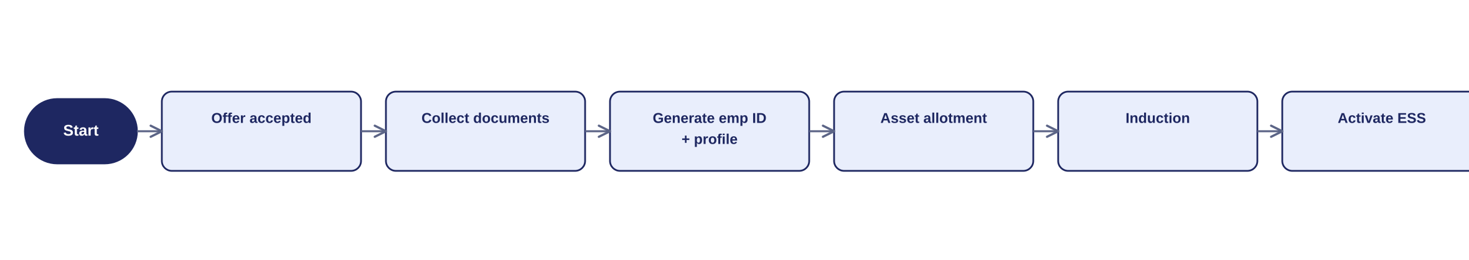
Figure 7. Onboarding workflow — offer acceptance to ESS activation.

7.4 Attendance
Attendance is captured exclusively through the QR check-in/out flow described below — biometric, GPS, and free-text web punches are not used. A successful scan auto-syncs against the assigned shift and overtime is computed; a failed or missed scan is corrected via a regularisation request routed to the manager for approval.

7.4.1 QR-based check-in / check-out — detailed flow
Every company location runs a dedicated QR terminal (qr_attendance_terminals) that continuously refreshes a signed QR code. Employees can only mark attendance from a device carrying an active WebAuthn passkey registered against their account (employee_devices).
- Employee opens the ESS app / portal and taps Check-In (or Check-Out).
- The backend checks employee_devices for this device: is there an active passkey credential linked to the employee?
- Not registered → check-in is blocked; the employee is prompted to log in and complete passkey (WebAuthn) registration first. There is no fallback method.
- Registered → the app automatically opens the camera to scan a QR code.
- The company’s QR terminal generates a new code every 5–10 seconds. Each code encodes a signed, short-lived token (JWT/HMAC) carrying terminal_id, an issued-at timestamp, and a unique jti.
- The employee scans the code currently displayed on the terminal.
- The backend validates the token: checks the HMAC/JWT signature against the terminal’s secret_key, confirms it is within its rotation window (not expired), confirms the jti has not been redeemed before (replay protection, checked against Redis rather than the database), and confirms the terminal belongs to the employee’s own company / brand.
- All checks pass → attendance.check_in (or check_out) is written together with device_id, terminal_id and qr_token_jti; shift, status and overtime rules apply as normal.
- Any check fails (expired token, bad signature, reused jti, wrong brand) → the scan is rejected and attendance is not marked; the employee retries with a fresh code or raises a regularisation request.
- Check-out follows the identical flow: tap Check-Out → device check → camera opens → scan the terminal’s current code → same validation → check_out is recorded.

7.4.2 QR security controls
- Short token lifetime. each QR-embedded token is valid only for its rotation window (5–10s), so a captured or photographed code is useless within seconds.
- Replay protection. qr_token_jti is written to Redis as SET jti EX rotation_seconds NX at redemption time — a duplicate scan fails the NX check instantly, with no database hit on the hot path; a token can be used once.
- Device binding. only a passkey-registered device (WebAuthn) can trigger the scan step, tying every attendance mark to a specific physical device per employee.
- Terminal scoping. validation confirms the terminal’s company_id / brand_id matches the employee’s own assignment, so a QR from one brand cannot mark attendance at another.
- Server-side trust only. the mobile/web client never decides validity — it only captures the token and forwards it; the backend is the sole source of truth.
- Redis-backed validation. the terminal’s current secret_key and rotation state are cached in Redis, so a scan is validated without hitting PostgreSQL on every single check-in/out — the database is only touched to persist the resulting attendance row.

7.4.3 Shift roster
Shift assignment supports day-level scheduling across Morning, Day and Night shifts, not just a single ongoing shift per employee. shift_rosters holds one row per employee per date and takes priority over the default employee_shifts assignment when present.
- Brand Admin / HR Manager / Manager (for their own team) builds a roster for an upcoming date range, assigning a shift (Morning, Day, or Night) to each employee for each day.
- The roster is saved as draft — visible only to the person building it — until it is published.
- On publish, shift_rosters rows move to published status and become visible to the affected employees on their ESS calendar / app.
- For any given date, attendance processing looks up shift_rosters first; if no roster entry exists for that employee and date, it falls back to the employee’s default shift in employee_shifts.
- QR check-in/out (7.4.1) is unaffected by which shift is active — it only changes which shift window the punch is measured against for lateness and overtime.

7.4.4 On-Duty (OD) requests
OD covers pre-approved offsite work — a client visit, field assignment, or offsite meeting — where the employee cannot scan a company QR terminal. It is modelled the same way as leave: applied for in advance and approved before the date arrives.
- Employee applies for OD from ESS, giving a date range, purpose, and the location they’ll be working from (od_requests).
- The request is routed to the manager / HR / Brand Admin for approval, the same reviewers who approve leave.
- Approved → for each date in range, an attendance record is created (or updated) with status = on_duty and source = od — no QR scan is required or possible for that day.
- Rejected or left pending → the employee is still expected to check in/out normally via QR; an unresolved OD request does not by itself excuse attendance.
- Employee can cancel a pending or approved OD request before the date passes, the same way leave can be cancelled.

7.5 Leave
Employees apply from ESS; the system checks balance; the manager approves or rejects; on approval the balance updates and the employee is notified.
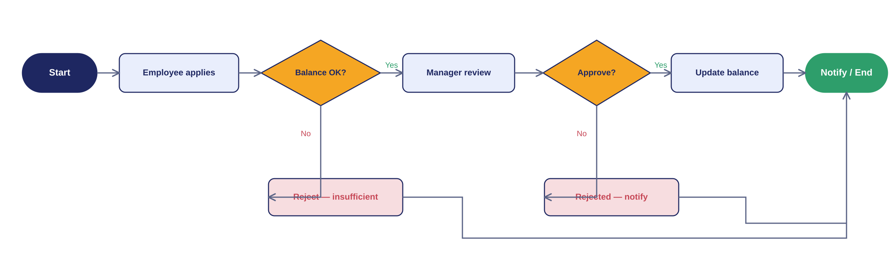
Figure 8. Leave application and approval workflow.

7.5.1 Comp-Off (Compensatory Off)
Comp-Off rewards an employee for working on a holiday or their weekly-off day. It is auto-detected from attendance, but still needs manager approval before it can be spent as leave.
- A daily job scans attendance for any employee whose status is present or on_duty on a date that is a holiday or their weekoff.
- For each such day, a comp_off_credits row is created with status = pending_approval, linked to the source attendance record.
- The employee’s manager / HR / Brand Admin reviews and approves or rejects the credit — the same reviewers as leave approval.
- Approved → the credit becomes available as a Comp-Off (CO) leave balance, with an expiry_date (default 90 days from the earned date, configurable per company).
- The employee applies to use it through the normal leave_requests flow (7.5), selecting the Comp-Off leave type, up to their approved balance.
- If not used by expiry_date, a scheduled job marks the credit expired and removes it from the available balance.
- Rejected → no balance is credited; the employee is notified.

7.6 Payroll
Attendance and approved leave are locked for the period, the salary structure is applied, statutory deductions are computed, the run is reviewed and approved, payslips and the bank file are generated, and employees are notified.
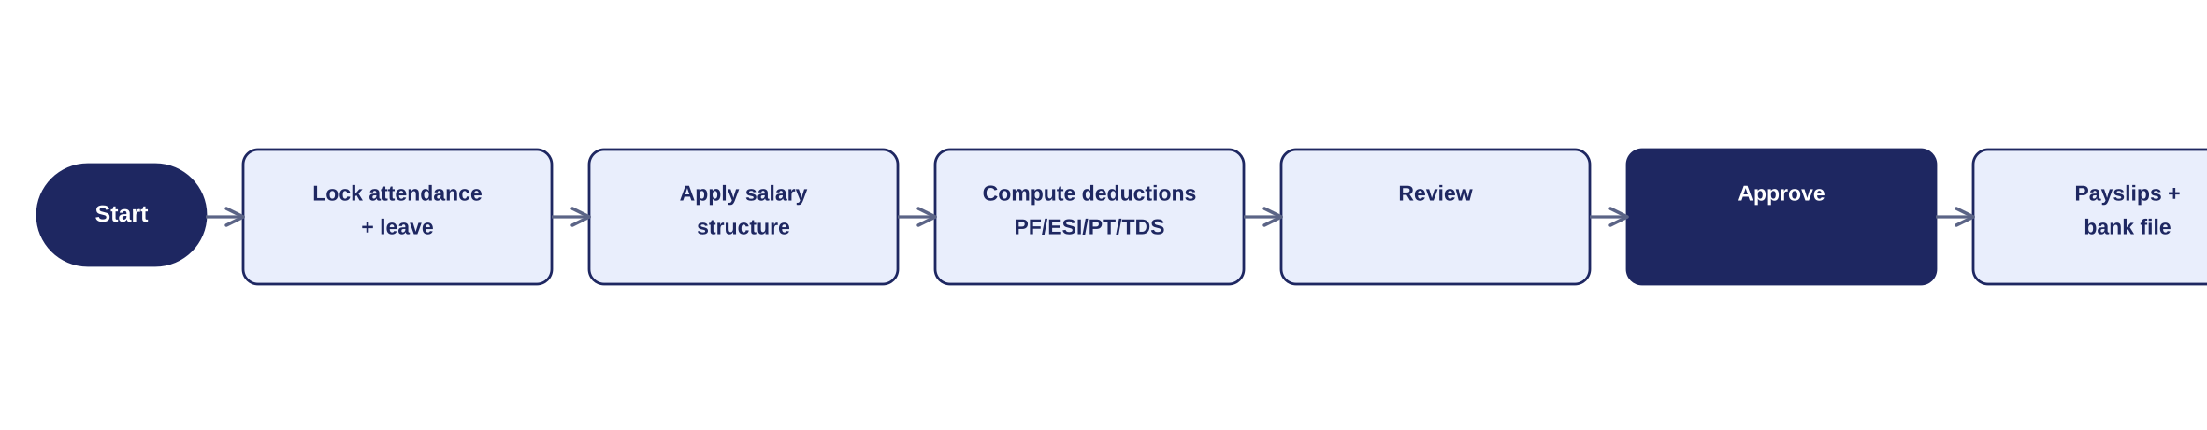
Figure 9. Payroll run workflow.

7.7 Performance
A review cycle opens → goals/OKRs are set → self-assessment and manager assessment → final rating linked to increments/promotions.

7.8 Exit
Resignation is submitted → clearance sign-offs from IT, Finance, Admin, HR → Full & Final settlement computed → exit interview recorded → employee data archived (retained for compliance).

8. Entity State Machines
The entities below have explicit lifecycles enforced in code. Each diagram is followed by its transition table.

8.1 Employee lifecycle
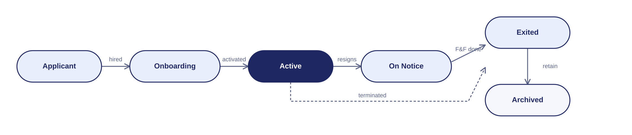
Figure 10. Employee lifecycle states.
From | To | Trigger
Applicant | Onboarding | Offer accepted / hired
Onboarding | Active | Profile activated
Active | On Notice | Resignation submitted
Active | Exited | Termination
On Notice | Exited | F&F completed
Exited | Archived | Retention for compliance

8.2 Leave request
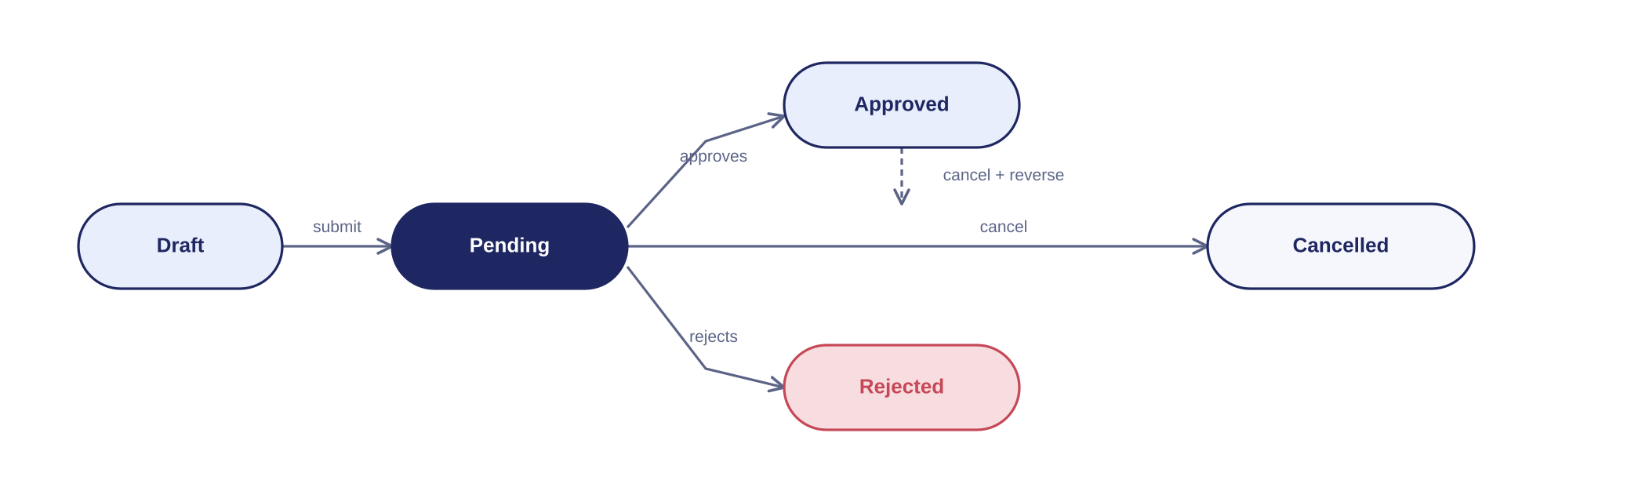
Figure 11. Leave request states.
From | To | Trigger
Draft | Pending | Employee submits
Pending | Approved | Manager approves
Pending | Rejected | Manager rejects
Pending | Cancelled | Employee cancels
Approved | Cancelled | Cancellation reverses balance

8.3 Payroll run
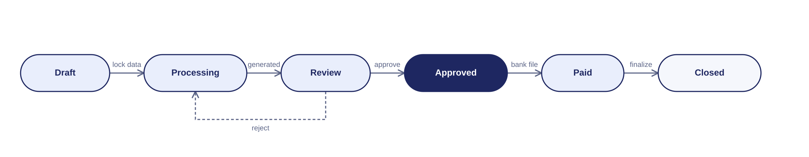
Figure 12. Payroll run states.
From | To | Trigger
Draft | Processing | Attendance & leave locked
Processing | Review | Payslips generated
Review | Draft | Rejected in review
Review | Approved | Approved
Approved | Paid | Bank file executed
Paid | Closed | Period finalised

8.4 Subscription / company status
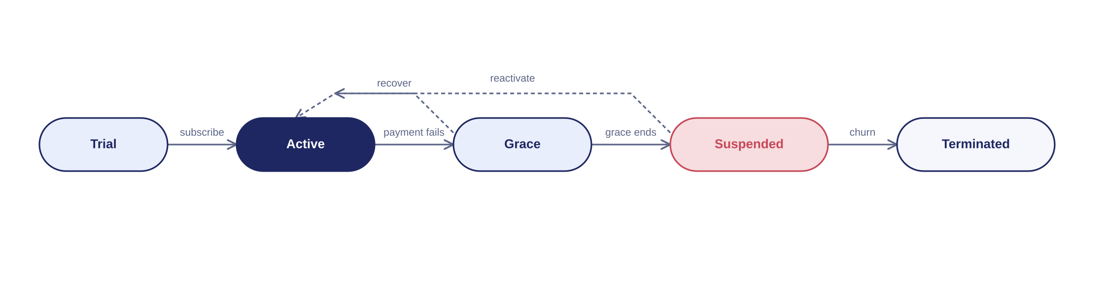
Figure 13. Subscription (company) status states.
From | To | Trigger
Trial | Active | Subscription paid
Active | Grace | Payment fails
Grace | Active | Payment recovered
Grace | Suspended | Grace period ends
Suspended | Active | Reactivated
Suspended | Terminated | Churn

8.5 On-Duty (OD) request
Mirrors the leave request lifecycle (8.2), without a Draft state — an OD request is submitted directly as Pending.
From | To | Trigger
Pending | Approved | Manager / HR / Brand Admin approves
Pending | Rejected | Approver rejects
Pending | Cancelled | Employee cancels
Approved | Cancelled | Cancellation reverts attendance to normal (QR required again)

8.6 Comp-Off credit
Auto-created by the attendance job (7.5.1); approval is a manual gate before the credit can be spent.
From | To | Trigger
Pending Approval | Approved | Manager / HR / Brand Admin approves
Pending Approval | Rejected | Approver rejects
Approved | Used | Spent via a Comp-Off leave request
Approved | Expired | Not used by expiry_date

9. API & Module Design

9.1 Conventions
- REST, versioned. Base path /api/v1; resource-oriented routes; JSON payloads.
- Auth header. Bearer JWT; the token carries userId, companyId, roles[] and scope.
- Middleware pipeline. authenticate → resolve tenant scope → permission guard (requirePermission('resource:action')) → controller.

9.2 Middleware pipeline
// every protected route
router.post('/employees',
authenticate, // verify JWT
tenantScope, // inject company_id / brand_id filter
requirePermission('employee:create'),// assert RBAC code
EmployeeController.create);

9.3 Representative endpoints
Method | Endpoint | Purpose | Permission
POST | /api/v1/groups | Create a Group + first Group Admin (Super Admin only) | tenant:manage
POST | /api/v1/groups/:id/companies | Create a Company under a Group + first Company Admin (Super Admin only) | tenant:manage
POST | /api/v1/companies/:id/brands | Create a Brand under a Company + first Brand Admin (Super Admin only) | tenant:manage
POST | /api/v1/employees | Create employee (blocked if Brand has zero Rosters) | employee:create
POST | /api/v1/employees/bulk-import | Bulk-create employees via CSV/Excel (all admin levels; blocked if target Brand has zero Rosters) | employee:create
GET | /api/v1/employees | List (scoped) | employee:read
POST | /api/v1/devices/register | Register device passkey (first login) | self
POST | /api/v1/attendance/check-in | Verify QR token & mark check-in | attendance:mark
POST | /api/v1/attendance/check-out | Verify QR token & mark check-out | attendance:mark
POST | /api/v1/leave-requests | Apply for leave | leave:apply
PATCH | /api/v1/leave-requests/:id/approve | Approve leave | leave:approve
POST | /api/v1/rosters | Create / update draft roster entries | roster:manage
PATCH | /api/v1/rosters/publish | Publish a date range of roster entries | roster:publish
POST | /api/v1/od-requests | Apply for On-Duty (OD) | od:apply
PATCH | /api/v1/od-requests/:id/approve | Approve / reject OD request | od:approve
PATCH | /api/v1/comp-off-credits/:id/approve | Approve / reject an auto-detected Comp-Off credit | compoff:approve
POST | /api/v1/payroll-runs | Start a payroll run | payroll:run
GET | /api/v1/payslips/:id | View payslip | payroll:read
POST | /api/v1/plans | Create a plan (platform) | plan:manage

10. Security & Compliance
- RBAC at the API. Every request validated against company_id and the required permission code.
- Encryption. At rest and in transit (TLS).
- Audit trail. Who changed what, when, and where — with before/after snapshots.
- Statutory compliance. PF, ESI, Professional Tax, TDS — configurable per company with platform defaults.
- Tenant isolation. Mandatory ORM-level filter; no cross-tenant reads even on UI or API misuse.
- Account security. Password policy, session timeout, 2FA enforcement, refresh-token rotation.
- QR attendance security. Rotating, signed (JWT/HMAC) QR tokens with a 5–10s validity window, jti-based replay protection, and device binding via WebAuthn passkeys — see 7.4.2.
- Backup & DR. Regular backups and a documented disaster-recovery plan.

11. Non-Functional Requirements
- Scalability. Stateless services scale horizontally; the shared-DB model adds rows, not servers, per company.
- Availability. Health checks and failover; background jobs isolated from request traffic.
- Performance. Near real-time sync between attendance, leave and payroll; heavy reports offloaded to workers.
- Data residency. Region-wise deployment; dedicated tenancy option for enterprise.
- Observability. Centralised logging, metrics, and per-tenant usage analytics.

12. Deployment & Infrastructure
- Environments. dev → staging → production, promoted through CI/CD.
- Compute. Containerised services on AWS/Azure with auto-scaling.
- Async. Redis + Bull workers for payroll, notifications, and reports; scheduled jobs for accruals and resets. Redis also caches QR terminal / token state for attendance so scans do not hit the database on every check-in/out.
- Storage. Managed PostgreSQL; object storage for documents with signed URLs.
- Monitoring. Centralised logs, metrics, alerting, and uptime checks.

13. Implementation Roadmap
- Phase 1 (MVP): multi-tenant core + RBAC, admin invitation flow, Group → Company → Brand provisioning (Super Admin only), roster-mandatory gate, Onboarding, QR Attendance, Comp-Off & Leave, ESS, subscription/billing (Group-managed).
- Phase 2: Payroll, Performance, Recruitment (ATS), Exit; Group white-label branding.
- Phase 3: dedicated tenancy, in-app provisioning-request queue (Group/Company Admin → Super Admin), SSO.

14. Open Decisions & Assumptions
- Billing ownership — resolved: Groups manage their own billing/invoices; removed from the Super Admin dashboard.
- White-labeling — extent of Group branding control (logo, domain).
- Provisioning requests — Phase 1: Group/Company Admin contacts the Super Admin manually to request a new Company/Brand. Phase 3 (see roadmap): formal in-app request queue.
- Data residency — dedicated DB/schema for enterprise in Phase 1 or later.
- Pricing — per-employee vs flat/tiered.
Assumptions: single shared PostgreSQL for Phase 1; INR statutory model (PF/ESI/PT/TDS); Sequelize with paranoid soft deletes; one primary region initially.

15. End-to-End Provisioning Flows
This section traces the complete creation chain from the Super Admin down to a normal employee, for both a single company and a Group with multiple companies. Every actor and every record they create is shown, so the flow can be checked at a glance against the intended design.

15.1 Single company
A company that uses the HRMS only for its own staff. One admin runs everything.
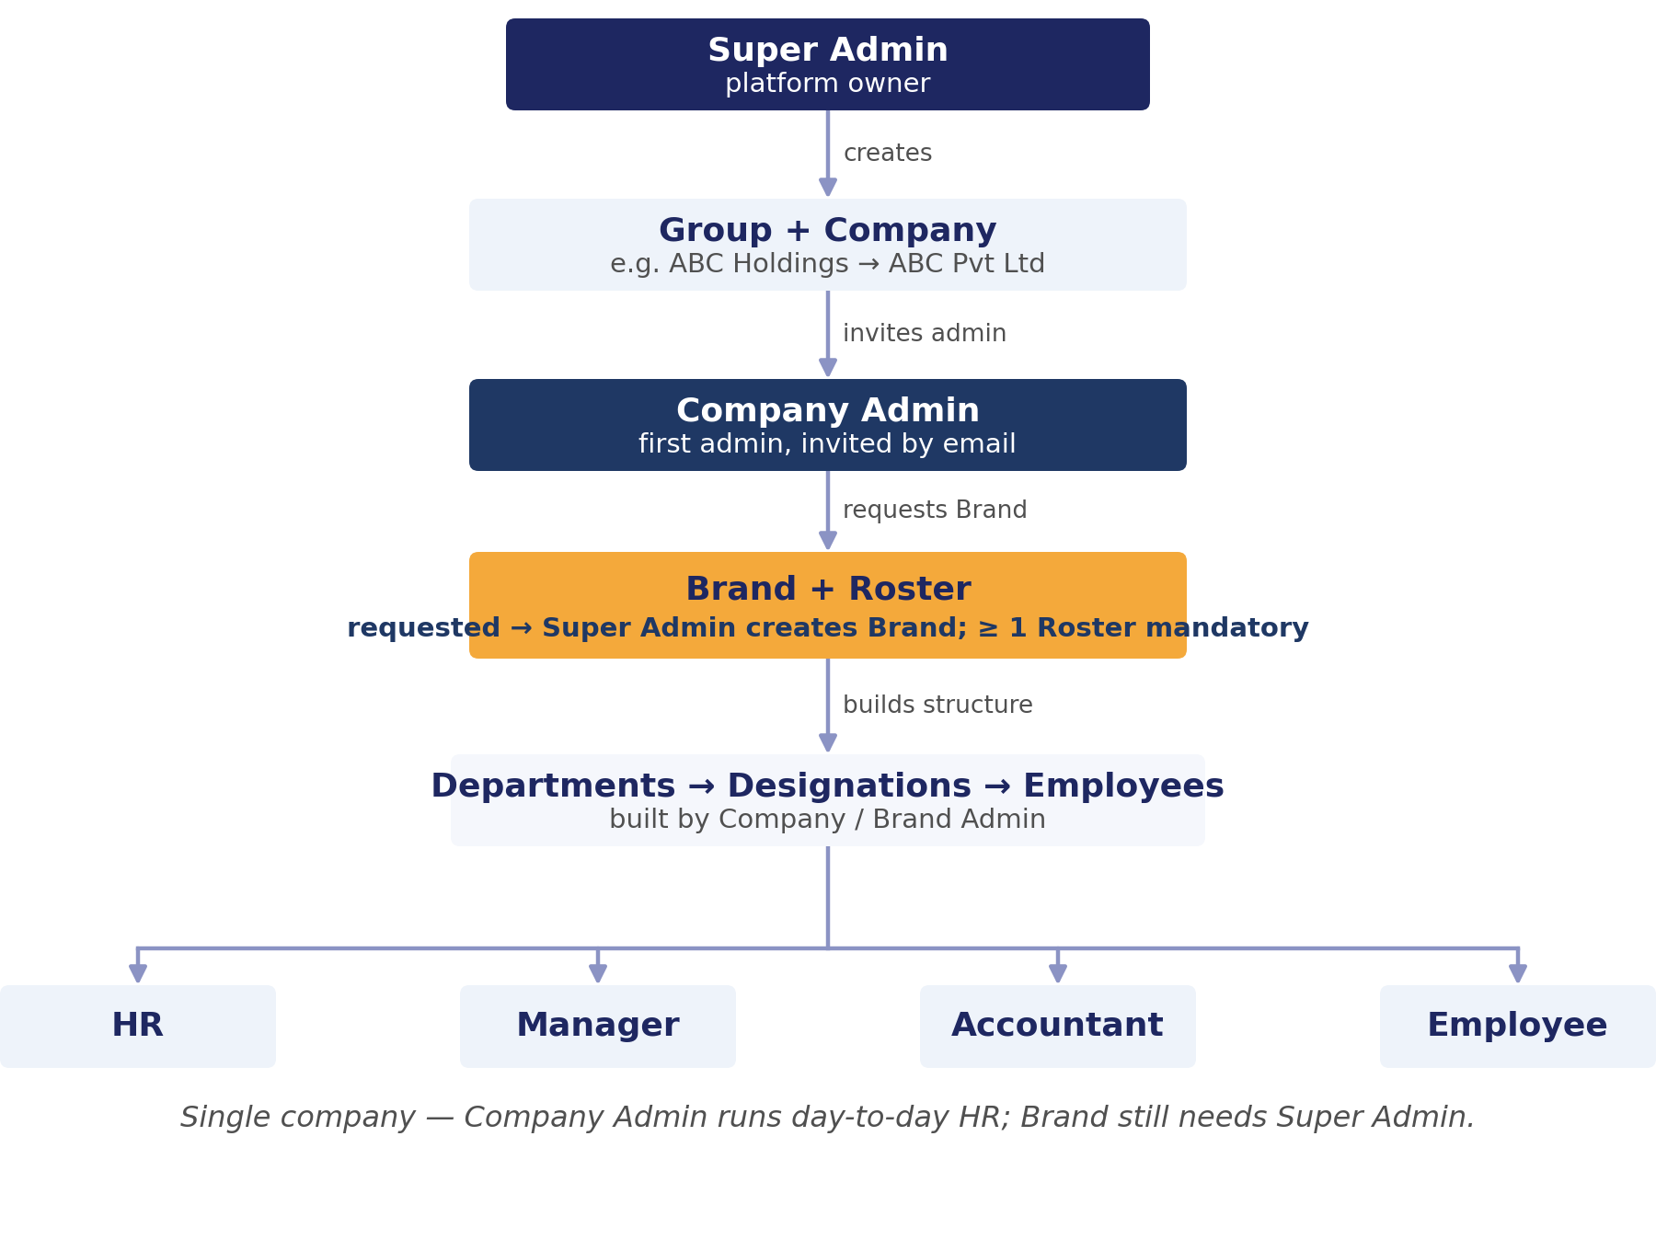
Figure 14. End-to-end flow — single company (Super Admin to Employee).
- Super Admin creates the Group and the Company under it (e.g. ABC Pvt Ltd).
- Super Admin enters the admin's email; the system creates the admin user (invited) with the Company Admin role scoped to that company and emails a one-time activation link.
- The admin opens the link, sets a password, and logs in.
- Company Admin requests the Super Admin to create its first Brand; once created (with its Brand Admin), a Roster (Morning / Day / Night) is defined for the Brand — mandatory before any employee can be added — then departments and designations are created.
- The Company Admin creates employees — individually or via bulk import — assigning each a role — HR, Manager, Accountant, or Employee — a brand, a department, a designation, and a reporting manager.
- Employees receive their own activation links and use the ESS portal.

15.2 Group with multiple companies
A Group containing more than one Company — each Company is created directly by the Super Admin at the Group Admin’s request; there is no sub-company self-service. The Group Admin oversees but does not run any single Company’s day-to-day HR. Using the Snow Village example:
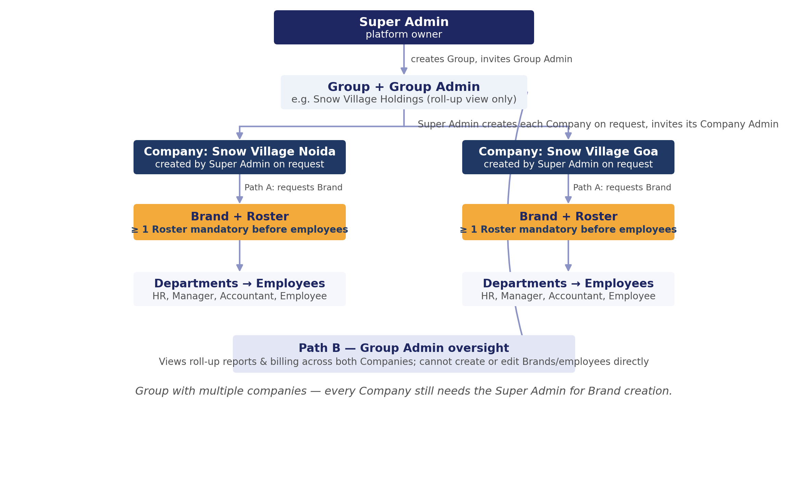
Figure 15. End-to-end flow — Group with multiple companies (Super Admin to Employee).
- Super Admin creates the Snow Village Group and invites its Group Admin (email + activation link).
- On the Group Admin’s request, Super Admin creates each Company under the Group (e.g. Snow Village Noida, Snow Village Goa) and invites each Company Admin separately.
- Path A — each Company Admin runs their own Company exactly as in 15.1: requests Brands from the Super Admin, defines a Roster per Brand (mandatory), then departments and employees.
- Path B — the Group Admin views roll-up reports and billing across every Company in the Group, but cannot create or edit any Company’s Brands or employees directly.
- Each sub-company admin activates their account and creates that sub-company's own employees (HR, Manager, Accountant, Employee), scoped strictly to their sub-company.
Isolation holds throughout: Snow Village Noida cannot see another Group’s data, and Snow Village Noida cannot see Snow Village Goa’s data — every record is filtered by company_id.

15.3 Who creates whom
The complete creator → created chain, with the resulting role at each level:
Actor | Creates | Resulting role / record | Scope
Super Admin | Group | groups row + invited Group Admin | Platform
Super Admin | Company (in a Group) | companies row + invited Company Admin | One company
Super Admin | Brand (in a Company) | brands row + invited Brand Admin | One brand
Company Admin | Departments / designations | org-structure rows | Own company
Company Admin / Brand Admin | Roster (per Brand, mandatory) | roster row — required before any employee | Own brand
Company Admin / Brand Admin | Employees (single or bulk import) | employees + users + role | Own company / brand
Group Admin | — no creation rights | requests Super Admin for a new Company | Own group (view-only)
HR / Brand Admin | Employees | employees + users | Company / brand
Employee | Own leave / attendance / tickets | self-service records | Self

16. Appendices

Appendix A — Permission codes (resource:action)
Module | Codes
Tenancy | company:create, company:read, company:update, company:suspend, company:delete
Access | role:manage, permission:read, user:create, user:invite, user:update, user:reset
Org | brand:manage, department:manage, designation:manage
Employee | employee:create, employee:read, employee:update, employee:delete, employee:transfer
Attendance | attendance:mark, attendance:read, attendance:approve
Leave | leave:apply, leave:read, leave:approve, leave:policy
Payroll | payroll:run, payroll:read, payroll:approve, salary:manage, statutory:manage
Recruitment | job:manage, candidate:manage, interview:manage, offer:manage
Performance | cycle:manage, goal:manage, appraisal:manage
Exit | resignation:manage, clearance:manage, fnf:manage
Billing | plan:manage, billing:read, invoice:manage, commission:read
Platform | tenant:manage, audit:read, settings:manage, feature:manage

Appendix B — Sample DDL (core tables)
CREATE TABLE groups (
id BIGSERIAL PRIMARY KEY,
name VARCHAR(150) NOT NULL,
status VARCHAR(15) NOT NULL DEFAULT 'active',
plan_id BIGINT REFERENCES plans(id),
created_by BIGINT REFERENCES users(id),
created_at TIMESTAMPTZ DEFAULT now(),
deleted_at TIMESTAMPTZ
);

CREATE TABLE companies (
id BIGSERIAL PRIMARY KEY,
group_id BIGINT NOT NULL REFERENCES groups(id),
name VARCHAR(150) NOT NULL,
status VARCHAR(15) NOT NULL DEFAULT 'trial',
plan_id BIGINT REFERENCES plans(id),
created_at TIMESTAMPTZ DEFAULT now(),
updated_at TIMESTAMPTZ DEFAULT now(),
deleted_at TIMESTAMPTZ
);

CREATE TABLE employees (
id BIGSERIAL PRIMARY KEY,
company_id BIGINT NOT NULL REFERENCES companies(id),
brand_id BIGINT NOT NULL REFERENCES brands(id),
department_id BIGINT NOT NULL REFERENCES departments(id),
designation_id BIGINT NOT NULL REFERENCES designations(id),
manager_id BIGINT REFERENCES employees(id),
user_id BIGINT REFERENCES users(id),
status VARCHAR(15) NOT NULL DEFAULT 'onboarding',
deleted_at TIMESTAMPTZ
);

CREATE TABLE leave_requests (
id BIGSERIAL PRIMARY KEY,
employee_id BIGINT NOT NULL REFERENCES employees(id),
leave_type_id BIGINT NOT NULL REFERENCES leave_types(id),
from_date DATE, to_date DATE, days NUMERIC(4,1),
status VARCHAR(12) NOT NULL DEFAULT 'pending',
approver_id BIGINT REFERENCES employees(id),
deleted_at TIMESTAMPTZ
);

