**Full Stack Developer Summer Work Challenge**

For Starting the project the following are the perquisites that must be installed.

**Installing latest version of php 7.4.5**

**Installing Laravel**

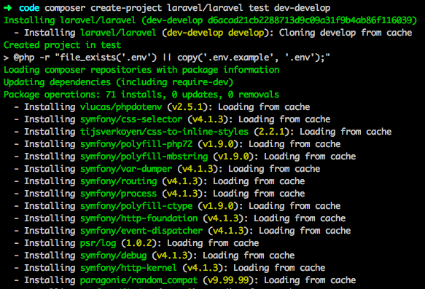

**Installing Mysql Latest version to access the database. I used application mySql Workbench.**

**Installing composer**

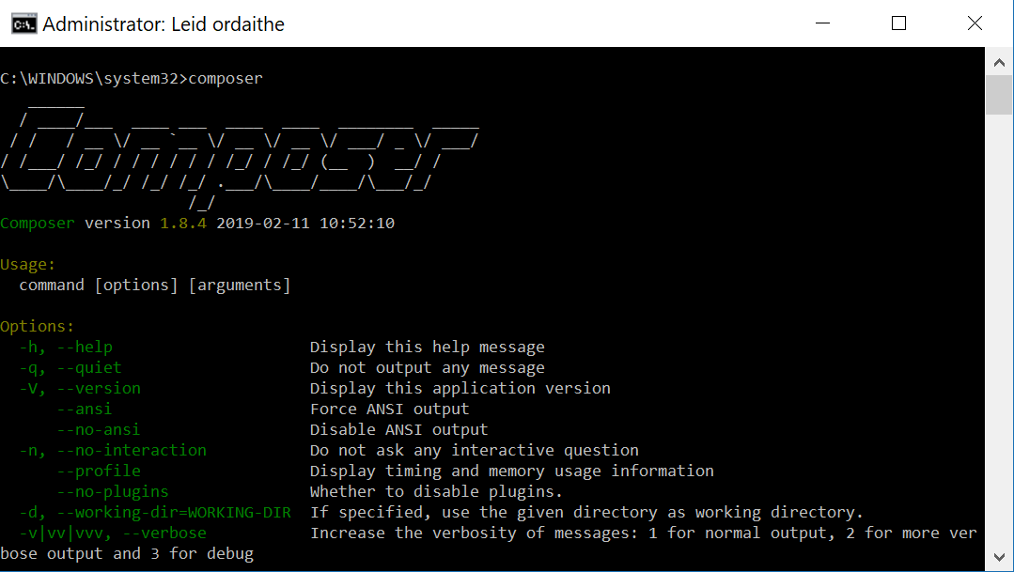

**Create the project I used following commands, these following commands will create a will install a layout view, registration and login views.**

composer require laravel/ui

php artisan ui vue --auth

laravel new ProjectName --auth

**Laravel new ProjectName** created a new project

**Laravel new ProjectName --auth**  created the login view. The user Is able to register the new user and login.

I coonceted this to the mySQL database .

Creating connection in .env file

**After this CURD views were Created**

The index page displayed list of labs along with date added and location and also a map showing the pinned location of all the labs.

Route for labs is added in web.php as following

To Display the list of labs a new model class for labs is created.

The controller for lab includes different functions to be implemented like

Create new lab

Edit a lab

Show a lab

Delete a lab

**Then the google maps API is embedded to pin the location of the labs**

A new controller name MapController is designed for this.

The location is pinned, and the longitude and latitude are stored in the data base as per the particular lab.