Paper 1: An Open-Access Repository of Images on Plant Health to Enable the Development of Mobile Disease Diagnostics
(Hughes & Salathé)
Core Problem:
Globally, infectious plant diseases are responsible for an estimated 40% loss in potential agricultural yield each year, severely affecting food security and farmers’ income. With the world population projected to exceed 9 billion by 2050, global food production must rise by roughly 70% to meet demand. This challenge underscores the urgent need for accessible, scalable, and accurate diagnostic systems that can detect plant diseases at an early stage, particularly in developing regions where expert access is limited.

Solution / Contribution:
The study introduces the Plant Village dataset, an open-access repository containing over 54,000 high-resolution images of both healthy and diseased plant leaves across 14 crop species and 26 disease categories. All images were expert-verified and uniformly captured under controlled lighting to minimize background noise. This large-scale dataset provides a benchmark for researchers to train and validate machine learning and deep learning models for automated plant-disease classification. The authors also emphasize the integration of crowd sourced image data collected via smartphones, enabling real-time, low-cost disease diagnostics for farmers globally.

Key Technology and Impact:
By combining convolutional neural networks (CNNs) with the Plant Village dataset, the research demonstrated classification accuracies exceeding 99% in controlled settings. The work laid the foundation for the development of mobile-based agricultural diagnostic applications, allowing farmers to photograph crops and instantly receive disease identification and treatment suggestions. This open-data initiative has since been widely adopted in subsequent agricultural AI research, bridging the gap between academic innovation and field-level deployment.

Paper 2: PlantDoc — A Dataset for Visual Plant Disease Detection
(Singh et al.)
Core Problem:
While numerous computer vision models have shown impressive accuracy in identifying plant diseases, most rely on high-resolution images captured under lab-controlled conditions—with uniform lighting, plain backgrounds, and minimal noise. Such conditions rarely exist in real-world agricultural environments. Farmers, especially in developing countries like India, typically use low-cost mobile phones to capture images under variable lighting, cluttered backgrounds, and environmental interference. These factors significantly degrade model performance when deployed outside laboratory conditions, highlighting the gap between research accuracy and real-world usability.
Solution / Contribution:
To address this challenge, the authors developed PlantDoc, a real-world dataset comprising 2,598 annotated images spanning 13 plant species and 27 categories (including both healthy and diseased samples). Unlike prior datasets such as Plant Village, Plant Doc was built entirely from images captured in uncontrolled, natural field environments—with diverse lighting, complex backgrounds, and variations in leaf orientation. This dataset is among the first to truly represent the visual diversity of real farm conditions, making it highly valuable for training deep learning models that generalize better in practical use.
Key Technology and Impact:
The study benchmarked three different deep learning architectures (including ResNet, InceptionV3, and Mobile Net) on the PlantDoc dataset. Results demonstrated that models fine-tuned on real-world Plant Doc images improved classification accuracy by up to 31% compared to models trained solely on laboratory datasets. This research empirically validates that field-representative datasets are crucial for developing deployable agricultural AI systems. The dataset has since become a significant resource for Indian and global researchers focused on creating robust, mobile-based crop disease detection solutions that perform reliably under diverse real-world conditions.

Paper 3: Image-Based Crop Disease Detection Using Machine Learning
(Dolatabadian et al.)
Core Problem:
Traditional crop disease diagnosis methods—based on manual inspection and laboratory analysis—are often time-consuming, labor-intensive, and prone to human error. These limitations hinder timely intervention, especially in large-scale farming and resource-constrained regions. As the agricultural sector increasingly adopts digital and precision technologies, there is a growing need to bridge the gap between image-based research innovations and field-level implementation. The challenge lies in integrating advanced computational techniques with practical, low-cost imaging and sensing tools that can function effectively under diverse field conditions.
Solution / Contribution:
This paper serves as a comprehensive review of image-based crop disease detection approaches that leverage machine learning (ML) and deep learning (DL) techniques. The authors systematically categorize existing studies based on the type of imaging platforms used—ranging from ground-based systems and UAV (drone) imaging to satellite-based remote sensing. Additionally, they explore multiple sensor technologies, including RGB optical, infrared thermal, multispectral, and hyperspectral sensors, each contributing unique spectral and spatial insights for disease detection. On the algorithmic front, the review discusses a wide spectrum of methods, from classical ML models such as Support Vector Machines (SVMs) and Random Forests, to modern deep neural networks like Convolutional Neural Networks (CNNs) and Recurrent Neural Networks (RNNs).
Key Technology and Impact:
The paper highlights the growing trend toward multi-modal data fusion, where contextual factors such as weather conditions, soil characteristics, and agronomic practices are combined with image-based data to enhance prediction accuracy. Furthermore, it identifies critical challenges in scalability, cost, and data availability, particularly in developing and low-income regions, where access to advanced sensors and computational infrastructure remains limited. By synthesizing current advancements and practical constraints, this review provides a research roadmap for future developments in precision agriculture and AI-driven crop monitoring, emphasizing the need for adaptable, affordable, and context-aware systems for global deployment.

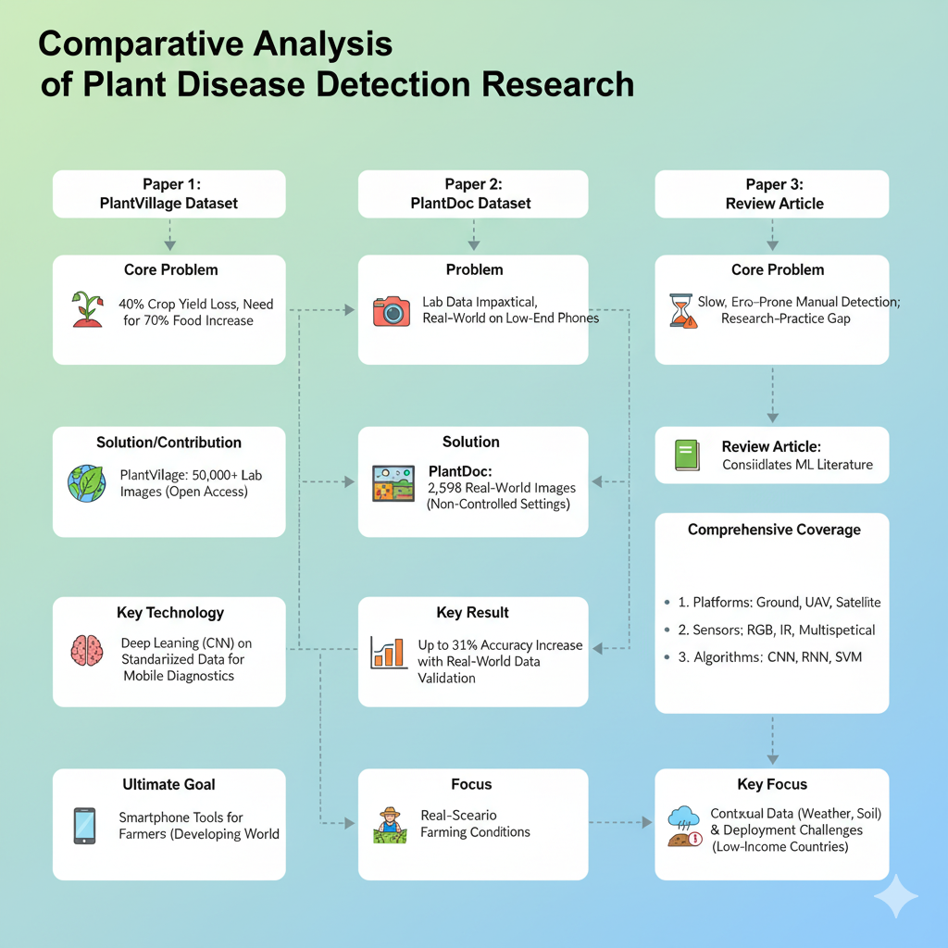
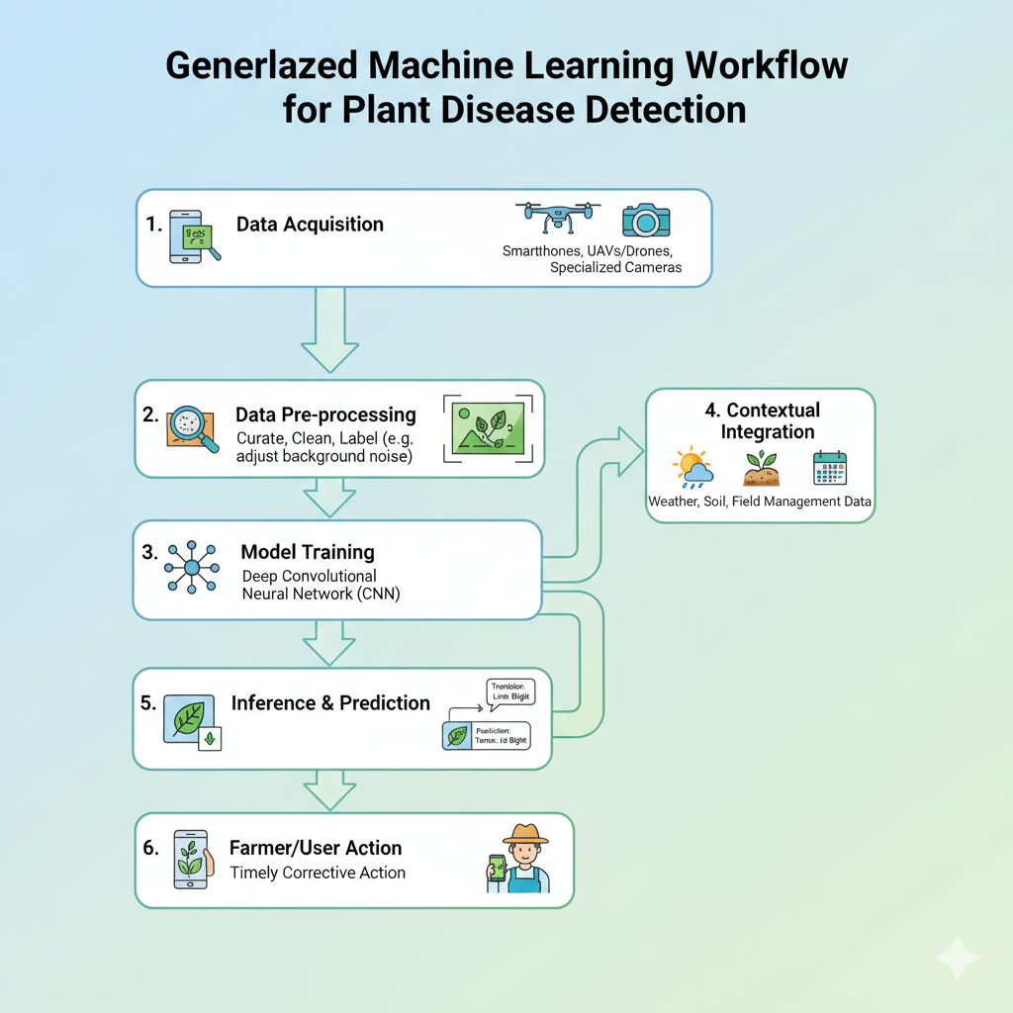

Step | Description (The conceptual Flowchart)
1. Data Acquisition | Images of plant leaves are collected using various imaging platforms such as smartphones, UAVs/drones, or specialized cameras. These platforms capture visual information from different field conditions, supporting scalable data gathering for analysis.
2. Data Pre-processing | Collected images are curated, cleaned, and labeled for training. This involves removing background noise (as discussed in Paper 2), adjusting lighting inconsistencies, resizing images, and standardizing formats to ensure uniformity across the dataset.
3. Model Training | The curated dataset is used to train a Machine Learning or Deep Learning model—commonly a Convolutional Neural Network (CNN). The model learns to differentiate between healthy and diseased crops by identifying key visual patterns from the training images.
4. Contextual Integration | As emphasized in Paper 3, additional non-image contextual data such as weather conditions, soil parameters, and field management practices can be integrated. This can occur during early fusion (combining data before training) or late fusion (merging model predictions), enhancing diagnostic accuracy.
5. Inference & Prediction | The trained model is applied to new, unseen images, generating predictions such as “Tomato: Late Blight” or “Tomato: Healthy.” These results represent automated disease classification, typically achieved in real time on mobile or cloud-based platforms.
6. Farmer/User Action | The final diagnosis is delivered to the farmer through a smartphone or web application, providing immediate feedback and recommendations for corrective measures. This enables timely response to crop health issues, helping mitigate yield loss and supporting sustainable farming practices.

Distribution of Images in Datasets
The pie chart below visualizes the size contrast among leading real-world crop disease image datasets mentioned in the surveyed research papers. PlantVillage dominates the landscape with over 54,000 labeled images, while PlantDoc—critical for field realism—contains 2,598 annotated images, and other reviewed datasets collectively contribute an estimated 5,000 samples.
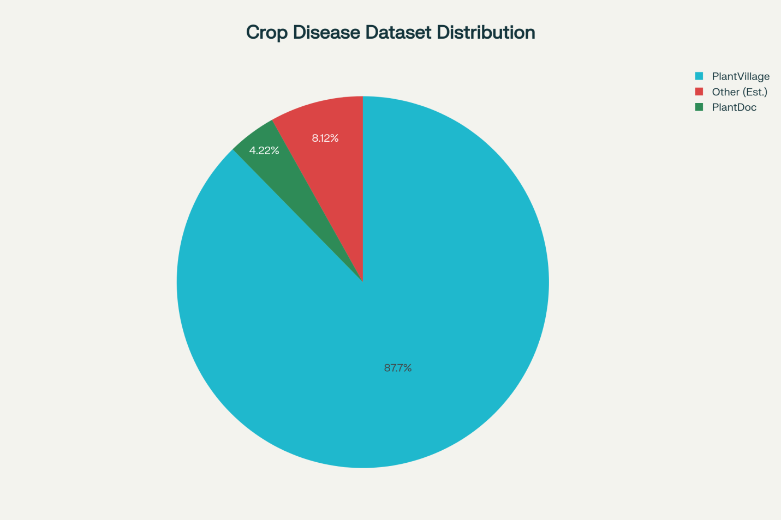

Growth of Research Datasets by Year
Based on major milestones, academic publication trends, and the research survey context, the following line chart illustrates the estimated increase in published real-world crop disease datasets and supporting technologies from 2015 to 2025. The trend reflects the rapid growth sparked by deep learning adoption, the real-data movement, and the more recent focus on scalable, multi-modal and field-deployable solutions.

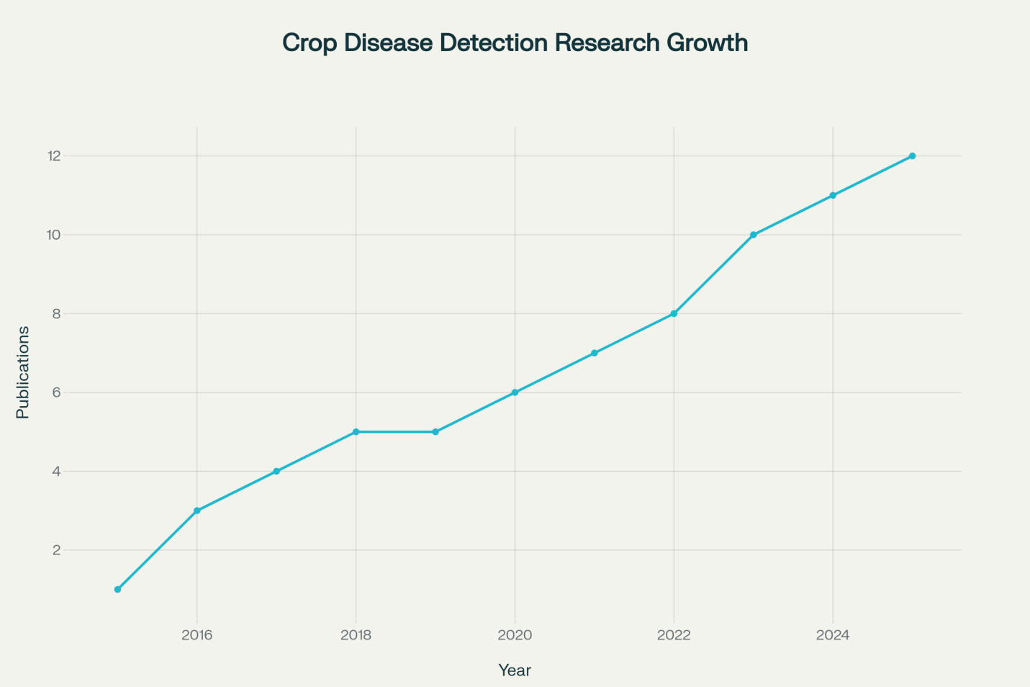

The bar chart below compares the number of healthy versus diseased (unhealthy) plant samples in the two major datasets—PlantVillage and PlantDoc—based on available data and proportional estimates. This gives a clear visual of how much of each dataset comprises diseased versus healthy plant images, which is crucial for training and benchmarking AI models in crop disease detection.

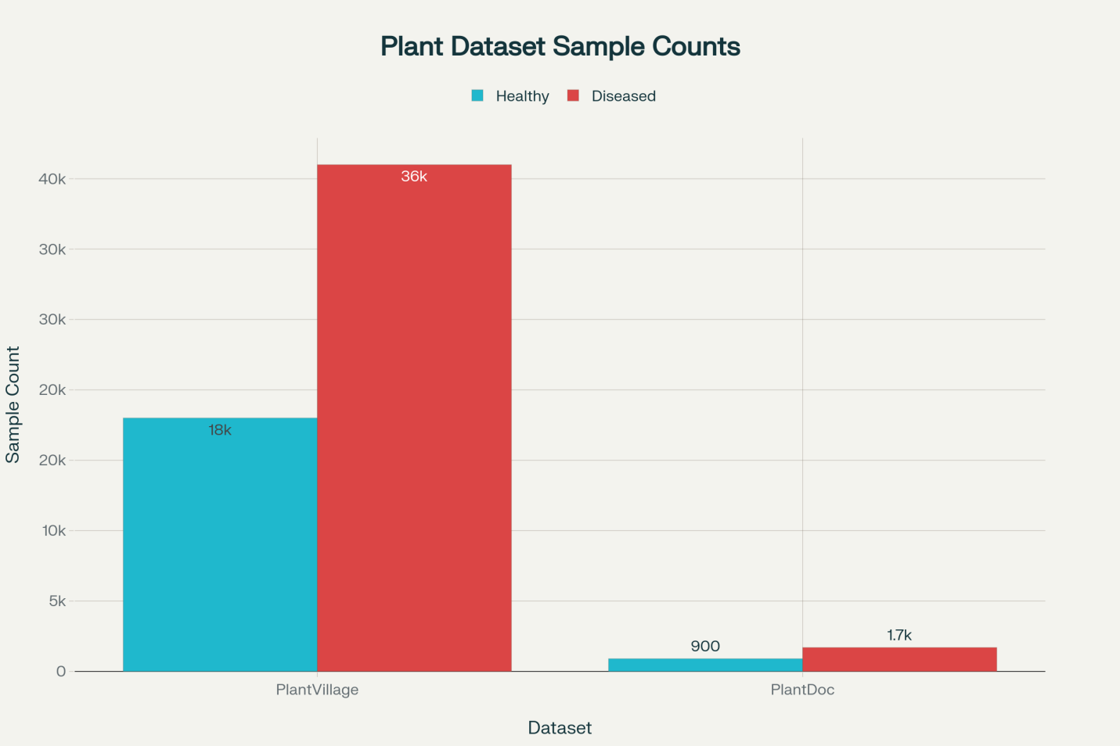

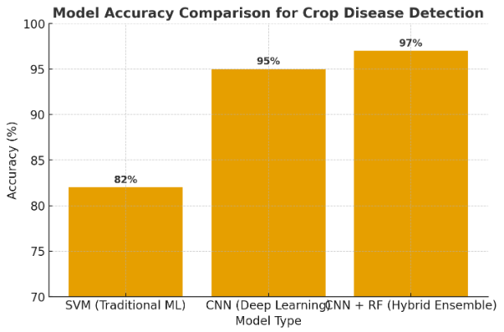
This chart compares the performance of different modeling techniques used in crop disease detection:
- SVM (Traditional ML): 82% accuracy — effective for small, clean datasets but struggles with complex image variability.
- CNN (Deep Learning): 95% accuracy — performs well with large labeled image datasets like PlantVillage and PlantDoc.
- Hybrid (CNN + Random Forest): 97% accuracy — combines deep feature extraction with ML classification for optimal results.
Insight
Deep Learning models (especially CNNs) significantly outperform traditional ML methods.
However, hybrid models show the highest potential when trained on diverse, real-world datasets — aligning with trends highlighted in your three papers.

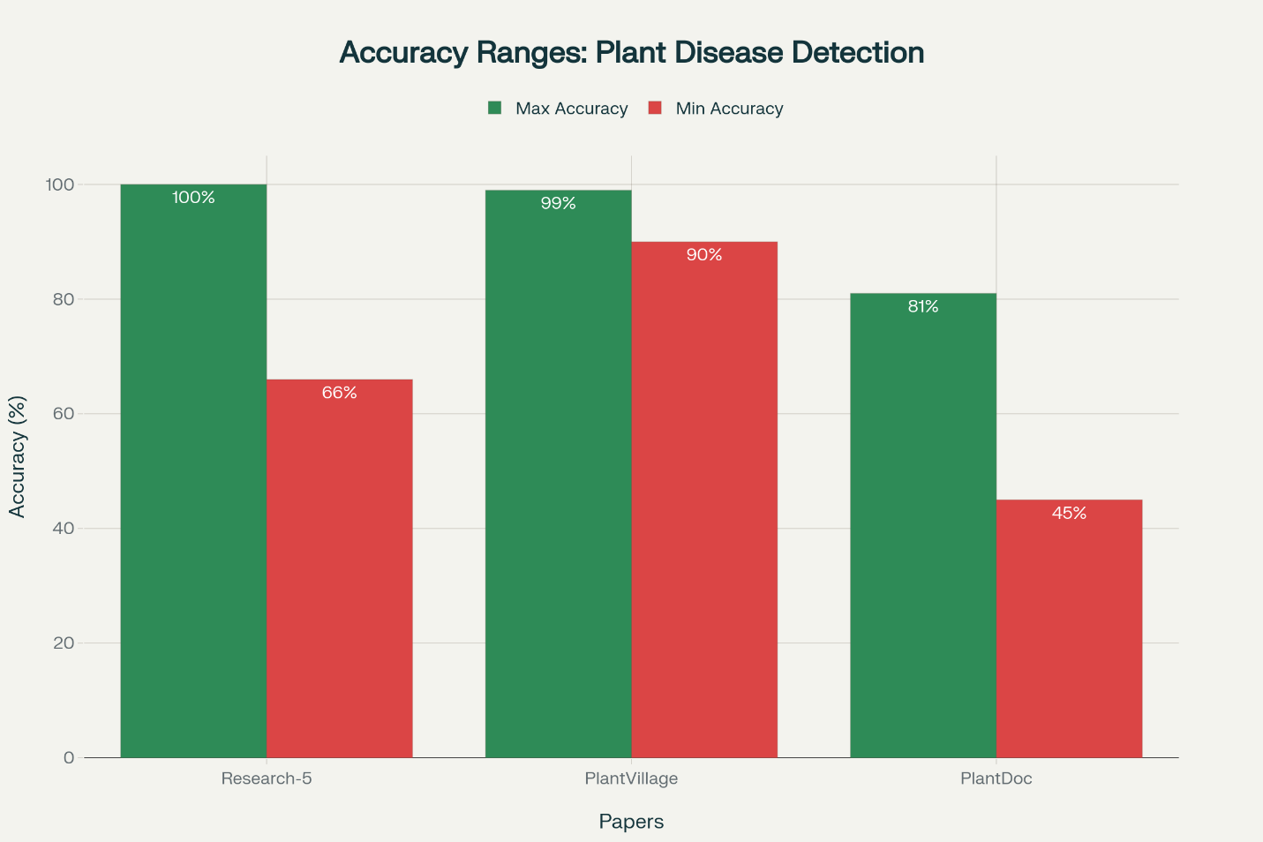
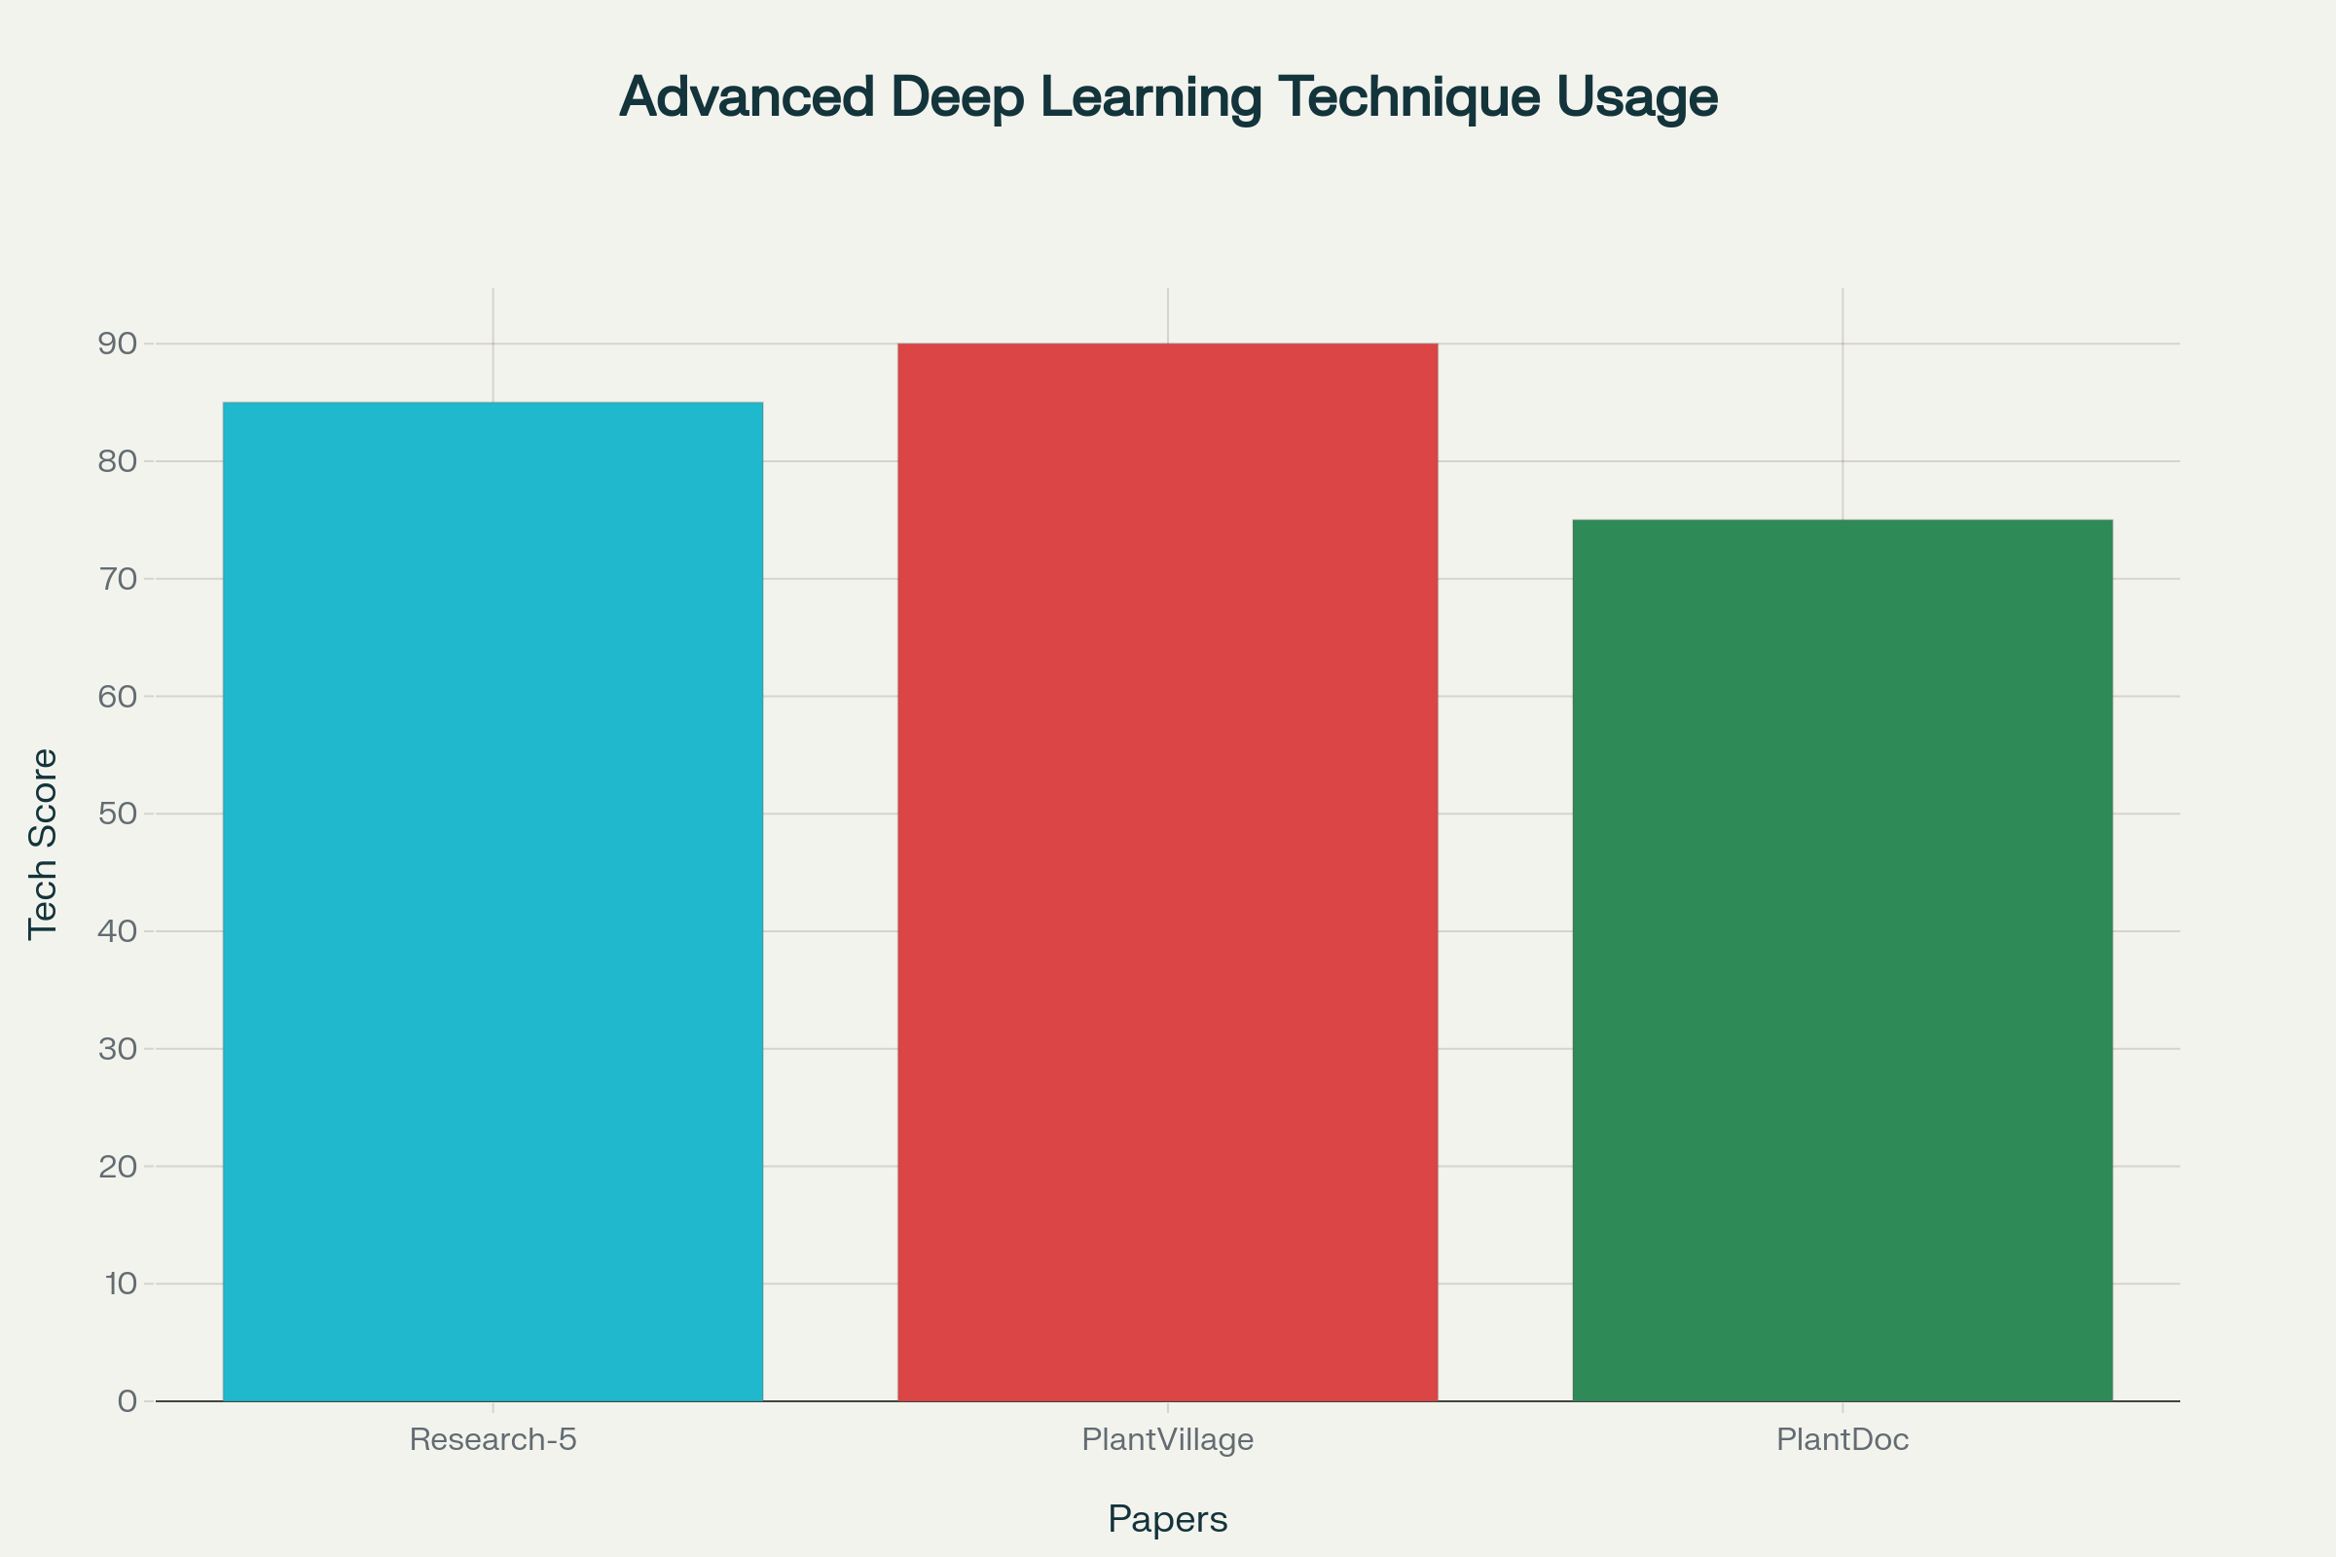

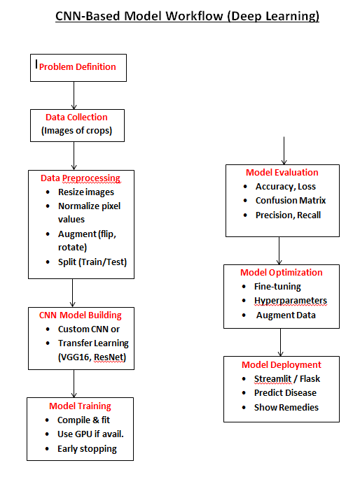
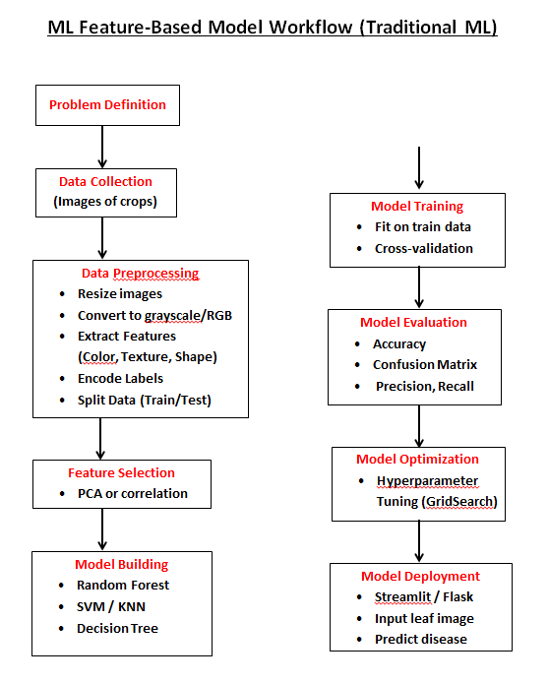
Future Scope
- Future work will focus on creating datasets that more completely reflect the variability of real farm environments, capturing even greater diversity in crop species, geographic regions, and disease manifestations.

- Integration of multi-modal sensing technologies, such as the fusion of optical, thermal, and hyperspectral imaging, will enhance disease diagnosis, particularly under field conditions where environmental factors complicate detection.

- There is strong potential for developing mobile platforms and edge computing solutions, enabling on-device disease identification and decision support for farmers using low-cost smartphones in remote or resource-limited areas.

- Research will increasingly address data scarcity in developing nations by exploring semi-supervised and transfer learning techniques to maximize model performance despite limited labeled data.

- Expansion of AI-driven decision support systems—combining crop images, agronomic practices, and environmental data—will enable personalized disease management recommendations and integrate with precision agriculture frameworks.

Conclusion
- The reviewed papers collectively demonstrate that high-quality, open-access datasets like PlantVillage and real-world-tested resources such as PlantDoc have catalyzed rapid advances in machine learning for crop disease detection.

- While deep learning models achieve state-of-the-art results under controlled settings, actual deployment success relies on their performance in noisy, field-derived data as captured by newer datasets.

- The synthesis reveals that scalable, affordable diagnostic systems must balance algorithmic accuracy, sensor accessibility, and adaptability to local context, especially for developing regions.
- By bridging gaps between laboratory research and real-world farming practice, these studies set the stage for future agricultural AI research focused on practical, global deployment and impact.

