Design and Study of Human-Human Interaction System to Control the Movement of Paralyzed Hands

Submitted by
Ankita Giroti
M. Sc. Semester III Year: 2024 - 2025

Under the Guidance of
Dr. Mrs. A. D. Sakhare



Department of Electronics and Computer Science, Rashtrasant Tukadoji Maharaj Nagpur University Campus,
Amravati Road, Nagpur – 440033

CHAPTER 2: Requirements and Analysis

  - Requirement Specification

    - Hardware

      - Computer

Processor: Intel Core i5-9400 processor with 2.90GHz clock speed System: Windows 10 with 64-bit operating system
RAM: 4 GB
Hard Disk: 500 GB

      - Arduino UNO
Arduino UNO is a microcontroller board based on the ATmega328P. It has 14 digital input/output pins, 6 analog inputs, a USB connection, a power jack, and an ICSP (In-Circuit Serial Programming) header, and a reset button. It has 2 KB of on-chip RAM and 32 KB of flash memory. The clock speed of Arduino UNO is 16 MHz

Specifications:
14 digital I/O pins
2 KB of in-built RAM 32 KB of Flash memory Clock speed: 16 MHz

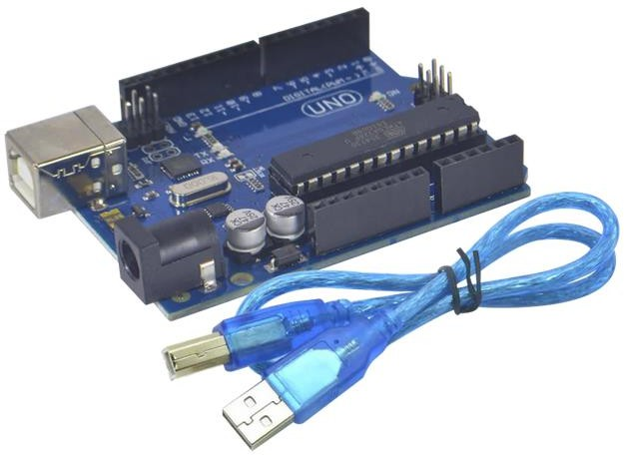

Fig. 2.1: Arduino UNO

      - MyoWare Muscle Sensor
The MyoWare muscle sensor is a three-lead muscle sensor specifically designed to used with microcontroller. It has 2.9 V to 5.7 V single supply and the adjustable gain.
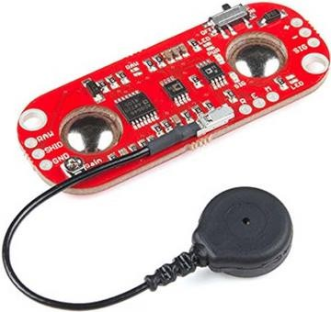
Fig. 2.2: MyoWare Sensor

      - Servo Motor
The servo motor SG90 is used to control the linear motion of the object in a 180º direction. It consists of three wires brown. Red, and orange for ground,

+5V, and PWM signal, respectively. The servo motors can be implemented of the device to control the movements of the paralyzed hand.
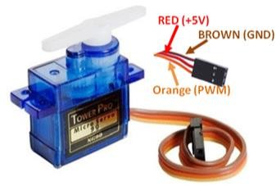
Fig. 2.3: Servo Motor

      - ESP8266 Wi-Fi Module
ESP8266 is a System on Chip (SoC) module with integrated an integrated Wi- Fi module. It comes with pre-programmed AT command firmware make it able to connect with any microcontroller to enable Wi-Fi functionality. It has integrated TCP/IP protocol stack and 32-bit CPU.

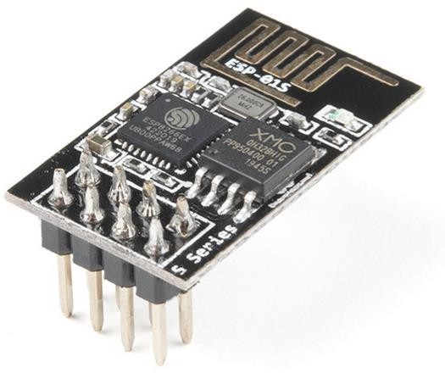
Fig. 2.4: ESP8266 Wi-Fi Module

    - Software
      - Arduino IDE
Arduino IDE is a cross-platform open-source application that allows users to write, compile, debug, and upload code to Arduino boards. It contains a text editor for writing code, a message area, a text console, a toolbar with buttons for common functions and a series of menus. It connects to the Arduino hardware to upload programs and communicate with them. The console displays text output by the Arduino Software (IDE), including complete error messages and other information.

      - PyCharm IDE
PyCharm is a powerful integrated development environment (IDE) designed specifically for Python programming. PyCharm is considered to be one of the most integrated Python IDEs, offering a range of modules and tools which make coding a lot faster and easier for programmers. It can be used for code analysis, debugging, and testing. PyCharm offers a smart code editor which improves the readability of code using a variety of color schemes and error highlighting. It also has a smart code completion feature

    - Libraries
      - NumPy: NumPy (Numerical Python) is a python library intended for computation. It aims to provide an array object known as ndarray. NumPy arrays are stored at one continuous place in memory, so that processes can access and manipulate them very efficiently.
      - Pandas: It is a Python library used to work with datasets for analyzing, cleaning, exploring, and manipulating data. Relevant data is very important to train the ML model, Pandas can be used to clean the messy data in the dataset.
      - Scikit-learn: Scikit-learn is a powerful and user-friendly Python library. is an open- source Python and machine learning library that implements a range of machine learning, pre-processing, cross-validation, and visualization algorithms using a unified interface.

      - Keras: Keras is an open-source library that runs efficiently on CPU as well as GPU. It is used for deep learning. The popular ML library works with the building blocks of neural networks such as activation functions, layers, objectives, and optimizers.

  - Planning and Scheduling
- Understanding the problem domain and the difficulties people facing with hand paralysis
- Gathering information related to the specified problem
- Collection of the required hardware components and software applications are specified in the requirement specification
- Analyzing the feasibility of the project
- Study of the suitable Machine Learning model that can be deployed on the system
- Designing the proposed system and verifying whether it is accepting inputs
- Collecting or creating dataset
- Training the Machine Learning model using suitable ML algorithm
- Deploying the ML model on the designed system
- Analyzing the results obtained by giving real time input to the system
- The system will recognize the gesture and perform the same action using servo motor

The proposed system will follow an iterative model for the development of the system which typically involves data collection, training ML model, evaluating, improving, and repeating
the process until the model is performing well.

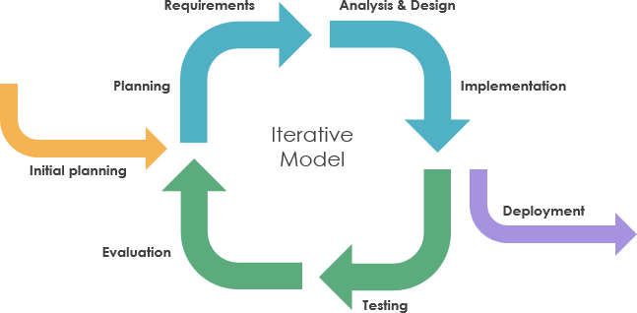

Fig. 2.5: Iterative Model
[Source: medium.com]

- Requirements Gathering and Analysis: In this phase, gathering and analyzing of the requirements for the system takes place. This includes identifying the needs of the users and stakeholders, and determining the features and functionality that the system must have.
- Planning: The team creates a plan for the development of the system. This includes estimating the time and resources required, and identifying the risks and challenges that the team may face.
- Design: The team designs the system architecture and user interface. This includes identifying the main components of the system and how they will interact with each other, and designing the screens and menus that users will see.
- Implementation: The team implements the system in small, incremental steps. Each increment should be a working product that can be tested and deployed to users.
- Testing: The team tests each increment of the system to ensure that it meets the requirements and that it is free of defects.
- Deployment: The team deploys the system to users and provides support for the system.
- Maintenance: The team maintains the system by fixing bugs and adding new features and functionality as needed.

  - Methodology

The development of the proposed work will be done as shown in the figure below:

    - Experimental Technique

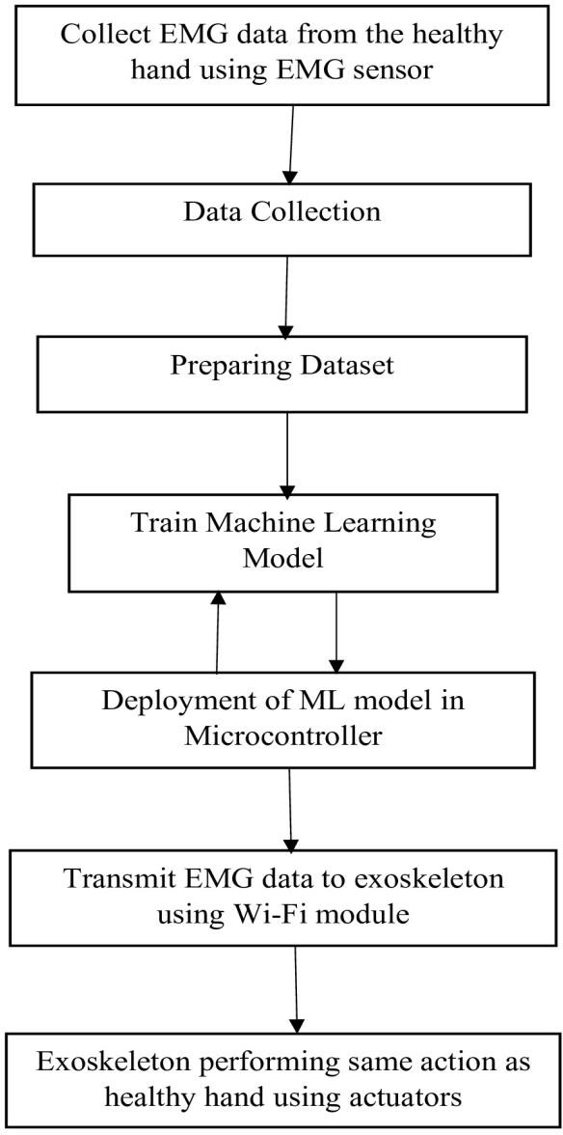

Fig. 2.6: Development of the Proposed System

Fig. 2.6. explains the work flow of the system. The system will take the real-time input will be taken from the healthy hand using EMG sensor. A machine learning model is prepared and trained to detect patterns in the collected data. The trained model is then deployed onto a microcontroller within the exoskeleton. Real-time EMG data from the healthy hand is transmitted to the exoskeleton via Wi-Fi, where it is processed by the model to control the exoskeleton's actuators, allowing it to mimic the movements of the healthy hand.

2.4 Algorithms

K Nearest Neighbor (k-NN)

K-NN is a supervised Machine Learning method used in classification and regression problems. It is used for pattern recognition and data mining. It is a non-parametric algorithm and does not make any assumptions about the underlying data distribution. To determine the nearest data point to the query point, the distance is calculated between the two point. The distance metrics form the decision boundaries, which partitions query points into different regions. Euclidean distance formula is commonly used to measure the distance.

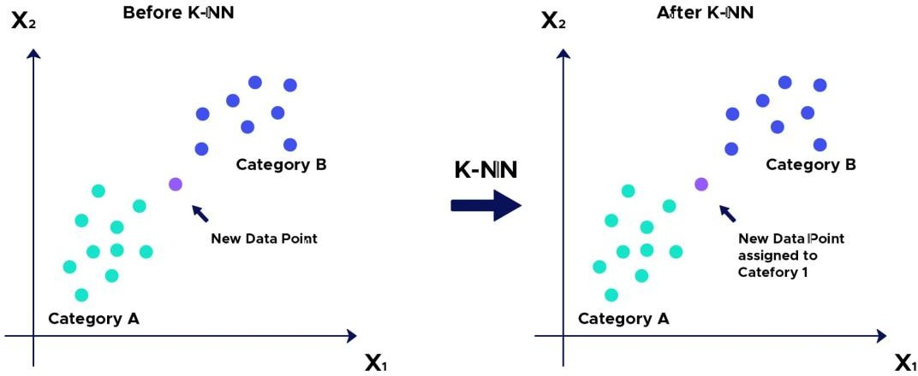

Fig. 2.7: K-NN Algorithm for Classification
[DataScientest.com]

2.5 Alternative Technique
Support Vector Machine (SVM)
Support Vector Machine is a supervised machine learning technique that classifies data by finding an optimal line or hyperplane to maximizes the distance between each class in an N-dimensional space. It can work for linear as well as non-linear classification, whereas for non-linear data, kernel functions are used to transform the high-dimension space to perform linear separation. The aim is to find the decision boundary that separates the data points of different classes.
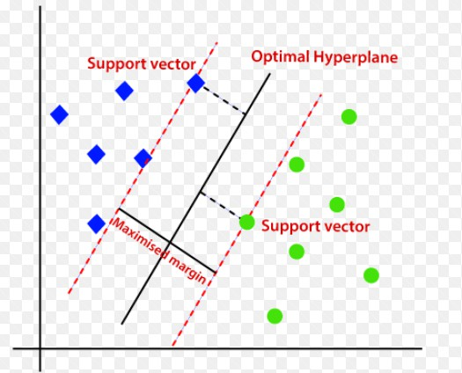

Fig. 2.8: Support Vector Machine
[Javatpoint.com]

Dr. Mrs. A. D. Sakhare Ankita Giroti
(Project Guide) Date: 15/10/2024

