Transmit EMG data to exoskeleton using Wi-Fi module
Deployment of ML model in Microcontroller
Train Machine Learning model
Preparing Dataset
Data Collection
Collect EMG data from the healthy hand using EMG sensor

Exoskeleton performing same action as healthy using actuators

Designing of the System

Converting Trained ML model using TensorFlow Lite
Exoskeleton performing same action as healthy using actuators
Rotate servo motors implemented on the device
Transmit data using ESP NOW protocol
Deployment of ML model in Microcontroller
Train ML model
Preparing Dataset
Data Collection through EMG sensor
Signal Processing

Transmitter (Wi-Fi module)
Signal
Conditioning Unit

Processing Unit
Sensors to detect hand movement
Real time input from hand
Fig.(a) Real time input from hand using sensor
Signal Conditioning Unit
Receiver
Actuator and Stimulator
Patient’s arm mimicking exact moves

Fig.(b) Patient’s hand replicating exact moves
Fig. Block Diagram of the Proposed System


Real time input taken from EMG sensor

Converting model into Tensorflow Lite
Muscle Onset/Offset Detection
Machine Learning Model

Microcontroller

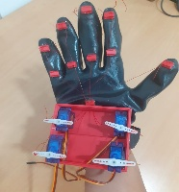
Microcontroller

Servo Motors for controlling exoskeleton
PCA9685 Servo Motor Driver

Transmitter Section
Real time input taken from EMG sensor

Converting model into TensorFlow Lite
Muscle Onset/Offset Detection
Machine Learning Model

Microcontroller

Receiver Section
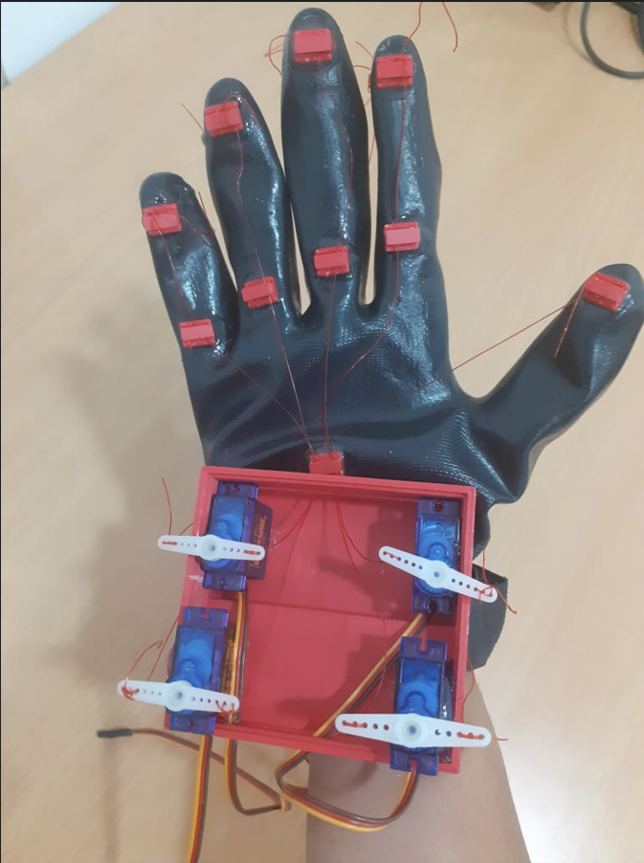
Microcontroller
Servo Motor Driver
Servo Motors for controlling exoskeleton

