Java Setup Instructions

JDK Version

Command used java -version
JDK Version Used: Java SE 21 (OpenJDK Temurin 21.0.4 LTS)

Hello World Program

A simple Hello World program was created and executed to verify the setup.
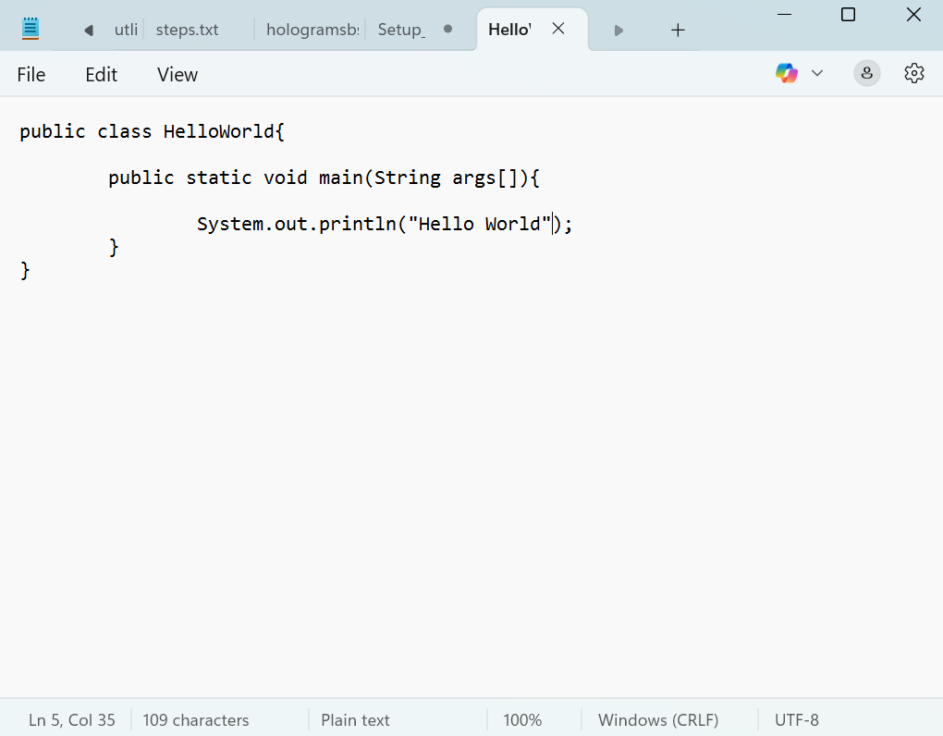
Output –
Hello World
The below Screenshot confirms that the Java development environment is set up correctly.
