1. Demonstrate that you have created Spark cluster

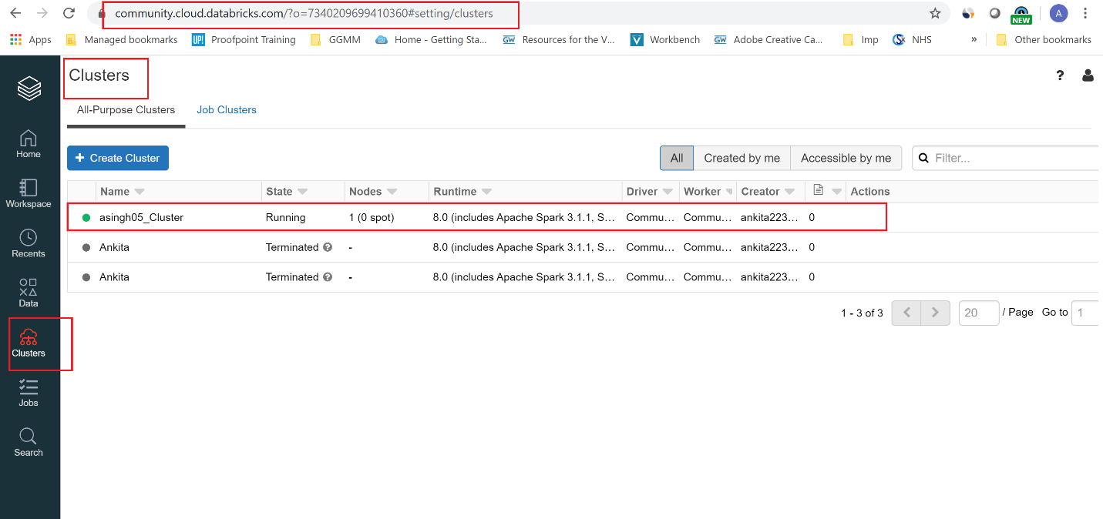

2. Demonstrate output of Step 6

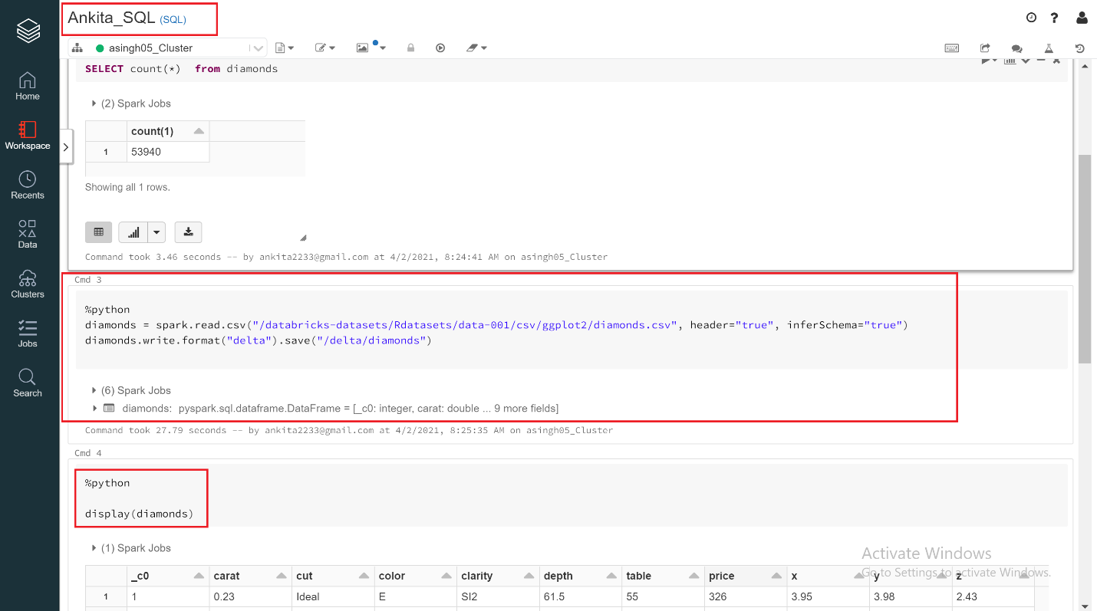

3. Demonstrate output of Step 12

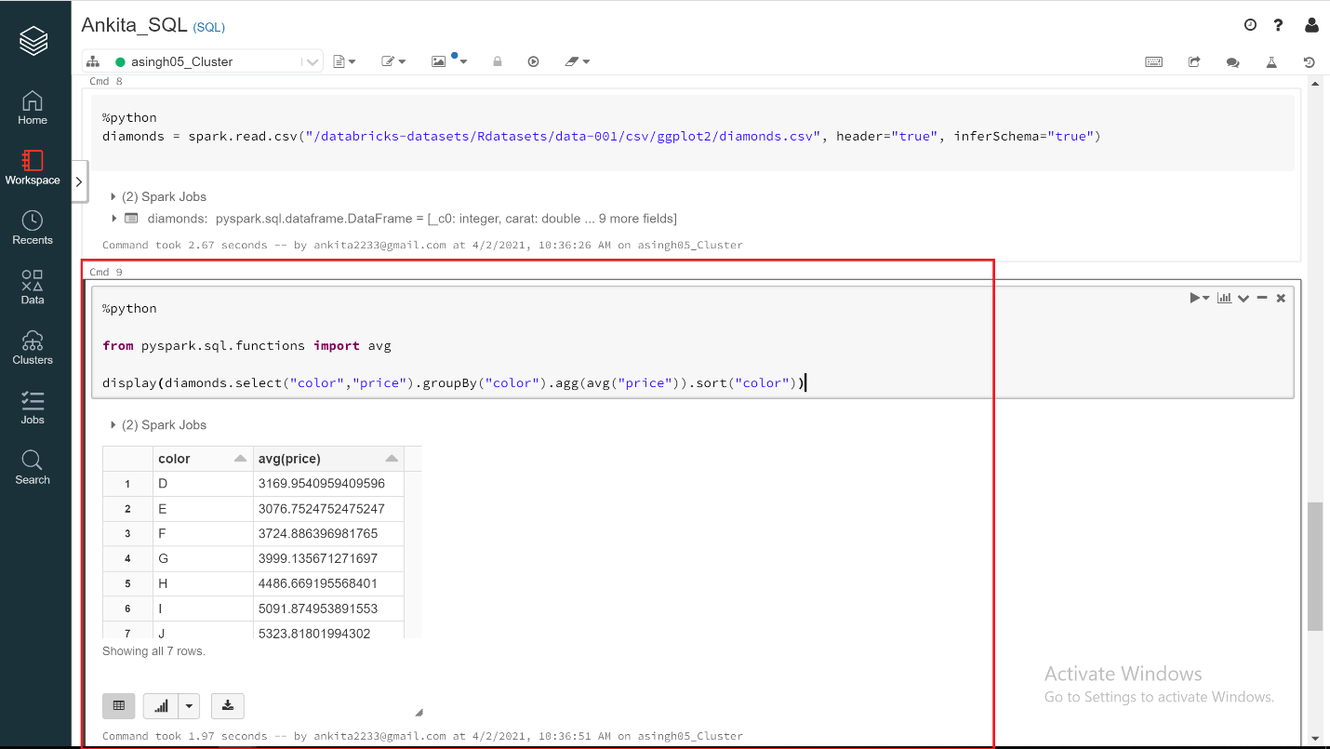

4. Demonstrate output of Step 16

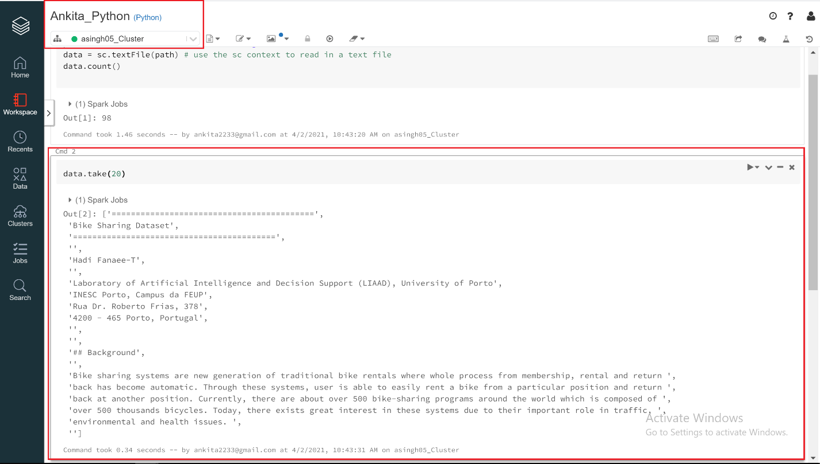

5. Demonstrate that you have loaded cogsley_sales into Spark

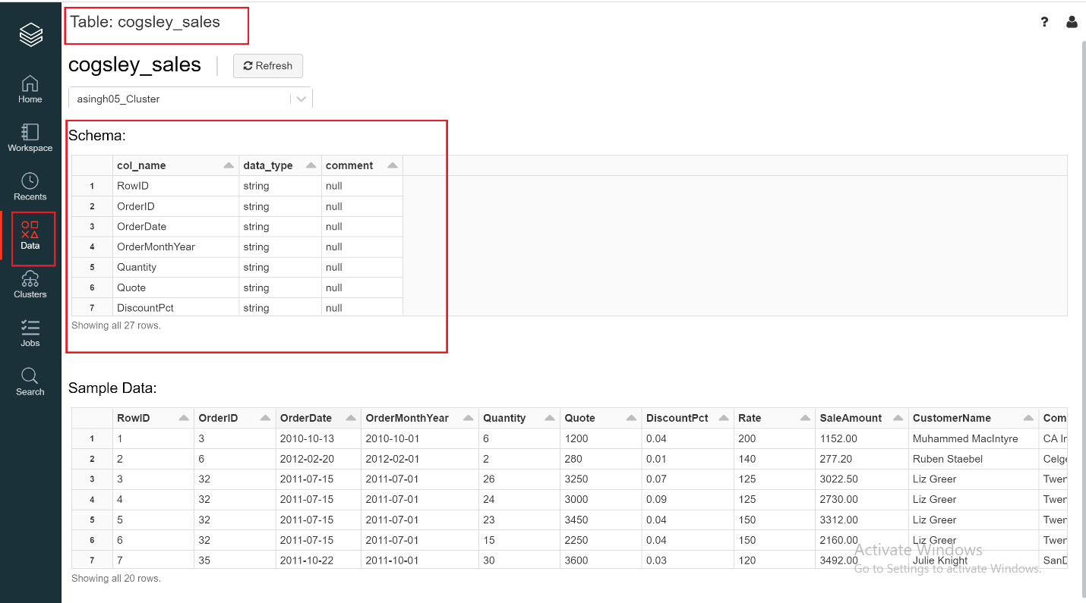

6. Demonstrate output of Step 24

