(1) Demonstrate that you have created DevOps Group in IAM

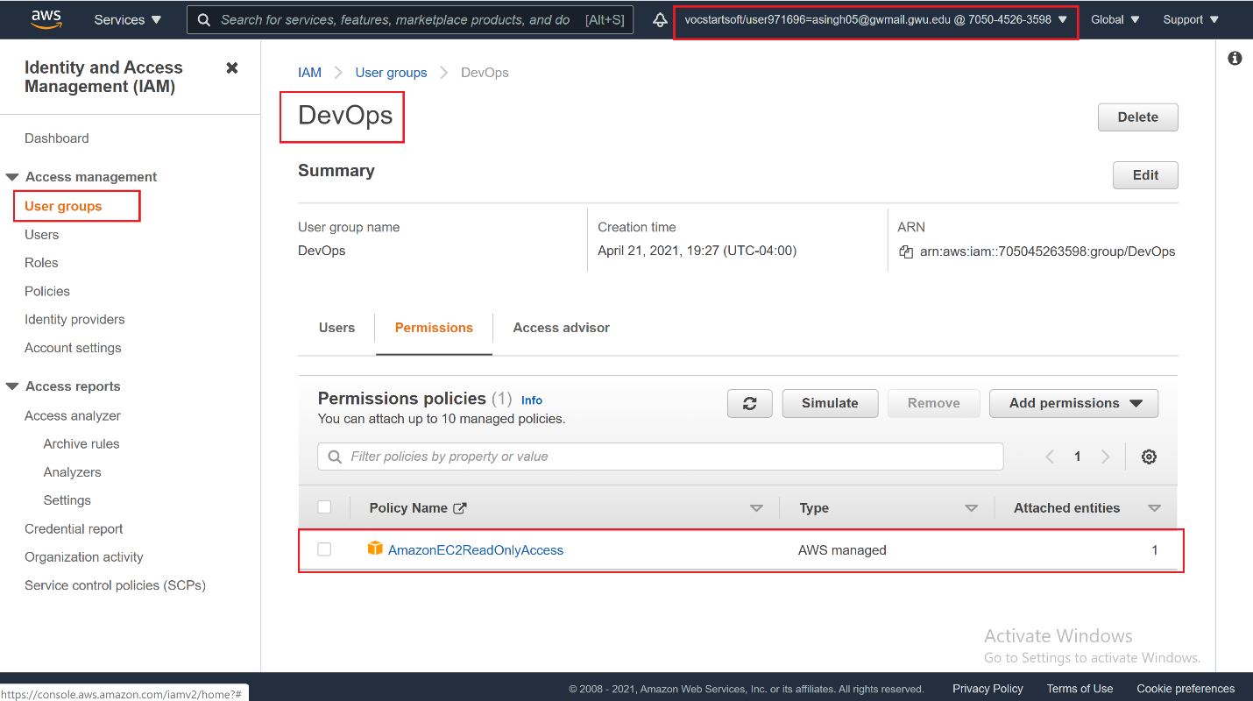

(2) Demonstrate that you have created an IAM user

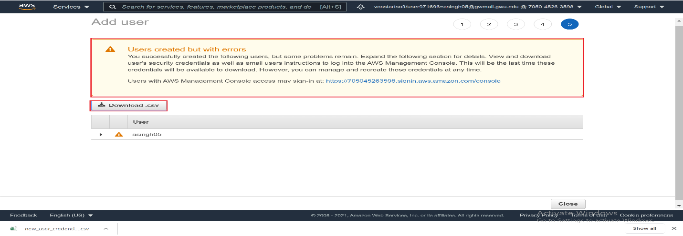

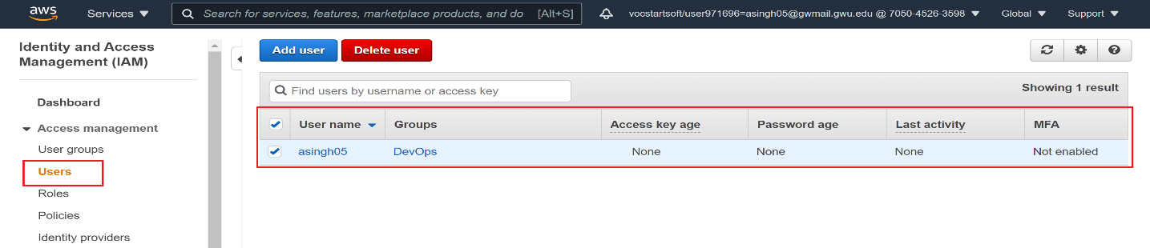

(3) Demonstrate that you have created Customer Managed Policy

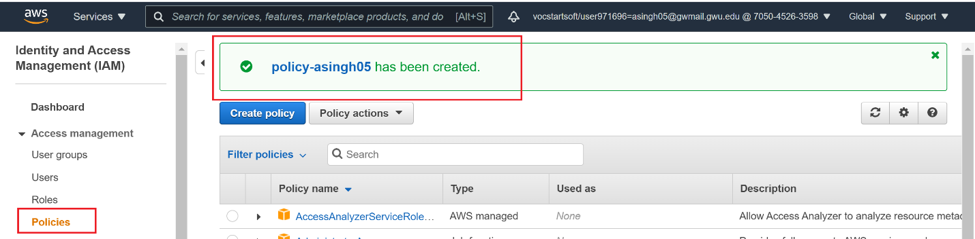

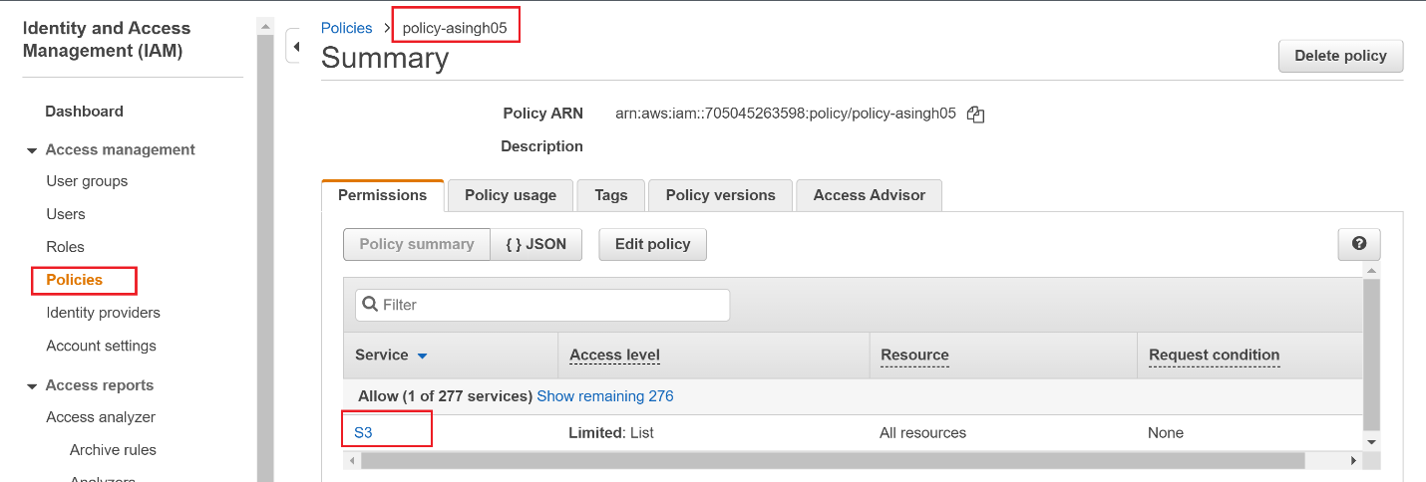

(4) Demonstrate that you attached policy to your user

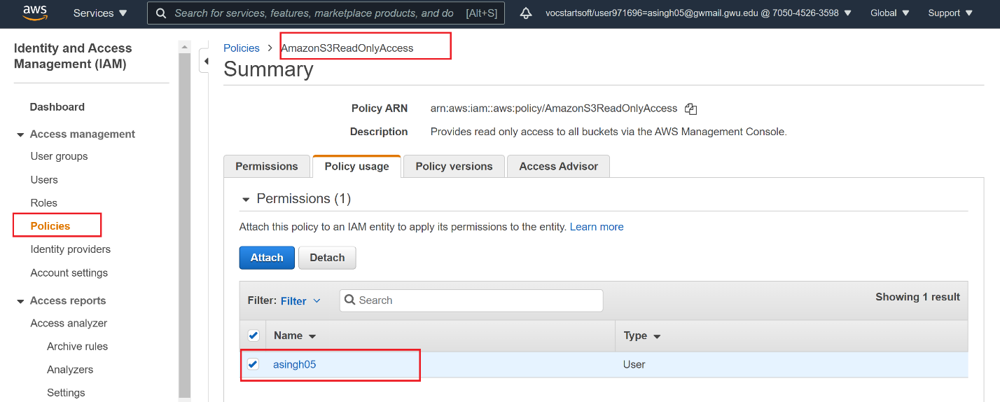

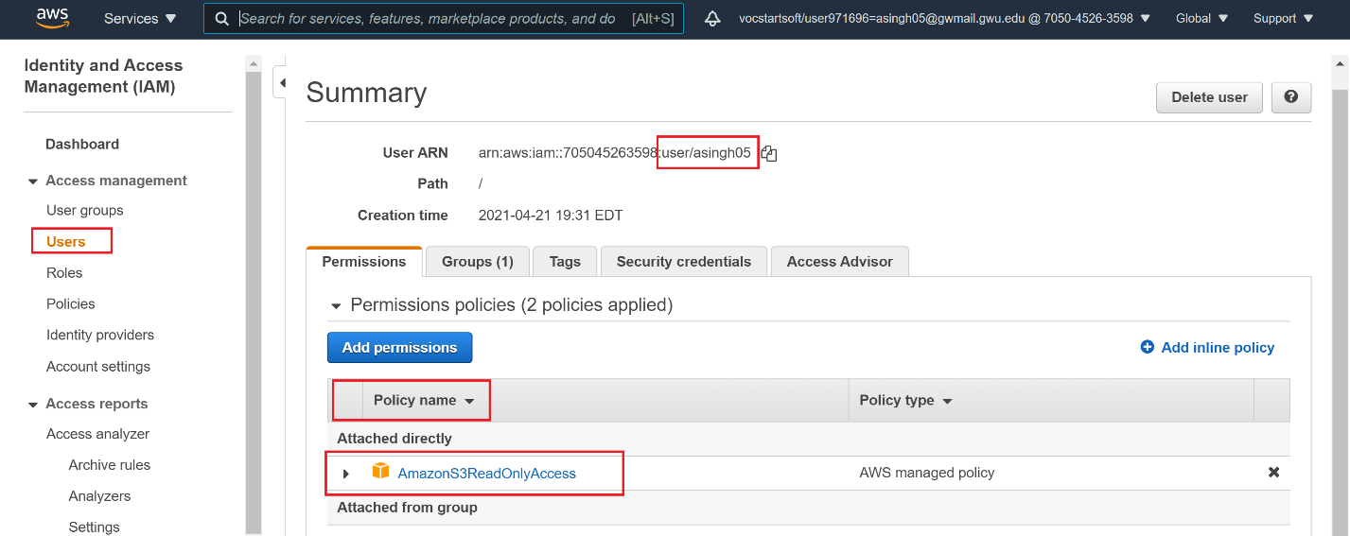

(5) Demonstrate that you created EC2 with your newly created role.

