1. Demonstrate that you have created MyTopic

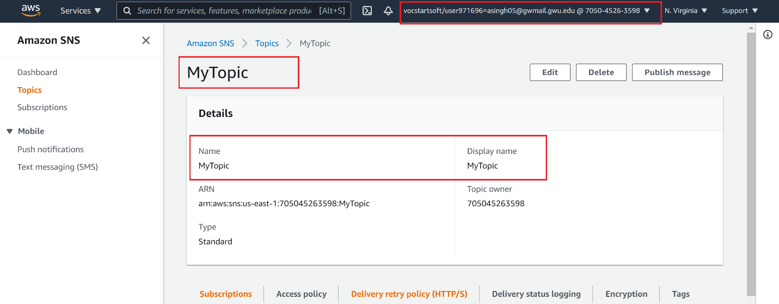

2. Demonstrate that you have subscribed to this topic and got a confirmation email

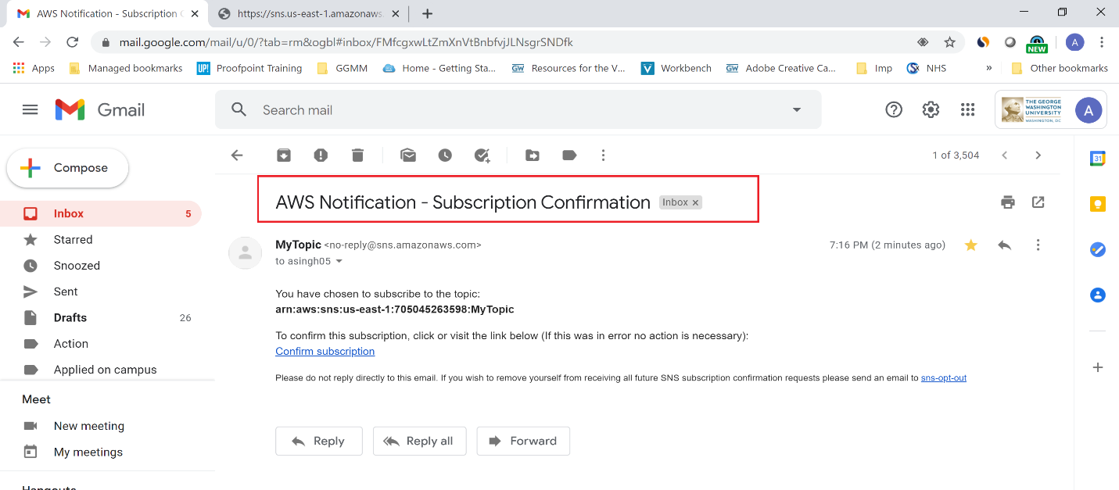

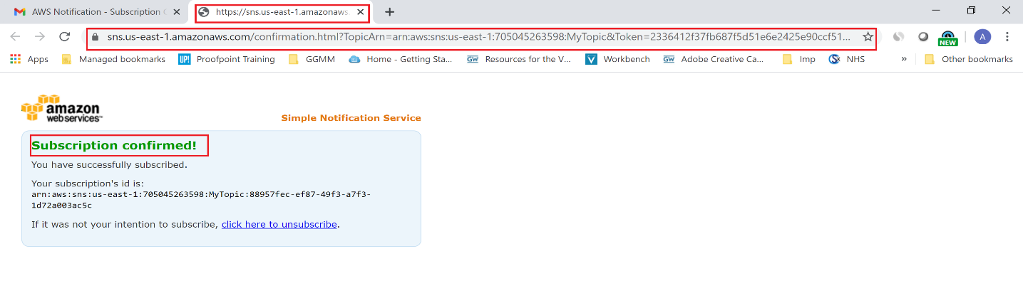

3. Demonstrate that you have crated custom Lambda function to test SNS

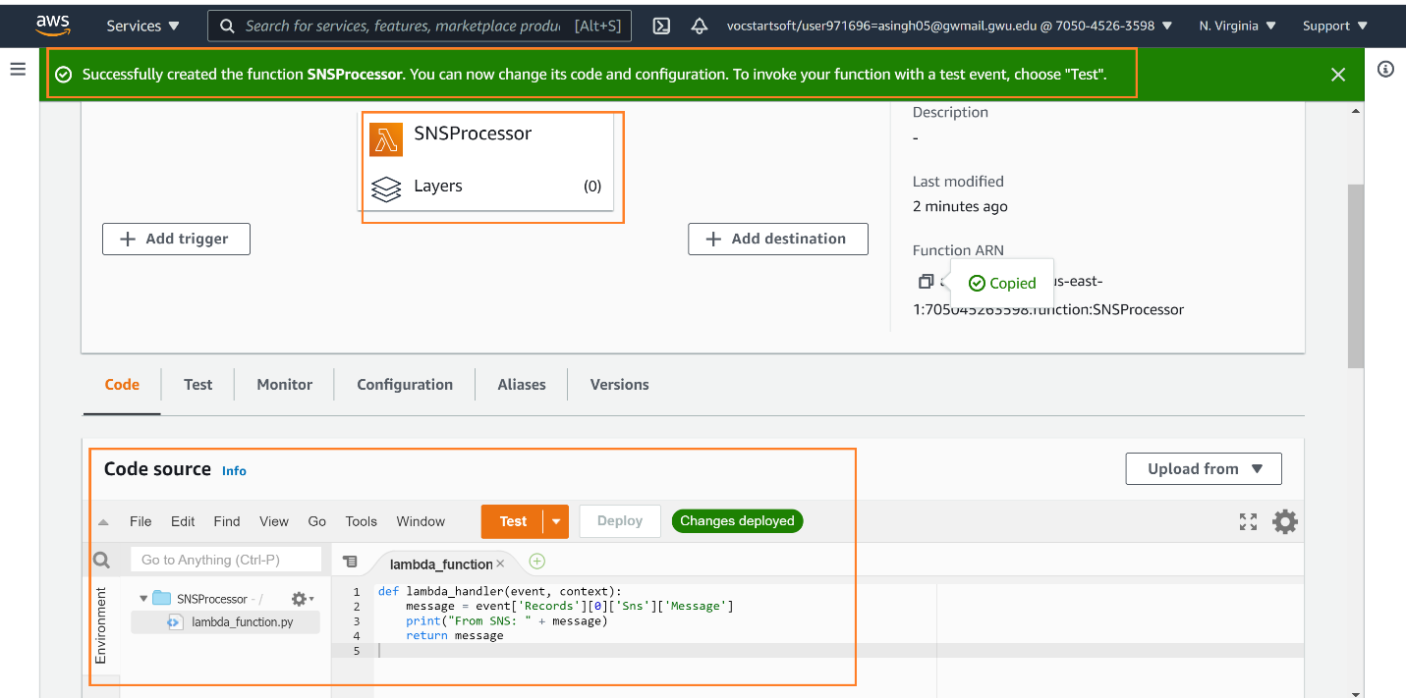

4. Demonstrate that you have modified message body to send custom email, sns and Lambda messages

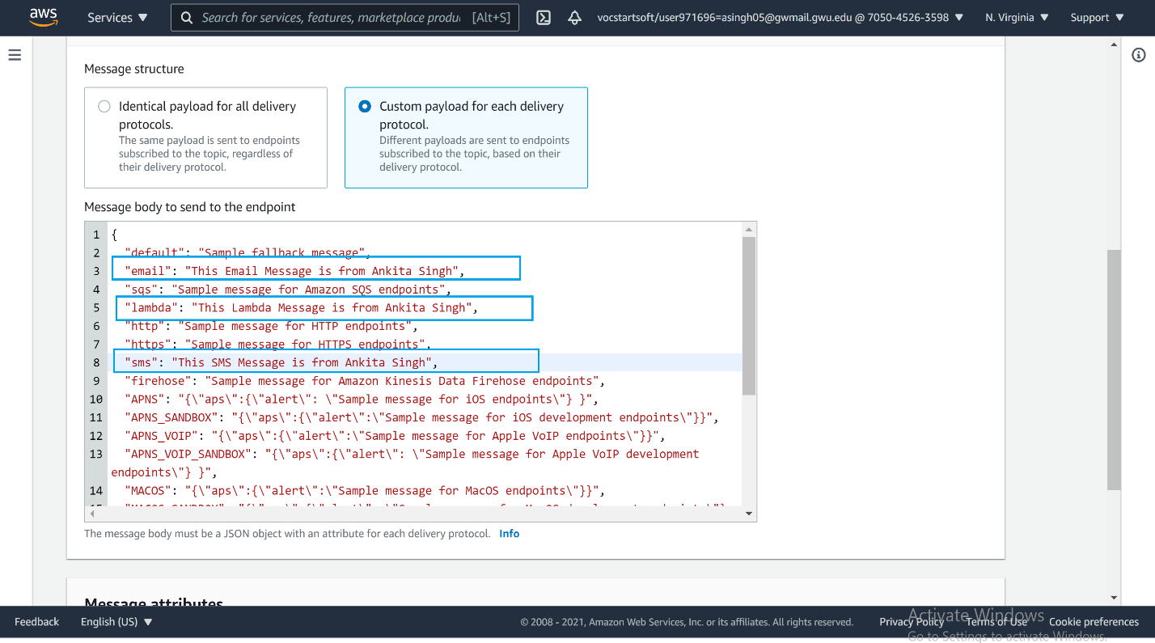

5. Demonstrate that you got email notification with the custom message

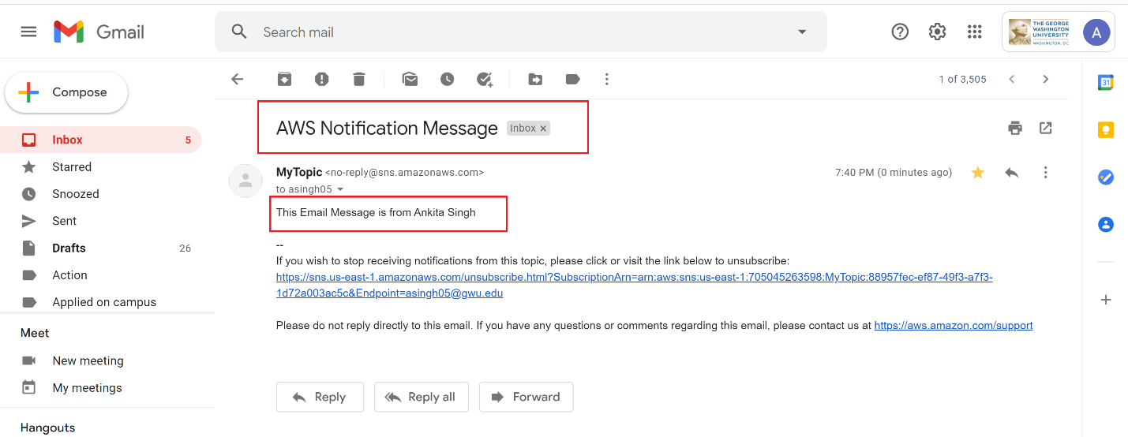

6. Demonstrate that you can see your custom message in the CloudWatch logs for the Lambda function

