**Interfaces**

Interfaces provide complete abstraction, containing only method declarations without implementations.

* interface is a keyword which is used to define User Defined Datatypes.
* Interfaces can be used to achieve **multiple inheritance in Java.**
* **Variables declared** in the interface are by default **public final and static**.
* Methods declared in the interface are by default **public and abstract.**
* Interface can contain the following members:
  1. public final static variables
  2. public abstract methods
  3. public static inner classes

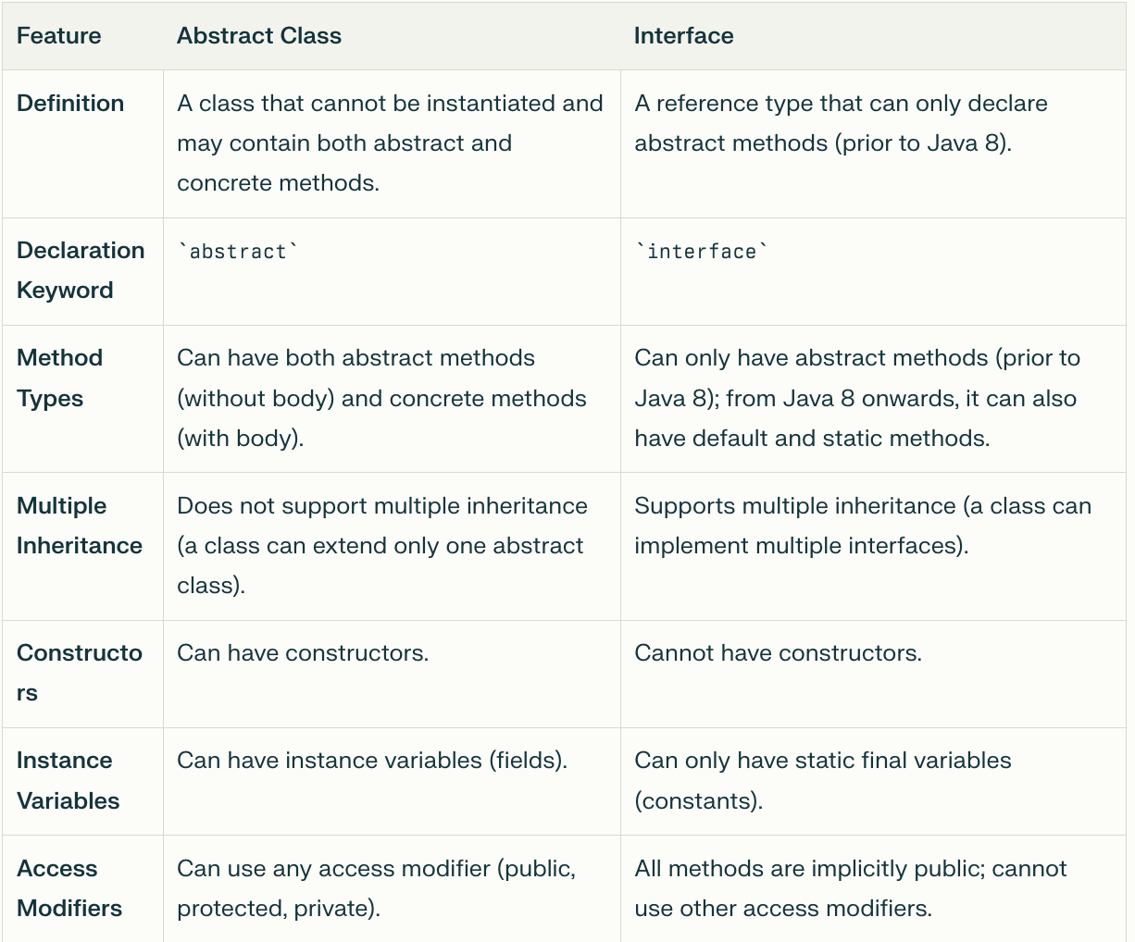

interface I11{}

interface I12{}

class A1{}

class B1{}

class Test1 extends A1{}

// class Test2 extends A1,B1{} // Multiple Interheirn in class is not allowed

class Test3 implements I11{}

class Test4 implements I12,I11{}

class Test5 extends A implements I11,I12{}

//class Test5 implements I11 extends A{}

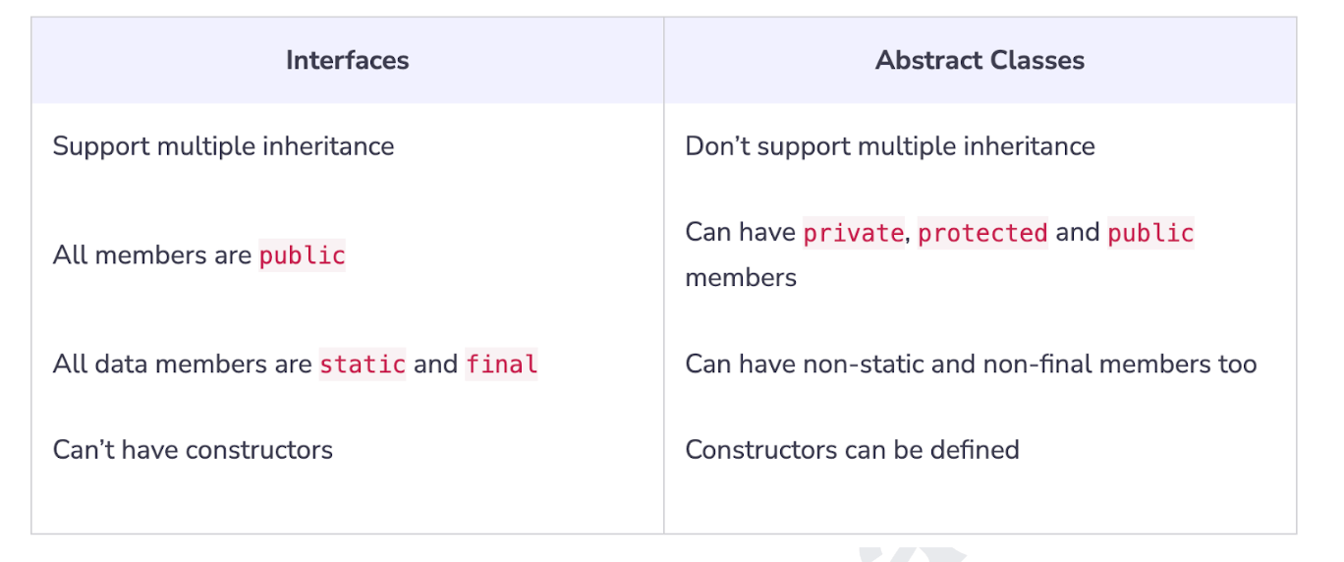

• Interface - implement, Class - Extent

• Interface is used to solve the problem of the multiple inheritance.