**Inheritance**

* Inheritance in Java is a **fundamental concept of object-oriented programmin**g that allows one class (the subclass) to inherit attributes and behaviour from another class.

**Single Inheritance:**

A class inherits from a single base class. (95%)

**Superclass | Parent Class | Father Class -** The class from which properties(A) and methods(B) are inherited.

CAB -> **C**lass contains - **A**ttributes + **B**ehaviour.

**Subclass | Child | Son -** The class that inherits from another class.

* **extends** **Keyword**: Used to indicate that a class is inheriting from another class.

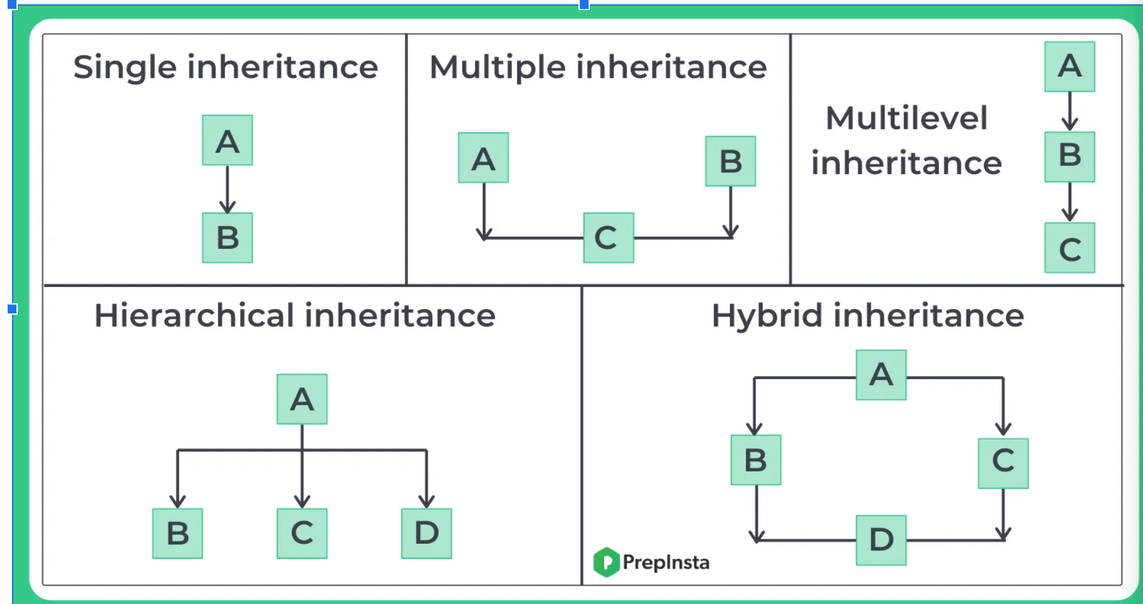

**Multiple Inheritance:**

* A class inherits from multiple base classes.
* In Java with class - multiple inheritance is not possible.
* Diamond problem -
* Only way to Solve by using the **Interface. (Data Type).**

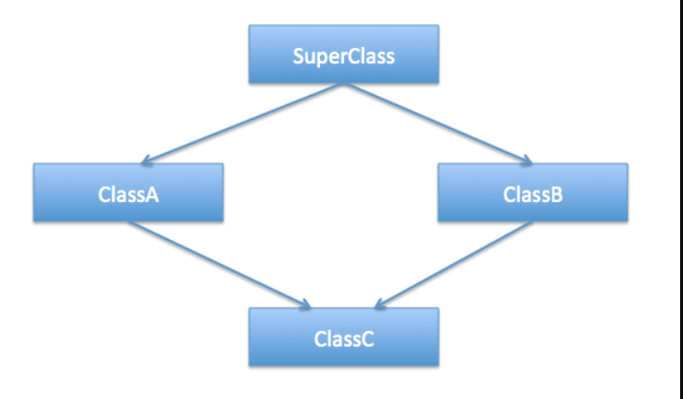

**Multilevel Inheritance:**

A class inherits from a derived class, forming a hierarchy of inheritance.

**Hierarchical Inheritance:**

Multiple derived classes inherit from a single base class.

Father - home -> Pramod, Lucky, Ruhani

**Hybrid Inheritance**

A combination of multiple inheritance and multilevel inheritance.

// Supported by using the Interfaces

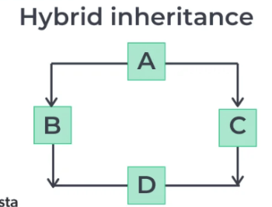

Calling method Preference

* If same method presents in child and parent class then on creation of child class object child class method will be called
* It always given preference to low level and moved to up level, if method is not present