Customer Shopping Behavior Analysis
End-to-End Data Analytics Project using Python, PostgreSQL & Power BI

1. Executive Summary
This project analyzes a retail customer shopping behavior dataset to identify purchasing trends, customer segments, product performance, and revenue opportunities. The workflow combines Python for exploratory data analysis (EDA), PostgreSQL for business query analysis, and Power BI for interactive dashboard creation.

2. Project Objectives
- Understand customer purchasing behavior.
- Identify high-performing products and categories.
- Measure the impact of subscriptions and discounts.
- Segment customers based on purchase history.
- Build an interactive dashboard for decision making.

3. Technology Stack
- Python (Pandas, NumPy, Matplotlib, Seaborn)
- PostgreSQL
- Power BI Desktop
- Jupyter Notebook / VS Code
- Git & GitHub

4. Dataset Summary
Dataset: Customer Shopping Behavior
Approximate Records: 3,900+
Key Columns:
• Customer ID
• Age
• Gender
• Item Purchased
• Category
• Purchase Amount (USD)
• Location
• Size
• Color
• Season
• Review Rating
• Subscription Status
• Shipping Type
• Discount Applied
• Promo Code Used
• Previous Purchases
• Payment Method
• Frequency of Purchases

5. Project Workflow
Raw CSV → Data Cleaning (Python) → Exploratory Data Analysis → PostgreSQL Database → SQL Business Queries → Power BI Dashboard → Business Insights & Recommendations

6. Exploratory Data Analysis (Python)

Dataset Overview
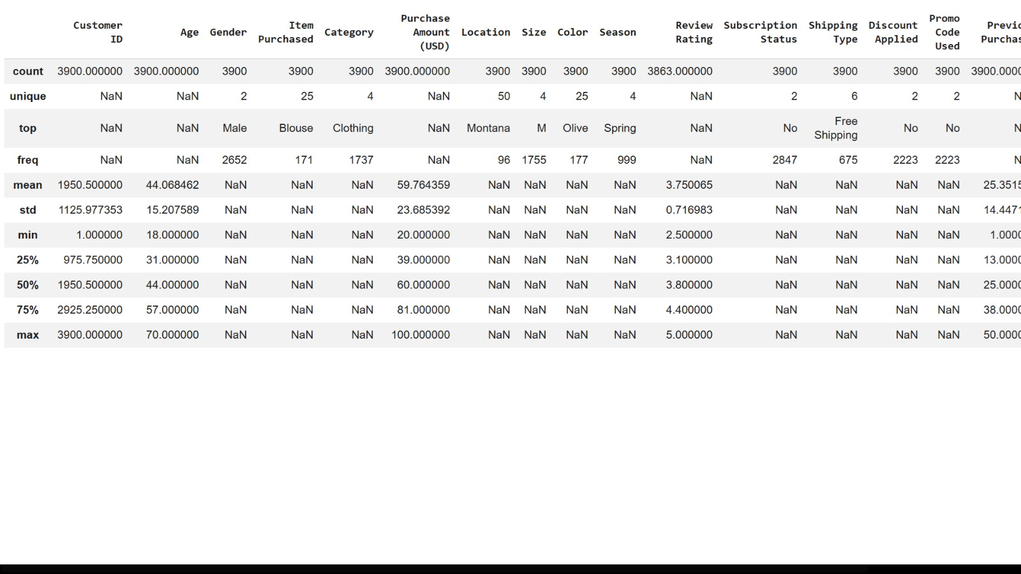
Observation
- Total records: 3,900
- Total features: 18
- Average customer age: 44 years
- Average purchase amount: $59.76
- Average review rating: 3.75
- Most customers are Male.
- Clothing is the most purchased category.

7. SQL Business Analysis

Q1. Total Revenue Generated by Gender
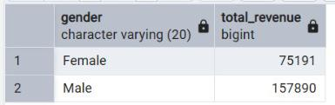
(Female: 75,191 | Male: 157,890)

Insight
Male customers generated significantly higher revenue than female customers, indicating a larger contribution to total sales.
Q2. Customers Using Discounts but Spending Above Average
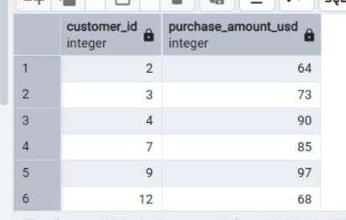
(customer_id and purchase_amount_usd table)

Insight
Several customers purchased above the average purchase amount despite receiving discounts, suggesting discounts successfully encouraged higher spending.
Q3. Top 5 Products with Highest Average Review Rating
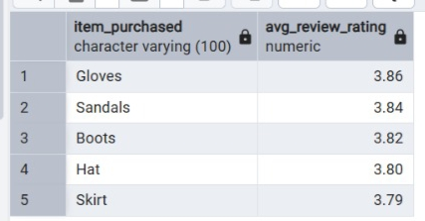
(Gloves, Sandals, Boots, Hat, Skirt)

Insight
Gloves received the highest average customer rating, followed closely by Sandals and Boots. These products demonstrate high customer satisfaction.

Q4. Average Purchase Amount by Shipping Type
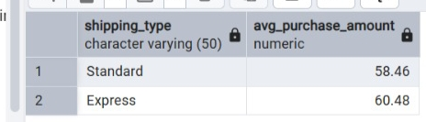
(Standard = 58.46, Express = 60.48)

Insight
Customers selecting Express Shipping spend slightly more than customers choosing Standard Shipping.

Q5. Subscriber vs Non-Subscriber Spending
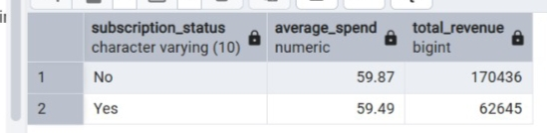
(Subscription Status table)

Insight
Although subscribers have a similar average purchase amount, non-subscribers contribute a larger share of total revenue due to their higher customer count.

Q6. Products with Highest Discount Usage
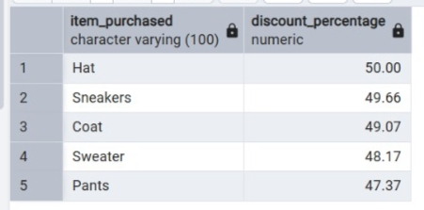
(Hat, Sneakers, Coat, Sweater, Pants)

Insight
Hat purchases received discounts most frequently, followed by Sneakers and Coats.

Q7. Customer Segmentation
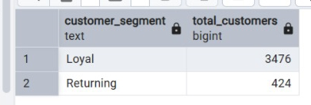
(Loyal = 3476, Returning = 424)

Insight
The majority of customers are Loyal customers, indicating strong customer retention.

Q8. Top 3 Products Purchased in Each Category
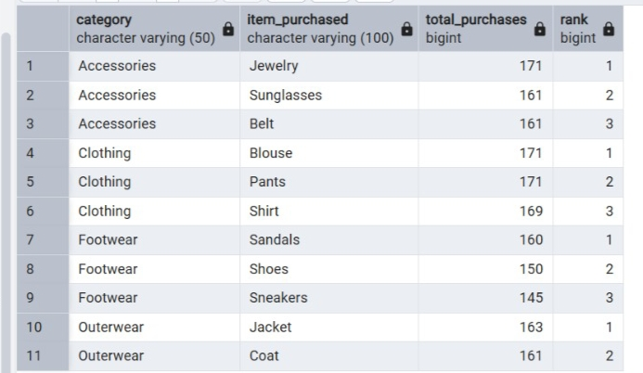
(Category-wise ranking table)

Insight
Jewelry, Blouse, Sandals, and Jackets dominate their respective product categories.

Q9. Repeat Buyers and Subscription Status
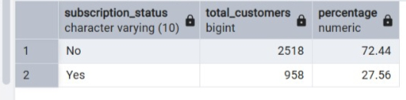
(72.44% No | 27.56% Yes)

Insight
Most repeat buyers are still non-subscribers, suggesting an opportunity to convert loyal customers into subscription members.
Q10. Revenue Contribution by Age Group
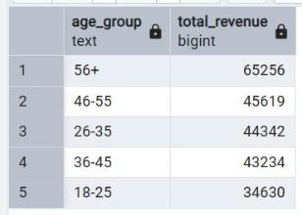
(56+, 46–55, 26–35...)

Insight
Customers aged 56+ contribute the highest revenue, followed by the 46–55 age group.

8. Power BI Dashboard
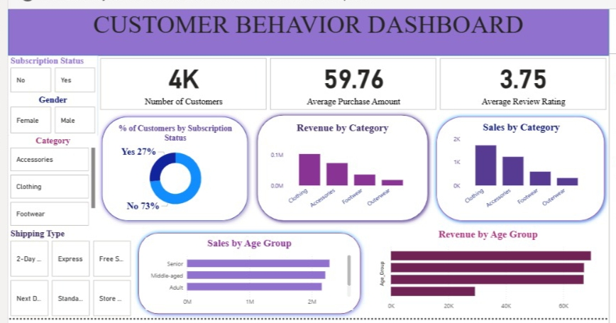

Dashboard KPIs
- Total Customers: 4K
- Average Purchase Amount: 59.76 USD
- Average Review Rating: 3.75

Dashboard Visuals
- Revenue by Category
- Sales by Category
- Revenue by Age Group
- Sales by Age Group
- Subscription Distribution
- Interactive Filters:
  - Gender
  - Subscription Status
  - Category
  - Shipping Type

Dashboard Insights
- Clothing generates the highest revenue.
- Senior customers contribute the largest revenue share.
- Only 27% of customers are subscribers.
- Clothing has the highest number of purchases.
- Interactive slicers allow detailed customer segmentation.

9. Key Business Insights
- Clothing contributes the highest sales and revenue.
- Adults and middle-aged customers generate the largest revenue share.
- Subscribers generally contribute higher revenue than non-subsscribers.
- Products with higher ratings tend to perform better.
- Discount campaigns improve customer purchases.
- Repeat buyers show stronger subscription adoption.

10. Business Recommendations
- Strengthen loyalty and membership programs.
- Target marketing campaigns toward high-value customer segments.
- Promote highly-rated products more aggressively.
- Offer personalized recommendations using previous purchase history.
- Optimize discount campaigns based on product performance.
- Improve inventory planning for top-selling categories.

11. Conclusion
The project demonstrates a complete analytics pipeline from raw data to executive dashboard. It showcases practical skills in Python, SQL, PostgreSQL, Power BI, business intelligence, and storytelling, making it suitable for a professional data analyst portfolio.

12. Future Scope
- Build predictive models for customer lifetime value.
- Develop churn prediction using machine learning.
- Create recommendation systems.
- Automate dashboard refresh using Power BI Service.

