**Problem Statement:**

* **Task 1**

Check whether **/user/acadgild/hadoop** directory exists or not in the HDFS

If it doesn’t exist, then create this.

Create a directory **/user/acadgild/hadoop**

**Solution:**

Checking whether **/user/acadgild/hadoop** directory exists in the HDFS or not by using following command:

Syntax: **$ hadoop fs –ls**

If there is no directory named **/user/acadgild/hadoop** then

Creating a new directory called **“/user/acadgild/hadoop”** by using following command:

Syntax: **$ hadood fs -mkdir /user/acadgild/hadoop**

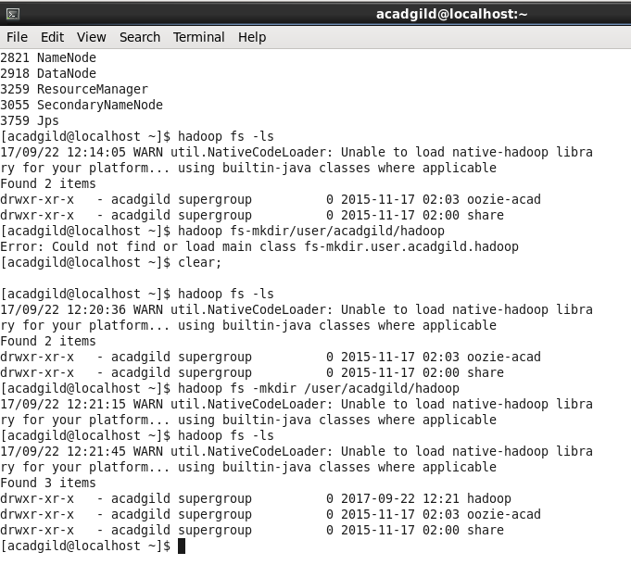

* **Task 2**

Create a file in HDFS Under directory /user/acadgild/hadoop, with name **word-count.txt** whatever we type on the screen should get appended to the file.

Try to type (on screen) few lines from any online article or textbook.

**Solution:**

Creating the file **word-count.txt**

Syntax: **$hadoop fs -touchz /user/acadgild/hadoop/word-count.txt**

Appending the text which is typed on screen to the file

Syntax: **$ echo “text” |hadoop fs -appendToFile - /user/acadgild/hadoop/word-count.txt**

Showing the **“word-count.txt”** contents

Syntax: **$ hadoop fs -cat /user/acadgild/hadoop/word-count.txt**

