**Problem Statement:**

* **Task 3**

Create a file max-temp.txt in local FS

Put some 10-15 records of date and temperature Example:

dd-mm-yyyy, temperature

Example:

10-01-1990, 10

10-02-1990, 20

Move this file to HDFS at /user/acadgild/hadoop.

**Solution:**

Create a file **“max-temp.txt”** in the local file system.

Syntax: **$ vi max-temp.txt**

Inserting date and temperature details in **“max-temp.txt”**

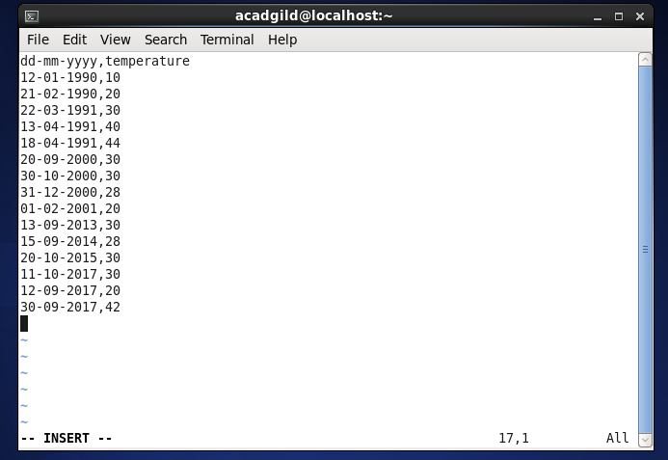

File **“max-temp.txt”** created in local file system.

Syntax: **$ ls**

Moving the file **“max-temp.txt”** from local file system to HDFS.

Syntax: **$ hadoop fs -copyFromLocal max-temp.txt /user/acadgild/hadoop**

Checking **“max-temp.txt”** file in HDFS is present or not using ls command,

Syntax: **$ hadoop fs -ls/user/acadgild/hadoop**

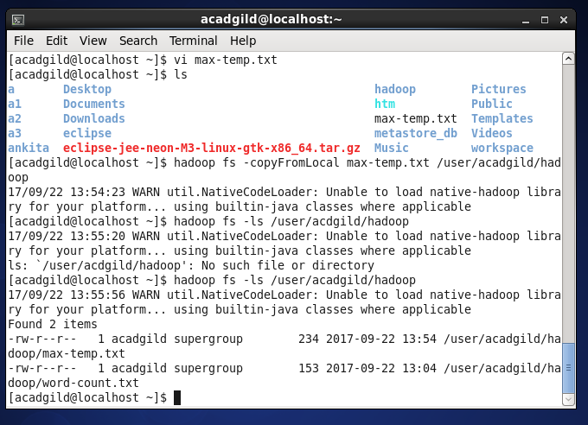

**Checking “max-temp.txt”** file contents in HDFS, using cat command

Syntax: **$ hadoop fs -cat /user/acadgild/hadoop/max-temp.txt**

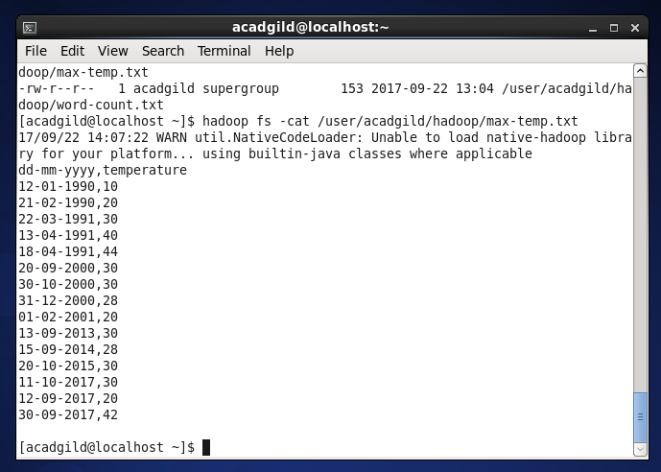

* **Task 4**

Change the permission of the file /user/acadgild/hadoop/max-temp.txt, such that

Only the owner and the group have full control over the file.

Others do not have any control over it.

**Solution:**

Showing default file permission of file **“max-temp.txt”**

Syntax: **$hadoop fs -ls /user/acadgild/hadoop**

Changing the user rights to have full permission i.e. Read, Write and execute

Syntax: **$ hadoop fs -chmod u+x /user/acadgild/hadoop/max-temp.txt**

Changing the group rights to have full permission i.e. Read, Write and execute

Syntax: **$ hadoop fs -chmod g+wx /user/acadgild/hadoop/max-temp.txt**

Changing the others rights to have no permission at all i.e. Read, Write and execute

Syntax: **$ hadoop fs -chmod o-r /user/acadgild/hadoop/max-temp.txt**

