**Problem Statement:**

Download and Import Acadgild Spark VM in the Oracle Virtual Box and share screenshot of imported Acadgild Spark VM.

**Acadgild Spark VM Installation:**

Open Virtual Box, Clicking on Import Appliance and Selecting the Acadgild VM for Sparkfrom location on file system and imported started.

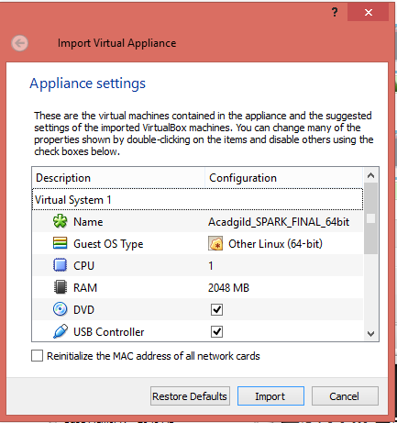

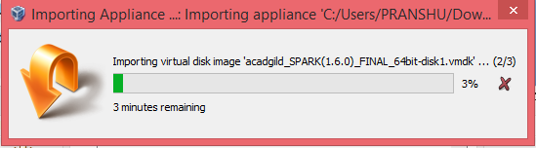

**Output:** Imported Acadgild Spark VM

