**Problem Statement**

Create a list of tuples, where the 1st element of the tuples is an int and the second element is a string.

Example - ((1, ‘alpha’), (2, ‘beta’), (3, ‘gamma’), (4, ‘zeta’), (5, ‘omega’))

* For the above list, print the numbers where the corresponding string length is 4
* Find the average of all numbers, where the corresponding string contains alphabet ‘m’ or alphabet ‘z’

**Solution:**

* print the numbers where the corresponding string length is 4

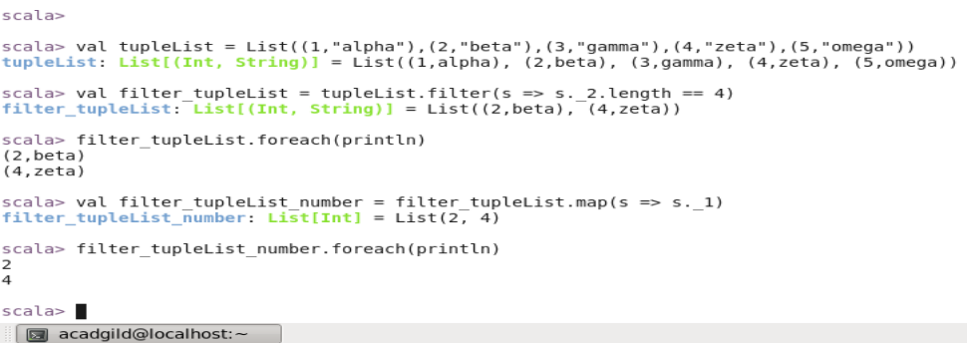

* Find the average of all numbers, where the corresponding string contains alphabet ‘m’ or alphabet ‘z’

