**Problem statement**

Create a database named ‘custom’

Create a table named temperature_data inside custom having following fields:

1. date (mm-dd-yyyy) format

2. zip code

3. temperature

The table will be loaded from a comma-delimited file.

Load the dataset.txt (which is ‘,’ delimited) in the table.

**Solution:**

**Starting sudo hive and creating the database ‘custom’**

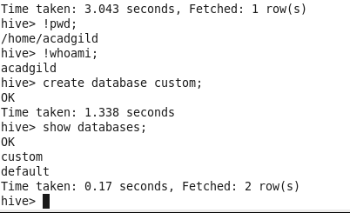

**Creating table ‘temperature_data’ in hive**

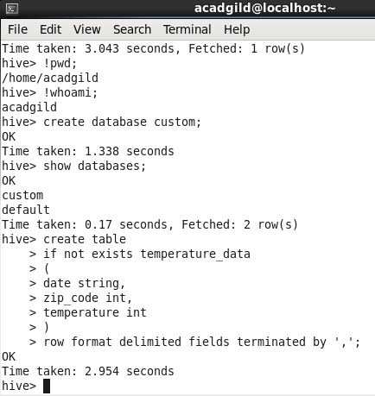

**Load ‘dataset.txt’ into the newly created table ‘temperature_data’**

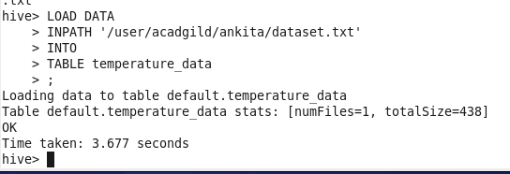

**Executing select query on the table ‘temperature_data’**

