**Problem Statement:**

* **Fetch date and temperature from temperature_data where zip_code is greater than 300000 and less than 399999.**

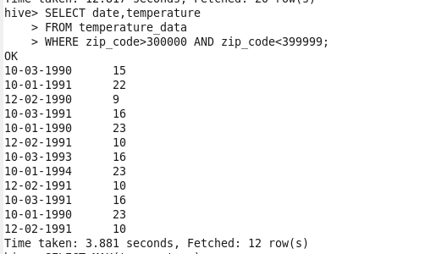

* **Calculate Maximum temperature corresponding to every year from temperature_data table.**

**For YEAR 1990**

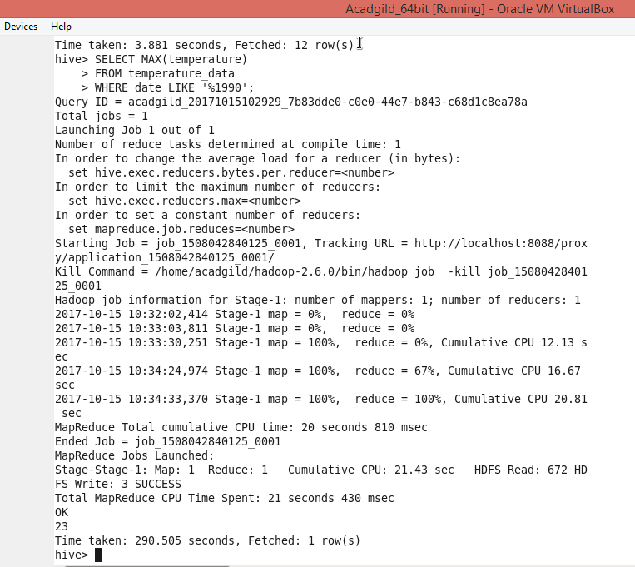

**For YEAR 1991**

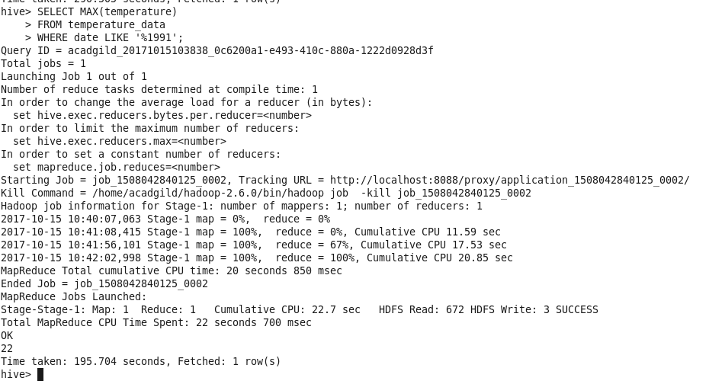

**FOR YEAR 1993**

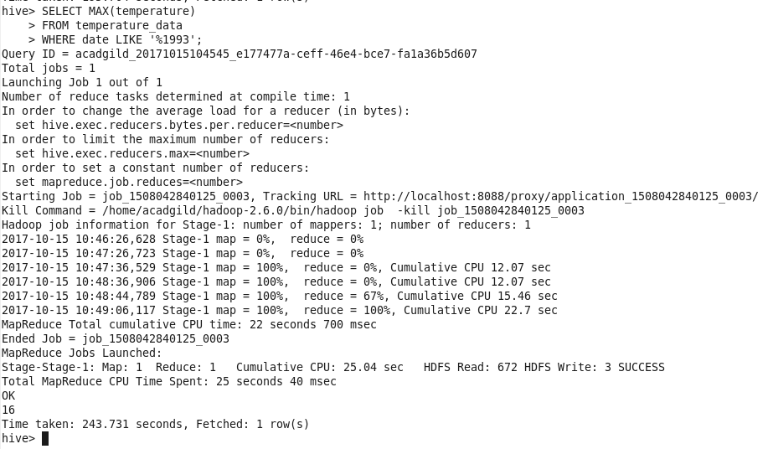

**FOR YEAR 1994**

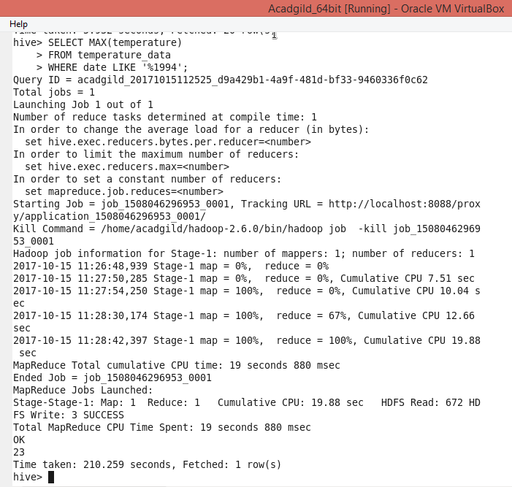

* **Calculate maximum temperature from temperature_data table corresponding to those years which have at least 2 entries in the table.**

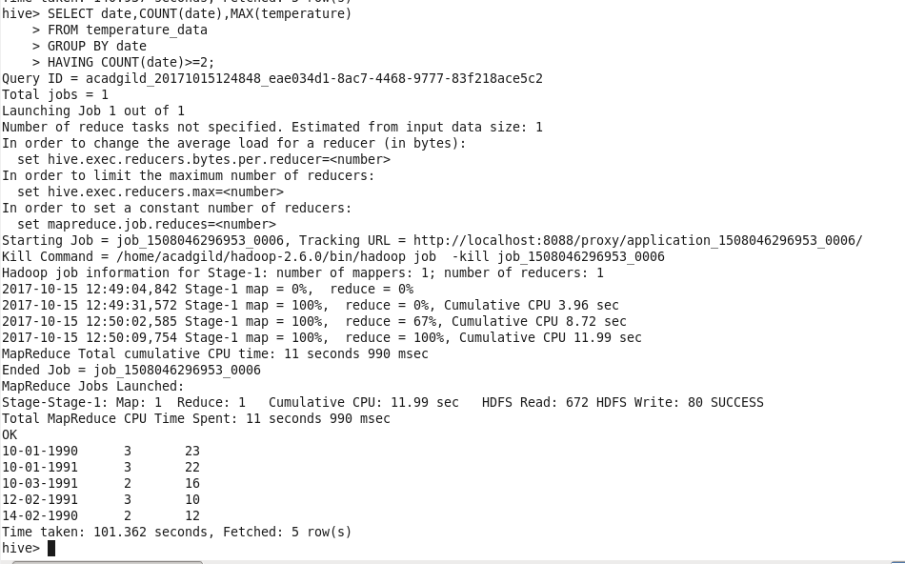

* **Create a view on the top of last query, name it temperature_data_vw**

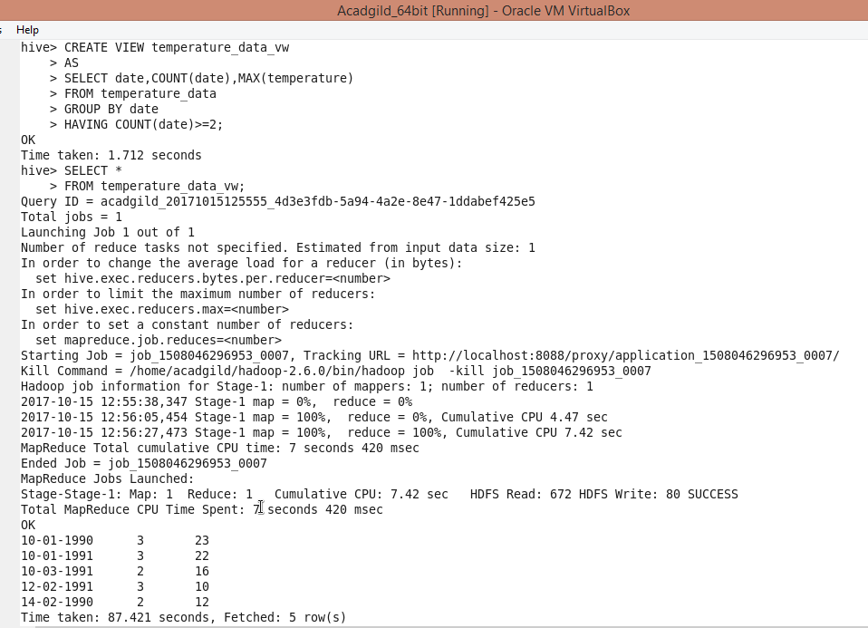

* **Export contents from temperature_data_vw to a file in local file system, such that each file is ‘|’ delimited**

