**Problem Statement**

*Calculate the number of employees corresponding to each skill from the table 'employee' which is loaded in the Demo.*

**Solution:**

Creating directory **Assignment7_1** in directory **ankita**

Copying **emp_details.txt** to directory **Assignment7_1/employee**

Showing **employee** contents

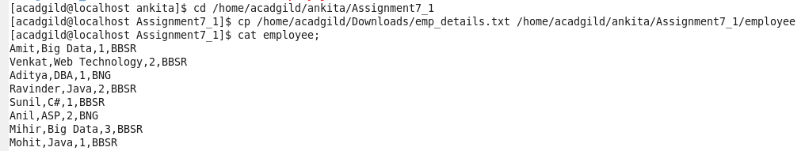

Starting **Hive**



Showing databases and Creating Database employee and using database employee and Creating Table employee

**hive> use employee  
hive>set hive.cli.print.current.db=true;**

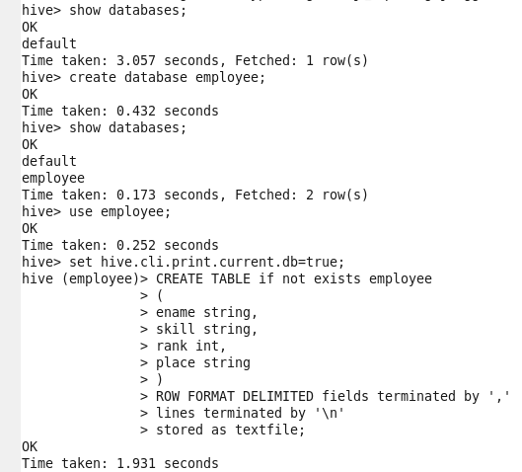

Load the data from ‘employee’ into table employee.



Showing data of table employee

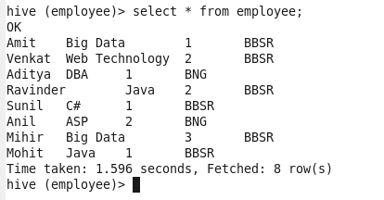

Calculating the number of employees corresponding to each skill from the table ‘employee’

