**Problem Statement**

Data set is about Olympics. You can download the data set from the below link:

<https://drive.google.com/open?id=0ByJLBTmJojjzV1czX3Nha0R3bTQ>

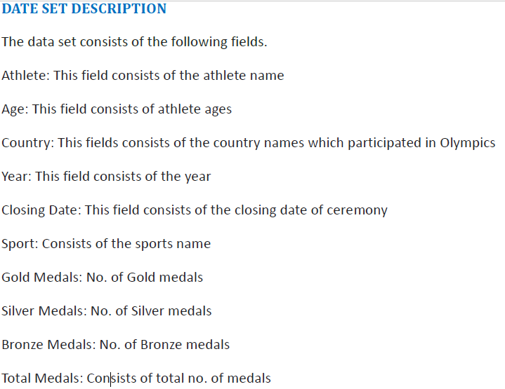

Creating a database in Hive named Olympics and creating a table named Olmpics and loading olympix_data.csv dataset into the table

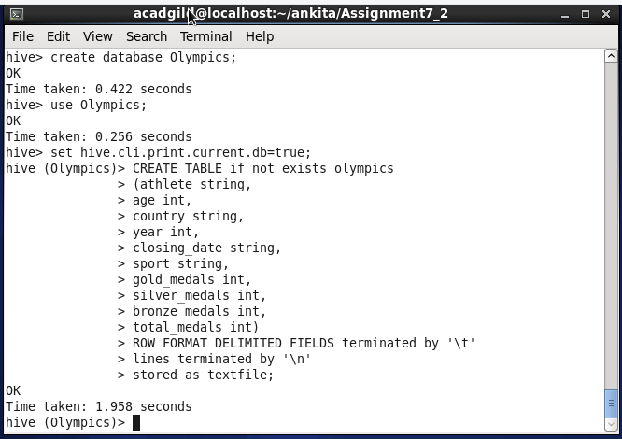

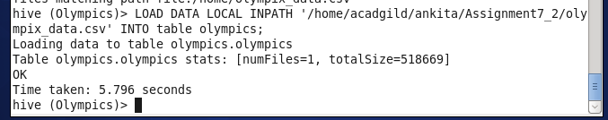

1. Write a Hive program to find the number of medals won by each country in swimming.

**Solution:**

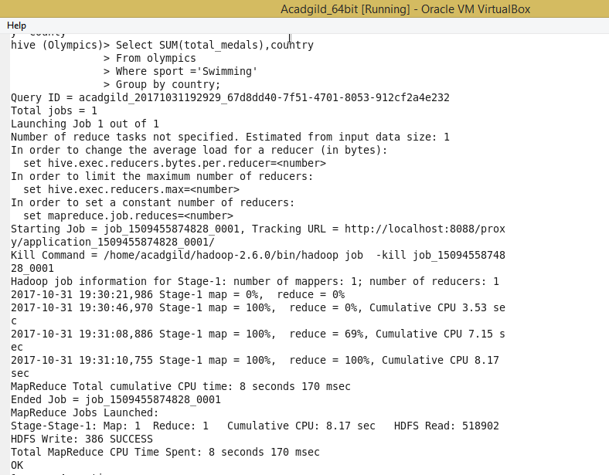

**Output:**

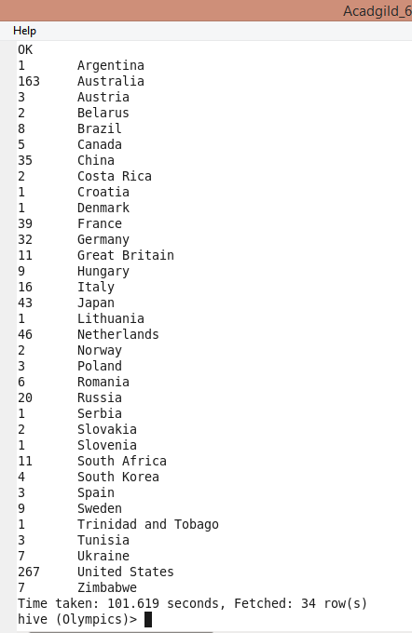

1. Write a Hive program to find the number of medals that India won year wise.

**Solution:**

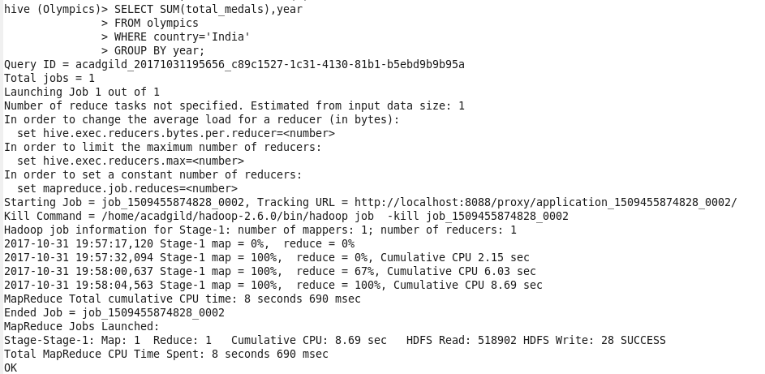

**Output:**

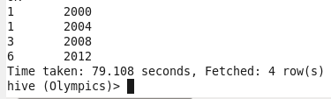

1. Write a Hive Program to find the total number of medals each country won.

**Solution:**

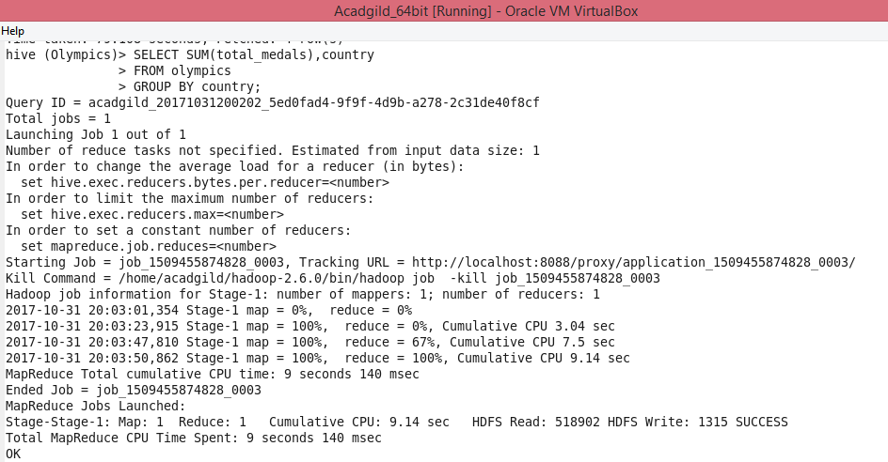

**Output:**

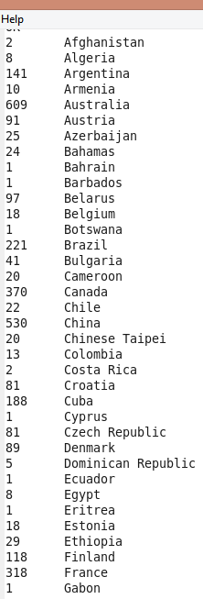 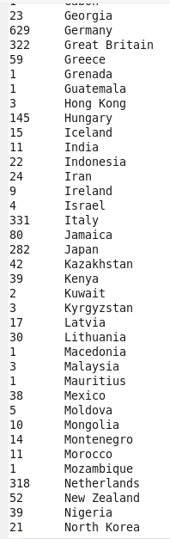 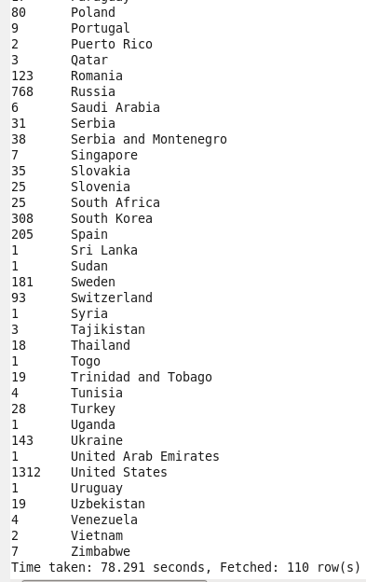

1. Write a Hive program to find the number of gold medals each country won.

**Solution:**

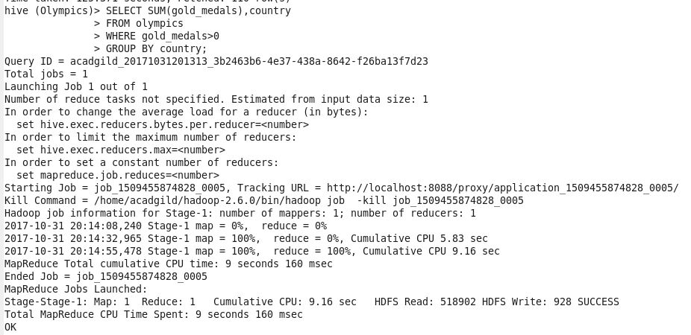

**Output:**

