**Problem Statement:**

* Get a list of employees who receive a salary less than 100, compared to their immediate employee with higher salary in the same unit
* List of all employees who draw higher salary than the average salary of that department

**Solution:**

Created a directory Assignment8_1 where I copied Emp_Sal.txt dataset.

Started all the daemons and the mysql service Required for Hive.

Started Hive.

Setting print header to true. Prints Column Headers.

Created table ‘Employee_Salary’ with fields for employee ID, Name, Salary and Department.

Loaded the dataset Emp_Sal.txt into the table Employee_Salary from the Local FS.

Checking to see if the data has been loaded properly by using the **SELECT** command

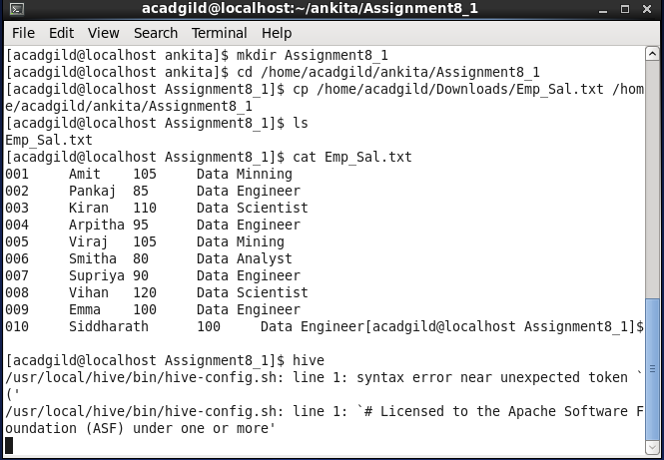

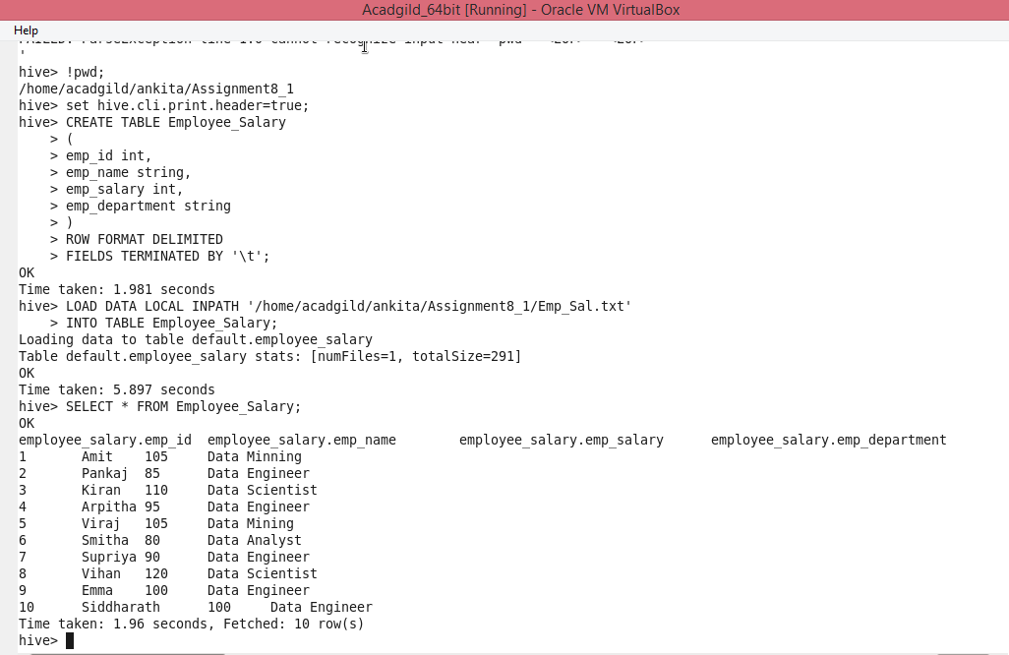

**Problem1:**

**Get a list of employees who receive a salary less than 100, compared to their immediate employee with higher salary in the same unit**

**Output:**

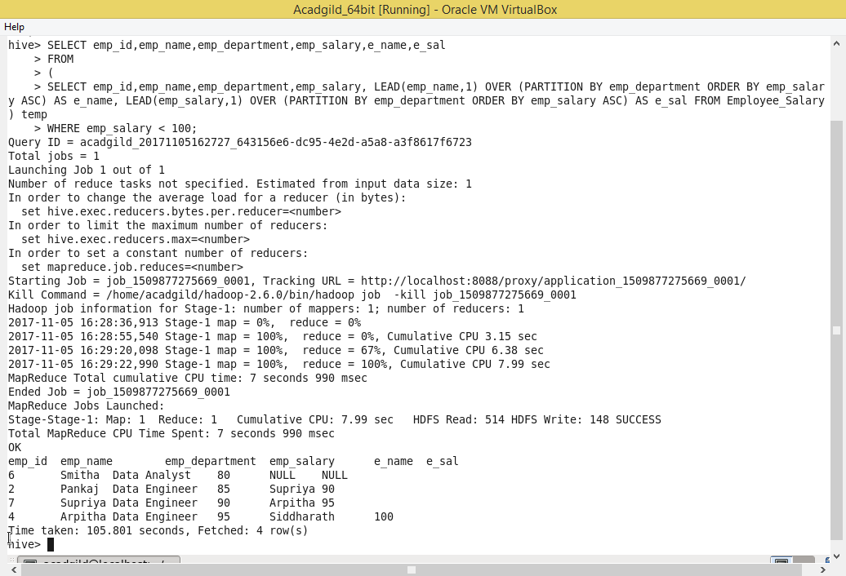

**Problem2:**

**List of all employees who draw higher salary than the average salary of that department**

**Output:**

