**Problem Statement**

Link: https://acadgild.com/blog/transactions-in-hive/

Refer the above given link for transactions in Hive and implement the operations given in the blog using your own sample data set and send us the screenshot.

**Hive 0.14 should be installed to implement the hive transaction property.**

**Solution:**

* Getting the Hive Version
* Starting all daemons.
* Starting MySQL (Needed for Hive)
* Starting Hive

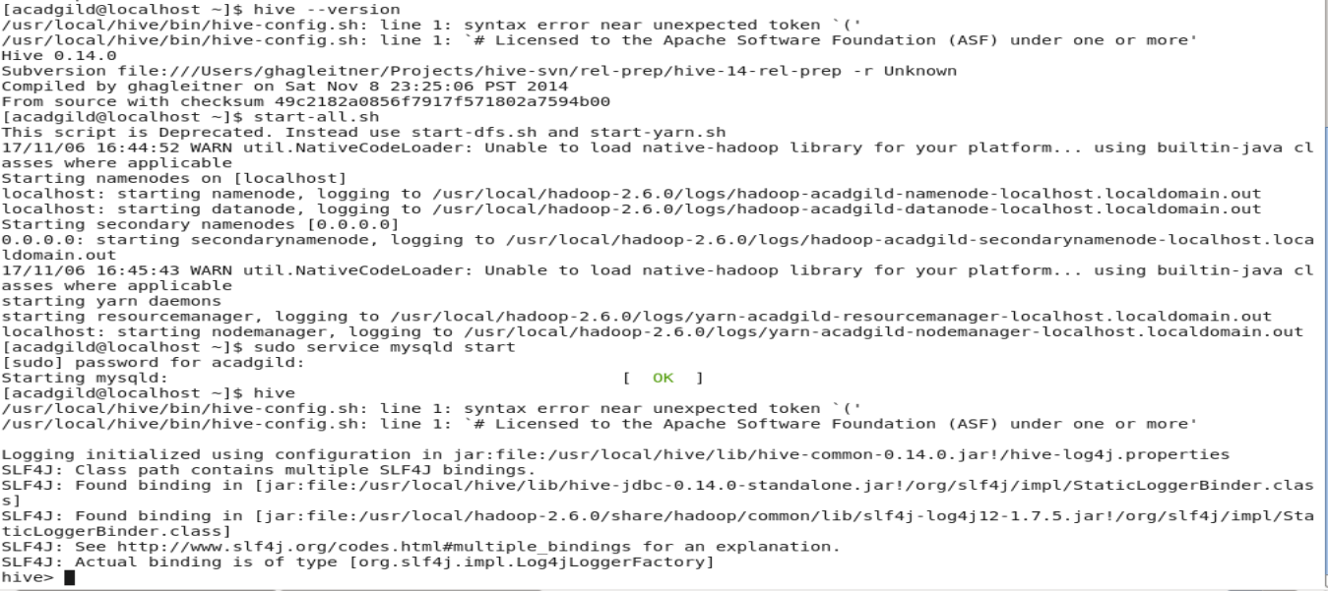

The below properties needs to be set appropriately in ***hive shell,*** order-wise to work with transactions in Hive:

**Steps:**

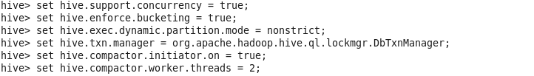

If the above properties are not set properly, the ‘Insert’ operation will work but ‘Update’ and ‘Delete’ will not work and you will receive the following error:

FAILED: SemanticException [Error 10294]: Attempt to do update or delete using transaction manager that does not support these operations.

**Creating a Table That Supports Hive Transactions**

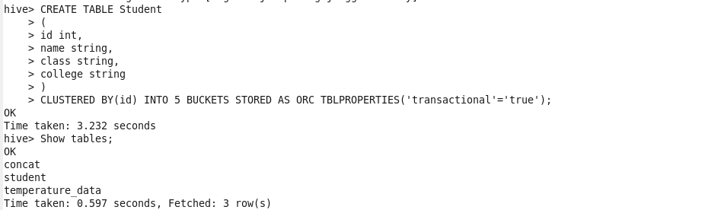

The above syntax will create a table with name ‘*Student’*and the columns present in the table are ‘id*, name, class, college’. W*e are *bucketing* the table by ‘id*’*and the table format is ‘*ORC’,*also we are enabling the transactions in the table by specifying it inside the *TBLPROPERTIES* as *‘transactional’=’true’*

I have successfully created a table with name ‘*Student’*which supports row-level transactions of Hive.The created table can be checked using the command ***Show tables;***

## Inserting Data into a Hive Table

## 

The above command is used to insert row wise data into the Hive table. Here, each row is separated by ‘*( )’ brackets. Now, we have successfully inserted the data into the Hive table.* *The contents of the table can be viewed using the command:* ***SELECT * FROM Student;***

From the above image, we can see that the data has been inserted successfully into the table.

Now if we try to re-insert the same data again, it will be appended to the previous data as shown below:

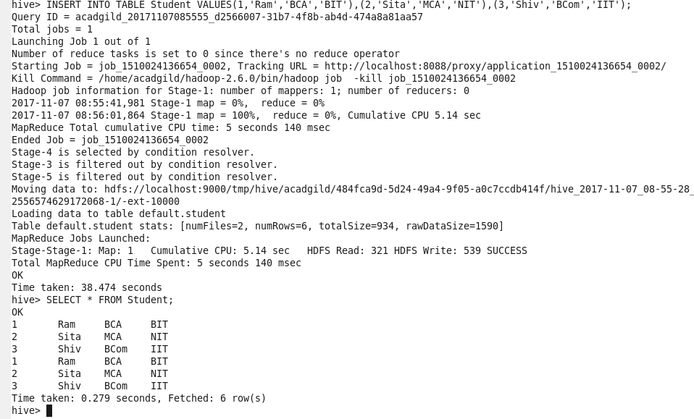

**Updating the Data in Hive Table**

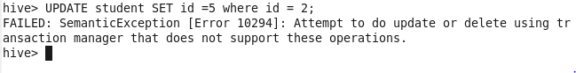

UPDATE Student SET id = 5 WHERE id = 2;

|  |
| --- |
|  |

In this table, i have bucketed the ***‘id’*** column and performing the Update operation on the same column, so the error will occurred

***FAILED: SemanticException[Error 10302]: Updating values of bucketing columns is not supported. Column id***

**Now let’s perform the update operation on Non bucketed column**

UPDATE Student SET name = ‘Ankita’ WHERE id = 2;

|  |
| --- |
|  |

The updated data can be checked using the command ***select * from Student_Details.***

We can see that the data has been updated successfully.

**Deleting a Row from Hive Table**



## DELETE FROM Student WHERE id = 2;

|  |
| --- |
|  |

The above command will delete a single row in the Hive table.We have now successfully deleted a row from the Hive table. This can be checked using the command **select * from Student.**We can see that there is no row with***id =2***. This means that we have successfully deleted the row from the Hive table. This is how the transactions or row-wise operations are performed in Hive.

**The Update and Delete Operation did not work in my Acadgild VM. Error occurs**

FAILED: SemanticException [Error 10294]: Attempt to do update or delete using transaction manager that does not support these operations **As discussed with the support team they told me just send the steps in the document and upload in the git hub and send link through acadgild dashboard.**