**Problem Statement**

**Problem 1:**

Create an HBase table named 'clicks' with a column family 'hits' such that it should be able to store last 5 values of qualifiers inside 'hits' column family.

**Problem 2:**

Add few records in the table and update some of them. Use IP Address as row-key. Scan the table to view if all the previous versions are getting displayed.

**Starting of hbase:**

* Starting the HBase shell with the commands **‘start-hbase.sh’** and ‘**hbase shell**’

Then checking if all daemons are running successfully with command **‘jps’**

* Once successfully entered into Hbase, I have executed
  + **version** command to check Hbase’s version (0.98.14)
  + **list** command to check the tables available in the system (No tables – []).

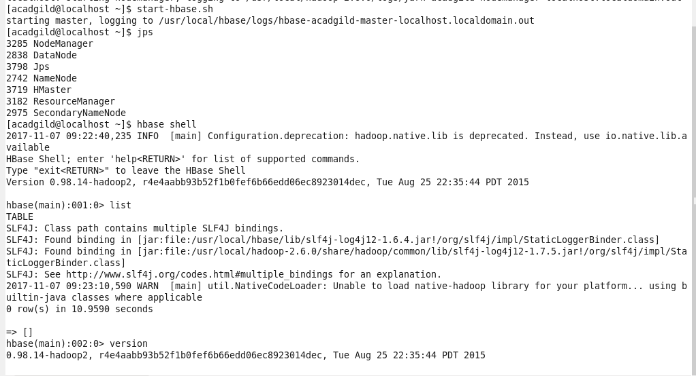

**Problem 1:**

Create an HBase table named 'clicks' with a column family 'hits' such that it should be able to store last 5 values of qualifiers inside 'hits' column family.

**Solution:**

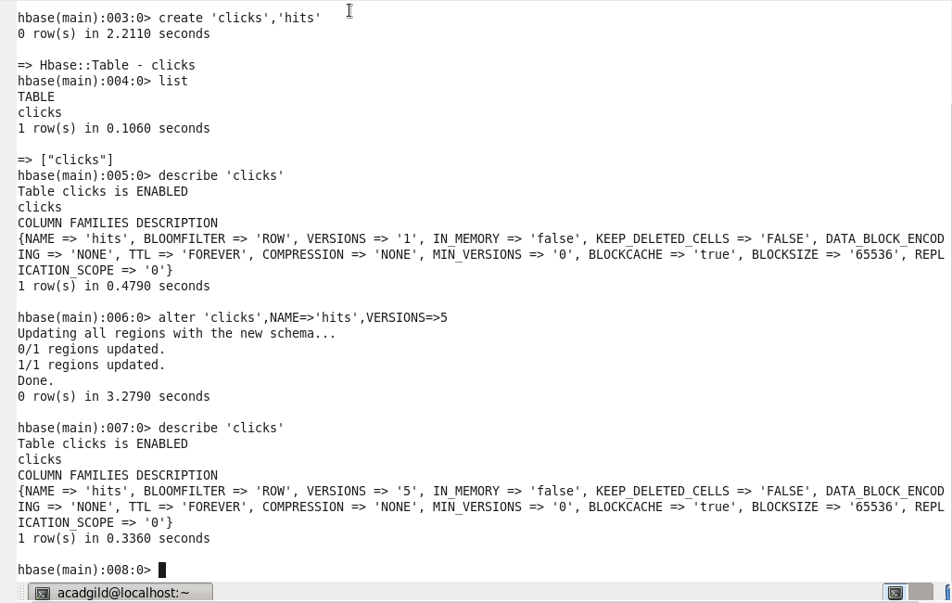

**Problem 2:**

Add few records in the table and update some of them. Use IP Address as row-key. Scan the table to view if all the previous versions are getting displayed.

**Solution:**

