**5 Career Options for Music Lovers**

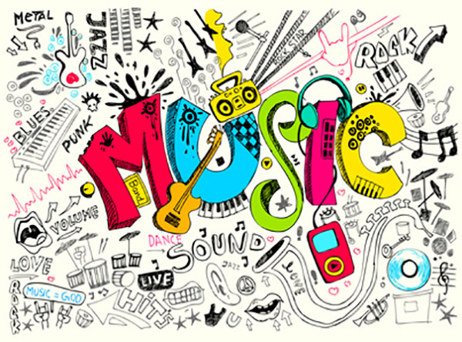

So you love music and wants to develop a career in the music industry.

In today’s world, as a person with interest in music, singing is not the only career option.

With the advancement of technology [career options has got diversified](http://www.seaindia.in/blog/7-new-age-career-opportunities-for-sound-engineers/) for those who have got interest in music to pursue a career in the same.

Other than singing the first thing that enthuse a music lover / a singer is music direction.

  
**Music Direction**  
Of course, the perceived reality with regard to a career in music direction appears too difficult / insecure and it requires a lot of work and commitment to take care of itself to achieve a certain level of recognition.

**Eligibility** -In order to become a successful “star” in the field of music direction you should possess sheer musical brilliance to entertain the mass.

Apart from that you need to have appropriate contacts within the music and film industry to receive new projects.

  
**Audio Engineer**  
As you know sound engineering has got different career options to choose from like in live sound or in studio.

If you are thinking about becoming a recording engineer, mix engineer, re-recordist, broadcast engineer or sound effects editor it is an added value to have an interest in music, sound, creative arts etc.

**Course-**In order to become a Sound Engineer one has to undergo professional training in the field and with a 1 year course from institute like Sound Engineering Academy can help you to achieve the same.

**Eligibility** -The [1 year Diploma in Sound Engineering and Sound Recording](http://www.seaindia.in/courses.php) can be pursued by those who have a basic qualification of 10+2. Students from any stream whether having science background or from people with commerce or humanities background can join the course.

  
**Artist Manger**  
One can imagine the situation in such a way that musicians are mainly interested in music and are often not so concerned about the business aspects of the music industry. And this is where the manager’s role is set. The manager is the business department of the artist. This means that he gets the best deal for the artists in negotiations and contract closures.

An artist manager is mostly involved in the artist’s revenue pro-rata. Forty percent of the revenue is more the rule than the rarity. As a good and capable manager, it is quite possible to become (almost) as rich as the artist without having to accept the fame of the media and fans.

**Music Journalist / Critic**  
**Eligibility** -If you posses writing skills and a basic knowledge in the field of music then you can become a Music Journalist.

Many publications whether it is new papers / magazines they do have a column for entertainment and they need to have in-depth articles on music industry. As a person with interest in music and singing you can pursue a long-term career in the field.



**Teaching**  
Other than singing and music direction the most sought after career in music is Teaching.

### COURSES AVAILABLE:- ****List of Music Courses:****

These courses can also be termed as Theory Courses

* Bachelor of Arts in Classical Music
* Bachelor of Arts in Instrumental Music
* Bachelor of Arts in Musicology
* Bachelor of Arts in Music Vocal
* Bachelor of Arts Honors in Classical Music
* MA Folk Music
* Master of Arts in Musicology
* Master of Arts in Music
* Master of Philosophy in Music (M.Phil)
* D Folk Music
* Doctor of Philosophy in Music and art and many more.

### ****Certification:****

Various Certification Courses are also available, here is the list.

* Certified Courses In Guitar
* Certified Courses in Sitar
* Certified Courses In Tabla
* Certified Courses In Music Therapy

### ****Courses Online:****

Other than Normal Courses, Certified Courses, there also exists the option Online Courses. Numerous courses are available in Online. Some of them are for free and some charge very less. These Online Courses also provide Certification and also Materials.

No Time Restriction, we can learn as per our flexibility.

The list of Online Courses is:

* Introduction To classical Music
* Music Business Foundations
* Fundamentals of Music Theory
* Survey of Musical Technology
* Introduction to classical Music Composition
* Music and Society
* Introduction to Guitar
* Vocals
* The Art of Vocal Production
* Art of Mixing
* Rhythm section
* Composing
* Contemporary
* Guitar Chords etc

#### ****Fee Structure:****

The fee structure varies, but for most of the certification courses it is free of cost and for some short courses it would be around 5000/-

#### ****Career Prospects:****

Those who have completed Music Courses can get bright career with many job opportunities. One can find offers of their own or can start an institute.

#### ****Salary Details:****

The pay scale will be starting 1 lakh and more.